|  |  |
| --- | --- |
| **NAME OF THE INSTITUTION** | SRI MOOGAMBIGAI POLYTECHNIC COLLEGE |
| **INSTITUTION CODE** | 912 |
| **COURSE CODE &**  **NAME OF THE DEPARTMENT** | 1030 & ELECTRICAL & ELECTRONICS ENGINEERING |
| **TITLE OF THE PROJECT** | **ARUDINO BASED WEATHER STATION WITH IOT** |
| **NAME OF THE GUIDE & DESIGNATION** | **ANBARASAN R S & LECTURER** |
| **TOTAL COST OF THE PROJECT** | 8,000/- |
| **NO.OF STUDENTS** | 06 |

|  |  |  |
| --- | --- | --- |
| **S.NO** | **REGISTER NUMBER** | **NAME OF THE STUDENT** |
| 01 | 22311879 | HARISHKANNA R |
| 02 | 22311885 | POOVARASAN M |
| 03 | 22311886 | PRADEEP KUMAR R |
| 04 | 22396058 | DHARANESH S |
| 05 | 22396059 | LOKESHWARAN T |
| 06 | 22396075 | SUDHAKAR S |

**SYNOPSIS**

**Brief Introduction:**

An Arduino weather station with IoT capabilities is a project that involves creating a device to monitor and collect weather-related data using Arduino microcontrollers and sensors, and then transmitting this data to the Internet for remote access and analysis. The combination of Arduino and IoT technology allows for the creation of a versatile weather monitoring system.

# Objective of the Project:

# The goal of this project is to make a temperature/humidity/Air pressure/Wind monitor that wirelessly logs the temperature, humidity, Air pressure and Wind to a remote server. We will use an Arduino Uno a DHT11, an ESP8266, and ThingSpeak.com for this project.

# Brief Methodology:

# The working of an Arduino weather station with IoT involves the integration of various components to measure weather parameters, read data from sensors, and transmit this information to an online platform for remote monitoring. It is equipped with environmental sensors used for measurements at any particular place and report them in real time on cloud. To accomplish this, we used Arduino Uno and different environmental sensors like DHT11, soil moisture sensor and rain drop sensor. The sensors constantly sense the weather parameters and keeps on transmitting it to the online webserver over a wifi connection. The weather parameters are uploaded on the cloud and then provides the live reporting of weather information. This paper also focuses on the IOT application in the new generation of environmental information and provides a new paradigm for environmental monitoring in future.

# Block Diagram:

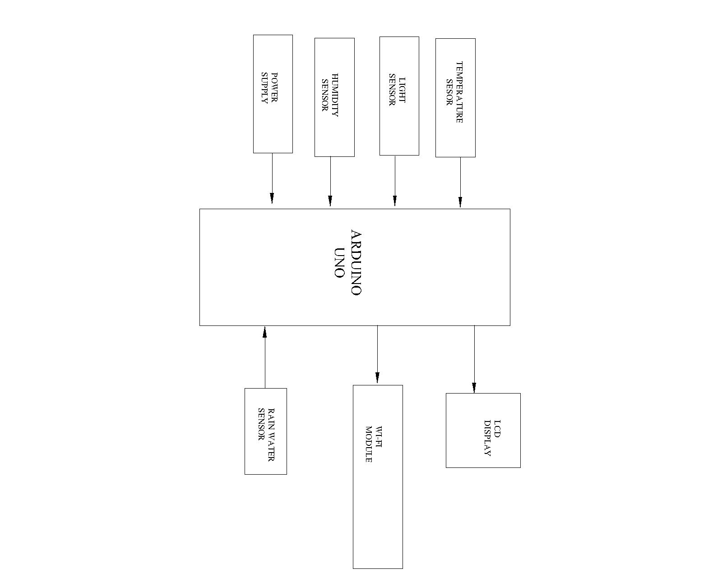

**Expected Outcome:**

An Arduino weather station with IoT (Internet of Things) capabilities can provide a range of functionalities and outcomes, depending on the components and sensors used, as well as the programming implemented. Like **Real-time Data Monitoring, Alerts and Notifications, Data Visualization, Educational Purposes.**

CERTIFICATE

The Project works is selected by the students based on the norms/rules prescribed by the DOTE, Chennai.

**Signature of the guide** **Signature of the HOD**

**Remarks of the Member/Monitoring Committee:-**

Recommended / Not Recommended Approved / Not Approved

**Signature of the member/Project Signature of the Head/Project**

**Work monitoring committee** **work monitoring committee with seal**