AI Usage DISCLOSURE FORM

1. Team Details
Team Name: PixelSyndicate
Project / Product Name: Voisync
Organization / Institution (if any): SRM Institution
Submission Date: 30-09-2026

2. AI Usage Declaration
Did your team use any Artificial Intelligence (AI) in developing this project? Yes / No
YES

3. Purpose of AI Usage (Brief Details)
Idea generation / brainstorming -Yes – AI was used to brainstorm implementation approaches, architecture, module responsibilities, and development workflow.
Code generation or assistance - Yes – AI was used to generate, explain, debug, and refine Kotlin/Android code and supporting project files.
UI / UX design - Limited/No – AI was not used to independently design the core application UI.
Content creation - Yes – AI was used to assist with project documentation, presentation content, explanations, and technical descriptions.
Data analysis -No significant data analysis was performed using AI.
Testing / debugging - Yes – AI was used to interpret build errors, Git conflicts, debugging output, and suggest fixes.
Other - AI-assisted technical documentation, Git/GitHub workflow assistance, and project planning.

4. Feature Origin Classification (Please add/delete based on the number of the feature)
1. Feature Name - Accessibility Service & UI Tree Reader
2. Self-Generated/AI-Generated/Both - BOTH
3. Description (include AI tools/platform Used, prompt used, Output Summary, Modification) -
The team defined the requirement for an Android AccessibilityService capable of receiving UI events and reading the active accessibility tree. AI tools, including ChatGPT and Antigravity/Claude, were used for code generation assistance, code explanation, debugging, and implementation guidance. Prompts described the required AccessibilityService behavior, UI-tree traversal, node properties, and Android project structure. AI-generated code was reviewed, modified, integrated, and tested by the team. The final implementation was adapted to the project's package structure and requirements.

1. Feature Name - Semantic Target & Teaching Action Capture
2. Self-Generated/AI-Generated/Both - BOTH
3. Description (include AI tools/platform Used, prompt used, Output Summary, Modification) -
The team designed the requirement to capture meaningful user actions as semantic targets instead of relying only on-screen coordinates. AI tools were used to assist in designing the Kotlin data models and implementation for SemanticTarget, TeachingAction, TextNormalizer, and TeachingRecorder. Prompts specified semantic properties such as resource ID, normalized text, content description, class, clickable/enabled state, bounds, package context, and sensitive-field handling. The generated implementation was reviewed, modified, integrated, and tested by the team.
1. Feature Name - Teaching Recorder & Click/Event Capture
2. Self-Generated/AI-Generated/Both – BOTH
3. Description (include AI tools/platform Used, prompt used, Output Summary, Modification) -
The team defined the requirement for recording meaningful UI actions during a teaching session. AI assistance was used to implement event handling, click detection, semantic target creation, TeachingAction creation, recording logic, and sensitive-field protection. The AI-generated implementation was reviewed and modified by the team to fit the existing AccessibilityService architecture. The functionality was tested on an Android device using real accessibility events and UI-tree data.
1. Feature Name - Android–Team Code Integration and Debugging
2. Self-Generated/AI-Generated/Both - BOTH
3. Description (include AI tools/platform Used, prompt used, Output Summary, Modification) -
AI tools were used to assist with Git/GitHub integration, merge-conflict analysis, build troubleshooting, and preservation of existing teammate functionality. Prompts provided the current Git state and required that both Person 1 teaching functionality and teammate replay/cloud functionality be preserved. AI-assisted resolution was reviewed and validated by the team. The final project was successfully merged and pushed to the team's GitHub main branch.
…

5. Ethical & Compliance Confirmation
AI usage complies with guidelines and policies. Yes
No proprietary or copyrighted data misused. I Agree

6. Declaration & Sign-Off
Name of Team Representative: Chirag Mehta
Role: Team Leader
Signature:
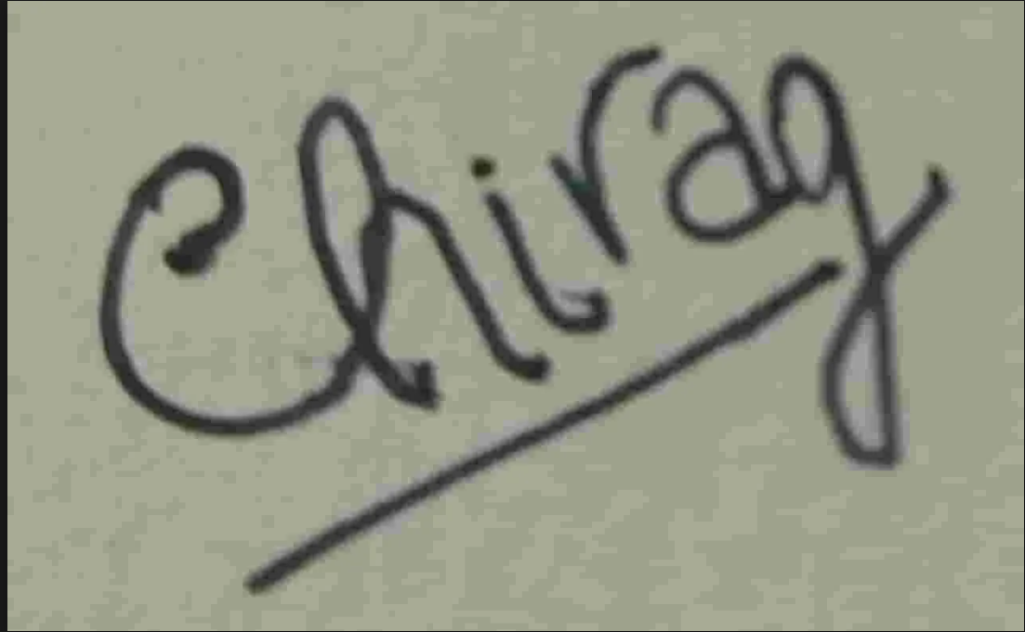
Date: 30-09-2026

