**Class Diagram:**

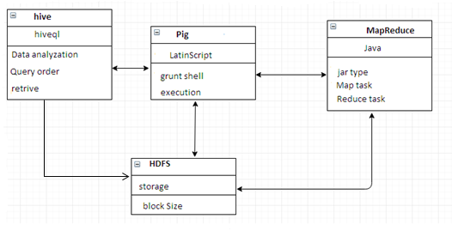

**EXPLANATION:**

A class diagram is an illustration of the relationships and source code dependencies among classes in the Unified Modeling Language (UML). In our class diagram the client reviews with analyze of healthcare data,which will be easy to predicate. The client need not want to go for hospital because he/she can easily identify the diseases with the help of bigdata analytic report .So hereafter easily analysed and what could be done for further process such as diseases occur while usage of home needs at low level.some of the important tools are implemented in hadoop ecosystem for bringing a solution.

**Object Diagram:**

Hive

Hdfs

 pig

Cri preprocess

client

mapreduce

**EXPLANATION:**

An object diagram in the Unified Modeling Language (UML) is a diagram that shows a complete or partial view of the structure of a modeled system at a specific time. In our object diagram the client concludes with analyze of healthcare data,which will be easy to predicate. There are different types of diseases spreading nowadays so we can research them our home needs by doing we are how much safer zone .whatever data we are analyzing that will adequates them into hdfs.

**State Diagram:**

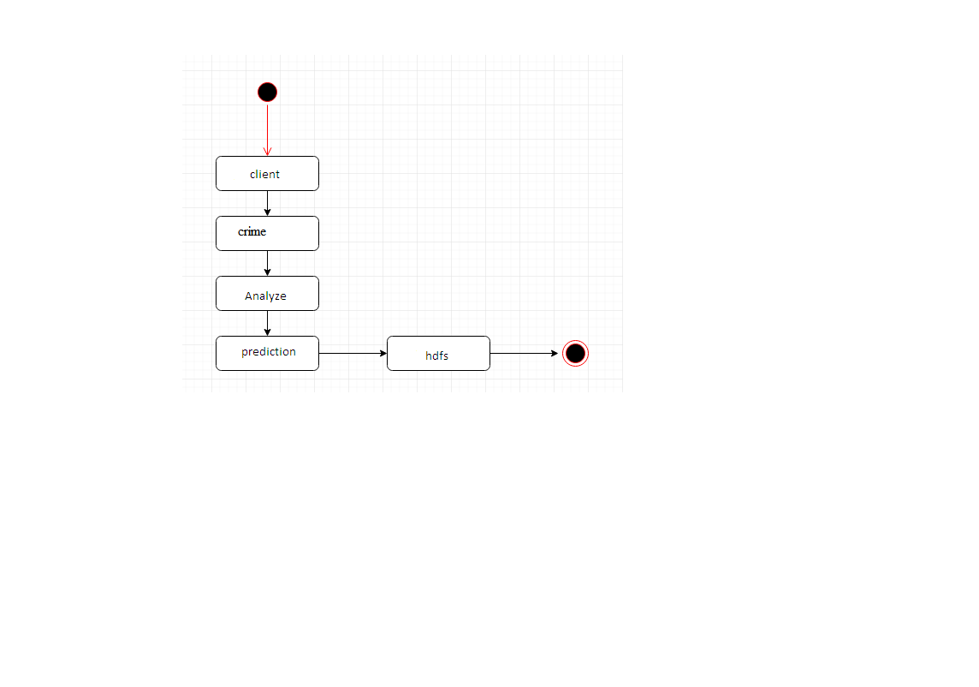

**EXPLANATION:**

A state diagram is a type of diagram used in computer science and related fields to describe the behavior of systems. State diagrams require that the system described is composed of a finite number of states; sometimes, this is indeed the case, while at other times this is a reasonable abstraction. In state diagram the client concludes with analyze of healthcare data,which will be easy to predicate.Here what we presents means again same data will be analyzed with different techniques and predictions are done those data stored in hdfs.So these much of data cannot be handle by limited database.They proceeding with hadoop ecosystems at backend processing tool.

**Activity Diagram:**

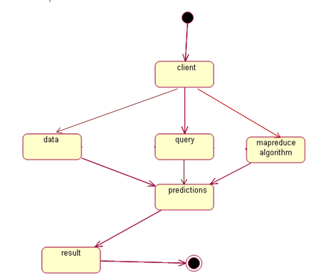

**EXPLANATION:**

Activity diagrams are graphical representations of workflows of stepwise activities and actions with support for choice, iteration and concurrency. In the Unified Modeling Language, activity diagrams are intended to model both computational and organizational processes (i.e. workflows).In our activity diagram the client concludes with analyze of healthcare data,which will be easy to predicate. Here what we presents means data will be analyzed with different techniques and predictions are done those data stored in hdfs.So these much of data cannot be handle by limited database.They proceeding with hadoop ecosystems at backend processing tool. And another popular techniques also used that is an mapreduce algorithm which can easily done in parallel approach.

**Sequence Diagram:**

client

hive

pig

mapreduce

Analyze with query

Analysis with script

Parallel process

Fast retrieval

Result prediction

**EXPLANATION:**

A Sequence diagram is an interaction diagram that shows how processes operate with one another and in what order. It is a construct of a Message Sequence Chart. A sequence diagram shows object interactions arranged in time sequence. In our sequence diagram the client concludes with analyze of healthcare data,which will be easy to predicate. Here what we presents means data will be analyzed with different techniques and predictions are done those data stored in hdfs.So these much of data cannot be handle by limited database.They proceeding with hadoop ecosystems at backend processing tool. By using any one of the tools can bring the data in a fast mode from the large number of data storage.

**Data Flow Diagram:**

**Level-0:**

crime Database

Client

Sqoop

Hdfs

**Level-1:**

  Hdfs

MapReduce

Pig

Hive

**EXPLANATION:**

A Data Flow Diagram (DFD) is a graphical representation of the "flow" of data through an information system, modeling its process aspects. A DFD is often used as a preliminary step to create an overview of the system, which can later be elaborated. In our Data Flow diagram the client concludes with analyze of healthcare data,which will be easy to predicate. Here what we presents means data will be analyzed with different techniques and predictions are done those data stored in hdfs.So these much of data cannot be handle by limited database.They proceeding with hadoop ecosystems at backend processing tool. By using any one of the tools can bring the data in a fast mode from the large number of data storage.

**E-R Diagram:**

crime

Database

Client

HDFS

Hive

MapReduce

Pig

**EXPLANATION:**

An entity-relationship diagram, or ERD, is a chart that visually represents the relationship between database entities. ERDs model an organization's data storage requirements with three main components: entities, attributes, and relationships.In our E-R diagram the client concludes with analyze of healthcare data,which will be easy to predicate. Here what we presents means data will be analyzed with different techniques and predictions are done those data stored in hdfs.So these much of data cannot be handle by limited database.They proceeding with hadoop ecosystems at backend processing tool. By using any one of the tools can bring the data in a fast mode from the large number of data storage.

**Component Diagram:**

client

Search

data

Database

Filter the

Result

Hdfs

**EXPLANATION:**

In the Unified Modeling Language, a component diagram depicts how components are wired together to form larger components and or software systems. They are used to illustrate the structure of arbitrarily complex systems. In our Component diagram the client concludes with analyze of healthcare data,which will be easy to predicate. Here what we presents means data will be analyzed with different techniques and predictions are done those data stored in hdfs.So these much of data cannot be handle by limited database.They proceeding with hadoop ecosystems at backend processing tool. By using any one of the tools can bring the data in a fast mode from the large number of data storage.