
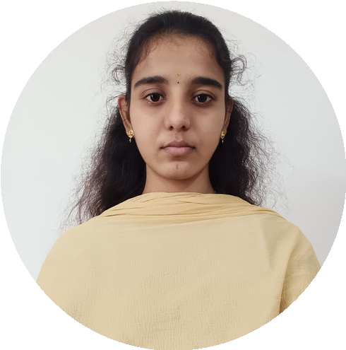

Open AI python .
Applied Generative AI Certification.
MongoDB.
HARISHMITHA.A
8754818035
harishmitha786@gmail.com
CONTACT
Teamwork
PERSONALITY SKILLS
Time Management
Leadership
Active listening
Adaptability
Problem solving
English
TECHNICAL SKILLS
Tamil
LANGUAGE
EDUCATION
CO-CURRICULAR ACTIVITIES
CERTIFICATIONS

B.E Computer science and Engineering:
Karpagam Academy of Higher Education (2023-2027)
current CGPA:80%
Schooling:
RG Matric higher secondary school
SSLC:100%(due to corona)
HSE:71.1%
Java
c++

C Programming
HTML

CSS
PROFILE

I am pursuing third year Computer science
Engineering student with a strong interest in the IT
field. I am learning programming and improving my
problem-solving skills. I am eager to gain experience,
learn new technologies, and grow in the software and
IT industry.
https://www.linkedin.com/in/
harishmitha-arumugam-
b27b52293
Participated in coding and tech quiz

Workshop on python
Internship in babbagens company for python and
open Ai

Attending workshops and seminars

FIELD OF INTEREST
Web development

Artificial intelligence

App development

Information Technology
PERSONAL DETAILS
Father’s Name:Arumugam .R
Date of birth:
03/08/2005
Address:
2
/10, D/O Arumugam, Om sakthi Kovil
Street pethappampatti, pethappampatti (p.o),
Udumalpet(T.k), Tiruppur (D.T)

