Data-Driven Solutions and Discoveries in Mechanics Using Physics-Informed Neural Networks
UE24CS352A Machine Learning Mini-Project
Problem #13
Team:

Problem Statement
Use a physics-informed neural network (PINN) on a mechanics problem governed by a differential equation: (a) solve it with the physics alone, and (b) recover unknown physical parameters from sparse, noisy measurements. We study a damped spring-mass system, m x'' + c x' + k x = 0 with x(0)=1, x'(0)=0 and m=1. Reference: Zhang, Chen and Yang, Data Driven Solutions and Discoveries in Mechanics Using Physics Informed Neural Network, Stanford CS229 (2020).

Dataset
No external dataset. Forward problem: 300 random collocation points in t in [0, 10] plus the initial conditions only. Inverse problem: 40 evenly spaced displacement readings generated from the closed-form underdamped solution with true c=0.4, k=4.0, plus Gaussian noise (sigma=0.02). The closed-form solution is used only to generate the readings and to evaluate error.

Approach
A fully connected network x(t) (4 hidden layers, 64 tanh units, scalar input and output) approximates displacement. The derivatives x' and x'' come from automatic differentiation (PyTorch autograd). Loss = mean squared ODE residual (m x'' + c x' + k x) + 10 x initial-condition loss (+ 10 x data loss in the inverse case). In the inverse case, c and k are trainable scalars, initialised at 1.0 (far from the truth) and optimised jointly with the network weights. Optimiser: Adam, learning rate 1e-3, 6000 iterations per experiment, seed 0.

Implementation Overview
Single script pinn_mechanics.py: a Net class, a derivs() helper that returns x, x' and x'' via autograd, train(inverse=False/True), evaluate() against the closed-form solution, then plotting and export of metrics to results.json and results.png. Run with python pinn_mechanics.py (setup in README). Repository:
[GitHub link].

Results
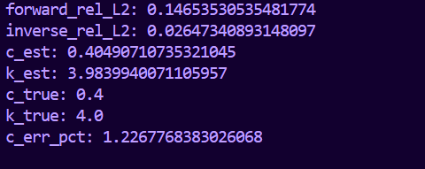
Experiment | Metric | Value
Forward (no data) | Relative L2 error vs closed form | 0.1465 (14.7%)
Inverse (noisy data) | Relative L2 error vs closed form | 0.0265 (2.6%)
Inverse | c estimated (true 0.4) | 0.4049 (1.23% error)
Inverse | k estimated (true 4.0) | 3.9840 (0.40% error)

-forward fit, inverse fit, and c/k convergence:

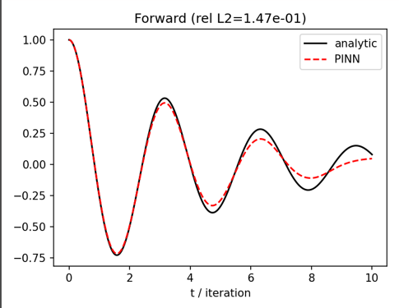
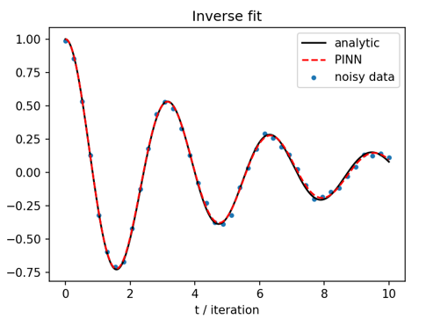
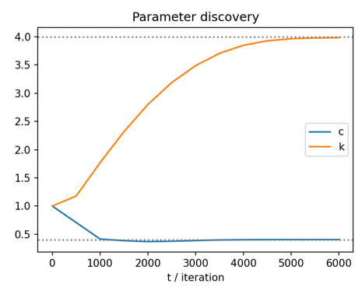

Conclusions
With the physics in the loss, the PINN recovered the damping and stiffness from 40 noisy readings to within about 1% despite a poor starting guess, and the inverse fit matched the true trajectory closely (2.6% relative error). The forward-only solution is less accurate (14.7%): it tracks the overall decaying oscillation but drifts over the long time window, a known difficulty for PINNs on oscillatory problems without data. We tried forcing the initial conditions exactly through an output transform; it made results worse, so the final model keeps them in the loss. Limitations: a single linear one-degree-of-freedom system, one seed, and results sensitive to loss weights, network size and iteration count. Future work: nonlinear (Duffing) oscillator, the PDE problems from the reference (1D consolidation, 2D heat conduction), L-BFGS refinement after Adam.

