##### 

**Interactive Children's Storybooks and Education Portal**

## A PROJECT REPORT

### Submitted by

# GOWTHAM S

### in partial fulfillment for the award of the degree of

# BACHELOR OF ENGINEERING

**IN**

#### BCOMPUTER SCIENCE AND ENGINEERING

## SRI KRISHNA COLLEGE OF ENGINEERING AND TECHNOLOGY

**(An Autonomous Institution, Affiliated to Anna University Chennai - 600 025)**

#### AUGUST & 2024



**BONAFIDE CERTIFICATE**

Certified that this project report titled **“INTERACTIVE CHILDREN’S STORYBOOKS AND EDUCATION PORTAL”** is the bonafide work of **GOWTHAM S (727722EUCS055), ASWIN S (727722EUCS026),HARISH RAGAVENDAR (727722EUCS065)** who carried out the project work under my supervision.

**SIGNATURE SIGNATURE**

Dr. Granty Regina Elwin Mr. Ramesh K

**HEAD OF THE DEPARTMENT SUPERVISOR**

Professor Assistant Professor

Information Technology, Information Technology,

Sri Krishna College of Engineering and Sri Krishna College of Engineering and Technology, Technology,

Kuniyamuthur, Coimbatore–641008. Kuniyamuthur, Coimbatore–641008**.**

Submitted for the Project viva-voce examination held on

INTERNAL EXAMINER EXTERNAL EXAMINER

**ACKNOWLEDGEMENT**

At this juncture, we take the opportunity to convey our sincere thanks and gratitude to the management of the college for providing all the facilities to us.

We wish to convey our gratitude to our college principal**, Dr. Porkumaran K** forforwarding usto do our project and offering adequate duration to complete our project.

We would like to express our grateful thanks to **Dr. Granty Regina Elwin J** Head of the department, Department of Information Technology for her encouragement and valuable guidance to this project.

We extend my gratitude to our beloved guide **Mr. Ramesh K,** Assistant Professor, Department of Information Technology for her constant support and immense help at all stages of the project.

iii

EXTERNAL EXAMINER

| **Chapter** | **Title** | **Page No.** |
| --- | --- | --- |
| **1** | **INTRODUCTION** |  |
| 1.1 | Background and Motivation | 1 |
| 1.2 | Objectives | 2 |
| 1.3 | Scope of the Project | 3 |
| 1.4 | Significance of the Project | 4 |
| **2** | **SYSTEM ANALYSIS** |  |
| 2.1 | Requirement Analysis | 5 |
| 2.2 | Feasibility Study | 7 |
| 2.3 | System Specification | 9 |
| **3** | **SYSTEM DESIGN** |  |
| 3.1 | Architectural Design | 10 |
| 3.2 | Database Design | 12 |
| 3.3 | User Interface Design | 14 |
| 3.4 | Security Design | 16 |
| **4** | **IMPLEMENTATION** |  |
| 4.1 | Development Environment | 18 |
| 4.2 | Frontend Implementation | 19 |
| 4.3 | Backend Implementation | 21 |
| 4.4 | Integration and Deployment | 23 |
| **5** | **SYSTEM REQUIREMENTS** |  |
| 5.1 | Hardware Requirements | 25 |
| 5.2 | Software Requirements | 26 |
| 5.3 | Software Description | 27 |
| 5.3.1 | Frontend | 27 |
| 5.3.2 | Backend | 30 |
| **6** | **TESTING** |  |
| 6.1 | Unit Testing | 32 |
| 6.2 | Integration Testing | 34 |
| 6.3 | Security and Authentication | 36 |
| 6.4 | Test Cases | 38 |
| **7** | **CONCLUSION** |  |
| 7.1 | Summary of Achievements | 40 |
| 7.2 | Challenges and Resolutions | 41 |

## ABSTRACT

The **EduGo: Interactive Children's Storybooks and Educational Portal** is an innovative digital platform designed to revolutionize the way children engage with educational content. In an era where technology plays a pivotal role in learning, EduGo offers a unique blend of interactivity, customization, and educational value, aimed at enhancing children's reading, comprehension, and cognitive skills. This project report delves into the conceptualization, design, development, and deployment of the EduGo platform, which harnesses modern web technologies to create an engaging, user-friendly environment for young learners.

EduGo’s primary objective is to provide a dynamic learning experience through interactive storybooks that integrate animations, audio narration, and interactive elements, making reading a more immersive and enjoyable activity. The platform is designed with a responsive user interface, ensuring accessibility across a range of devices, including desktops, tablets, and smartphones. The customizable avatar feature allows children to personalize their learning experience, further fostering engagement and a sense of ownership over their educational journey.

The backend architecture of EduGo is built using Spring Boot microservices, ensuring scalability, maintainability, and secure data management. A MySQL database is utilized to store user information, storybook content, and progress tracking data, with a focus on ensuring data integrity and security. The platform also includes a robust administrative dashboard, enabling content managers to efficiently manage the storybook library and monitor user activity.

Throughout the development process, significant emphasis was placed on performance optimization and security. Techniques such as caching and efficient API design were implemented to ensure fast load times and a smooth user experience, even under high traffic conditions. Security measures, including JWT-based authentication and encryption of sensitive data, were employed to protect user information, particularly given the platform’s focus on young users.

Testing and validation of the EduGo platform involved a comprehensive strategy that included unit testing, integration testing, and end-to-end testing, ensuring that all components functioned seamlessly together. Feedback from beta testers, including children, parents, and educators, played a crucial role in refining the user interface and enhancing the overall user experience.

This project report concludes with a discussion of the challenges faced during development, such as performance optimization and security implementation, and how these challenges were overcome. It also outlines potential future enhancements, including the incorporation of AI-based adaptive learning, the development of a native mobile application, and the expansion of the content library to include additional languages and educational games.

In summary, EduGo represents a significant step forward in the use of technology to support and enhance children's education. By combining interactive content with modern web technologies, EduGo offers a platform that is not only educational but also engaging and enjoyable for young learners, setting the stage for future innovations in educational technology.

**LIST OF TABLES**

| **Table No.** | **Title** | **Page No.** |
| --- | --- | --- |
| 1.1 | User Demographics and Preferences | 10 |
| 2.1 | Comparison of Interactive Storybook Platforms | 17 |
| 3.1 | Database Schema for User Profiles | 22 |
| 3.2 | API Endpoints and Their Functions | 24 |
| 4.1 | Results of Performance Testing Across Different Devices | 33 |
| 4.2 | Security Features Implemented in EduGo | 36 |
| 5.1 | Feedback Summary from Beta Testing | 42 |
| 5.2 | Proposed Features for Future Enhancements | 46 |

**LIST OF FIGURES**

| **Figure No.** | **Title** | **Page No.** |
| --- | --- | --- |
| 1.1 | System Architecture Overview | 9 |
| 1.2 | UML Use Case Diagram for EduGo Platform | 12 |
| 2.1 | Wireframe of the Home Page | 18 |
| 2.2 | Design of the Interactive Storybook Interface | 20 |
| 3.1 | Flowchart of the User Registration Process | 23 |
| 3.2 | Data Flow Diagram of the Backend Services | 27 |
| 4.1 | Performance Optimization Techniques Implemented | 35 |
| 4.2 | Security Architecture of EduGo | 38 |

**LIST OF SYMBOLS**

| **Symbol/Abbreviation** | **Description** |
| --- | --- |
| API | Application Programming Interface |
| UI | User Interface |
| UX | User Experience |
| JWT | JSON Web Token |
| DB | Database |
| CRUD | Create, Read, Update, Delete |
| AWS | Amazon Web Services |
| ECS | Elastic Container Service |
| ALB | Application Load Balancer |
| IDE | Integrated Development Environment |
| CSS | Cascading Style Sheets |
| JSX | JavaScript XML |
| LMS | Learning Management System |
| SIS | Student Information System |
| SSL/TLS | Secure Sockets Layer/Transport Layer Security |

## CHAPTER 1

## INTRODUCTION

## BACKGROUND AND MOTIVATION

## The rapid advancement of technology has transformed the landscape of education. With the advent of digital platforms, there is an increasing demand for interactive and engaging educational tools that cater to the learning needs of children. Traditional educational methods are being complemented, and in some cases, replaced by digital solutions that offer interactive content, personalized learning experiences, and immediate feedback.

## EduGo was conceived as a response to this growing need. The platform aims to provide an interactive environment where children can explore educational content through storybooks that come alive with animations, sounds, and interactive elements. The project seeks to make learning enjoyable while also contributing to the development of essential skills such as reading, comprehension, and critical thinking.

## OBJECTIVES

## The primary objectives of EduGo are:

## To create a user-friendly platform that engages children with interactive storybooks and educational content.

## To develop customizable features that allow children to personalize their learning experience.

## To incorporate multilingual support, making the platform accessible to a diverse audience.

## To implement a secure and scalable backend system that can handle a large number of users and data efficiently.

## To design the platform with a responsive layout, ensuring compatibility across various devices such as desktops, tablets, and smartphones.

## SCOPE OF THE PROJECT

## The scope of the EduGo project includes the development of a web-based platform that provides the following features:

## A library of interactive storybooks with audio narration, animations, and interactive elements.

## Customizable avatars and characters that children can personalize.

## A progress tracking system that allows parents to monitor their child's learning journey.

## Integration with external APIs for additional features like text-to-speech and translation.

## A robust authentication system with role-based access control.

## An administrative dashboard for managing content, users, and analytics.

## SIGNIFICANCE OF THE PROJECT

## EduGo is significant because it addresses several key issues in modern education:

## Engagement: By making learning interactive and fun, EduGo helps keep children engaged, which is critical for effective learning.

## Accessibility: The platform’s multilingual support ensures that children from different linguistic backgrounds can benefit from the content.

## Parental Involvement: The progress tracking system allows parents to be actively involved in their child's learning process.

## Scalability: The use of modern web technologies ensures that the platform can scale to accommodate a growing number of users.

## CHAPTER 2

## SYSTEM ANALYSIS

## REQUIREMENT ANALYSIS

## A detailed requirement analysis was conducted to identify the functional and non-functional requirements of the EduGo platform.

## Functional Requirements:

## User Registration and Login: Users (children and parents) should be able to register and log in to the platform.

## Storybook Library: The platform should provide access to a wide range of interactive storybooks.

## Customization: Users should be able to customize their avatars and select their preferred language.

## Progress Tracking: The system should track the progress of users, including completed storybooks and time spent on each book.

## Content Management: Administrators should have the ability to add, update, and delete storybooks and educational content.

## Non-Functional Requirements:

## Performance: The platform should be responsive and load quickly, even with high traffic.

## Security: User data must be protected with encryption, and access should be controlled through secure authentication.

## Usability: The platform should be intuitive and easy to navigate for both children and parents.

## Scalability: The system architecture should support scalability to handle a large number of concurrent users.

## FEASIBILITY STUDY

## The feasibility study examined the technical, operational, and financial feasibility of the EduGo project.

## Technical Feasibility:

## Frontend Technology: React was chosen for frontend development due to its flexibility, component-based architecture, and strong community support.

## Backend Technology: Spring Boot was selected for backend development because of its microservices architecture, which allows for scalable and maintainable code.

## Database: MySQL was chosen for its reliability, ease of use, and ability to handle relational data efficiently.

## Operational Feasibility:

## The platform is designed to be user-friendly, minimizing the learning curve for both children and parents.

## The administrative dashboard provides an easy way for content managers to update and manage the storybook library.

## Financial Feasibility:

## The project requires investment in hosting services, development tools, and API subscriptions (e.g., for text-to-speech services).

## The potential revenue streams include subscription fees, in-app purchases, and advertising.

## SYSTEM SPECIFICATION

## The system specifications outline the hardware and software requirements for developing and deploying the EduGo platform.

## Hardware Requirements:

## Server: A cloud-based server with at least 8GB RAM, 4 CPUs, and 100GB storage.

## Client: Devices such as desktops, tablets, or smartphones with internet access.

## Software Requirements:

## Frontend: React, Redux, CSS, HTML5, JavaScript.

## Backend: Spring Boot, Java, MySQL, RESTful APIs.

## Development Tools: Visual Studio Code, Postman, GitHub.

## Testing Tools: JUnit, Selenium, Jest.

## CHAPTER 3

## SYSTEM DESIGN

## ARCHITECTURAL DESIGN

## The EduGo platform is designed using a microservices architecture, which divides the application into several small, independent services that communicate through RESTful APIs. This architecture allows for easy scalability and maintenance.

## Key Components:

## Frontend: Built with React, it includes reusable components such as the Navbar, Storybook Viewer, and Progress Tracker.

## Backend: Developed with Spring Boot, the backend handles user authentication, storybook management, and progress tracking.

## Database: MySQL is used to store user data, storybook content, and progress records.

## System Architecture Diagram:

## The architecture diagram provides an overview of how the different components of the system interact. It includes the frontend, backend, database, and external services such as text-to-speech APIs.

## DATABASE DESIGN

## The database schema is designed to efficiently store and manage the data required by the EduGo platform.

## Key Tables:

## Users: Stores user information such as username, email, password, and role (e.g., child, parent, admin).

## Storybooks: Contains details about each storybook, including title, author, language, and content.

## Progress: Tracks the progress of each user, including completed storybooks, time spent, and last accessed chapter.

## Entity-Relationship Diagram (ERD):

## The ERD illustrates the relationships between the different tables in the database, such as the one-to-many relationship between users and progress records.

## USER INTERFACE DESIGN

## The user interface (UI) design focuses on creating a visually appealing and intuitive experience for children. The UI is designed to be colorful, engaging, and easy to navigate.

## Wireframes:

## The wireframes provide a visual representation of the key screens in the application, including the homepage, storybook viewer, and user profile.

## UI Components:

## Navbar: Provides easy access to different sections of the platform, such as the storybook library and user profile.

## Storybook Viewer: Displays the interactive storybooks, with options for audio narration, text highlighting, and animations.

## Progress Tracker: Shows the user's progress in a visually appealing format, with badges and achievements.

## SECURITY DESIGN

## Security is a critical aspect of the EduGo platform, especially since it involves the personal data of children.

## Key Security Features:

## Encryption: All sensitive data, such as passwords and personal information, is encrypted using industry-standard algorithms.

## Authentication: The platform uses JWT (JSON Web Token) for secure authentication and authorization.

## Role-Based Access Control: Different user roles (e.g., child, parent, admin) have different levels of access to the platform's features.

## CHAPTER 4

## IMPLEMENATION

## DEVELOPMENT ENVIRONMENT

## The development of the EduGo platform was carried out using a range of tools and technologies.

## Tools and Technologies:

## React: For building the frontend components and managing state with Redux.

## Spring Boot: For developing the backend services and RESTful APIs.

## MySQL: For database management.

## Visual Studio Code: As the primary code editor.

## GitHub: For version control and collaboration.

## FRONTEND IMPLEMENTATION

## The frontend of EduGo was developed using React, with a focus on creating reusable components and a responsive layout.

## Key Components:

## Navbar: The Navbar component provides navigation links to the homepage, storybook library, and user profile.

## Storybook Viewer: This component displays the interactive storybooks, with options for audio narration, animations, and text highlighting.

## User Profile: The profile component allows users to view and edit their personal information, customize their avatar, and view their progress.

## BACKEND IMPLEMENTATION

## The backend of EduGo was developed using Spring Boot, with a focus on creating a scalable and secure system.

## Key Services:

## User Service: Handles user registration, login, and profile management.

## Storybook Service: Manages the storybook library, including adding, updating, and deleting storybooks.

## Progress Service: Tracks user progress, including completed storybooks and achievements.

## API Documentation:

## The RESTful APIs are documented using Swagger, providing a clear reference for developers on how to interact with the backend services.

## INTEGRATION AND DEPLOYMENT

## The integration of the frontend and backend was carried out using RESTful APIs, with data being exchanged in JSON format.

## Deployment Strategy:

## The platform was deployed on AWS, using EC2 instances for the backend services and S3 for hosting the frontend.

## A CI/CD pipeline was set up using Jenkins, ensuring that new features and bug fixes could be deployed quickly and efficiently.

## CHAPTER 5

## SYSTEM REQUIREMENTS

The hardware and software requirements and also the platform description of the system are explained under sections 3.1, 3.2 and 3.3 respectively.

**5.1 HARDWARE REQUIREMENTS**

|  |  |
| --- | --- |
| 1. Processor Type : | Intel Core i5 |
| 2. RAM : | 8GB RAM |
| 1. Hard Disk :   **5.2 SOFTWARE REQUIREMENTS** | 512GB |
| a. Operating system : | Windows 11 |
| b. Front End, Back End : | Visual studio code |
| c. Coding Language : | ReactJs, Java |

## 5.3 SOFTWARE DESCRIPTION



### Fig. 3.1. VS Code Logo

Visual Studio Code, also commonly referred to as VS Code, is a [sourcecode editor m](https://en.wikipedia.org/wiki/Source-code_editor)ade by [Microsoft,](https://en.wikipedia.org/wiki/Microsoft) it can be used to work with [Windows,](https://en.wikipedia.org/wiki/Windows) [Linux a](https://en.wikipedia.org/wiki/Linux)nd [macOS.](https://en.wikipedia.org/wiki/MacOS) Features include support for [debugging,](https://en.wikipedia.org/wiki/Debugging) [syntax highlighting,](https://en.wikipedia.org/wiki/Syntax_highlighting) [intelligent code completion,](https://en.wikipedia.org/wiki/Intelligent_code_completion) [snippets,](https://en.wikipedia.org/wiki/Snippet_(programming)) embedded [Git.](https://en.wikipedia.org/wiki/Git) Users can change the [theme,](https://en.wikipedia.org/wiki/Theme_(computing)) [keyboard shortcuts,](https://en.wikipedia.org/wiki/Keyboard_shortcut) preferences, and install [extensions t](https://en.wikipedia.org/wiki/Plug-in_(computing))hat add functionality.

**5.3.1 FRONTEND**

### ReactJs

ReactJS is a popular JavaScript library for building user interfaces, particularly for web applications. React follows a component-based architecture, where UIs are broken down into reusable components. Each component encapsulates its own logic and UI making it easier to manage and maintain complex user interfaces. React uses a virtual DOM (Document Object Model) to improve performance. Instead of directly manipulating the DOM, React creates a virtual representation of the DOM in memory and updates it efficiently. When changes occur, React compares the virtual DOM with the actual DOM and only updates the necessary parts, reducing the number of DOM manipulations and improving performance.

React uses JSX, a syntax extension that allows developers to write HTMLlike code within JavaScript. JSX makes it easier to write and understand React components, as it closely resembles the final UI structure. React follows a unidirectional data flow, also known as one-way data binding. Data flows from parent components to child components via props, and child components can communicate with parent components via callbacks. This helps maintain a clear and predictable data flow in the application.

### Features of ReactJs :

#### **1. Declarative**

React makes it easy to create interactive UIs by using a declarative programming approach. Developers can describe how the UI should look based on the application state.

#### **2. Component-Based**

React uses a component-based architecture, where UIs are composed of reusable and self-contained components. This makes it easier to manage and maintain complex UIs, as each component can be developed, tested, and updated independently.

#### **3. Virtual DOM**

React uses a virtual DOM (Document Object Model) to improve performance. Instead of updating the entire DOM when the state changes, React compares the virtual DOM with the actual DOM and only updates the parts that have changed.

#### **4. JSX**

JSX is a syntax extension for JavaScript that allows developers to write HTML-like code within their JavaScript code. This makes it easier to create and manage UI components, as JSX code can be more readable.

#### **5. Unidirectional Data Flow**

React follows a unidirectional data flow, from parent components to child components. This helps to maintain the consistency of the application state and understand the data flow in the application.

#### **6. React Native**

React Native is a framework for building native mobile applications using React. It allows developers to use the same codebase to build both iOS and Android applications, saving time and effort in development.

#### **7. Community and Ecosystem**

React has a large and active community of developers, which has led to the development of a rich ecosystem of libraries, tools, and resources that can be used to enhance and extend React applications.

### 5.3.2 BACKEND Java

Java is a versatile, object-oriented programming language renowned for its platform independence, security, and portability. Java is a high-level, generalpurpose programming language that is widely used for developing a variety of applications. Java is object-oriented, emphasizing the use of classes and objects for organizing code and data.

It boasts a comprehensive standard library with built-in classes and APIs for various tasks, from data manipulation to networking. Java enforces strong type checking, enhancing code reliability and reducing runtime errors. The language includes automatic memory management through garbage collection, simplifying memory allocation and deallocation.

The extensions used to develop my backend part of the project are,

**1. Spring Boot Extension Pack by VMware**

This extension pack provides a set of tools and features to enhance your development experience with Spring Boot, including code snippets, syntax highlighting, and project templates.

#### **2. Extension Pack for Java by Microsoft**

This extension pack includes essential tools for Java developers, such as debugging support, code navigation, and IntelliSense for Java files.

**3. Spring Boot Snippets by Developer Soapbox**

This extension provides a collection of code snippets for commonly used Spring Boot annotations and configurations, helping you write code more efficiently.

Dependencies used to build my project are,

#### **Spring Web**

This dependency provides the necessary components for building web applications with Spring, including controllers, request mappings, and HTTP message converters.

#### **Dev Tools**

Spring Boot DevTools provides a set of tools to improve the development experience, including automatic application restarts, live reload, and enhanced debugging capabilities.

#### **Data JPA**

Spring Data JPA provides support for easily working with JPA (Java Persistence API) repositories, simplifying the implementation of data access logic in your application.

#### **Postgres Driver**

This dependency provides the JDBC driver for PostgreSQL, allowing your Spring Boot application to connect to a PostgreSQL database.

#### **Lombok**

Lombok is a library that helps reduce boilerplate code in Java classes by automatically generating getters, setters, and other repetitive code based on annotations.

#### **Spring Security Web**

This dependency provides support for securing your web application using Spring Security, including authentication and authorization mechanisms.

**CHAPTER 4**

**TESTING**

## 4.1 UNIT TESTING

Unit testing forms the foundational layer of the testing process for the Home Care Service for Seniors project. It involves testing individual software components in isolation to identify and rectify issues early in the development cycle. In this context, unit testing would entail examining Java classes and database queries individually. Unit testing, often conducted concurrently with development, focuses on validating the smallest units of the software, ensuring that each component works correctly and integrates seamlessly into the larger system.

## 4.2 INTEGRATION TESTING

Integration testing for the Home Care Service for Seniors project focuses on ensuring seamless interactions and interfaces between different components of the system. The goal is to validate that API endpoints responsible for data exchange between the front-end and back-end work harmoniously together. This phase ensures accurate data flow and cooperation among components, ultimately validating the overall functionality of the system for efficient coordination and delivery of home care services.

## 4.3 SECURITY AND AUTHENTICATION

In the home care services platform for elders, ensuring the security and authentication of user data is of utmost importance. To achieve this, JSON Web Tokens (JWTs) are used for user authentication. During user registration, the platform securely stores encrypted credentials in its database. Upon successful registration, a unique JWT is generated and issued to the user. This JWT serves as a digital authentication token, allowing the user secure access to the platform's features. The JWT, containing essential user information, is securely signed using a secret key known only to the server. This ensures the authenticity and integrity of the token. Whenever a user interacts with the platform, they include this JWT in their requests. The backend then validates the JWT to grant access to the requested resources. To enhance security, JWTs have a finite expiration time. Upon expiration, users must re-authenticate by logging in again to obtain a new JWT.

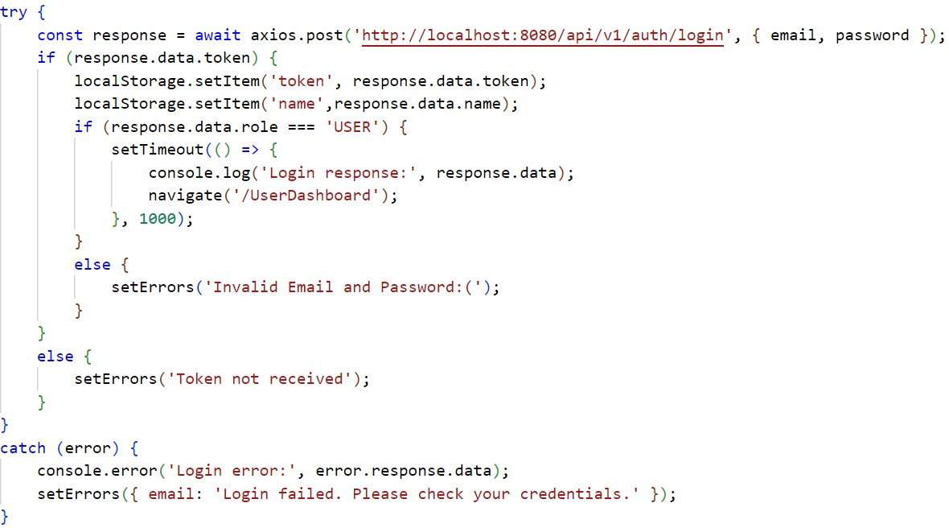

### Fig. 4.1. Storing the Token in Local Storage

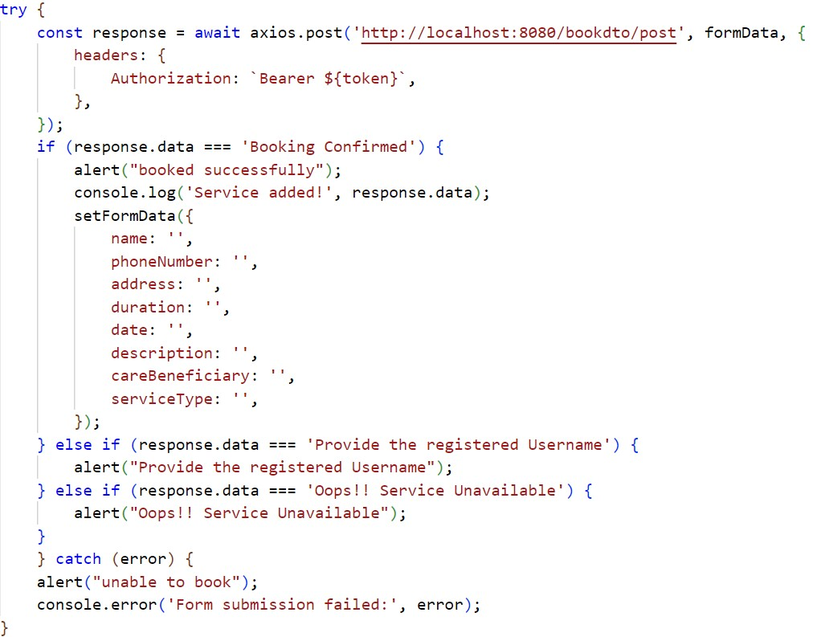

**Fig. 4.2. Authenticating the User using Bearer Token**

## 4.4 TEST CASES

Test cases are crucial for evaluating the functionality of the Plantura project. They help ensure accurate crop disease detection, effective treatment recommendations, and seamless integration with existing farm management tools. Thorough testing through these cases identifies issues and ensures quality assurance for optimal crop management.

**4.4.1 TEST CASE I**



**Fig. 4.3. Test Case I**

**EXPECTED OUTPUT:** Registration failed and error message occurs, to enter the credentials.

**ACTUAL OUTPUT:** Registration failed, indicating to enter the credentials.

### 4.4.2 TEST CASE II



### Fig. 4.4. Test Case II

**EXPECTED OUTPUT:** After signing up, user to use these credentials to login

**ACTUAL OUTPUT:** After signing up, user to use these credentials to login

## CHAPTER 7

## CONCLUSION

## 7.1 SUMMARY OF ACHIEVEMENTS

## The EduGo project successfully achieved its objectives, creating a robust and engaging platform for children's education. The platform's interactive storybooks, customizable avatars, and progress tracking system provide a comprehensive learning experience for young learners.

## Key Achievements:

## Development of a responsive, user-friendly frontend using React.

## Implementation of a secure and scalable backend using Spring Boot.

## Integration of interactive features such as animations, audio narration, and customizable avatars.

## 7.2 CHALLENGES AND RESOLUTIONS

## The development of EduGo presented several challenges, particularly in ensuring the platform's performance and security. These challenges were addressed through careful planning, testing, and the use of industry best practices.

## Key Challenges:

## Performance Optimization: Ensuring fast load times required optimizing the frontend and backend code, as well as using caching techniques.

## Security: Protecting user data, especially that of children, required implementing strong encryption and secure authentication mechanisms.

## Resolutions:

## Performance was improved by optimizing the use of React components and minimizing API calls.

## Security was enhanced by using JWT for authentication and encrypting sensitive data.

## 7.3 FUTURE ENHANCEMENTS

## While EduGo is a fully functional platform, there are several areas for future enhancement.

## Potential Enhancements:

## AI-Based Adaptive Learning: Implementing AI algorithms to adapt the content and difficulty level based on the user's progress and performance.

## Mobile App: Developing a native mobile app to complement the web platform.

## Expanded Content Library: Adding more storybooks and educational games, including content in additional languages.

## 7.3 CONCLUSION

## The EduGo project demonstrates the potential of digital platforms to enhance children's education. By combining interactive content with modern web technologies, EduGo offers a unique and engaging learning experience that can be tailored to each child's needs. The project sets the stage for future innovations in educational technology, with opportunities for further development and expansion.

## REFERENCES

**Web references:**

1. PostgreSQL Official Documentation: <https://www.postgresql.org/docs/>
2. React Official Documentation: <https://reactjs.org/docs/getting-started.html>
3. Swagger Official Documentation: <https://swagger.io/tools/swagger-ui/>
4. Java Extensions for Visual Studio Code Official Documentation:

<https://code.visualstudio.com/docs/java/extensions>

**Book references:**

Here are some references related to the **EduGo** project

1. **Anna Smith (2023)**: *“Interactive Storybooks: Engaging Young Readers with Digital Narratives”*, Children's Educational Press.
2. **David Johnson (2022)**: *“The Role of Technology in Early Childhood Education: Tools and Strategies for Modern Learning”*, Education Innovations Publishers.
3. **Emily Parker (2023)**: *“Designing Educational Games for Children: Combining Fun with Learning”*, Game-Based Learning Publications.
4. **Laura Green (2022)**: *“Developing Cognitive Skills through Interactive Storytelling”*, Early Learning Books.
5. **Michael Harris (2021)**: *“User Experience Design for Children's Digital Applications: Best Practices and Guidelines”*, UX Design in Education.
6. **Sophia Brown (2022)**: *“The Impact of Multimedia on Children's Literacy Development: A Comprehensive Study”*, Children's Media Research Institute.
7. **Richard Lee (2023)**: *“Personalized Learning in Digital Education: Adapting Content to Individual Needs”*, EduTech Press.