**Ex: 5 Animation**

**1) Main.xml**

**Input:**

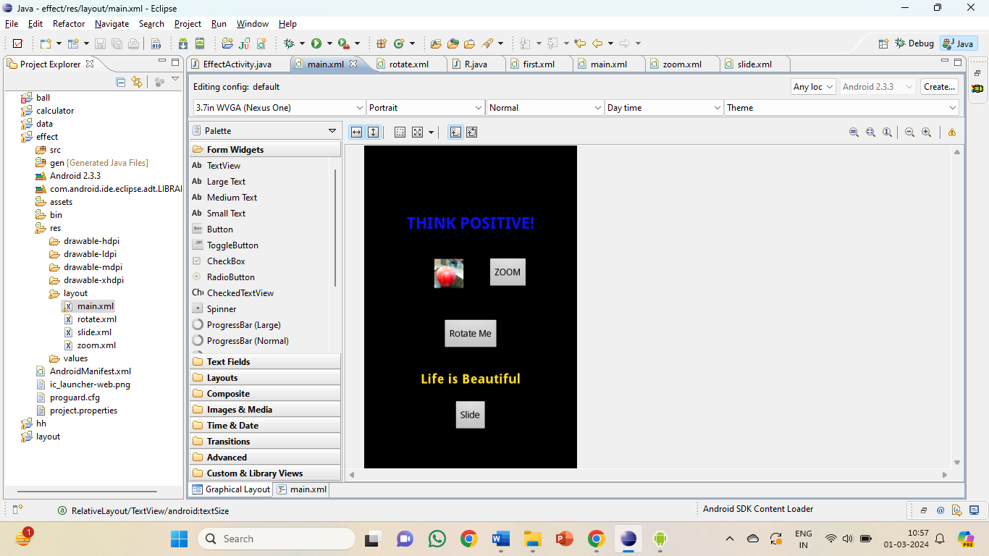

<?xml version=*"1.0"* encoding=*"utf-8"*?>

<RelativeLayout xmlns:android=*"http://schemas.android.com/apk/res/android"*

android:layout_width=*"match_parent"*

android:layout_height=*"match_parent"* >

<TextView

android:id=*"@+id/blink1"*

android:layout_width=*"wrap_content"*

android:layout_height=*"wrap_content"*

android:layout_alignParentTop=*"true"*

android:layout_centerHorizontal=*"true"*

android:layout_marginTop=*"102dp"*

android:text=*"THINK POSITIVE!"*

android:textColor=*"#0e0eff"*

android:textSize=*"24sp"*

android:textStyle=*"bold"* />

<Button

android:id=*"@+id/slideButton"*

android:layout_width=*"wrap_content"*

android:layout_height=*"wrap_content"*

android:layout_alignParentBottom=*"true"*

android:layout_centerHorizontal=*"true"*

android:layout_marginBottom=*"54dp"*

android:text=*"Slide"* />

<ImageView

android:id=*"@+id/imageView1"*

android:layout_width=*"wrap_content"*

android:layout_height=*"wrap_content"*

android:layout_alignRight=*"@+id/slideButton"*

android:layout_below=*"@+id/blink1"*

android:layout_marginRight=*"34dp"*

android:layout_marginTop=*"37dp"*

android:src=*"@drawable/ic_launcher"* />

<Button

android:id=*"@+id/zoom"*

android:layout_width=*"wrap_content"*

android:layout_height=*"wrap_content"*

android:layout_alignTop=*"@+id/imageView1"*

android:layout_toRightOf=*"@+id/slideButton"*

android:text=*"ZOOM"* />

<TextView

android:id=*"@+id/textView"*

android:layout_width=*"wrap_content"*

android:layout_height=*"wrap_content"*

android:layout_above=*"@+id/slideButton"*

android:layout_centerHorizontal=*"true"*

android:layout_marginBottom=*"20dp"*

android:text=*"Life is Beautiful"*

android:textColor=*"#FCDC2A"*

android:textStyle=*"bold"*

android:textSize=*"20sp"* />

<Button

android:id=*"@+id/robut"*

android:layout_width=*"wrap_content"*

android:layout_height=*"wrap_content"*

android:layout_above=*"@+id/textView"*

android:layout_centerHorizontal=*"true"*

android:layout_marginBottom=*"30dp"*

android:text=*"Rotate Me"* />

</RelativeLayout>

**2) Zoom.Xml**

<scale xmlns:android=*"http://schemas.android.com/apk/res/android"*

android:interpolator=*"@android:anim/accelerate_interpolator"*

android:fromXScale=*"1.0"*

android:fromYScale=*"1.0"*

android:toXScale=*"1.5"*

android:toYScale=*"1.5"*

android:pivotX=*"50%"*

android:pivotY=*"50%"*

android:fillAfter=*"false"*

android:duration=*"500"* />

**3) Rotate.xml**

<?xml version=*"1.0"* encoding=*"utf-8"*?>

<rotate xmlns:android=*"http://schemas.android.com/apk/res/android"*

android:fromDegrees=*"0"*

android:toDegrees=*"360"*

android:pivotX=*"50%"*

android:pivotY=*"50%"*

android:duration=*"1000"*

android:interpolator=*"@android:anim/linear_interpolator"*/>

**4) Slide. Xml**

<?xml version=*"1.0"* encoding=*"utf-8"*?>

<set xmlns:android=*"http://schemas.android.com/apk/res/android"*

android:fillAfter=*"true"*>

<translate

android:fromXDelta=*"0%p"*

android:toXDelta=*"100%p"*

android:duration=*"500"*/>

</set>

**5) Java Code**

**package** com.an;

**import** android.app.Activity;

**import** android.os.Bundle;

**import** android.os.Handler;

**import** android.view.View;

**import** android.view.animation.Animation;

**import** android.view.animation.AnimationUtils;

**import** android.widget.Button;

**import** android.widget.ImageView;

**import** android.widget.TextView;

**public** **class** EffectActivity **extends** Activity {

**private** TextView blinkingText,txt;

**private** **boolean** isBlinking = **false**;

@Override

**protected** **void** onCreate(Bundle savedInstanceState) {

**super**.onCreate(savedInstanceState);

setContentView(R.layout.*main*);

blinkingText = (TextView) findViewById(R.id.*blink1*);

// Start the blink animation

blinkText();

}

**private** **void** blinkText() {

**final** Handler handler = **new** Handler();

**final** **int** delay = 500; // milliseconds

handler.postDelayed(**new** Runnable() {

**public** **void** run() {

**if** (isBlinking) {

blinkingText.setVisibility(View.*VISIBLE*);

} **else** {

blinkingText.setVisibility(View.*INVISIBLE*);

}

isBlinking = !isBlinking;

handler.postDelayed(**this**, delay);

}

}, delay);

**final** Button rotateButton = (Button) findViewById(R.id.*robut*);

rotateButton.setOnClickListener(**new** View.OnClickListener() {

**public** **void** onClick(View view) {

// Load the animation

Animation animation = AnimationUtils.*loadAnimation*(EffectActivity.**this**, R.layout.*rotate*);

// Set listener to reset the animation after it's done

animation.setAnimationListener(**new** Animation.AnimationListener() {

**public** **void** onAnimationStart(Animation animation) {

}

**public** **void** onAnimationEnd(Animation animation) {

rotateButton.clearAnimation(); // Reset the rotation to its original state

}

**public** **void** onAnimationRepeat(Animation animation) {

}

});

// Start the animation

rotateButton.startAnimation(animation);

}

});

**final** Button zoom = (Button) findViewById(R.id.*zoom*);

zoom.setOnClickListener(**new** View.OnClickListener() {

**public** **void** onClick(View view) {

Animation zoomAnimation = AnimationUtils.*loadAnimation*(getApplicationContext(), R.layout.*zoom*);

ImageView imageView = (ImageView) findViewById(R.id.*imageView1*);

imageView.startAnimation(zoomAnimation);

}

});

txt = (TextView) findViewById(R.id.*textView*);

**final** Button sb = (Button) findViewById(R.id.*slideButton*);

sb.setOnClickListener(**new** View.OnClickListener() {

**public** **void** onClick(View v) {

Animation slide = AnimationUtils.*loadAnimation*(getApplicationContext(), R.layout.*slide*);

txt.startAnimation(slide);

}

});

}

}

**Output:**

