AWS Serverless Data Analytics Pipeline

1. Introduction
In today’s data-driven world, organizations require scalable and cost-efficient solutions to ingest,
process, and analyze large volumes of data generated from diverse sources such as APIs and batch files.
Traditional data pipelines often involve complex infrastructure management, leading to higher
operational overhead and limited scalability.

This project implements an AWS Serverless Data Analytics Pipeline that enables end-to-end data
ingestion, transformation, analytics, and visualization using fully managed AWS services. The
pipeline is designed to handle both real-time API data and batch CSV data, transform it into
analytics-ready formats, and provide business insights using SQL queries and dashboards.

The architecture follows modern data engineering best practices and closely mirrors real-world
cloud analytics systems used in production environments.

2. Objectives of the Project
- Design a fully serverless data analytics architecture
- Ingest data from API and batch-based sources
- Perform ETL processing and schema normalization
- Store optimized analytical data in Parquet format
- Enable SQL-based analytics using Amazon Athena
- Implement monitoring and logging using CloudWatch
- Visualize insights using Power BI
- Build a resume-worthy, real-world data engineering project

3. System Architecture
The system is built using a serverless data lake architecture on AWS. Each component is fully managed,
ensuring scalability, fault tolerance, and minimal operational overhead.

Architecture Flow:
1. Client sends order data through an API endpoint
2. API Gateway triggers a Lambda function
3. Lambda stores raw data in Amazon S3
4. AWS Glue performs ETL and schema transformations
5. Processed data is stored in Parquet format in S3
6. Amazon Athena queries the processed data
7. Power BI visualizes analytical insights
8. Amazon CloudWatch monitors logs and executions

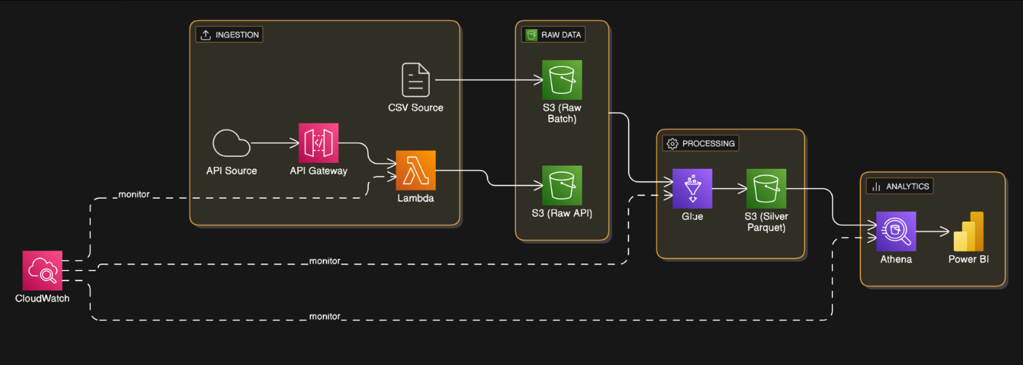

4. Data Ingestion Layer
API-based ingestion is implemented using Amazon API Gateway. A REST endpoint (/orders) accepts
order details and forwards the request to an AWS Lambda function.

Lambda Processing:
- Parses incoming JSON payload
- Validates required fields
- Adds ingestion timestamp
- Stores records in Amazon S3 raw layer

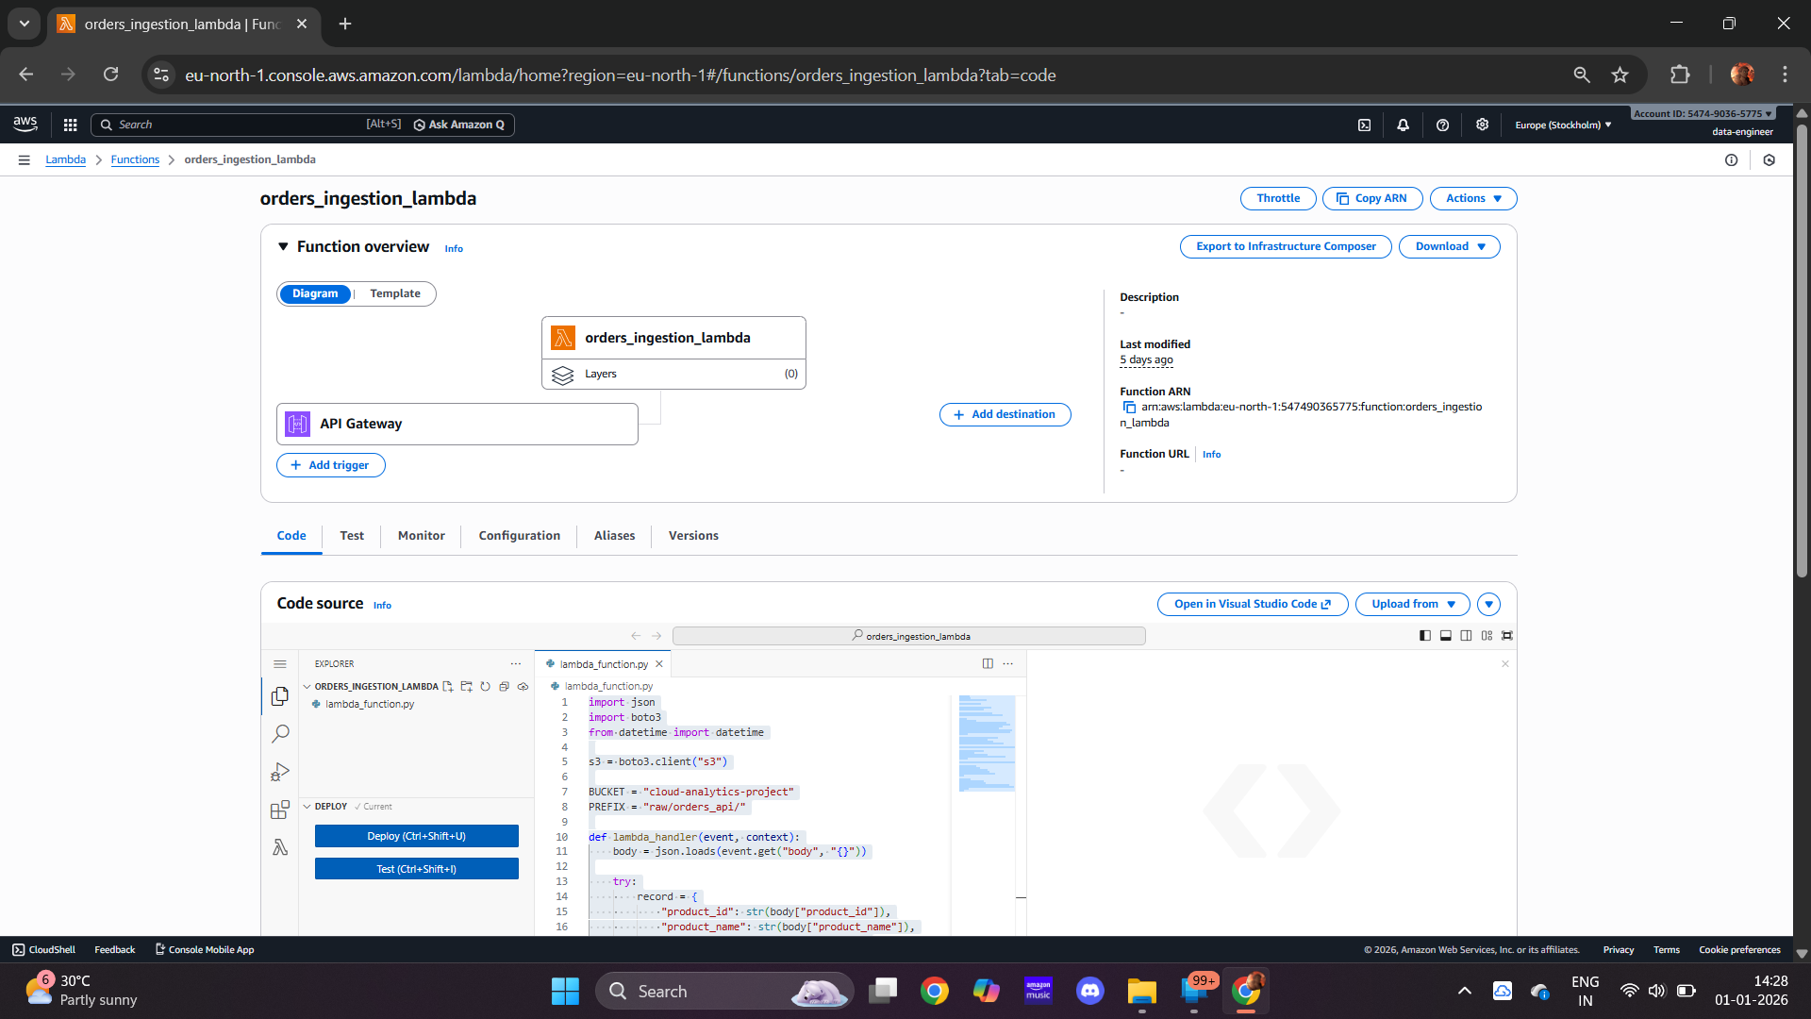

5. Storage Layer – Amazon S3
Amazon S3 acts as the centralized data lake.

Folder Structure:
- raw/ : Unprocessed API and CSV data
- silver/ : Transformed Parquet data
- athena-results/ : Athena query outputs

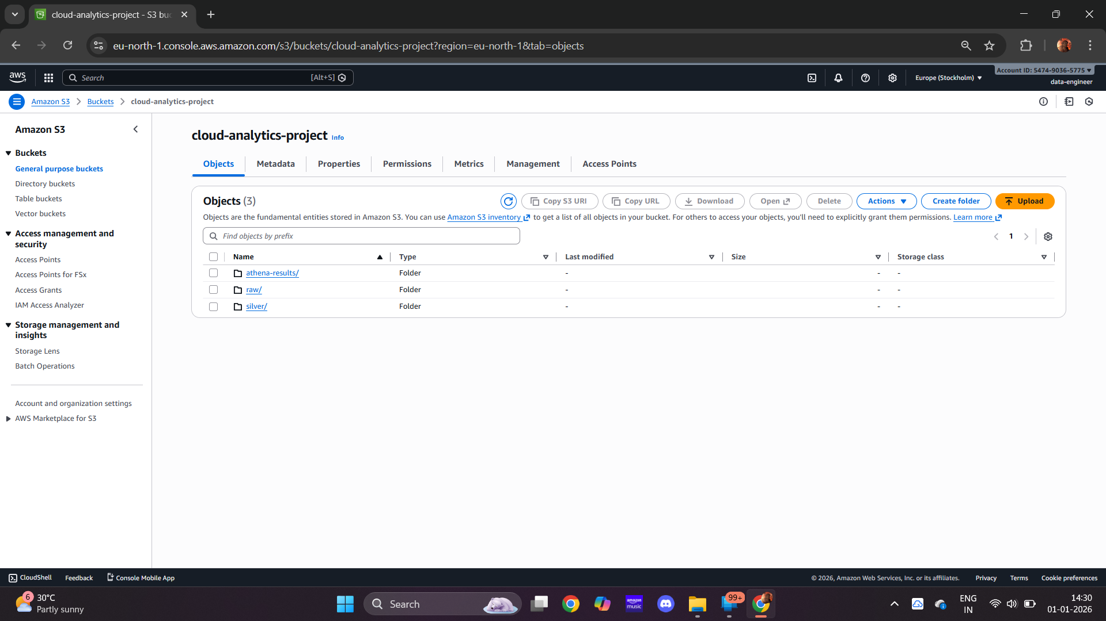

6. ETL Processing using AWS Glue
ETL processing is implemented using AWS Glue.

Glue Job Operations:
- Reads JSON data from API source
- Reads CSV data from batch source
- Applies schema mapping and type conversion
- Merges datasets using UNION
- Performs basic data quality validation
- Writes output in Parquet format with Snappy compression

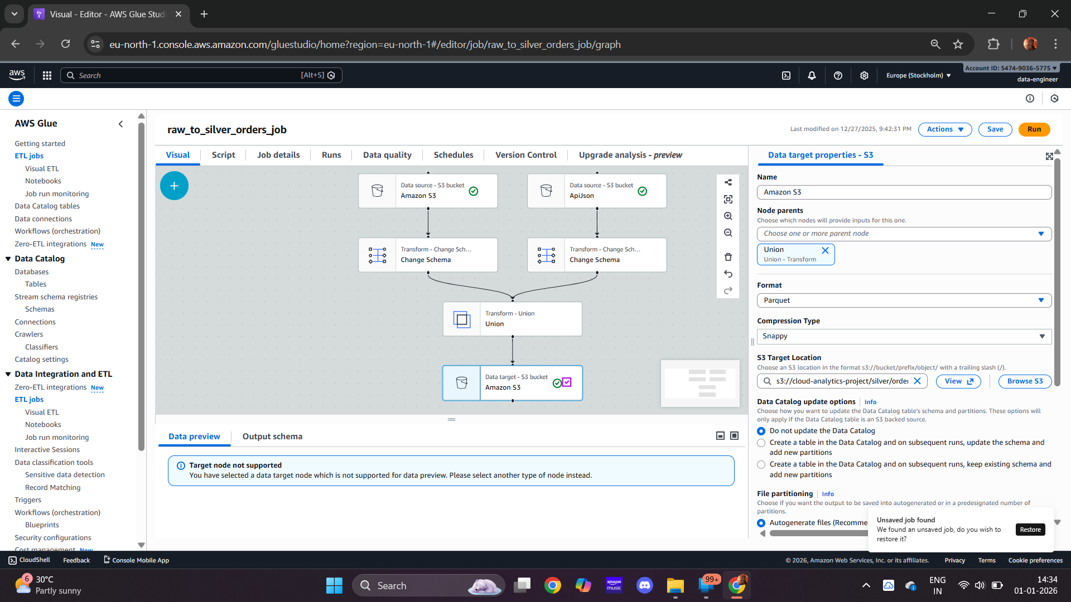

7. Analytics Layer using Amazon Athena
Amazon Athena is used to run SQL queries directly on Parquet data stored in Amazon S3.

Tables are registered using AWS Glue Data Catalog and views are created for analytics.

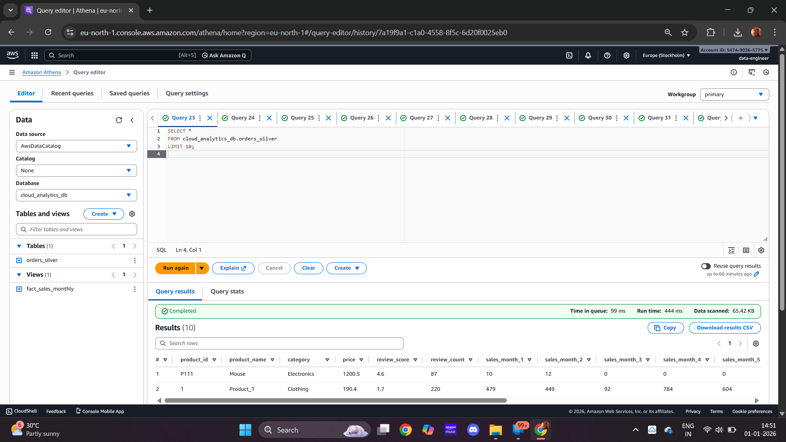
8. Monitoring and Logging using CloudWatch
Amazon CloudWatch is used for observability.

- Lambda execution logs
- Glue ETL job logs
- Request lifecycle tracking
- Error diagnostics

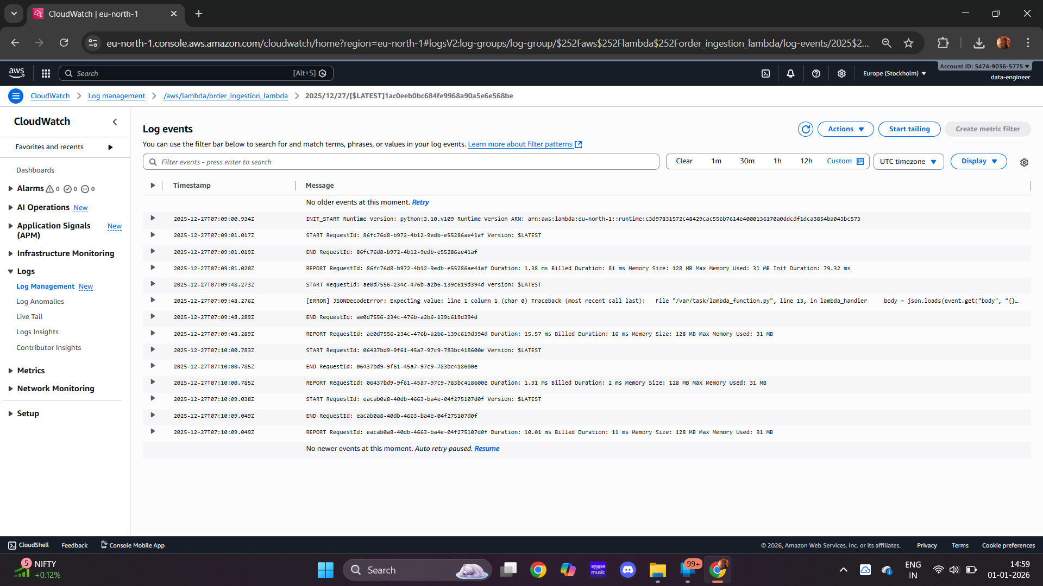

9. Data Visualization using Power BI
Power BI connects to Amazon Athena to visualize analytical insights.
Dashboards include:
- Total Revenue
- Total Units Sold
- Average Review Score
- Revenue by Category
- Monthly Revenue Trends
- Top Products by Revenue
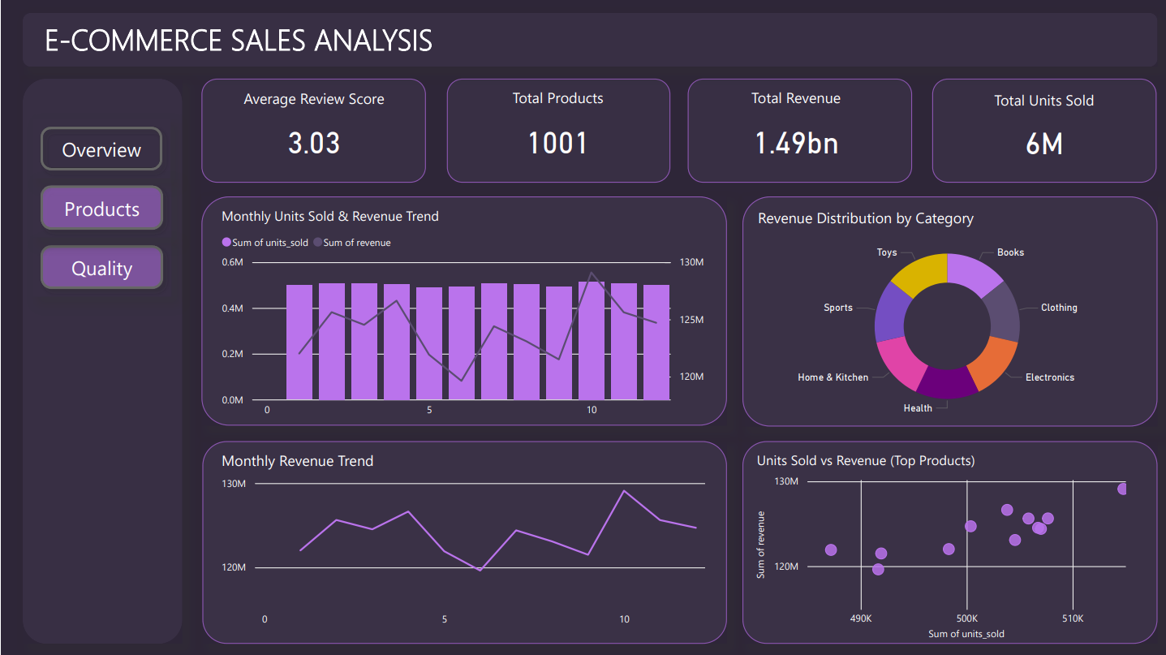

10. Results and Observations
- Serverless architecture reduced infrastructure complexity
- Parquet format improved query performance
- Athena enabled cost-efficient analytics
- CloudWatch ensured observability
- Power BI provided actionable insights

11. Conclusion
This project successfully demonstrates the implementation of a scalable, serverless data analytics
pipeline on AWS, reflecting real-world data engineering practices.

12. Future Enhancements
- Gold layer aggregations
- Scheduled ETL workflows
- Power BI incremental refresh
- Data quality alerts
- Role-based access control

