PowerPulse
An Adaptive Low-Power RISC-V SoC with Hardware Activity Profiling and Autonomous Peripheral Wake-Up
SoC Boundary Signal List and Block Diagram

1. Purpose and Scope
This document defines the top-level boundary of the PowerPulse SoC — the complete set of signals that cross the chip/top-module pin boundary between the SoC and its external environment (test bench, board-level I/O, or FPGA pins) — together with a clean, organised block diagram of the SoC's internal structure showing where each boundary signal connects.
Boundary signals are distinct from the internal inter-IP signals (such as hap_idle, periph_enable and wakeup_req) that never leave the chip. Internal signals are summarised in Section 5 for architectural context, but only the signals in Section 3 form the SoC's external pin list.

2. Direction Convention
Direction | Meaning
Input | Signal enters the SoC (or the referenced block) from outside.
Output | Signal is generated by the SoC (or the referenced block) and driven outward.
In/Out | Bidirectional signal, driven in both directions across the boundary.

3. Top-Level SoC Boundary Signals
These are the only signals that physically cross the PowerPulse SoC boundary. All internal peripherals and the three custom IP blocks (HAP, PPMC, AWEC) are memory-mapped and accessed entirely through the internal bus — they do not add their own external pins.
Signal | Direction | Width | Description
clk | Input | 1 | Common system clock supplied to the SoC top level.
rst_n | Input | 1 | Active-low asynchronous system reset.
uart_rx | Input | 1 | External serial receive line into the UART peripheral.
uart_tx | Output | 1 | External serial transmit line driven by the UART peripheral.
gpio_in[N-1:0] | Input | N | External parallel digital inputs into the GPIO peripheral (N is parameterizable).
gpio_out[N-1:0] | Output | N | External parallel digital outputs driven by the GPIO peripheral (N is parameterizable).
Note: N is a synthesis-time parameter defining GPIO bus width; it is not fixed by the architecture.

4. Top-Level Boundary Diagram
The diagram below shows the SoC as a single black-box boundary with every external pin labelled by name and direction. This is the view relevant for top-level instantiation, pin-out, and testbench connection.
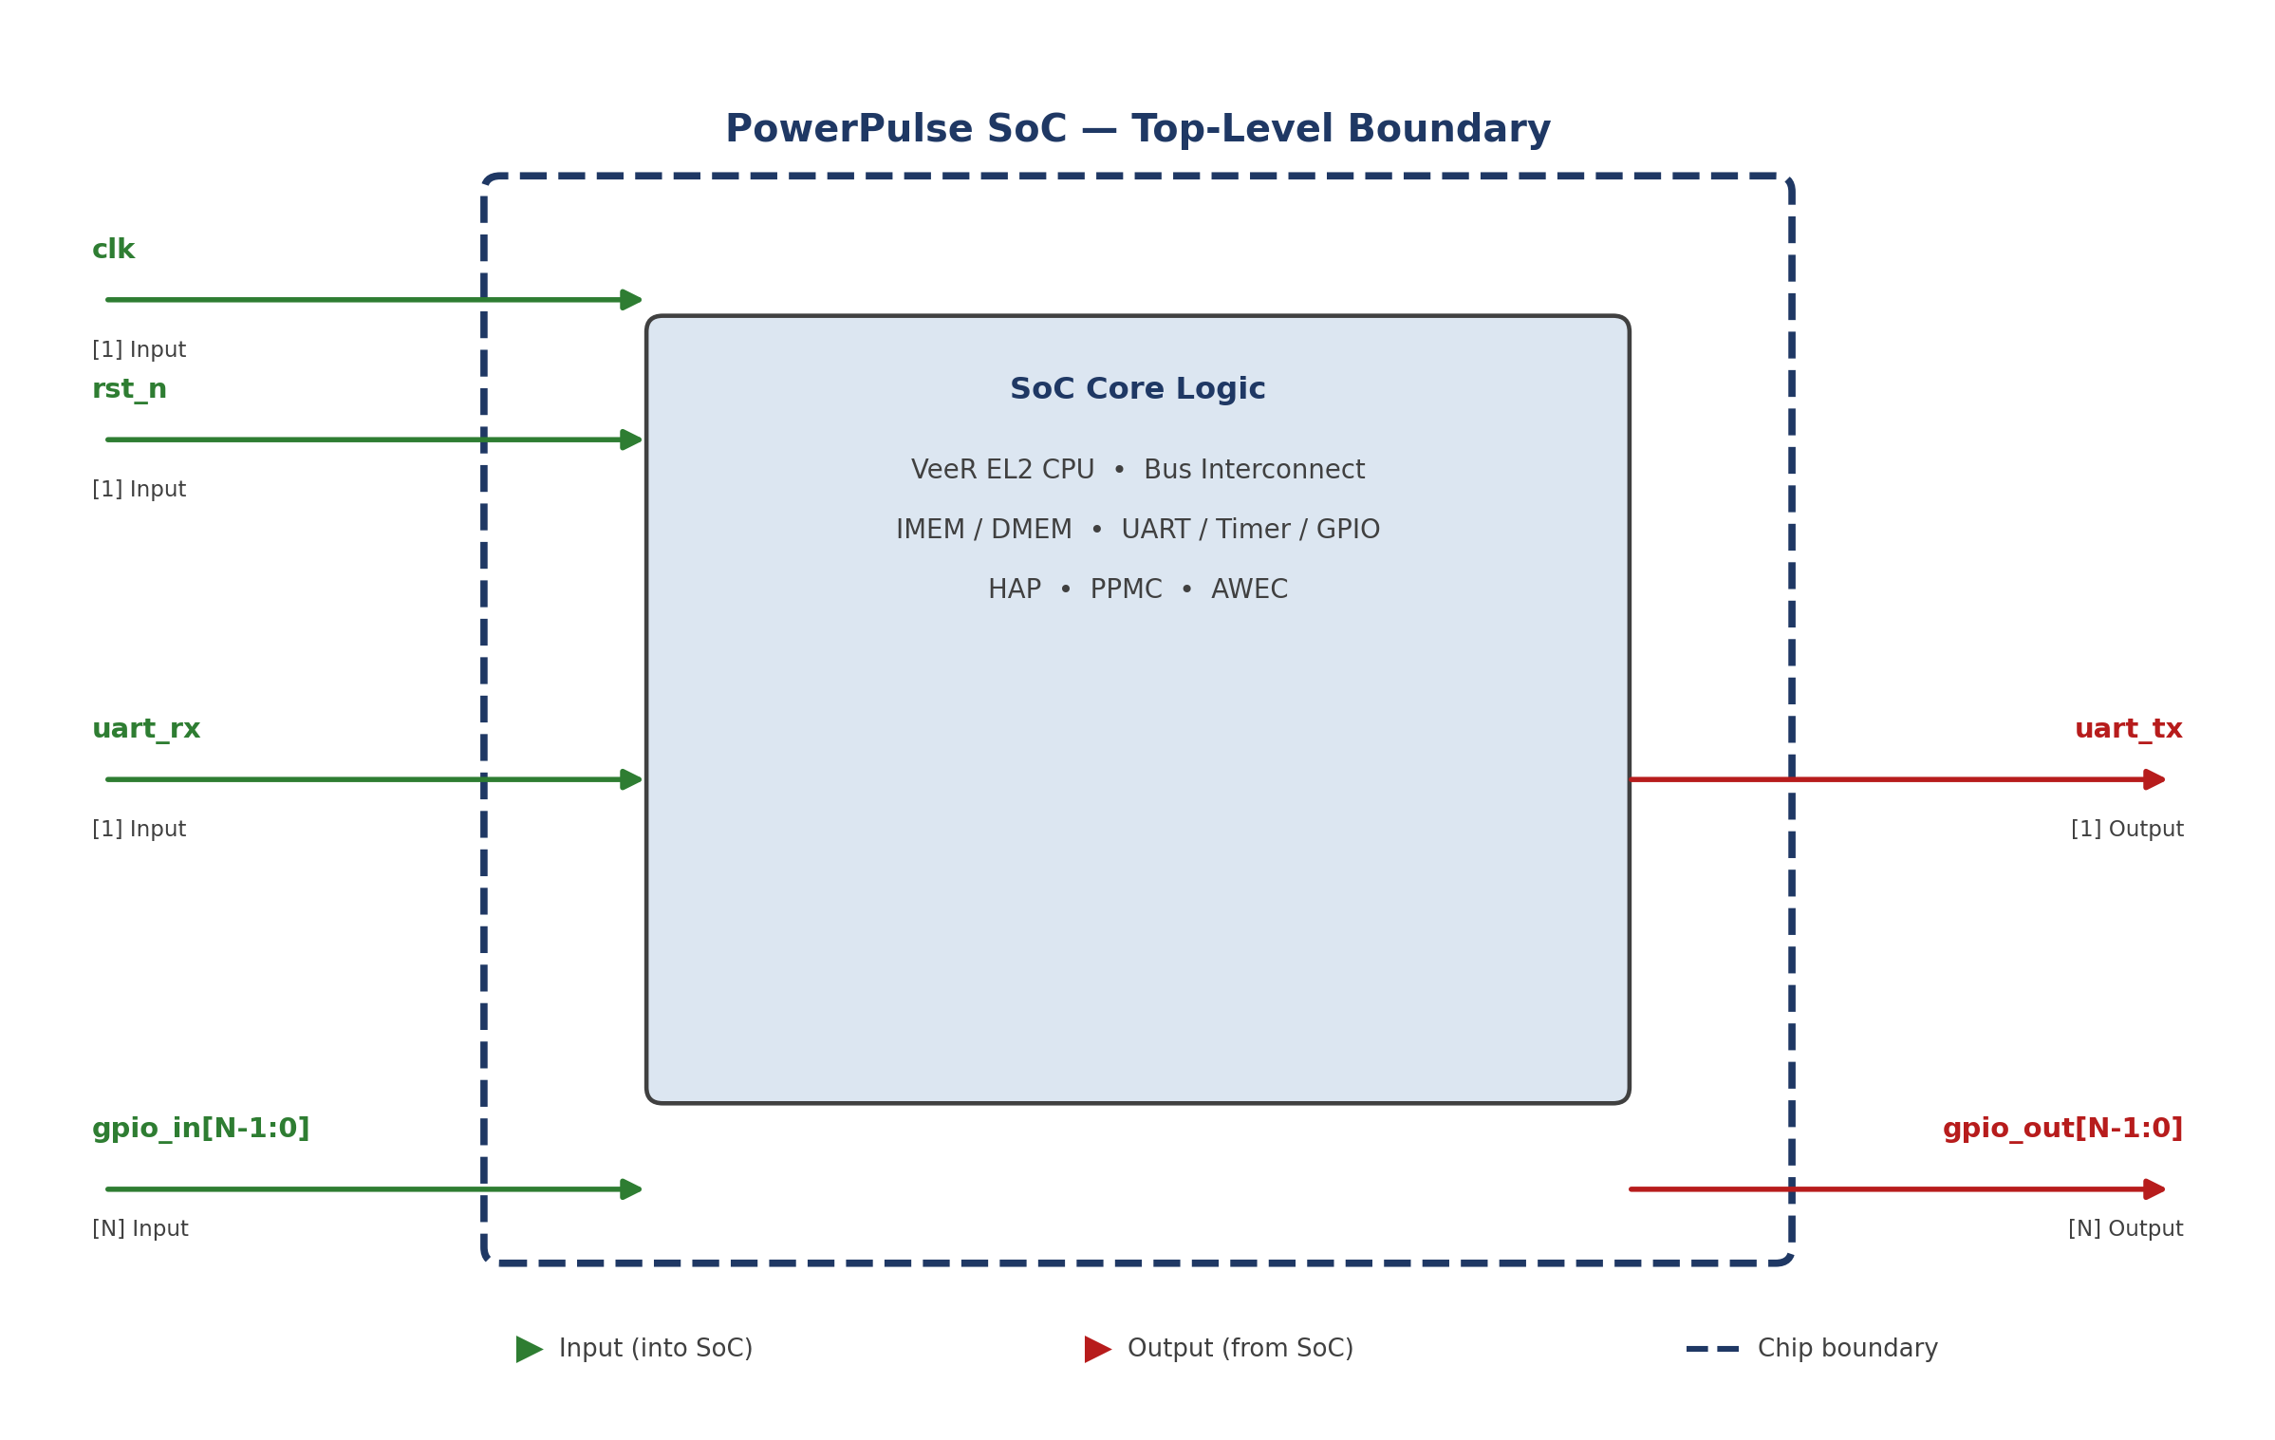
Figure 1. PowerPulse SoC top-level boundary — all external pins with direction.

5. Detailed Internal Block Diagram
The diagram below expands the SoC core logic to show the full internal architecture: the VeeR EL2 processor, the shared bus interconnect, the memory-mapped slaves (IMEM, DMEM, UART, Timer, GPIO), and the three custom IP blocks (HAP, PPMC, AWEC). Signal paths are colour-coded and routed in clean horizontal/vertical lanes to avoid crossings and ambiguity:
- Navy solid — bus / control signals (processor → bus → slaves, and PPMC → peripheral enables).
- Green solid — activity signals from UART / Timer / GPIO into the Hardware Activity Profiler (HAP).
- Red dashed — wake-up event signals from UART / Timer / GPIO into the Autonomous Wake-Up Event Controller (AWEC), and the resulting wakeup_req into PPMC.
- Dashed navy outline — the SoC chip boundary; only clk, rst_n, uart_rx, uart_tx, gpio_in and gpio_out cross it.
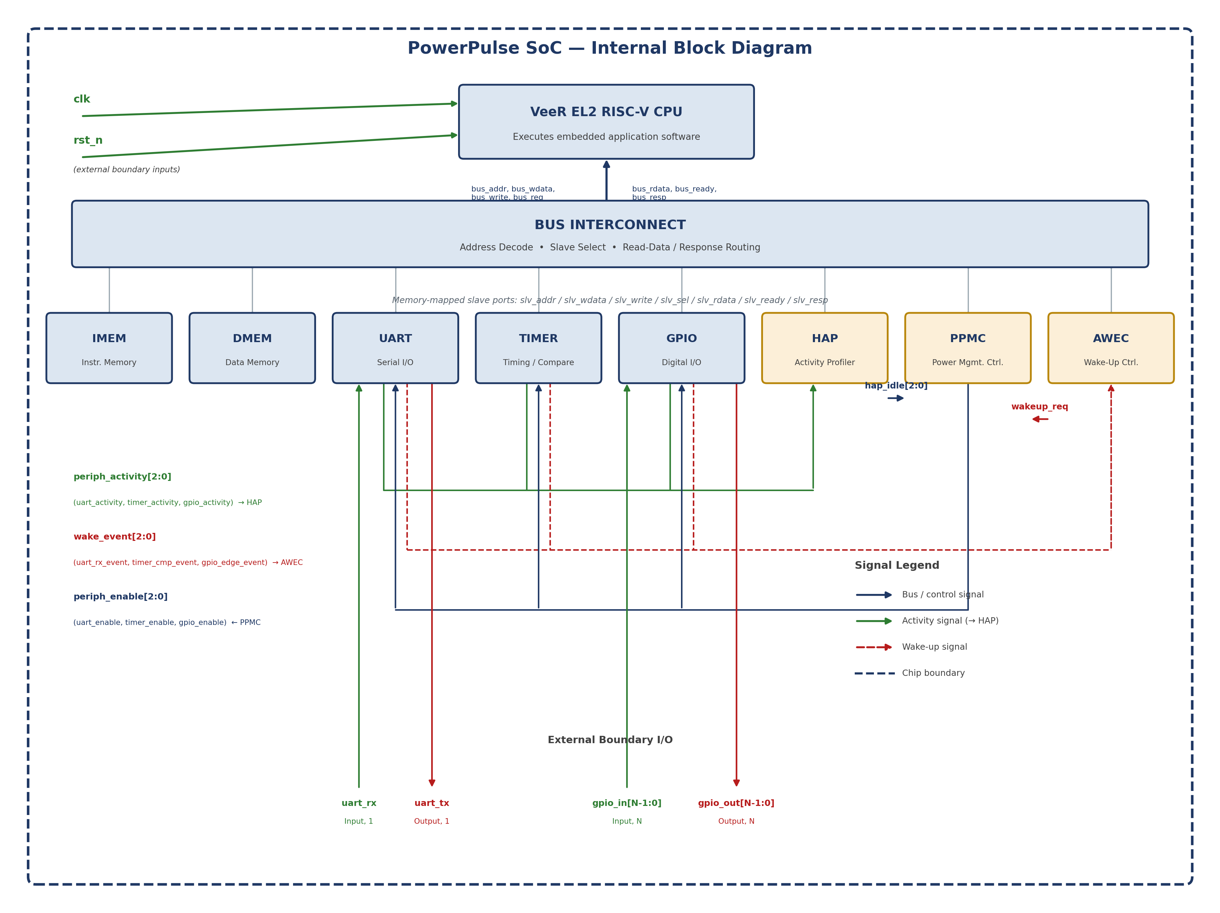
Figure 2. PowerPulse SoC internal block diagram with signal-flow paths.

6. Internal Signal Group Summary (Non-Boundary)
The signals below operate entirely within the chip and are shown for architectural completeness; they are not part of the external pin list in Section 3.
Signal Group | Path | Direction | Purpose
periph_activity[2:0] | UART / Timer / GPIO → HAP | Internal | Reports peripheral activity so HAP can track inactivity.
hap_idle[2:0] | HAP → PPMC | Internal | Idle indication once the programmable threshold is reached.
periph_enable[2:0] | PPMC → UART / Timer / GPIO | Internal | Enable / clock-enable control for ACTIVE ↔ LOW-ACTIVITY transitions.
wake_event[2:0] | UART / Timer / GPIO → AWEC | Internal | Raw wake-source events monitored by AWEC.
wakeup_req | AWEC → PPMC | Internal | Valid enabled wake-up request; triggers restoration to ACTIVE.
bus_addr / bus_wdata / bus_write / bus_req | VeeR EL2 → Bus Interconnect | Internal | Processor-initiated memory-mapped transaction.
bus_rdata / bus_ready / bus_resp | Bus Interconnect → VeeR EL2 | Internal | Transaction completion and read data returned to the processor.
slv_addr / slv_wdata / slv_write / slv_sel / slv_rdata / slv_ready / slv_resp | Bus Interconnect ↔ IMEM / DMEM / UART / Timer / GPIO / HAP / PPMC / AWEC | Internal | Per-slave memory-mapped interface used by every addressed block.

7. Notes
- LOW-ACTIVITY state is implemented at RTL level using controlled peripheral-enable / clock-enable signals; the design does not claim technology-dependent physical power gating.
- Exact processor-side bus port names will be mapped to the faculty-provided VeeR EL2 RTL wrapper during final integration; the bus_* names above are the proposed logical interface.
- HAP, PPMC and AWEC are internal memory-mapped slaves only — they are configured and read entirely through the bus interconnect and contribute no external pins of their own.

