# Bank Loan Report

## Overview

The Bank Loan Report Project combines SQL for data manipulation and Tableau for visualization to create a comprehensive report on bank loan data. This report aims to provide stakeholders with actionable insights into loan applications, approvals, and related metrics.

## Problem Statement

To monitor and assess the bank's lending activities and performance, a comprehensive Bank Loan Report is required. This report aims to provide valuable insights into key loan-related metrics, trends, and risk assessments. By leveraging SQL for data extraction and Tableau for visualization, the report will enable stakeholders to make data-driven decisions and optimize lending strategies.

**Key Challenges to Address**

1. Tracking Loan Performance: Understanding loan applications, approvals, disbursements, and repayments over time.
2. Portfolio Health Assessment: Identifying good vs. bad loans based on repayment behavior and risk classification.
3. Key Performance Indicator (KPI) Analysis: Monitoring loan metrics such as total funded amount, total received amount, interest rates, and debt-to-income ratio on a month-to-date (MTD) and month-over-month (MoM) basis.
4. Regional and Demographic Insights: Examining loan distribution by state, employment length, loan purpose, homeownership status, and loan terms to identify patterns.
5. Data Accuracy & Validation: Ensuring data consistency through SQL queries and Tableau visualizations to maintain integrity in reporting.

**Objective**

By creating interactive dashboards and leveraging advanced data analytics, this report will empower decision-makers to:  
✔ Improve loan approval strategies  
✔ Optimize risk management practices  
✔ Identify profitable lending opportunities  
✔ Enhance portfolio quality and reduce bad loans

## Data Source

The loan data for this project is sourced from an internal banking database, capturing comprehensive information about the bank's lending activities.

## Tools

SQL: The project leverages SQL queries to retrieve, process, and analyze data.

Tableau: Dynamic and interactive visualizations are crafted in Tableau to present key findings effectively.

## Dashboards

### Dashboard 1: Summary

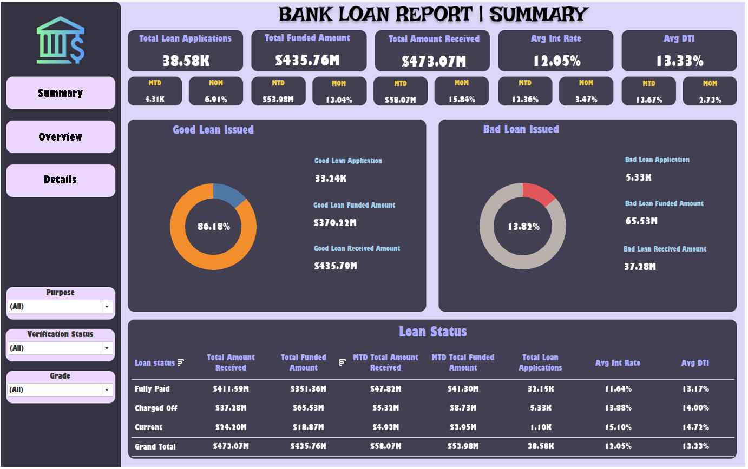

The Summary Dashboard captures key loan-related metrics and their changes over time, providing a snapshot of the loan portfolio's health and lending strategy impact. It includes the following KPIs:

• Total Loan Applications (MTD and MoM)

• Total Funded Amount (MTD and MoM)

• Total Amount Received (MTD and MoM)

• Average Interest Rate (MTD and MoM)

• Average Debt-to-Income Ratio (DTI) (MTD and MoM)

Additionally, it distinguishes between 'Good Loans' and 'Bad Loans,' with specific indicators for each category, helping in the assessment of loan portfolio quality.

### Dashboard 2: Overview

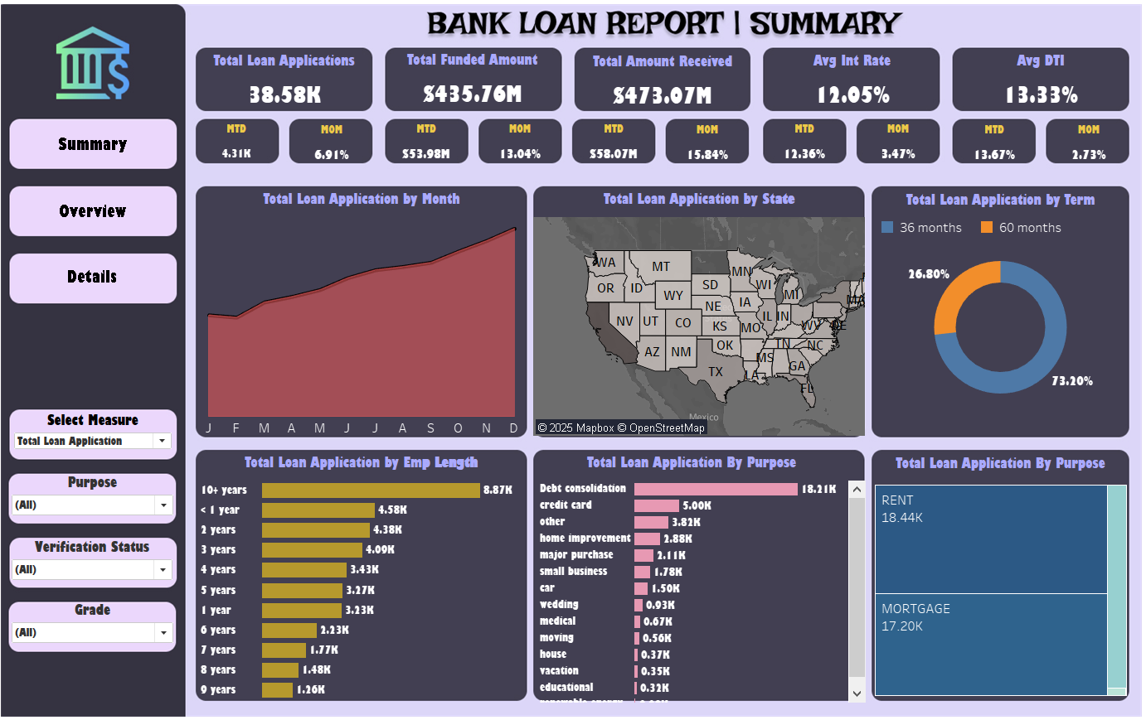

The Overview Dashboard visually represents various loan-related metrics through different chart types:

• Monthly Trends by Issue Date

• Regional Analysis by State

• Loan Term Analysis

• Employment Length Analysis

• Loan Purpose Breakdown

• Home Ownership Analysis

These visualizations aid in identifying trends, seasonal patterns, and the distribution of loans across various categories.

### Dashboard 3: Details

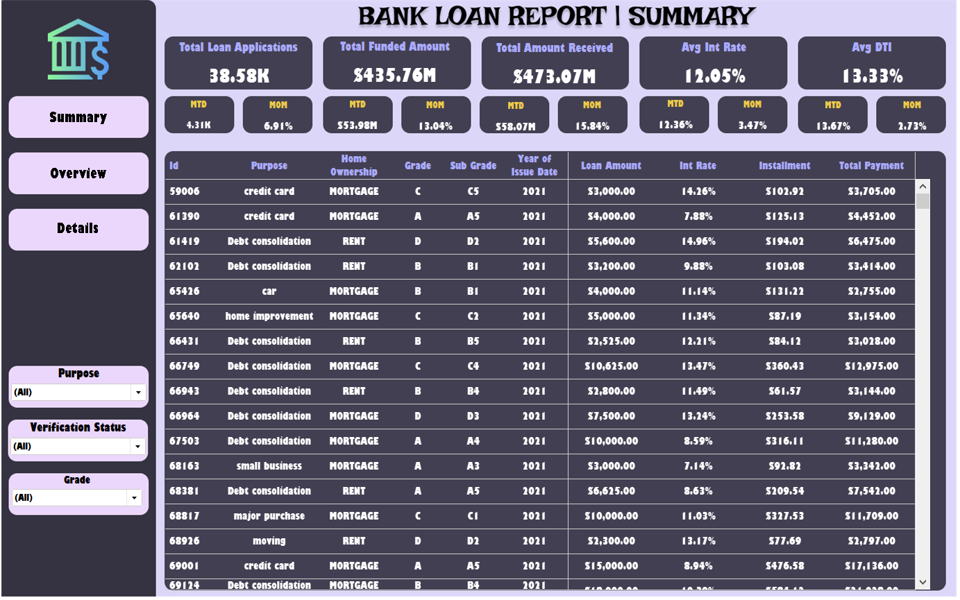

The Details Dashboard offers a detailed view of the loan data, providing a comprehensive and user-friendly interface for accessing vital loan metrics, borrower profiles, and performance data.

## Data Fields and Usage

The data utilized in the dashboards comprise several fields, each serving a specific purpose in loan management and risk assessment:

• Loan ID: Unique identifier for loans.

• Address State: Borrower location for regional analysis.

• Employment Length: Indicates employment stability.

• Employee Title: Job title for income source verification.

• Grade/Sub Grade: Creditworthiness and risk classification.

• Home Ownership: Housing status for financial stability assessment.

• Issue Date: Loan origination date.

* Loan Status: Current state of the loan for performance tracking.
* Purpose: Loan reason for segmentation and customization.
* Term: Loan duration.
* Verification Status: Status of Financial Information Verification.
* Annual Income: Yearly earnings for creditworthiness.
* DTI: Debt burden relative to income.
* Instalment: Monthly repayment amount.
* Interest Rate: Cost of borrowing.
* Loan Amount: Principal amount borrowed.

## Implementation

The project required importing the dataset from Excel into SQL Server for analysis and visualization using Tableau. Dashboards were crafted using Tableau's powerful visualization tools and analytical capabilities, aligning with the specified requirements in the problem statement and utilizing the data dictionary to ensure precise field utilization.

## Data Validation

To ensure the accuracy and integrity of the data reflected in the dashboards, a thorough data validation process was undertaken. After the dataset was loaded into Tableau and from SQL Server database, the following measures were implemented:

* SQL Query Verification: Direct queries were executed against the SQL Server database to retrieve raw data. This dataset served as a benchmark, validating the accuracy and consistency of the information presented in the dashboards.
* Data Consistency Checks: The results from Tableau were compared against the SQL query results to ensure consistency. This step was critical to confirm that the data transformation and logic applied within Tableau did not alter the actual figures.
* KPI Logic Validation: The calculations and logic underlying the Key Performance Indicators (KPIs) were thoroughly reviewed. SQL scripts were employed to independently replicate the KPI calculations, ensuring the accuracy and reliability of the computations performed in Tableau.
* Cross-Verification with Source Data: The transformed data in Tableau was cross-verified with the source data from the SQL Server database. This step was crucial to confirm that all data transformations, including filtering, grouping, and aggregation, were correctly applied.

**Key Findings**

* Loan Approval Trends: The majority of loan approvals occurred in the first quarter of the year, showing a seasonal trend in lending.
* Risk Distribution: A significant portion of 'Bad Loans' originated from borrowers with a high debt-to-income ratio and lower credit grades.
* Regional Variations: Certain states exhibited higher loan defaults, indicating potential regional economic challenges.
* Impact of Employment Stability: Borrowers with longer employment histories had a higher approval rate and lower default rates.
* Loan Purpose Insights: The highest number of loan applications were for debt consolidation, highlighting a demand for financial restructuring.

**Recommendations**

* Enhance Risk Assessment Models: Implement stricter credit evaluations for high-risk borrowers to minimize defaults.
* Targeted Loan Offerings: Develop customized loan packages for different borrower segments based on employment length and loan purpose.
* Regional Strategy Optimization: Adjust lending strategies in states with higher default rates to reduce risk exposure.
* Data-Driven Interest Rate Adjustments: Modify interest rates based on borrower risk profiles to balance profitability and affordability.
* Improve Loan Recovery Strategies: Strengthen follow-up mechanisms and repayment plans for borrowers classified as high-risk.

**Conclusion**

By incorporating robust data validation techniques, the **Bank Loan Dashboard Project** establishes itself as a reliable and authoritative source for monitoring the bank’s loan activities. The project not only presents critical data through intuitive visualizations but also guarantees the precision of the information displayed, enabling the bank to make informed and assured strategic decisions with confidence.