TryHackMe Progress Report – Harish Kumar

This document showcases a snapshot of the TryHackMe rooms completed by Harish Kumar, highlighting hands-on experience with core cybersecurity topics such as OWASP Top 10, SQL Injection, XSS, Enumeration, Brute Force, and more. These exercises were part of continuous upskilling efforts to gain practical security knowledge aligned with SOC and Penetration Testing roles.

# Completed Rooms

The following screenshots show some of the rooms completed on TryHackMe:

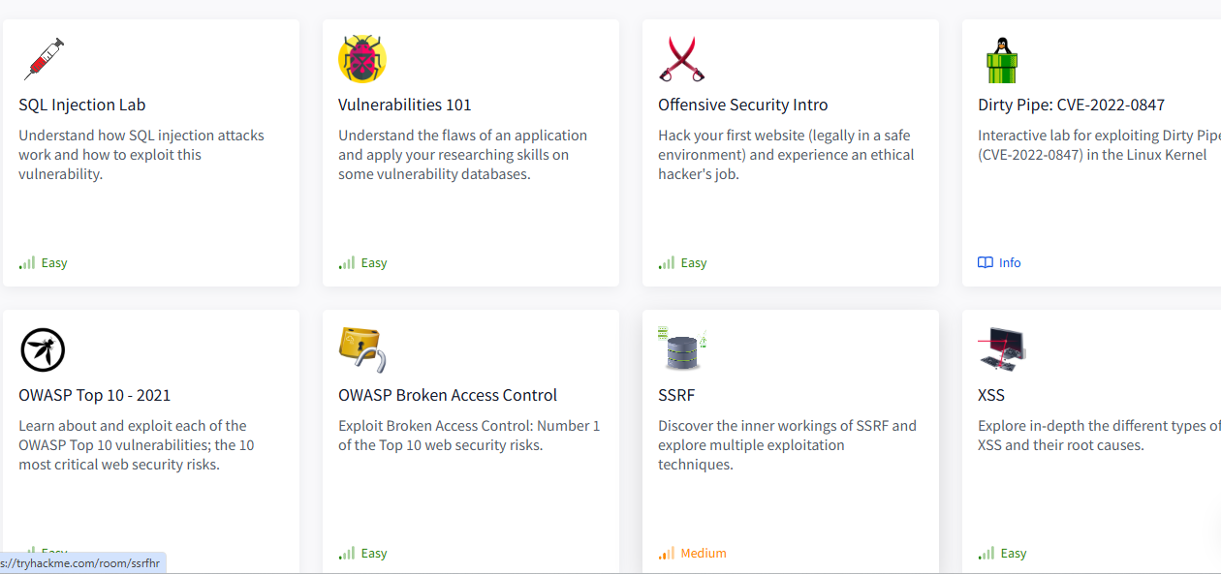

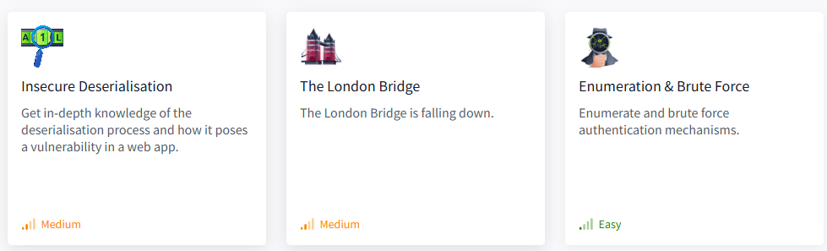

# Summary of Notable Completed Rooms

* ✔️ SQL Injection Lab
* ✔️ XSS (Cross-site scripting)
* ✔️ OWASP Top 10 - 2021
* ✔️ OWASP Broken Access Control
* ✔️ Offensive Security Intro
* ✔️ Dirty Pipe CVE-2022-0847
* ✔️ Enumeration & Brute Force
* ✔️ Insecure Deserialization
* ✔️ Vulnerabilities 101
* ✔️ The London Bridge
* ✔️ SSRF (Server-Side Request Forgery)