**Event Grid: Route Blob Storage Events to Web Endpoint**

Azure Event Grid is an eventing service for the cloud. In this article, you use the Azure portal to create a Blob storage account, subscribe to events for that blob storage, and trigger an event to view the result. Typically, you send events to an endpoint that processes the event data and takes actions. However, to simplify this article, you send the events to a web app that collects and displays the messages.

**Step 1:** Open **Microsoft Azure Portal**

<http://portal.azure.com/>

**Step 2:** Create **Storage Account**

**+ Create a resource -> Storage -> Storage account – blob, file, table, queue**

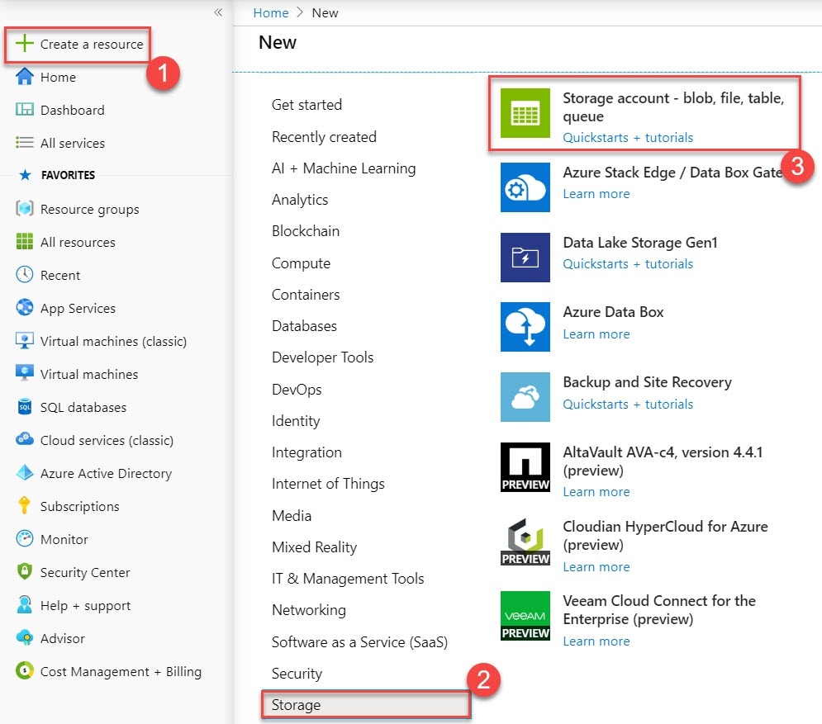

**Step 3:** Subscription: **Choose any active Subscription**

Resource Group: **Create New Resource Group** Ex. **EventGridStorageDemoRG**

Storage Account Name: **Enter unique name** ex. **eventgridstrg**

Performance: **Standard**

Account Kind: **Storage V2 (general purpose v2)**

Replication: **Choose any replication**

Click on **Review + Create** button

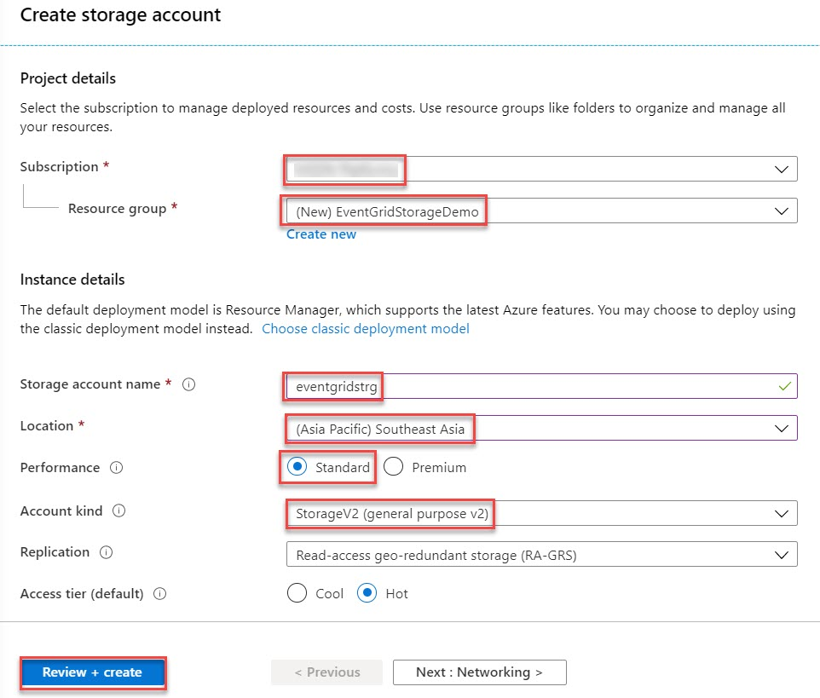

**Note: Only Account kind Storage V2 (general purpose v2) and Blob Storage support event integration.**

**Step 4:** Click on **Create** button

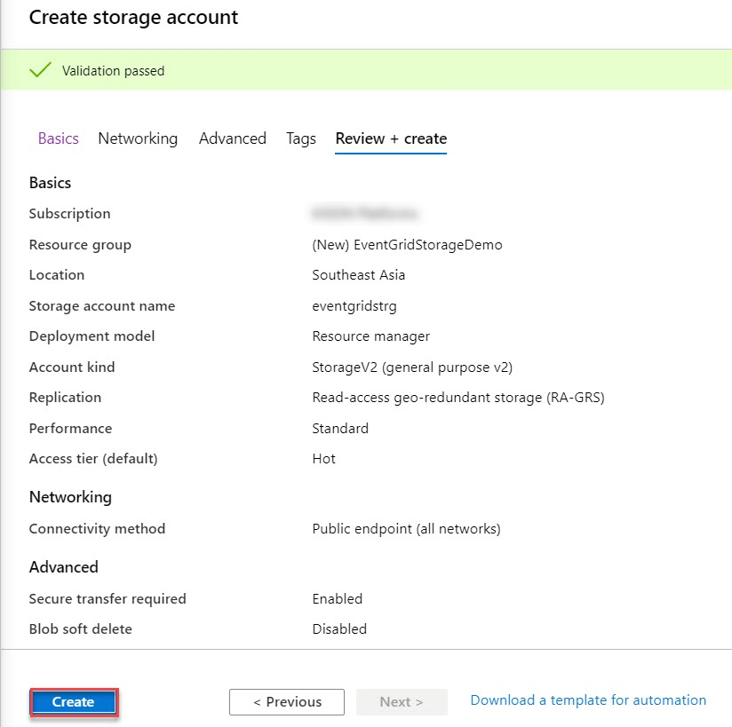

**Step 5:** Click on **Go to resource** button

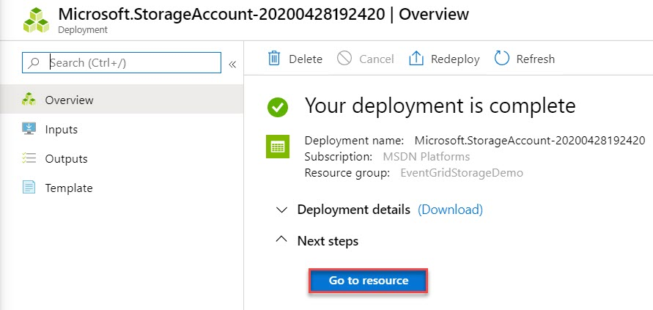

**Create Message Endpoint**

Before subscribing to the events for the Blob storage, let's create the endpoint for the event message. Typically, the endpoint takes actions based on the event data. To simplify this quickstart, you deploy a pre-built web app that displays the event messages. The deployed solution includes an App Service plan, an App Service web app, and source code from GitHub.

Sample Github Repo - <https://github.com/Azure-Samples/azure-event-grid-viewer>

**Step 6:** Open another tab in same browser and paste pre-built resources URL (ARM Template) from below:

<https://portal.azure.com/#create/Microsoft.Template/uri/https%3A%2F%2Fraw.githubusercontent.com%2FAzure-Samples%2Fazure-event-grid-viewer%2Fmaster%2Fazuredeploy.json>

Subscription: **Choose Subscription**

Resource Group: **Choose existing resource group** Ex. **EventGridStorageDemoRG**

Site Name: **Enter web app unique name** Ex. **eventgridweb[number]**

Hosting Plan: **Enter Web App Plan Name** Ex. **eventgridwebPlan**

SKU: **F1**

Repo URL: **Github web app repo url will be there automatic**

Branch: **master**

Location: **[resourceGroup().Location]**

**Accept the terms and conditions**

Click on **Purchase** button

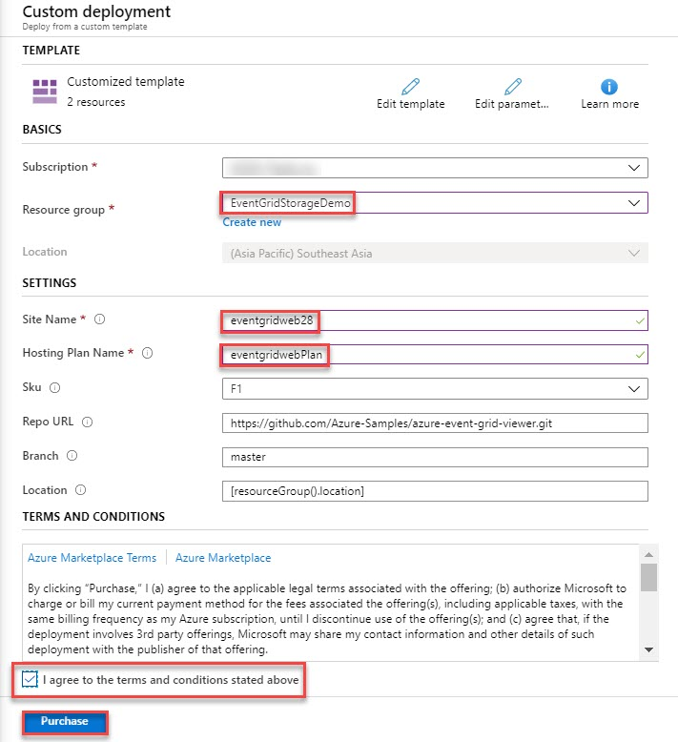

**Step 7:** Click on **Notification** icon and click on **Go to resource** **group** button

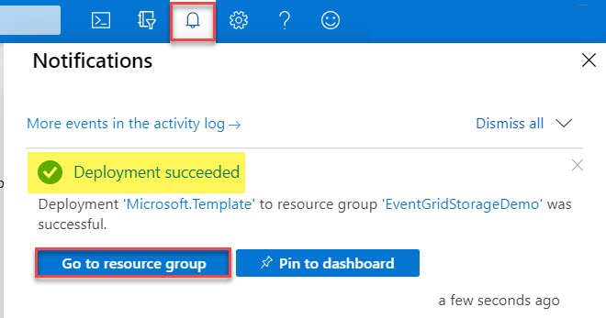

**Step 8:** EventGridStorageDemoRG will open

Click on **Web App** Ex. **eventgridweb**

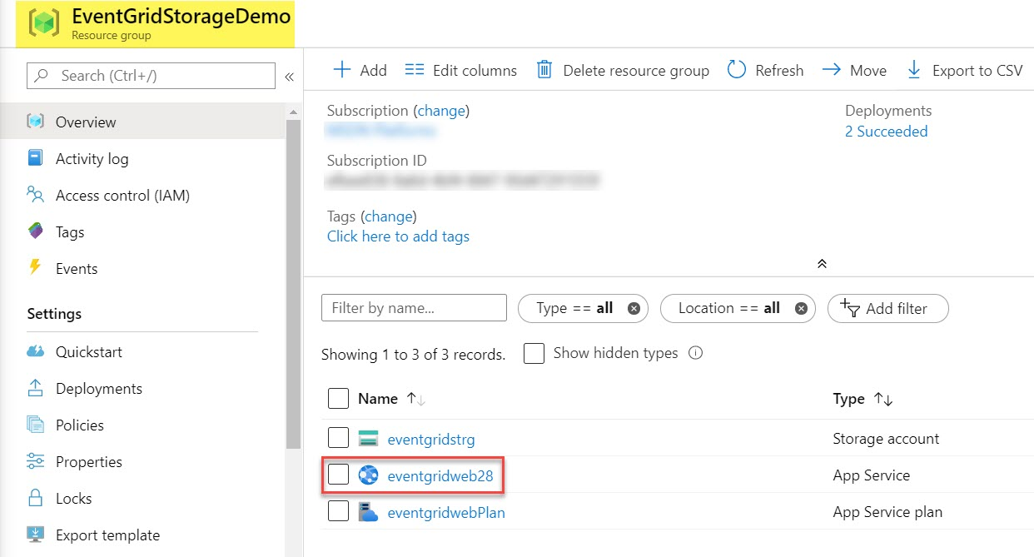

**Step 9:** Click on **Browse** button to view web app

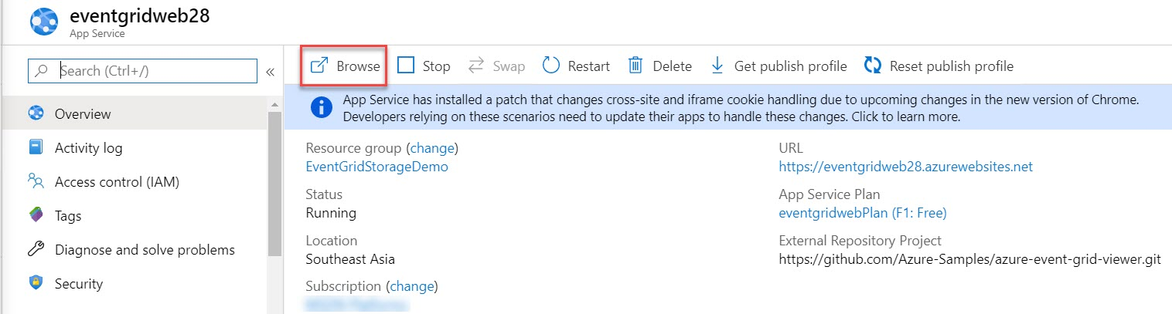

**Step 10:** Sample Azure Event Grid Viewer page will be there.

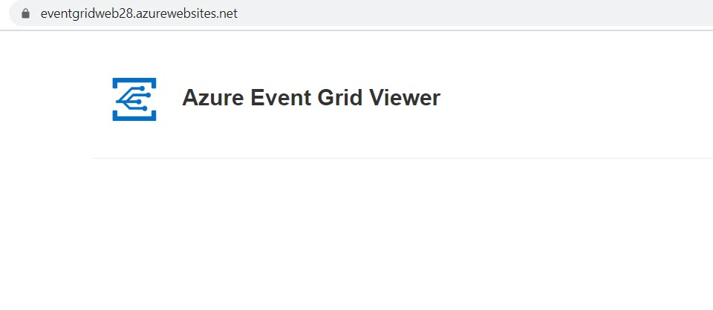

**Enable Event Grid Resource Provider**

If you haven't previously used Event Grid in your Azure subscription, you may need to register the Event Grid resource provider.

**Step 11:** Click on **All services** -> search for “**subscription**” -> Click on **Subscription**

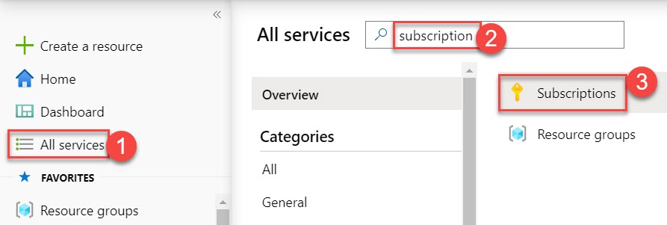

**Step 12:** Click on **Subscription**

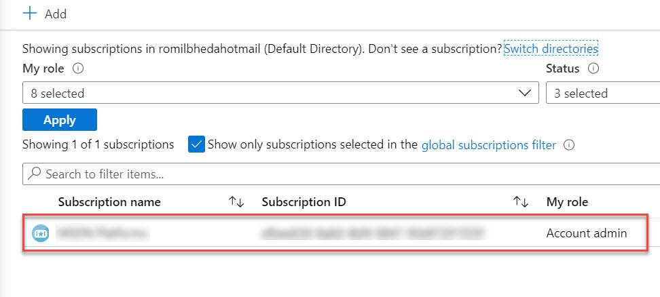

**Step 13:** Choose **Resource Providers** and search for “**eventgrid**”

If Status is **NotRegistered** click on **Register** button otherwise you can skip this step

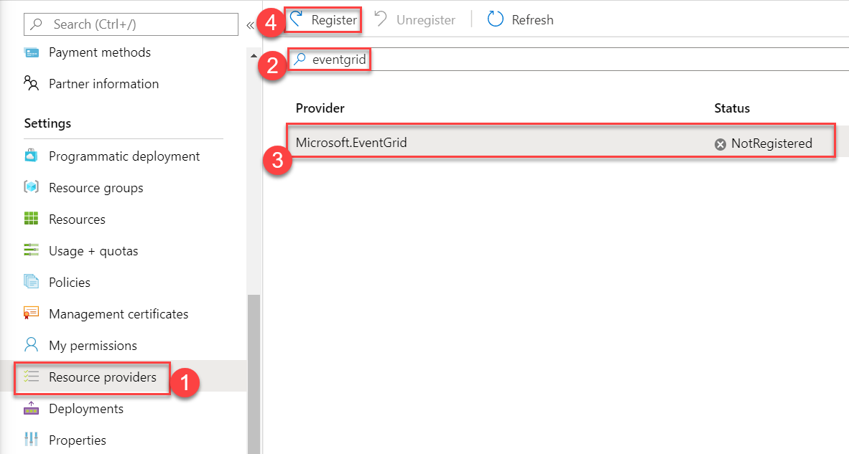

**Subscribe to Blob Storage**

**Step 14:** Choose **Storage account** from Resource Group

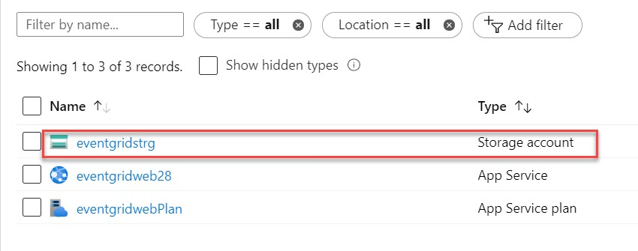

**Step 15:** Click on **Events**

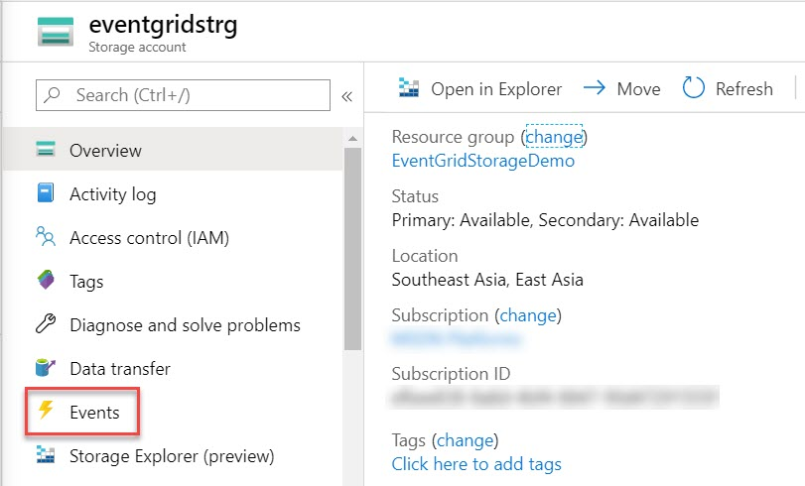

**Step 16:** Choose **More Options** and select **Web Hook**

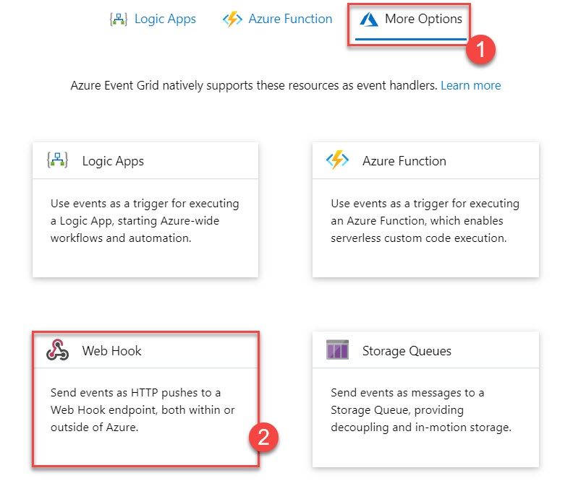

**Step 17:** Event Subscription Details

Name: **eventgridsub**

Event Schema: **Event Grid Schema**

Topic Details

Topic Type: **Storage account**

Topic Resource: **existing storage account** Ex. **eventgridstrg**

Event Types

Filter to Event Type: **2 Selected** (if require more you can select)

Endpoint Details

Endpoint Type: **Web Hook**

Endpoint: **Click on Select an endpoint option**

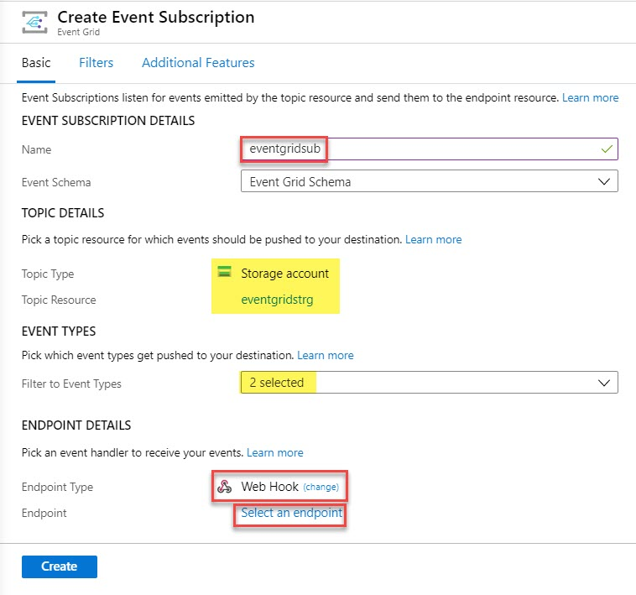

**Step 18:** Subscriber Endpoint: **enter web app url** and **add api/updates**

Ex. <https://webapp.azurewebsites.net/api/updates>

Click on **Confirm** Selection

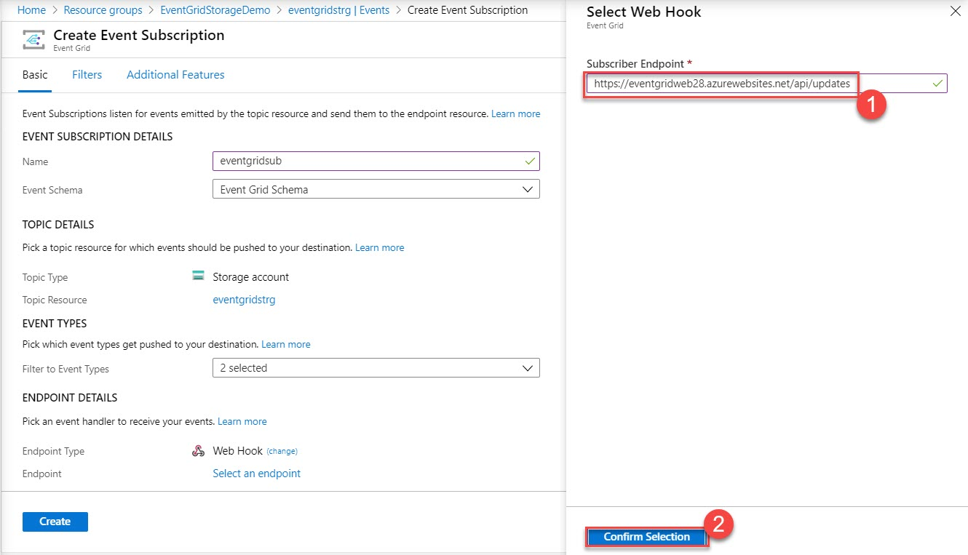

After updating all Click on **Create** button

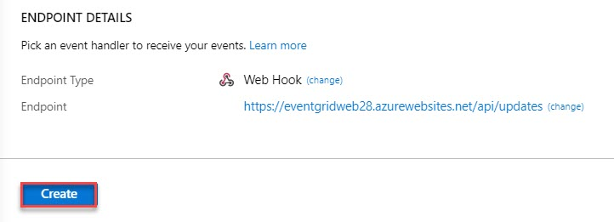

**Step 19:** Don’t require to refresh web app, automatic will update here related to current event.

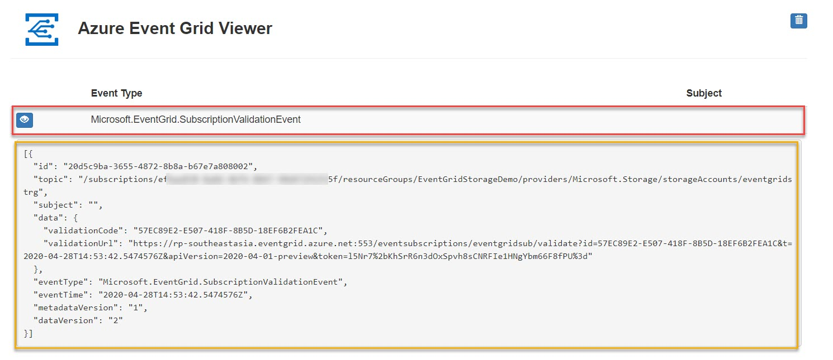

**Send an Event to your endpoint**

**Step 20:** Navigate to **Storage account**

Choose **Containers** under **Blob Service**

Click on **+ Container** option

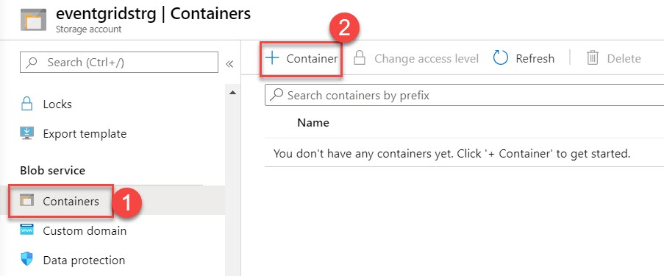

**Step 21:** Name: **eventcontainer**

Public access level: **Private (no anonymous access)**

Click on **Create** button

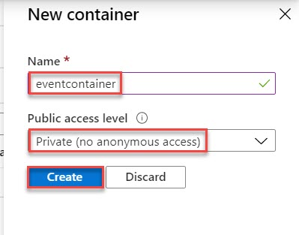

Click on **eventcontainer**

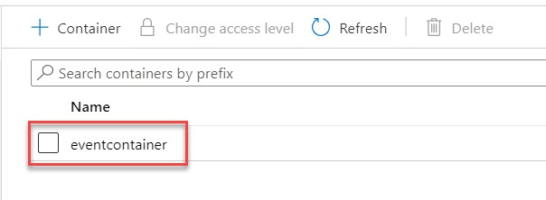

Click on **Upload**.

Browse any file and click on **Upload** button

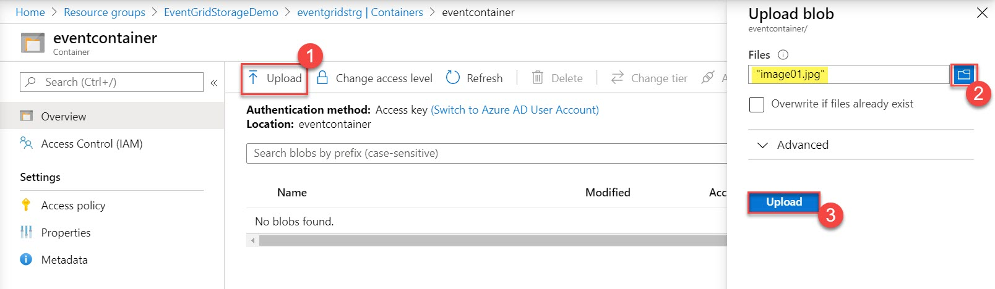

**Step 22:** Again, navigate to Web App and check event related to Storage

