**Exercise - 2**

**Perform keyword search for a skincare hospital website based on search volume and competition using Google keyword planner tool**

**Aim:**

To perform a keyword search for a skincare hospital website based on search volume and competition, you can follow these steps:

**Procedure:**

**Go to Google ads:** Visit the Google Ads website ([**ads.google.com**](https://ads.google.com/home/)) and log in with your Google account. If you don't have a Google Ads account, you'll need to create one to access the Keyword Planner tool.

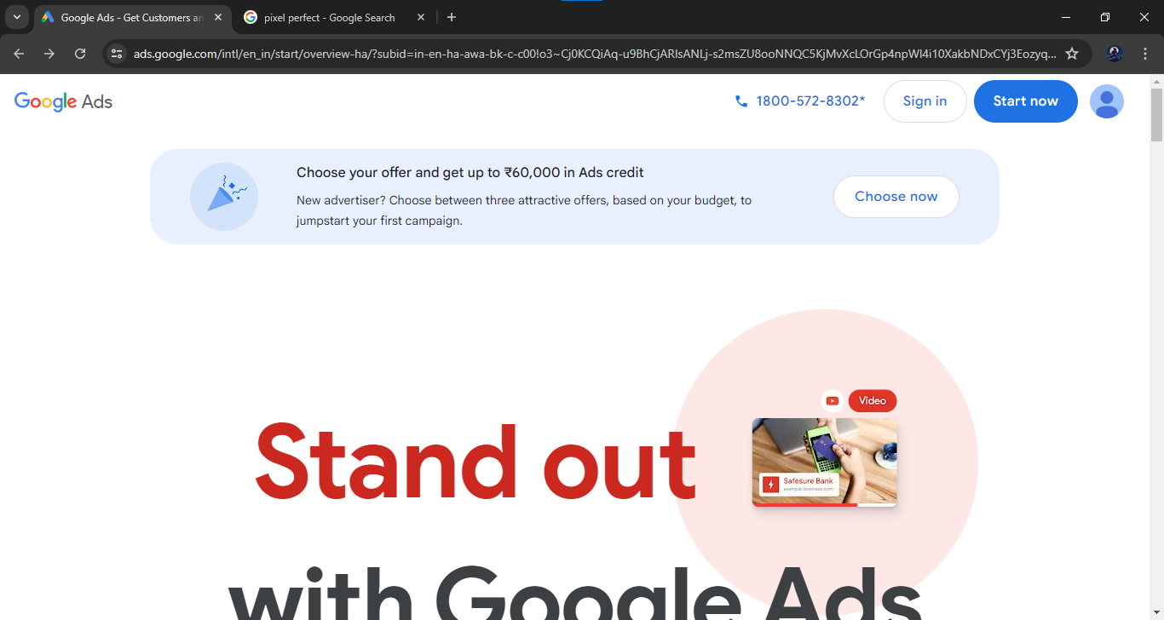

1. **Creating campaign**

**Add Business Information**

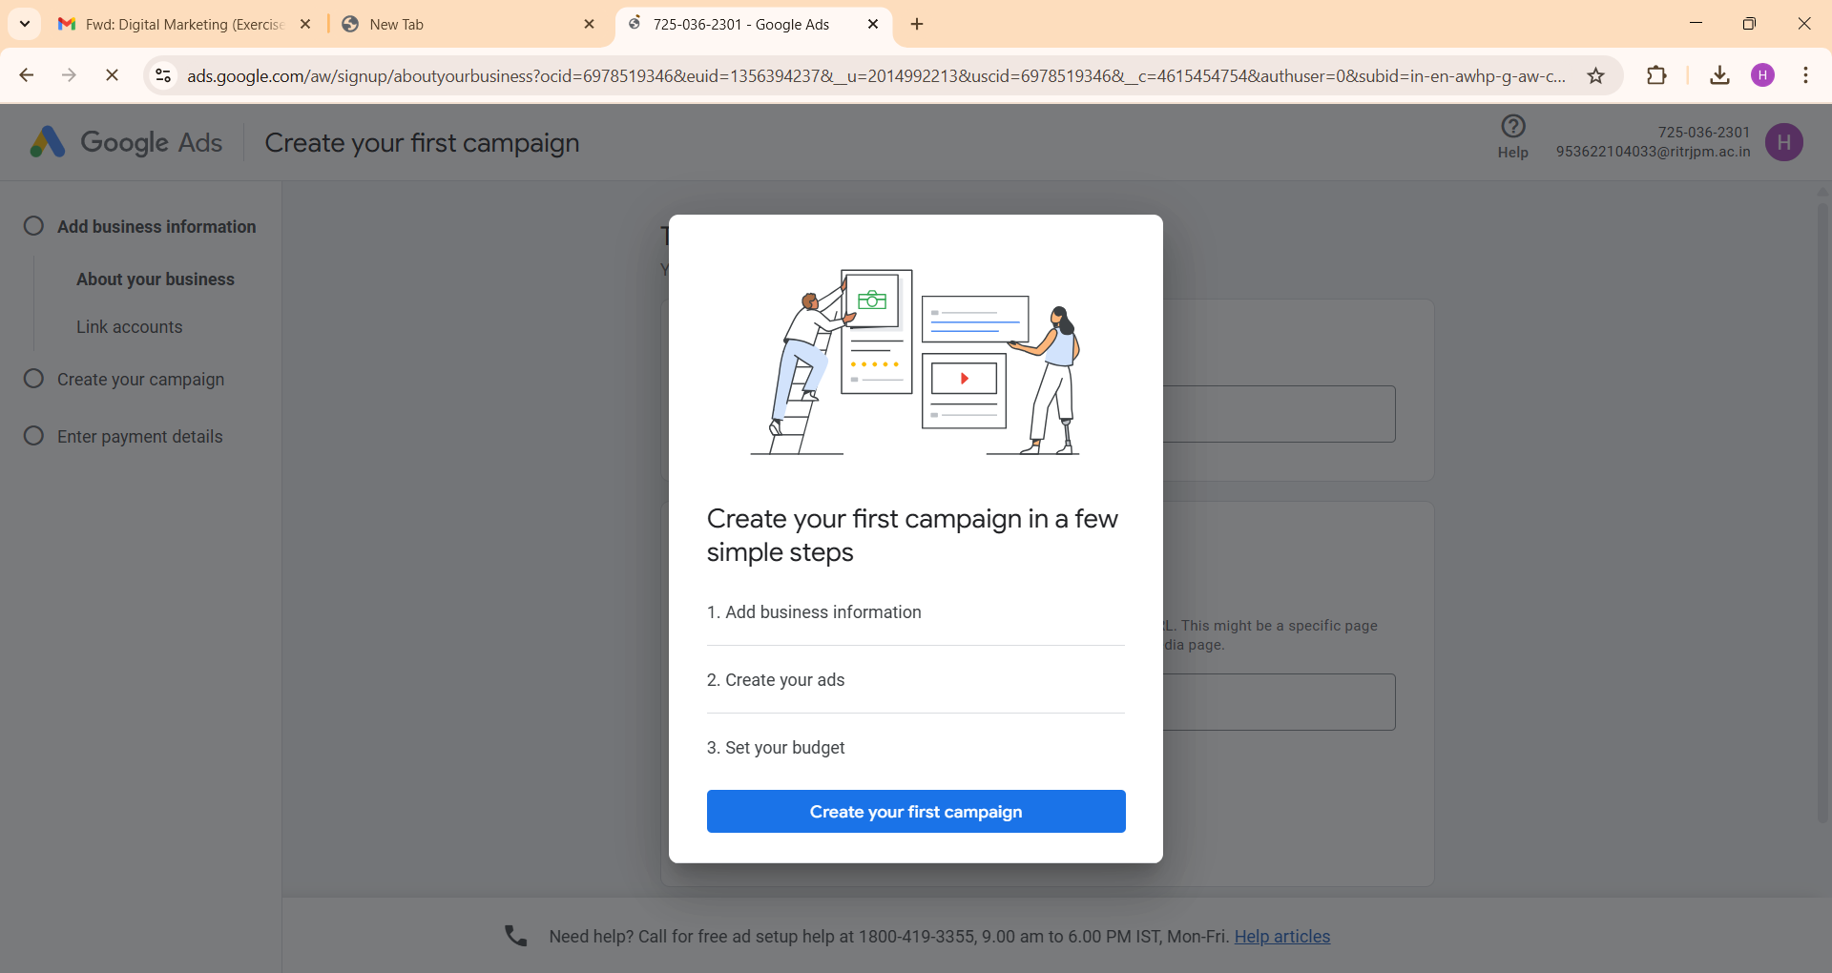

About your business:

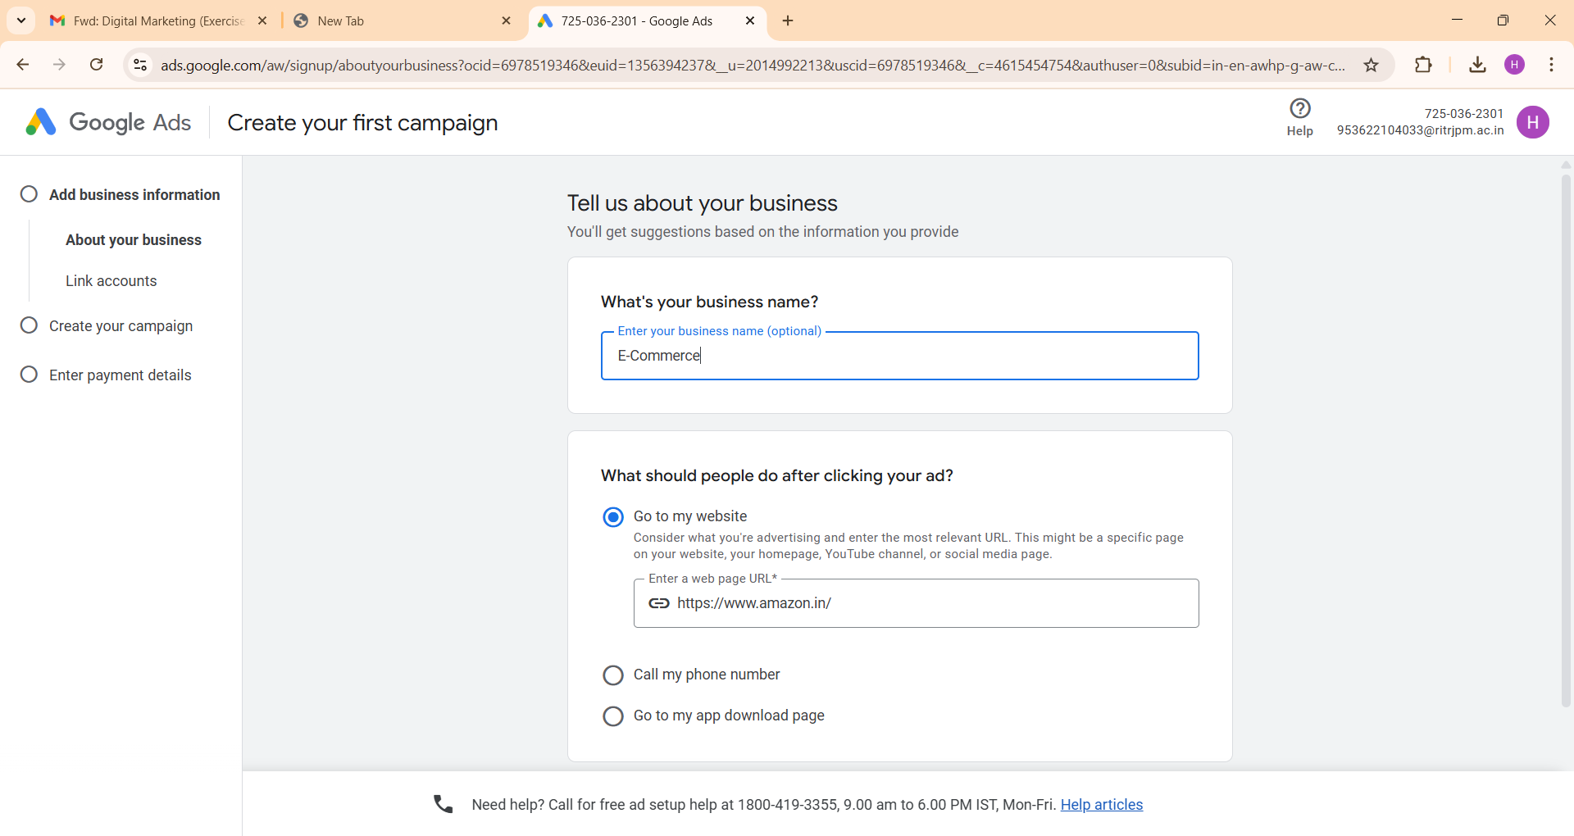

Link Accounts:

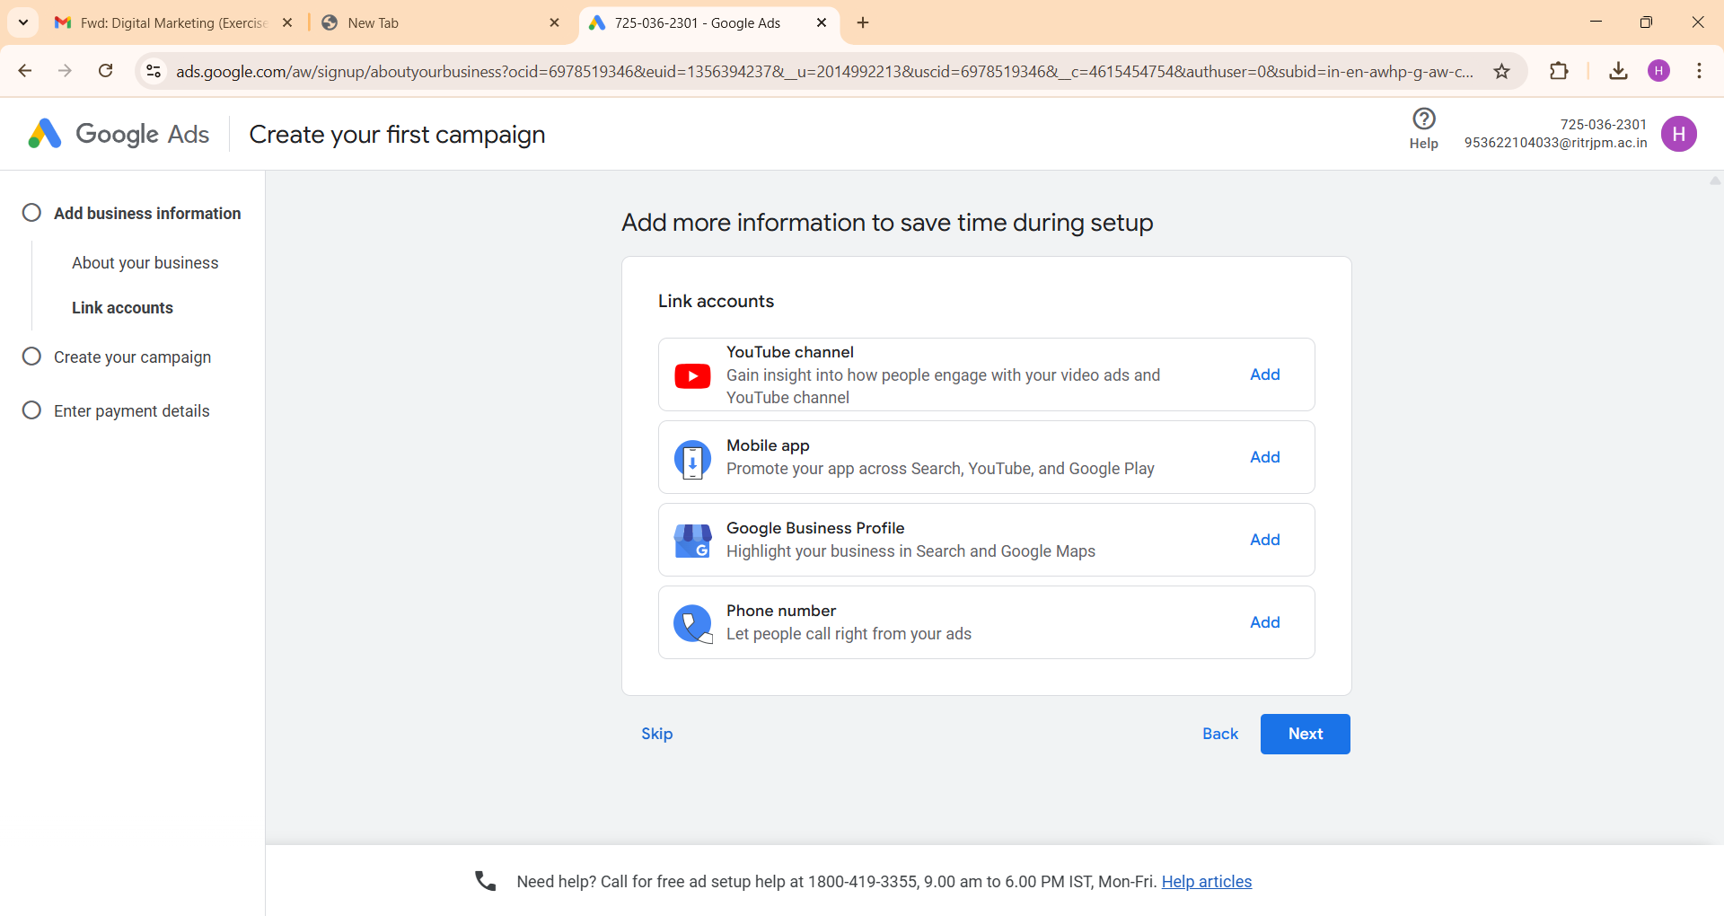

Create your campaign -> choose goal

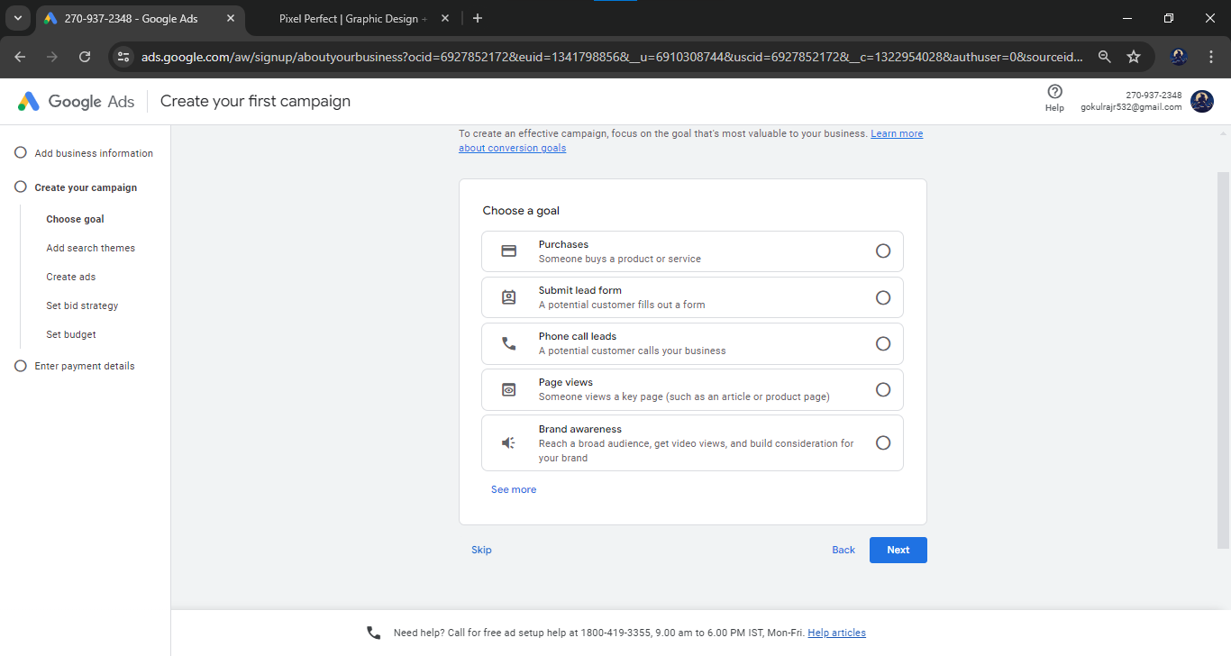

Choose campaign:

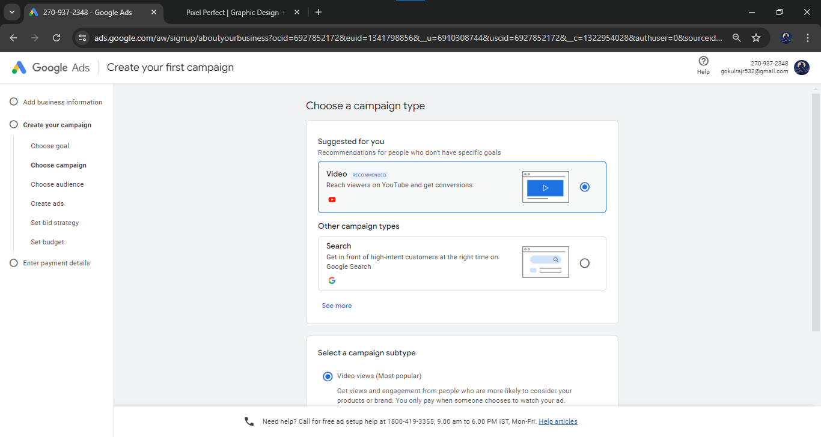

Select -> Other campaign types -> Search

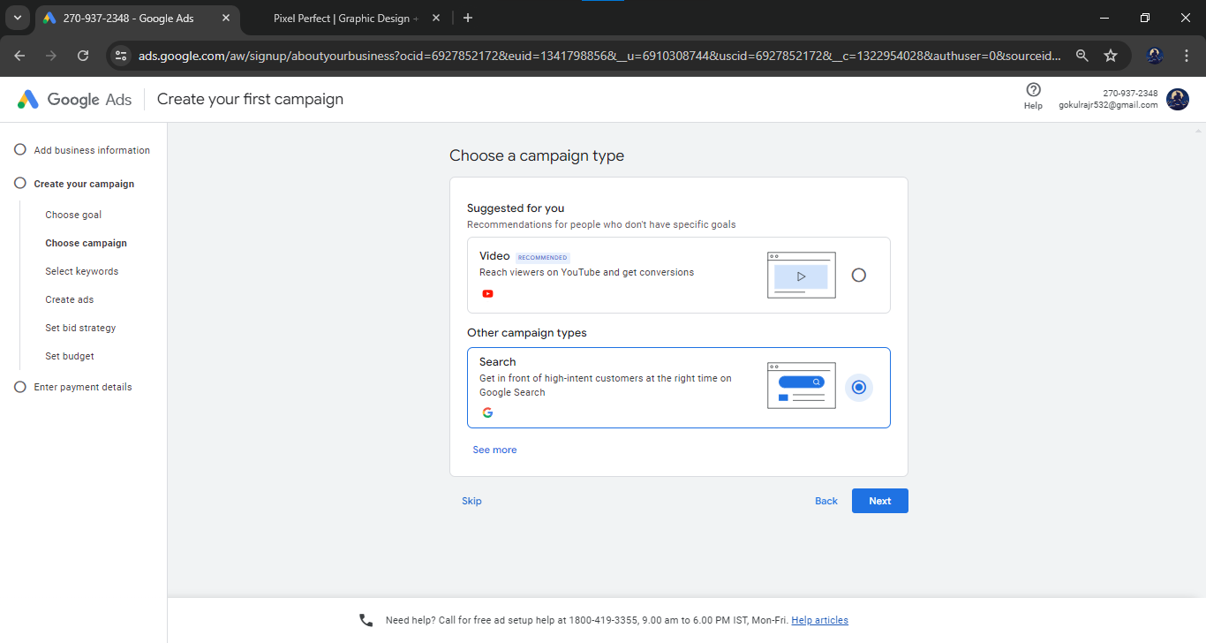

Select Keywords -> Custom Locations -> Enter the location

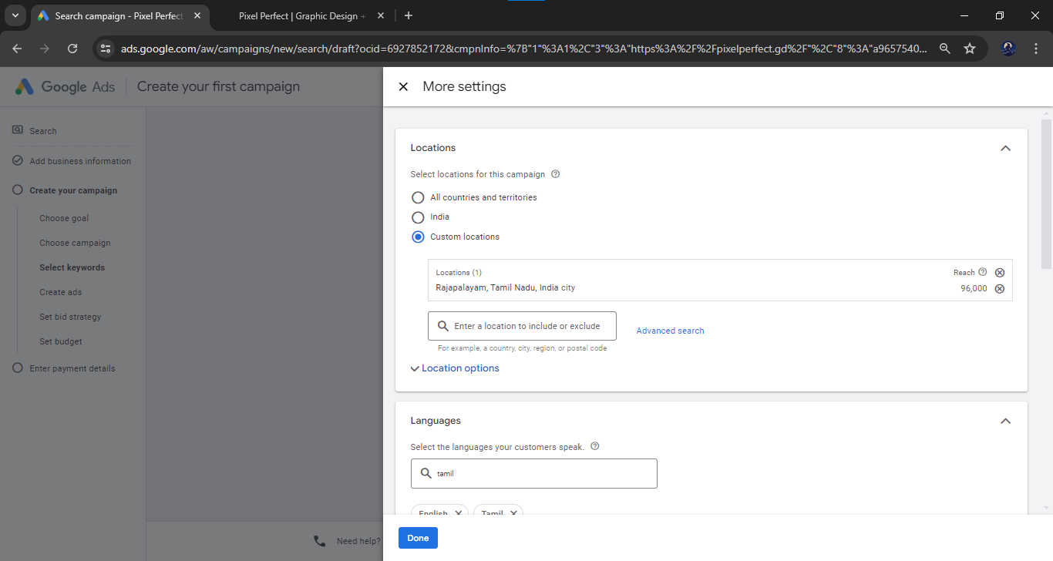

Audience Segments -> Browse -> Targeting

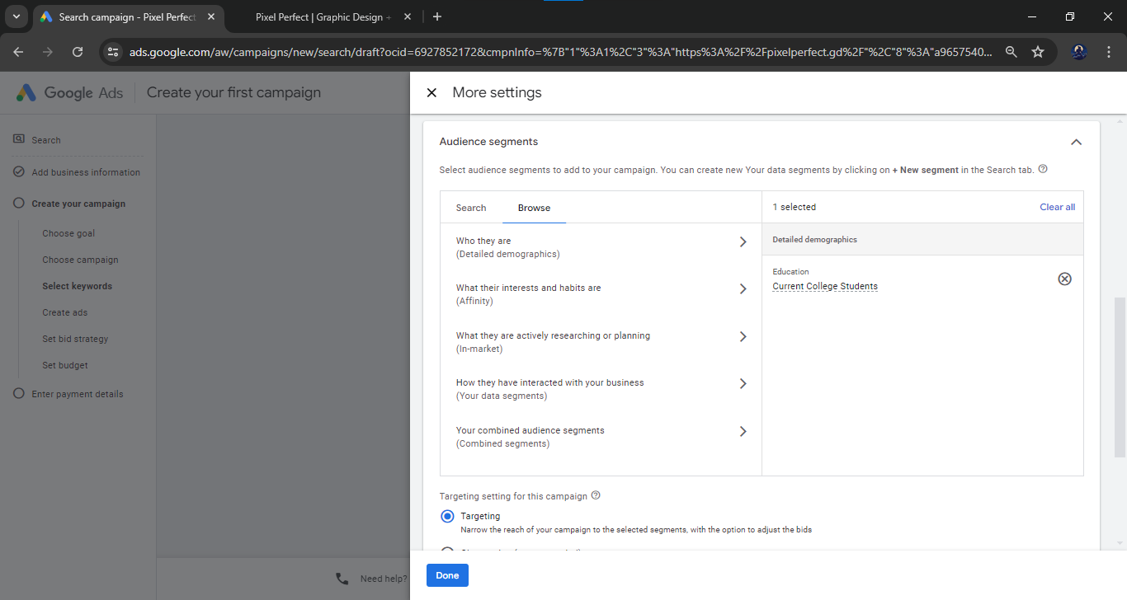

Select the keywords

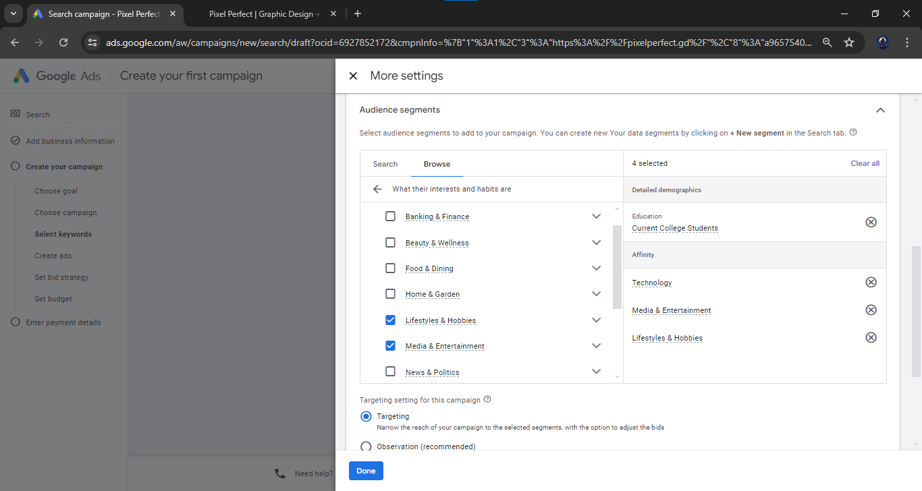

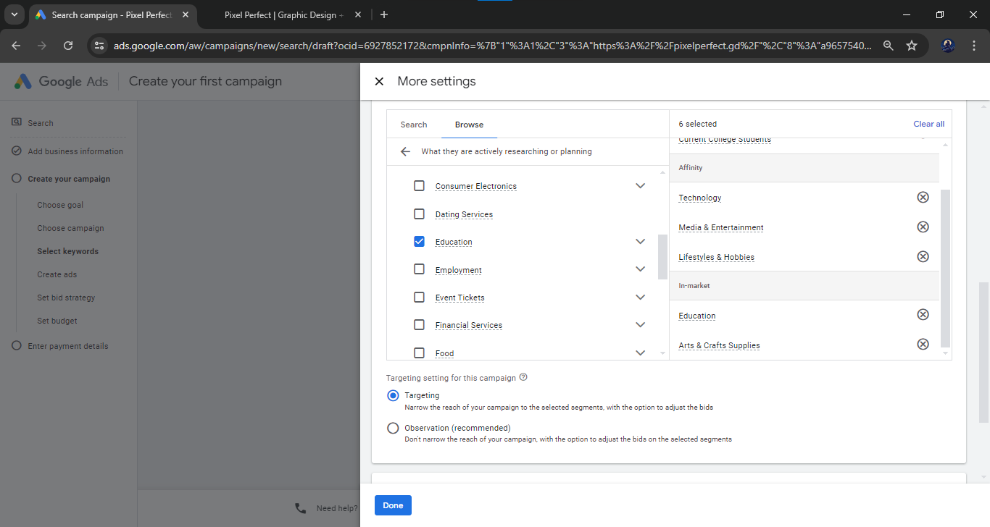

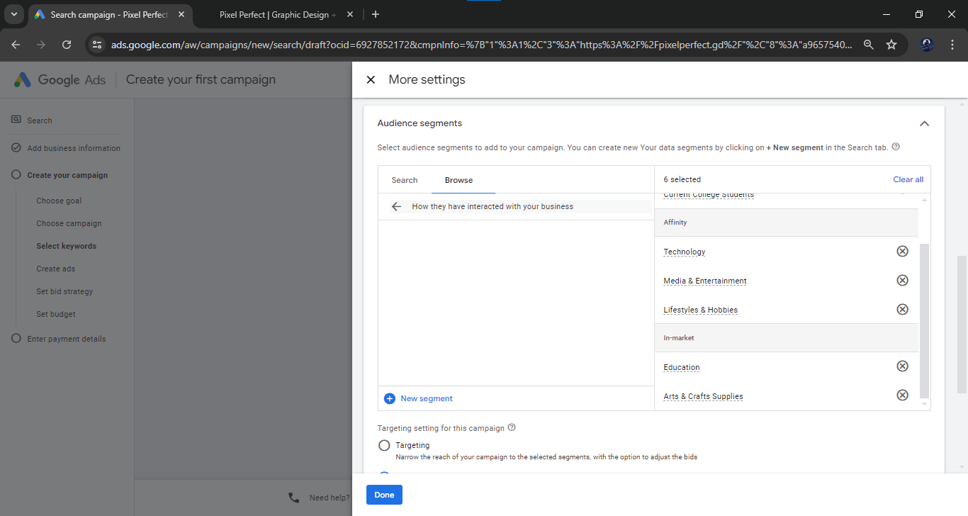

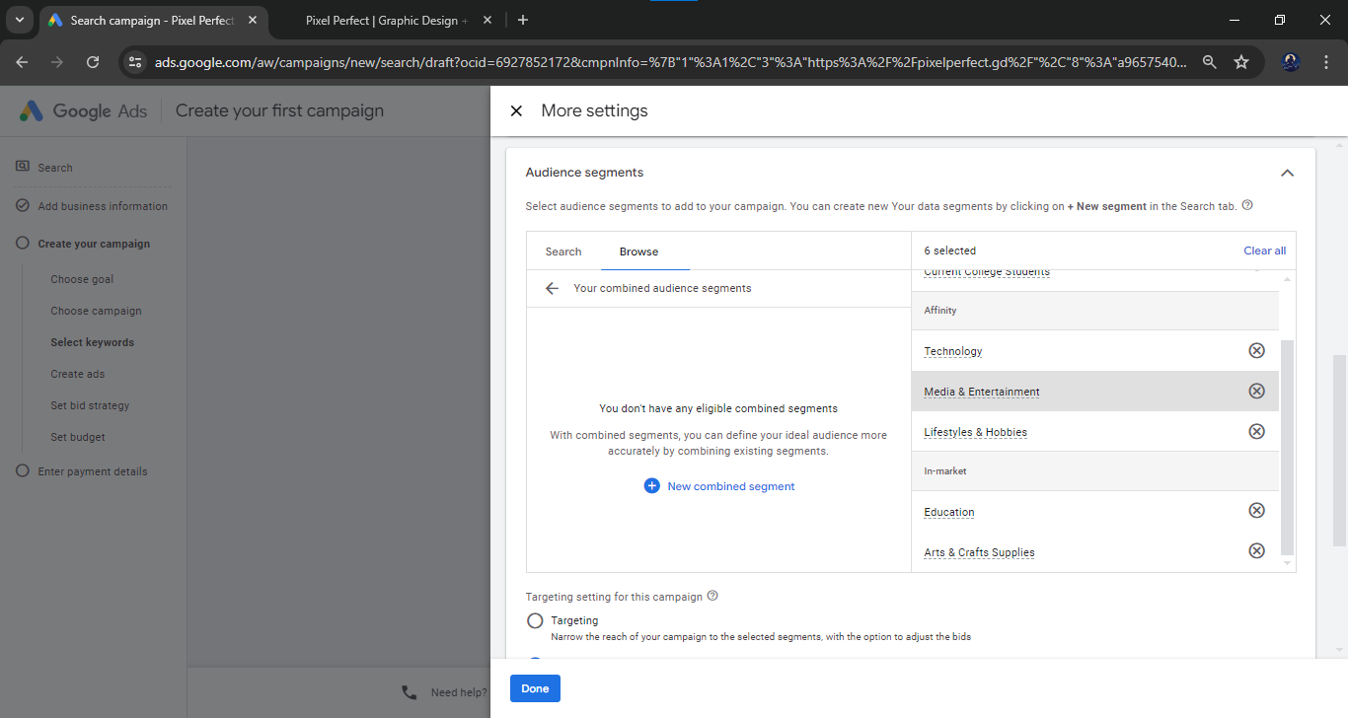

Select the **Observation** to observe the user activities:

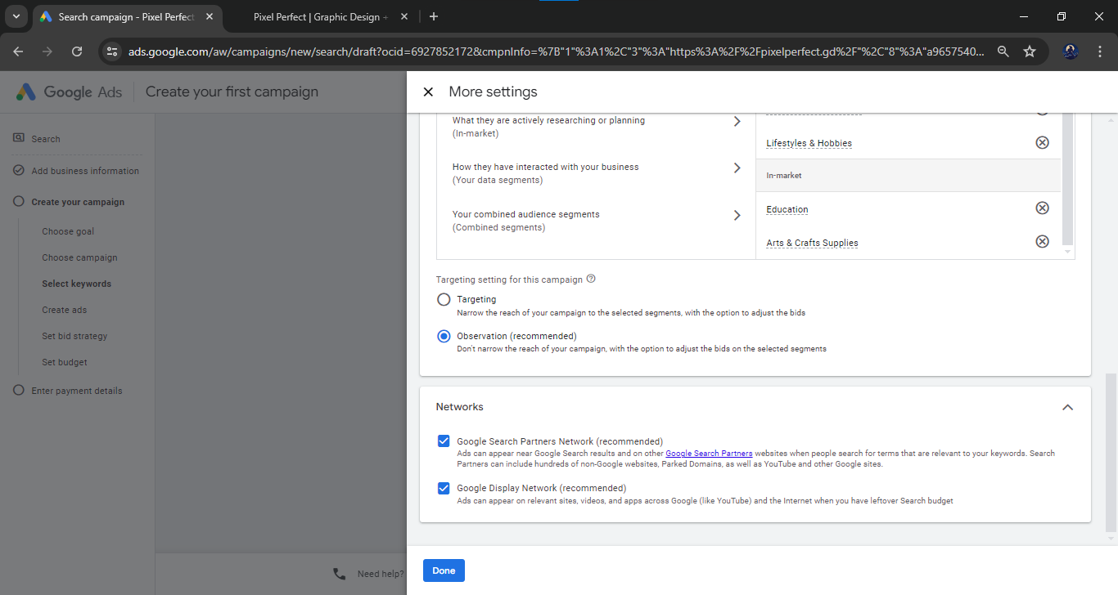

Enter the URL of your website for creating the ad

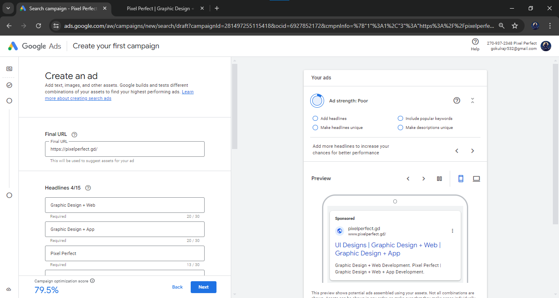

Preview of the sponsored ad (website view):

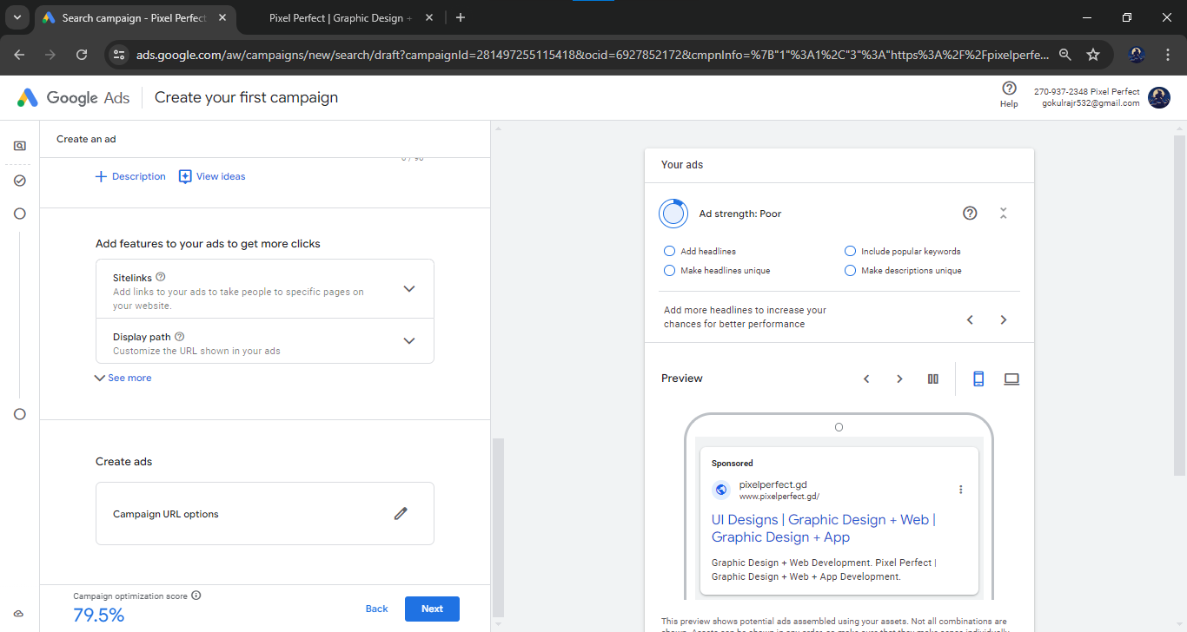

Preview of the sponsored ad (mobile view):

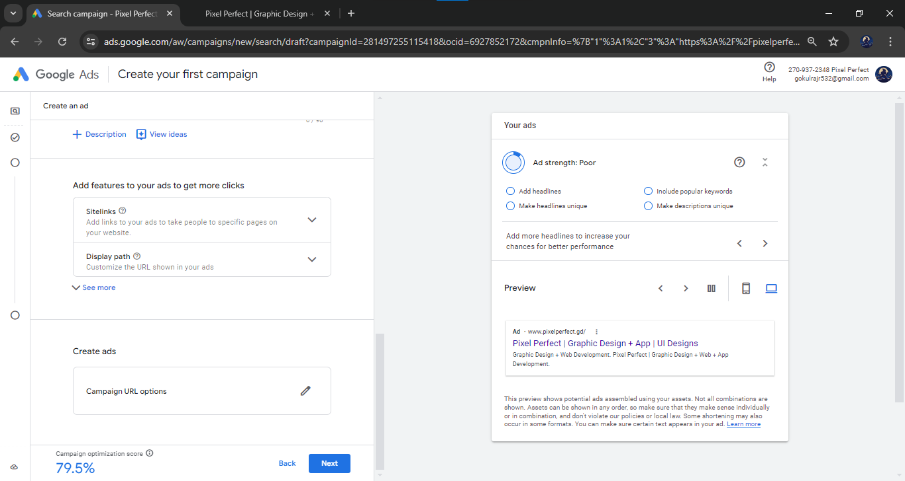

Set bid strategy -> Next

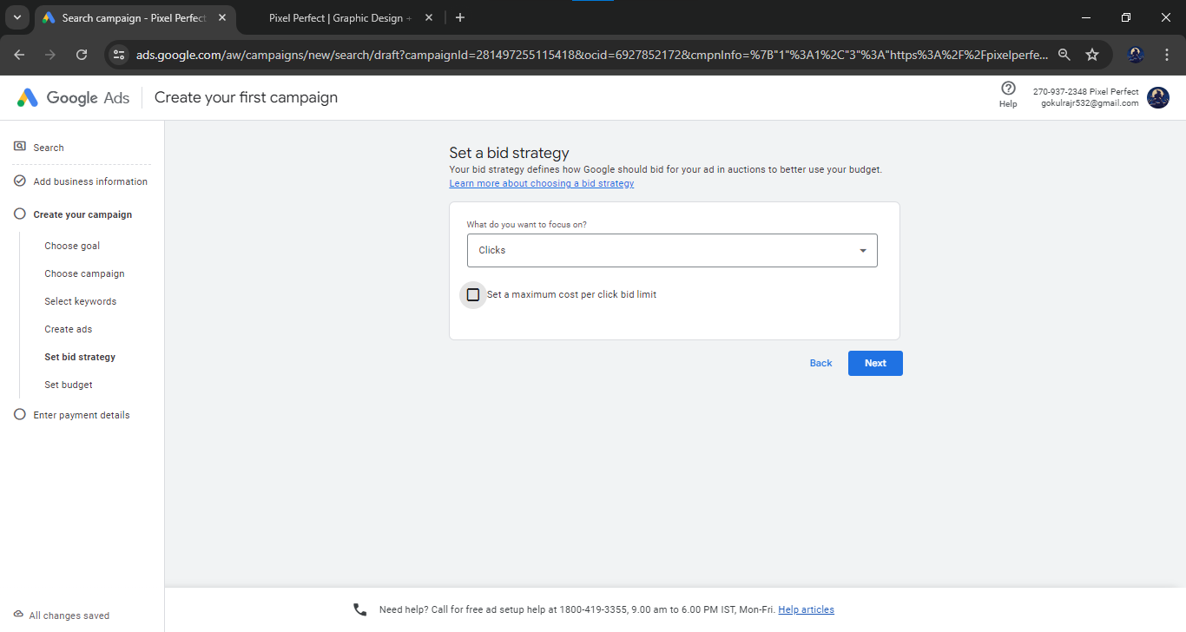

Set budget -> Select a custom budget -> Enter the budget

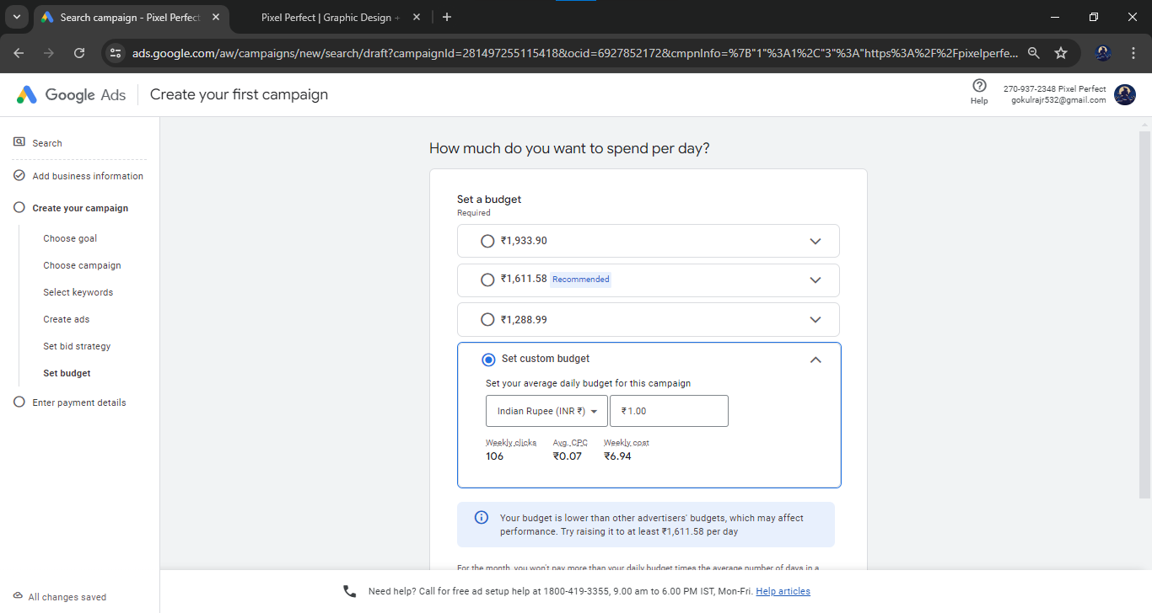

Enter the payment details

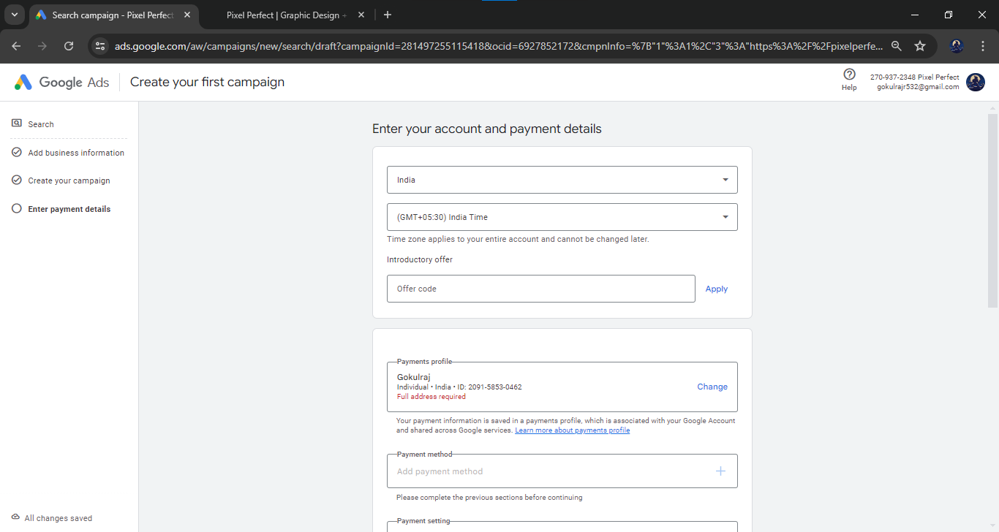

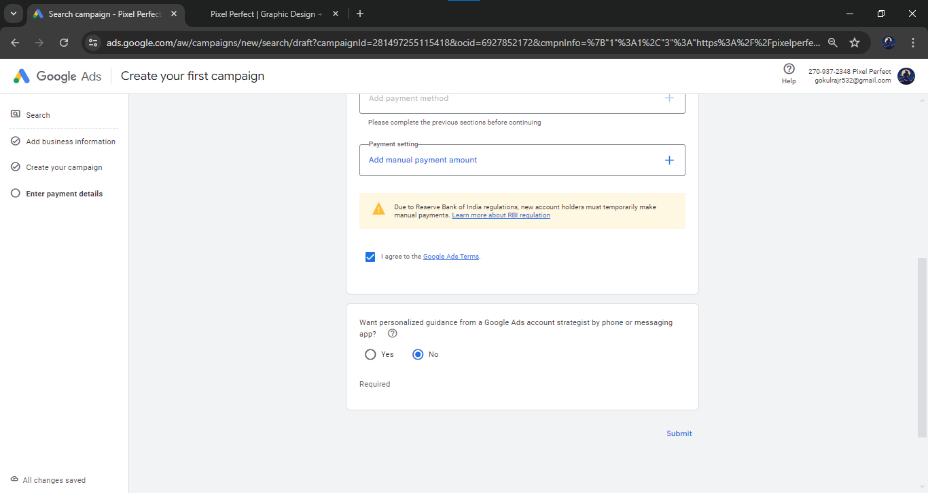

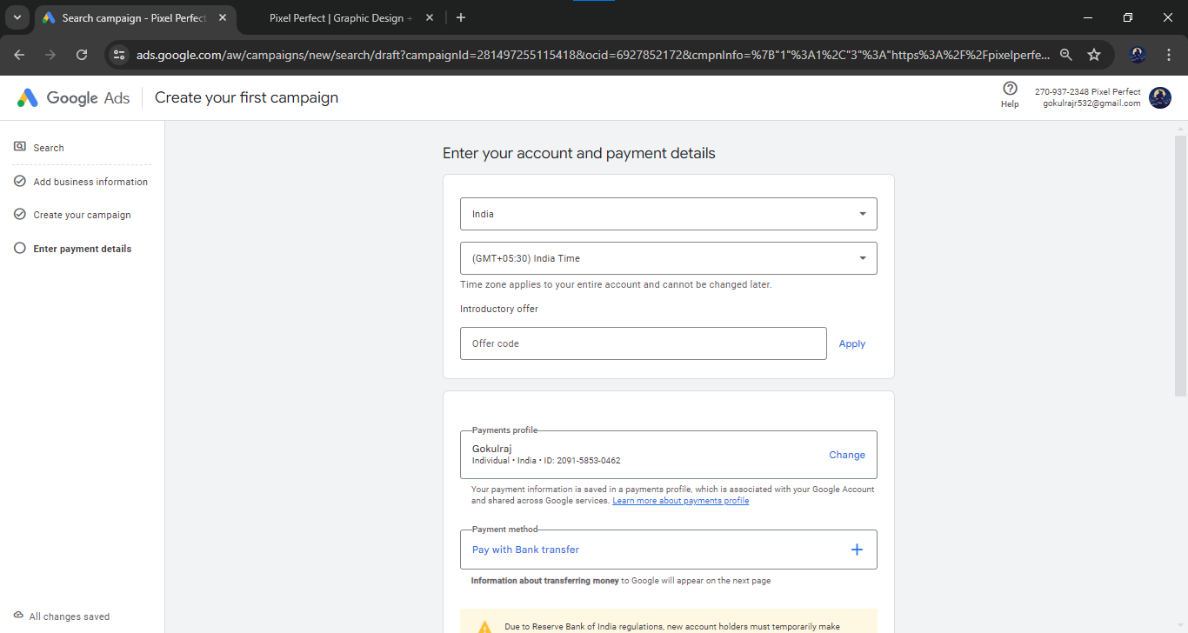

Page for reference:

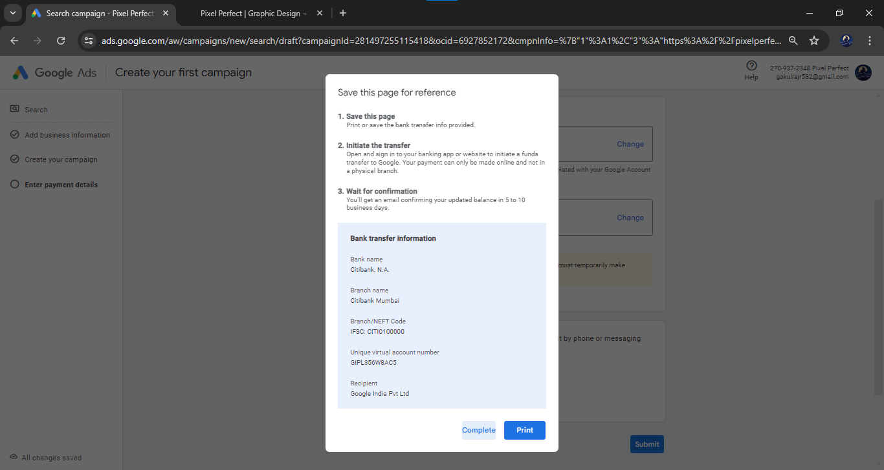



**Step - 1 : Go to Google Keyword Planner:** Visit the Google Ads website ([ads.google.com](https://ads.google.com/home/)) and log in with your Google account. If you don't have a Google Ads account, you'll need to create one to access the Keyword Planner tool.

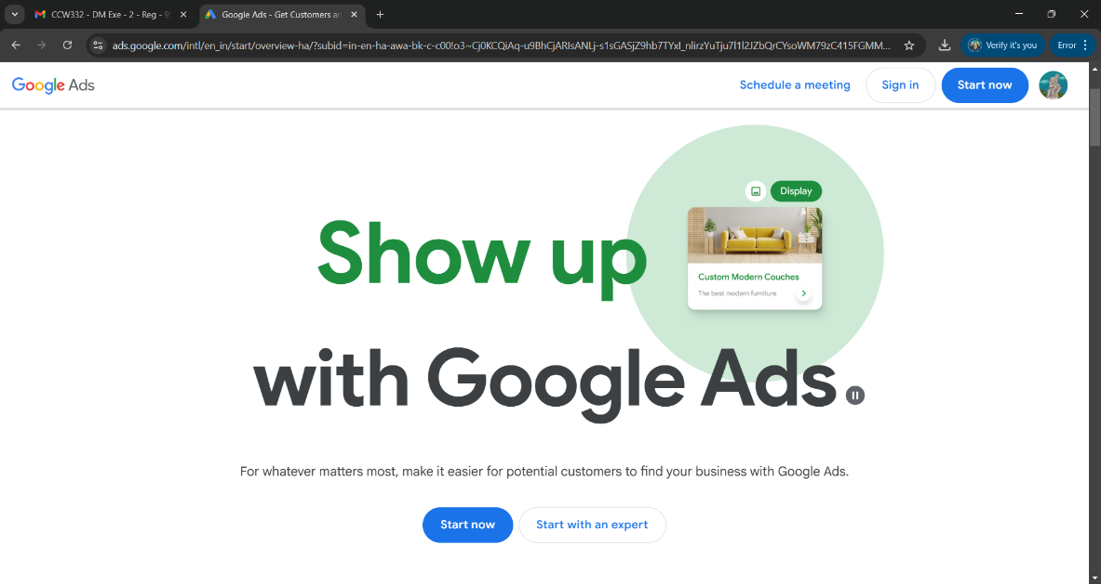

**Step – 2: Access the Keyword Planner:** Once you're logged in, click on the "Tools" menu at the left, then select "Keyword Planner" under the "Planning" section.

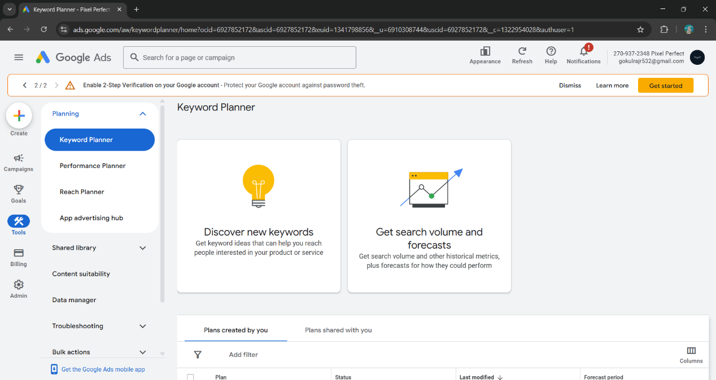

**Step – 3: Discover new keywords:** In the Keyword Planner, choose the option to "Discover new keywords." Here, you can enter various relevant seed keywords related to skincare hospitals, such as "skincare hospital," "dermatology clinic," "skin treatment center," etc.

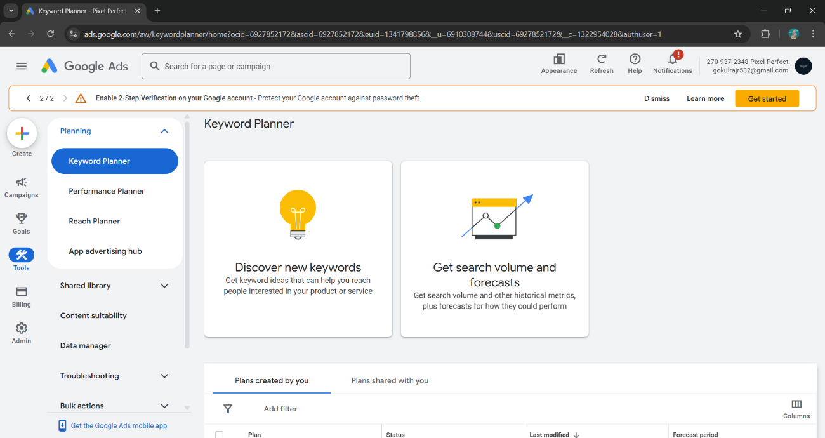

**Step – 4: Filter by location and language:** Specify the location where the skincare hospital is located or wants to target its services. You can also choose the language for the search if applicable.

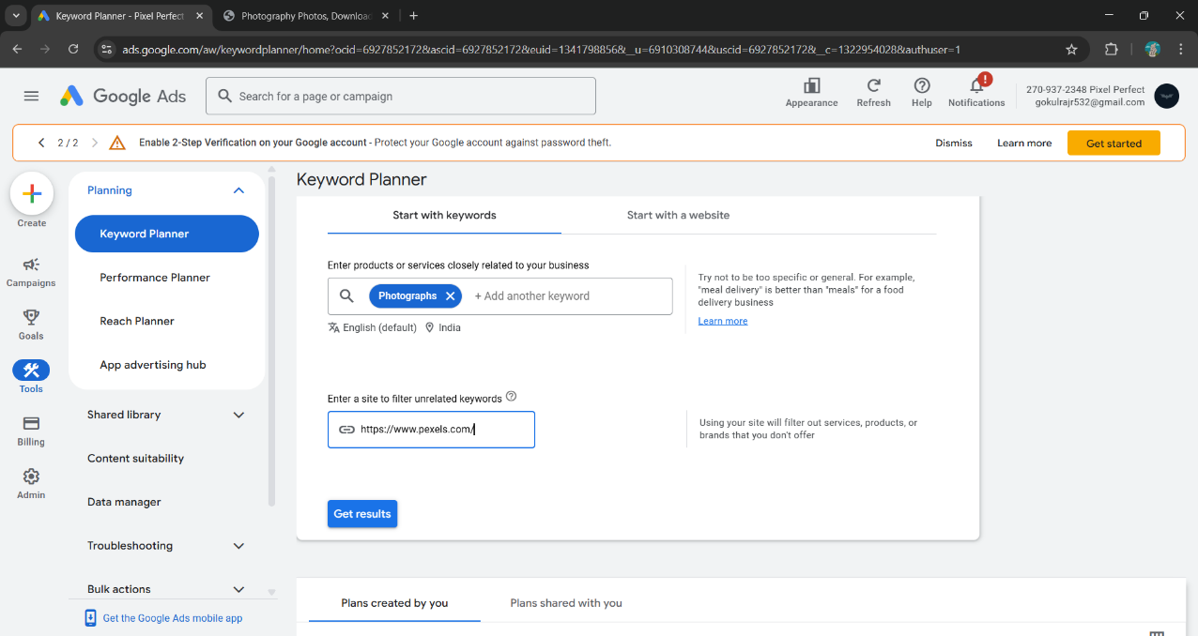

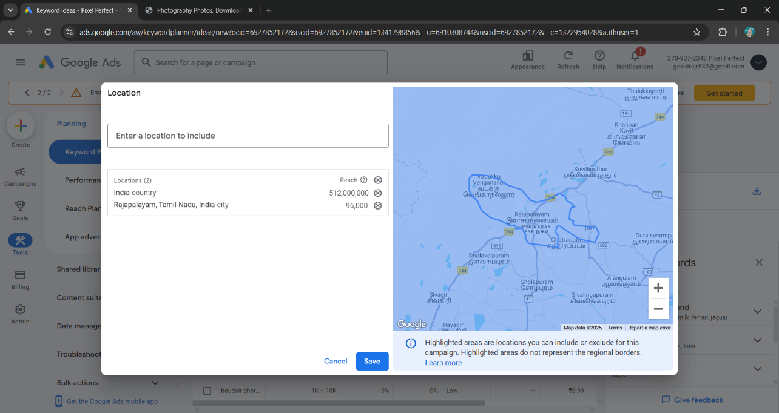

**Step – 5: Review search volume and competition:** Once you enter the seed keywords and apply location and language filters, the tool will provide you with a list of related keywords along with their average monthly search volume and competition metrics. The search volume will give you an idea of how popular each keyword is, and the competition will indicate how challenging it might be to rank for those keywords in Google's search results.

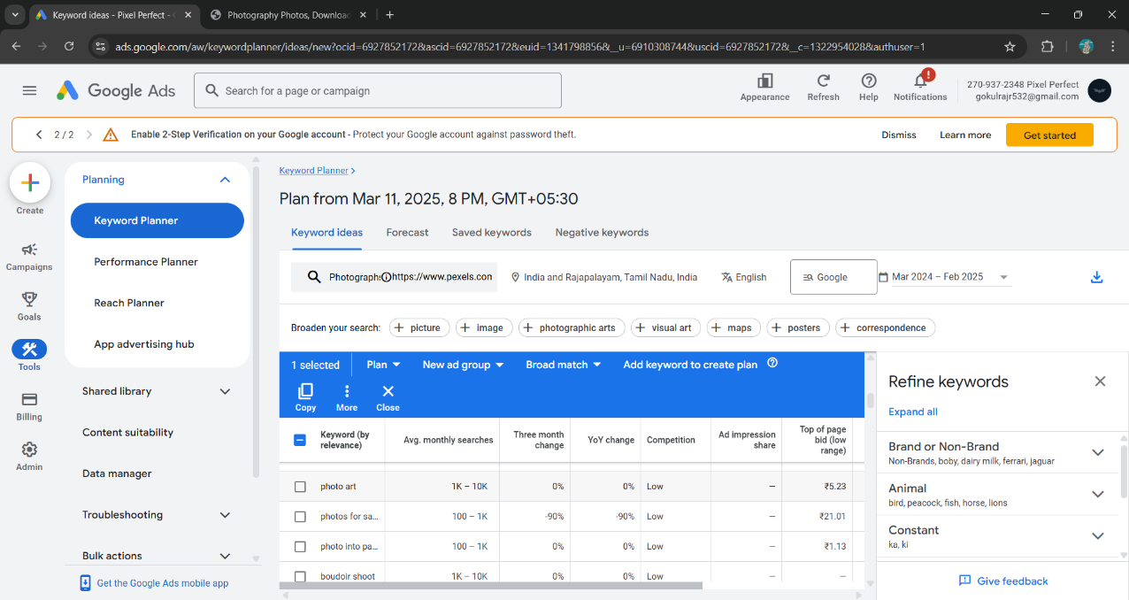

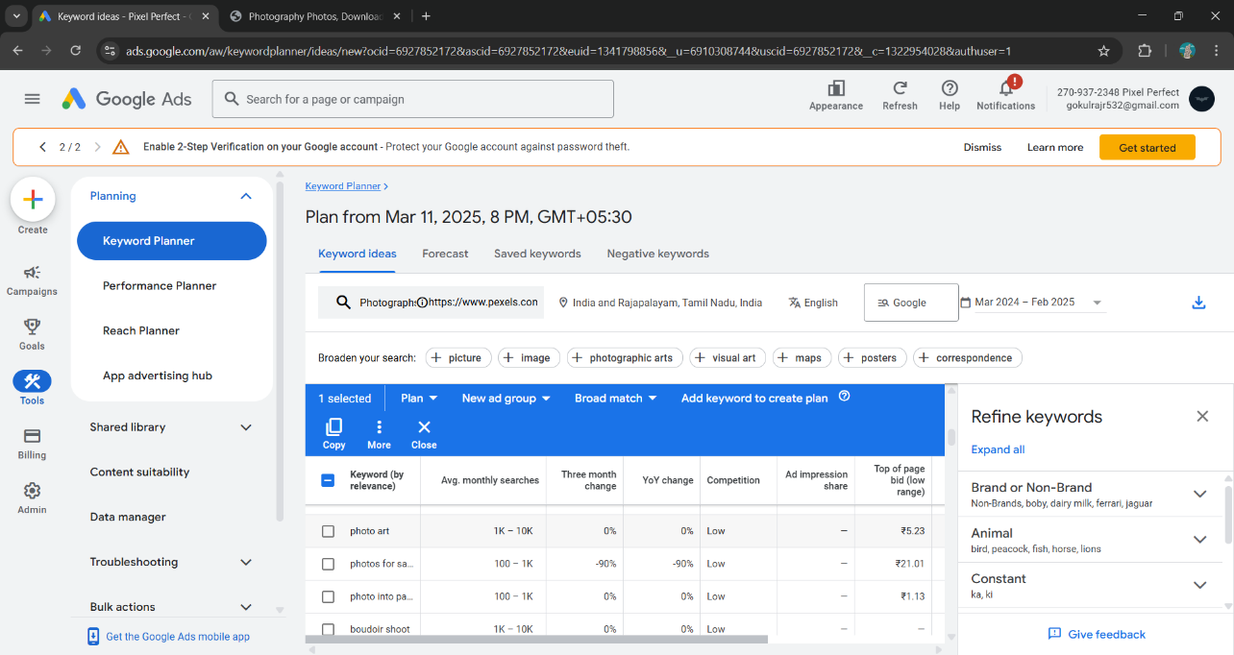

**Google to calculate Competition (indexed value):**

Number of ad slots filled / the total number of ad slots available

This is the definition directly from Google:

“Competition (indexed value)” shows how competitive ad placement is for a keyword, specific to the location and Search Network targeting options that you’ve selected. The level of competition from 0-100 is determined by the number of ad slots filled divided by the total number of ad slots available. If not enough data is available, you’ll see a dash (-)”.

The value provides a more granular figure than the more well-known Competition value, which is just; Low, Medium and High. It enables you to see if a keyword has really low competition, i.e. 1 or just under medium, i.e. 32.

1. **Select relevant keywords:** Analyze the list of keywords provided by the tool and select those that have a decent search volume and manageable competition. Focus on keywords that are highly relevant to the skincare hospital's services and target audience.
2. **Get Search Volume and Forecasts:** In the Keyword Planner, choose the option to "Get Search Volume and Forecasts." Here, you can enter various relevant seed keywords related to skincare hospitals, such as "skincare hospital," "dermatology clinic," "skin treatment center," etc. To get forecasts for your keywords, you can click on the "Get forecasts" option. This will provide you with estimated performance metrics for your keywords, including estimated clicks, impressions, and cost.
3. **Start with a Website:** In this option enter the website URL of your competitor website. This shows the competitor a website or a page to find keywords that match your business or site.

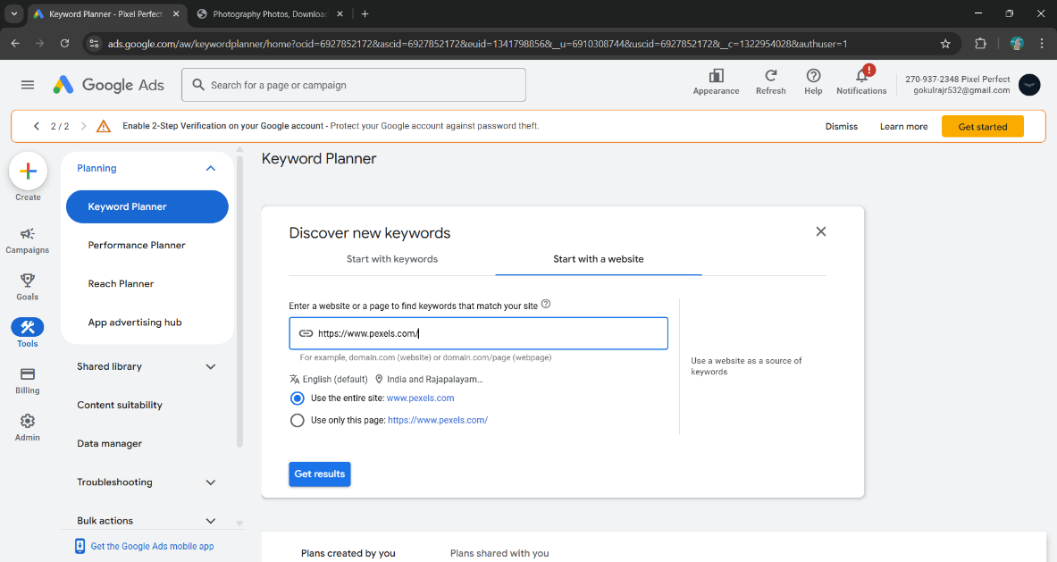

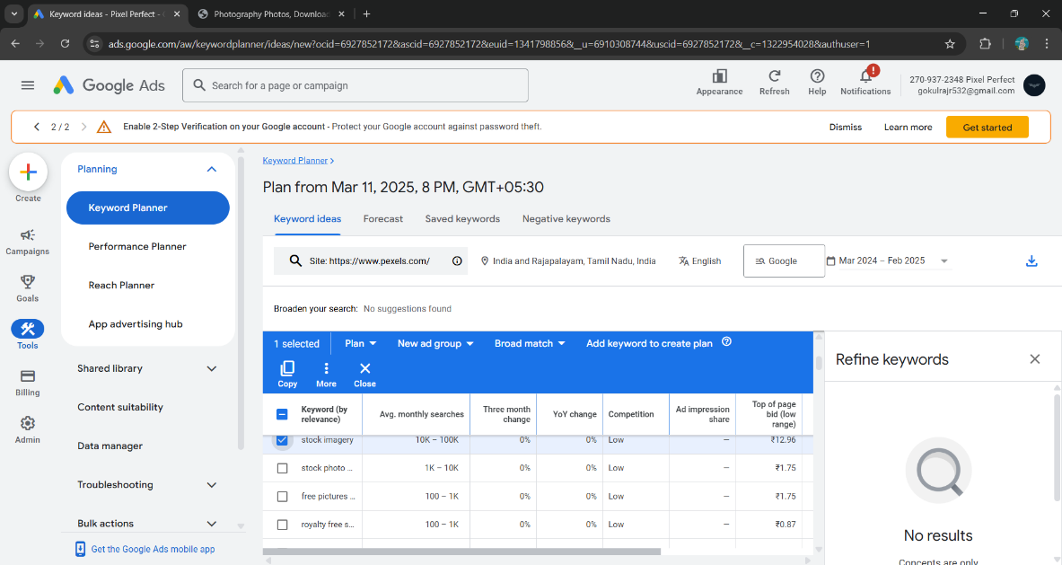

Remember that keyword research is an ongoing process, and it's essential to keep monitoring and updating your keyword strategy based on changes in trends and user behaviour.

**Result:**

Thus the keyword search was conducted for a skincare hospital website, taking into account factors such as search volume and competition. The process and findings of this search were demonstrated.

|  |  |
| --- | --- |
| Performance (25) |  |
| Viva Voce (10) |  |
| Record (15) |  |
| Total (50) |  |