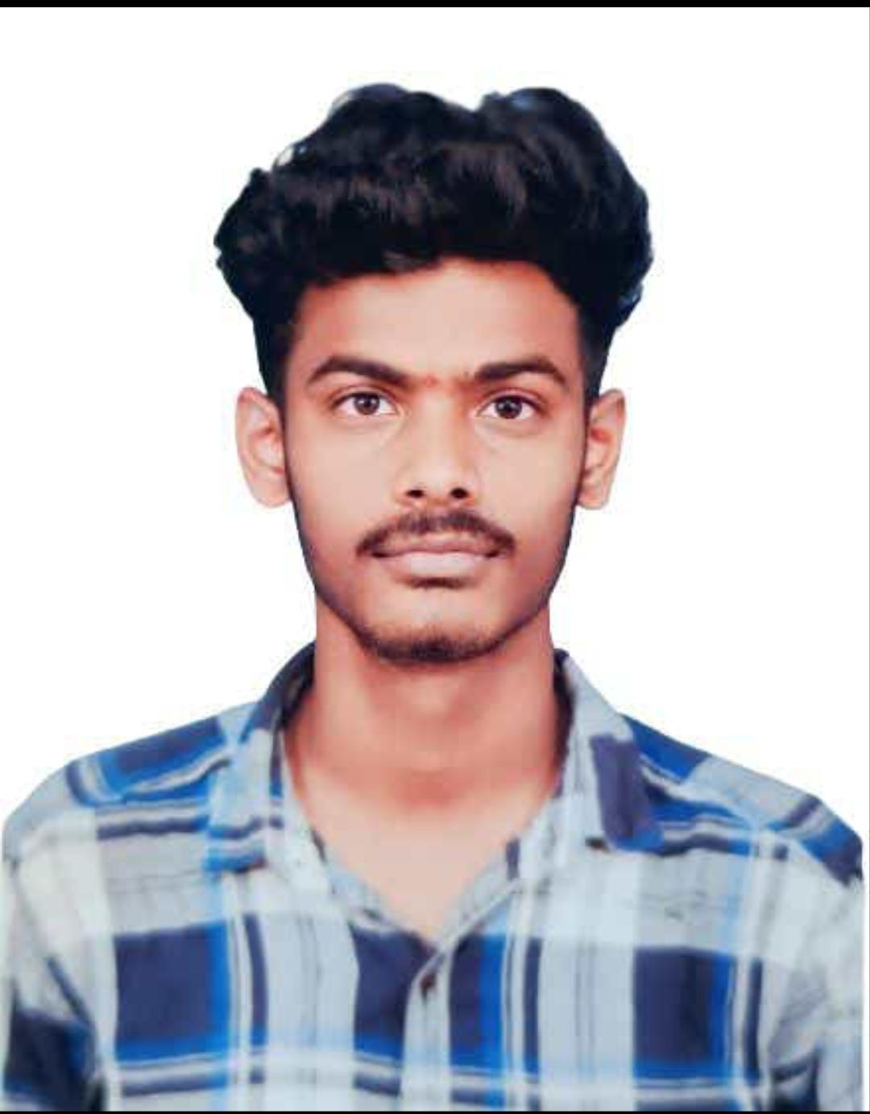HARIHARASUDHAN S K

Phone Number : 7824926252

Mail : [harisksk78@gmail.com](mailto:harisksk78@gmail.com)

GitHub : <https://github.com/Harisk78>

LinkedIN <https://www.linkedin.com/in/hariharasudhan-sk-a53361249/>

Address : Thulasiyappatinam, Vedaranyam TK, Nagappatinam,614714

**CAREER OBJECTIVE**

Dedicated and enthusiastic budding web developer with a passion for crafting elegant and functional websites.Eager to contribute my technical skills and creative flair to a dynamic team environment where I can continuously learn and grow.

**EDUCATION**

**Bachelor of Engineering - Computer Science And Design**

2025

Karpagam Academy Of Higher Education, Coimbatore

CGPA - 7.30

**HSC**

Jun 2019 - Mar 2021

Victory Higher Secondary School, Nagapattinam

Percentage - 80%

**SSLC**

Jun 2018 - Mar 2019

Victory Higher Secondary School, Nagapattinam

Percentage - 76.6%

**PROJECT**

**TITLE :** Grocery Delivery Website

**DESCRIPTION :** This projects make a user to login and displays some grocery Products to buy and add to cart . By Using frontend languages like HTML, CSS and ,JavaScript this site was developed and some more developments on backend has to be added to feed products.

**INTERNSHIP**

Undergone an Internship for 15 days on "Python Programming" by Pantech e-Learning

(virtual).

**SKILLS**

C Programming | Python | Web Development (FrontEnd) | SQL | Java

**CERTIFICATION**

* **Introduction to C** Solo learn 2023
* **Fundamentals in C** Infosys Springboard 2022

**Language**

* **Basics of Python** Infosys Springboard 2022
* **Learning C**  LinkedIN 2023
* **SQL Basics**  Hacker Rank 2024

**AREA OF INTEREST**

* Web Designing
* Photography

**STRENGTH**

* Presentation Skills
* Communication Skills
* Flexible

**DECLARATION**

I hereby declare that the information given above are genuine and true to the best of my knowledge and belief.

**DATE**

**PLACE**

**[HARIHARASUDHAN SK]**