Name: HARI SUNDAR REDDY
rollno.:19X01A0437
Batch: 2019-2023
Title: ONLINE MOVIE TICKET BOOKING SYSTEM

1. Talking about ‘showbook.py’ the user needs to create an account with the button displayed as ‘create account’, fill the following credentials asked of the user , with the username as a unique identify key.

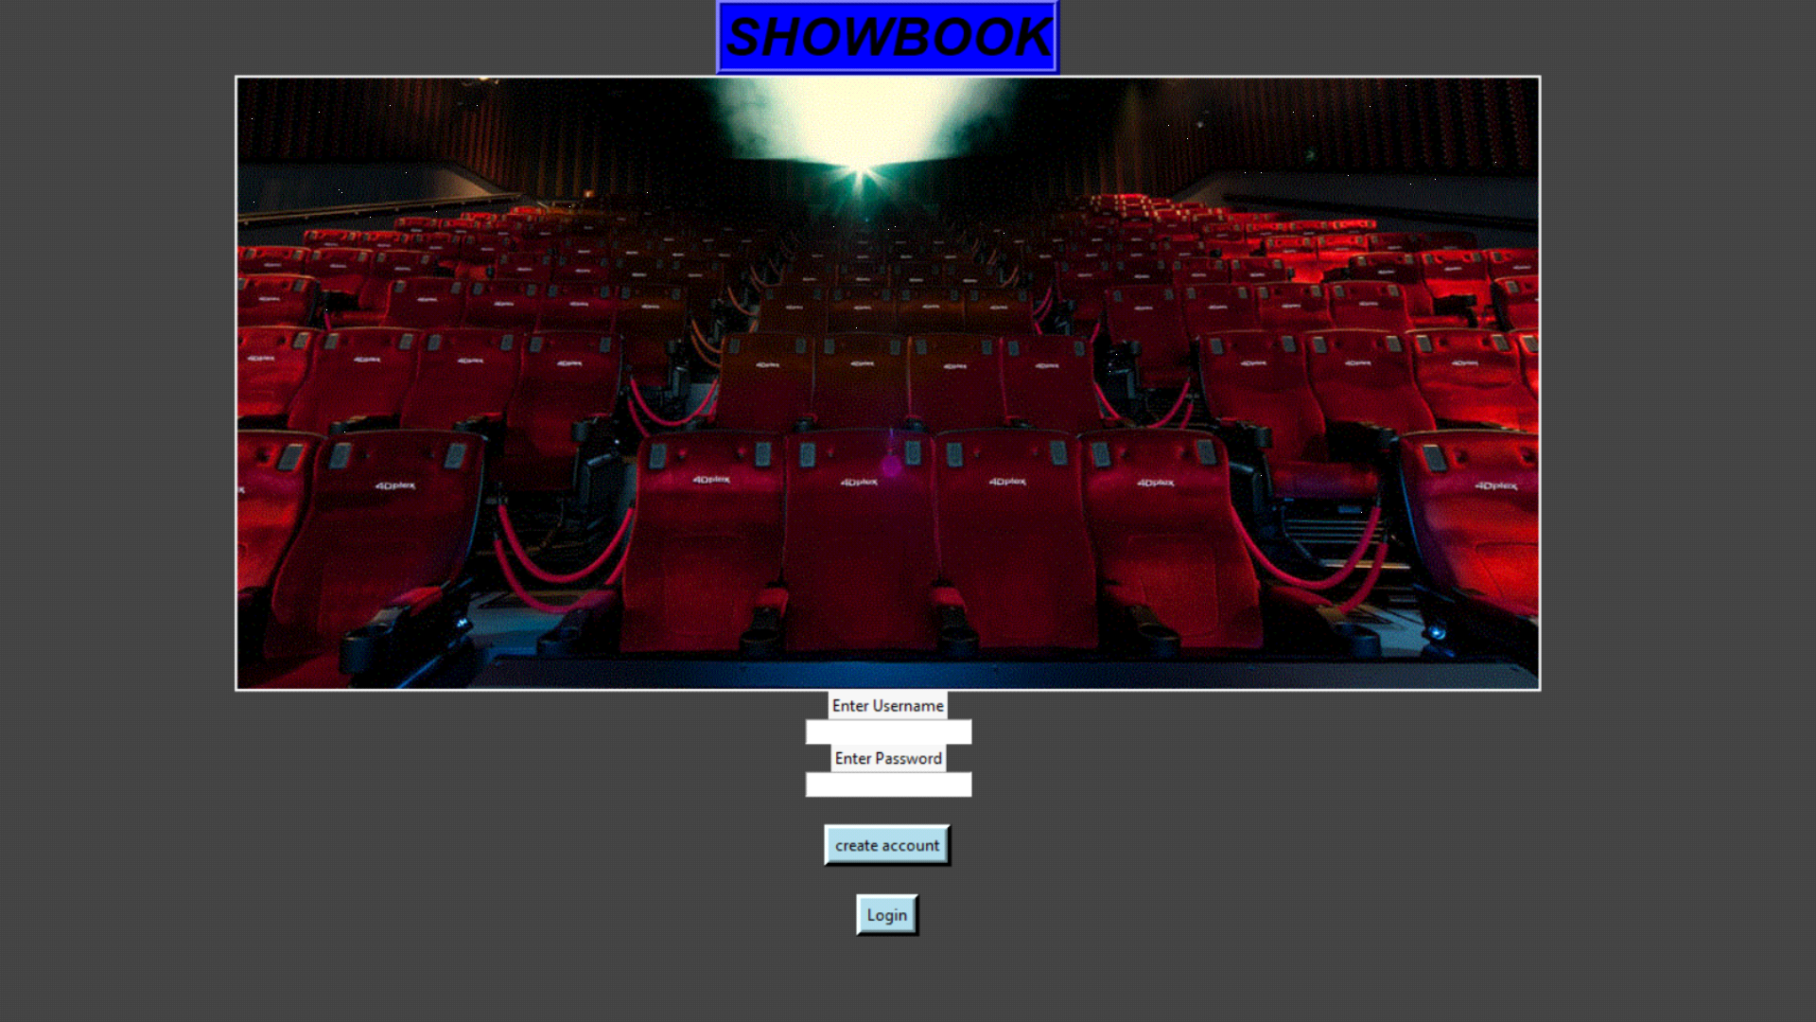
2. Once the users create an account he can login with the respectively username and password. Its takes you to the ticket booking page where you can book your movie tickets .

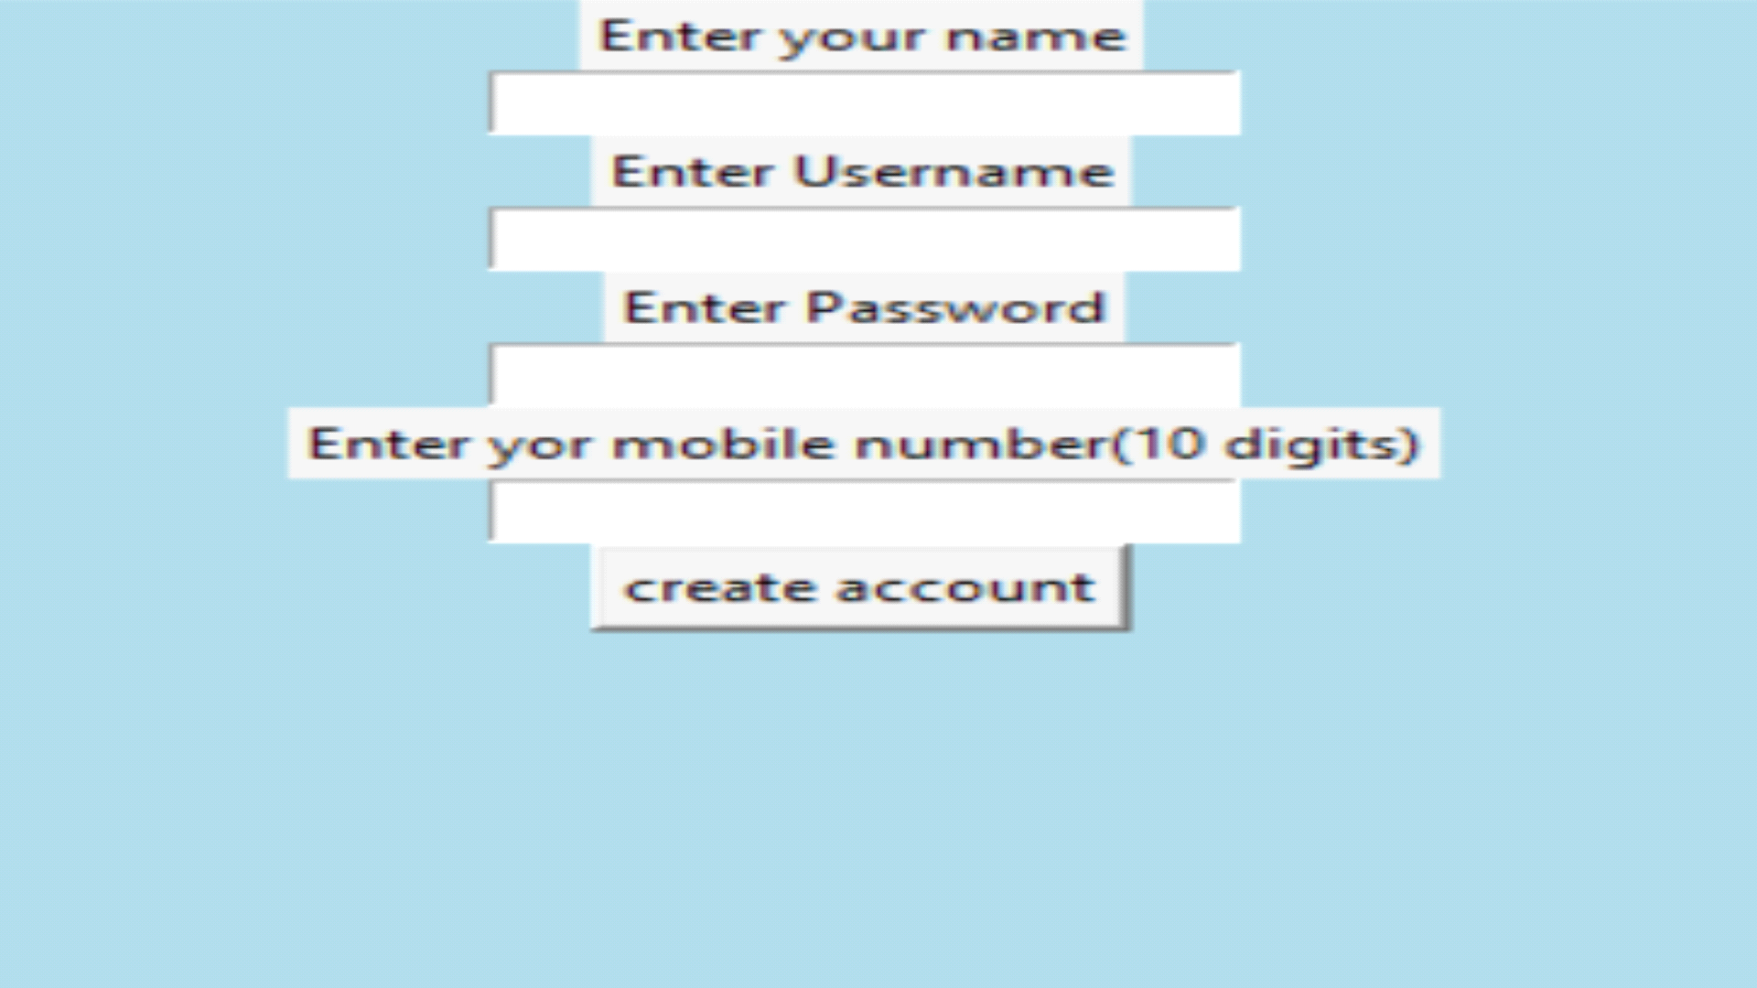

SAMPLE :-
USERNAME:- 1
PASSWORD:- 1

3. now we talk about third screen which is open by and calling by splash screen , when login is
successful , first we now that we use “tkinter” here.
4. now , there are 3 things user can perform "Book tickets", "My tickets" and "Cancel ticket

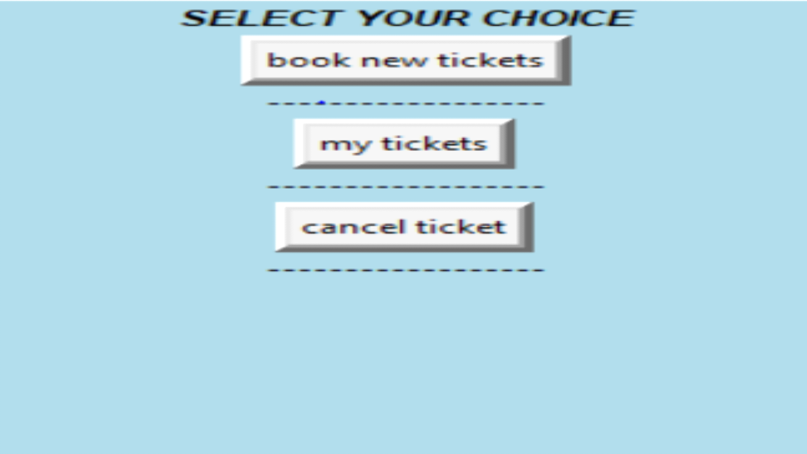

6. now, new window appears according to users selection.

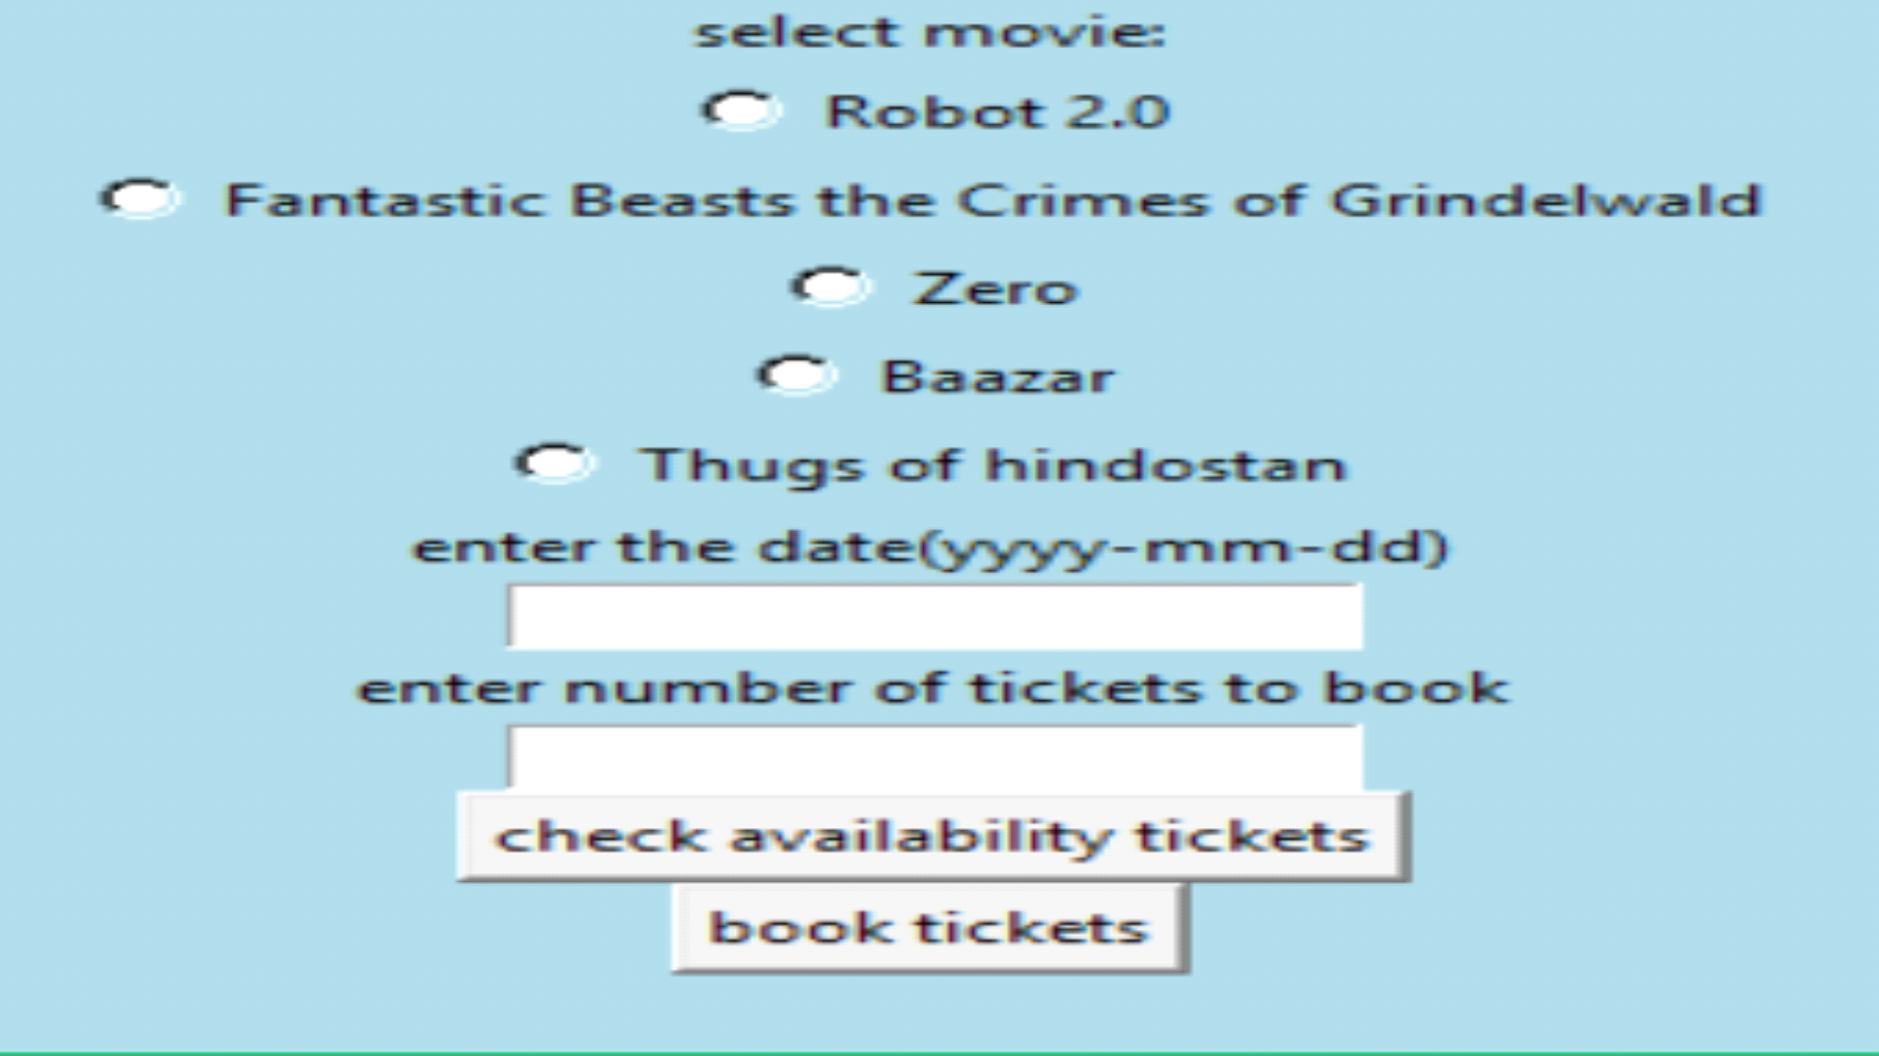

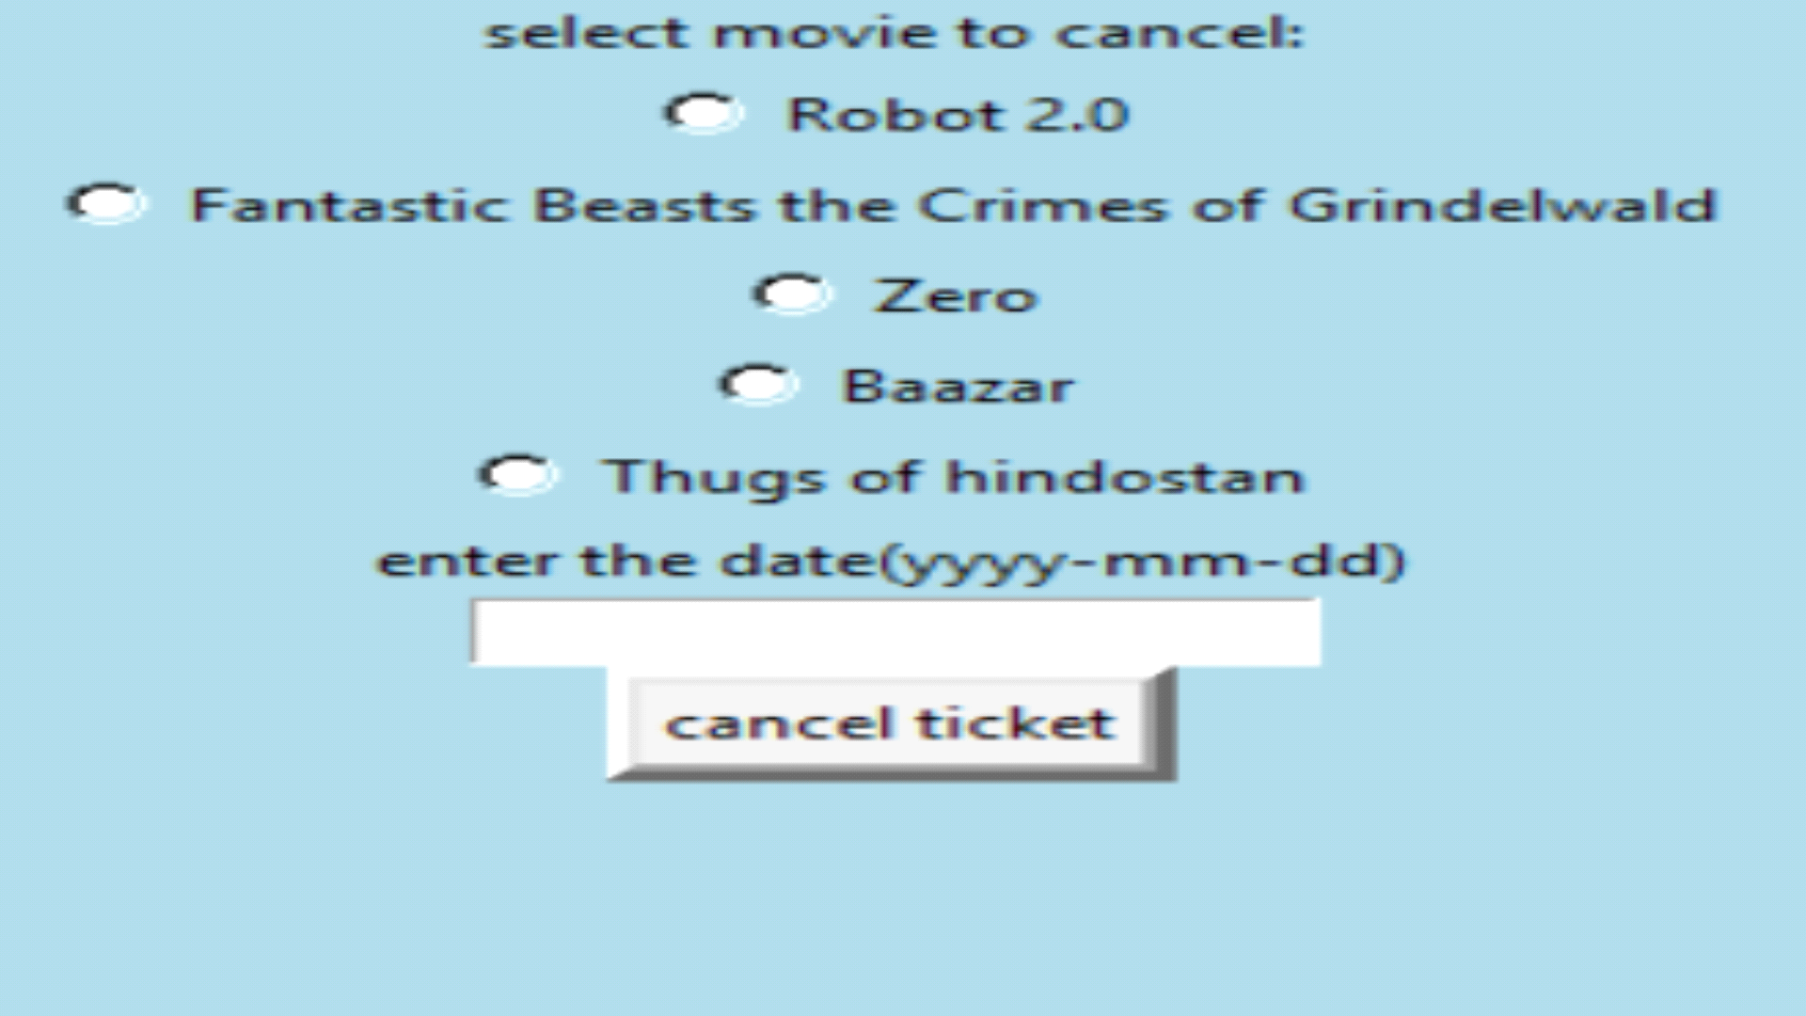

there are error messages ,regarding their mistakes.

