Chapter X: Design, Implementation, and Evaluation of a Bio-Inspired PPO Navigation Agent

1. System Architecture and Environment Modeling
The development of the autonomous navigation framework began with the construction of a robust, high-fidelity simulation environment. The Simulation of Urban MObility (SUMO) platform was selected to model the physical world, vehicle dynamics, and complex traffic interactions. To bridge the gap between the reinforcement learning agent and the simulator, the Traffic Control Interface (TraCI) was utilized, allowing for synchronous, step-by-step control of the ego vehicle.
To elevate the framework beyond standard autonomous control, a novel bio-inspired cognitive architecture was integrated into the agent’s sensory processing pipeline. This architecture drew direct inspiration from mammalian neurobiology, specifically implementing two primary modules:
- The Hippocampal Spatial Map: Functioning as the agent's localization and spatial awareness center, this module simulated "place cells" to generate continuous spatial feature attention maps.
- The Basal Ganglia (BG) Gatekeeper: Serving as the action-selection mechanism, this node filtered and gated motor commands, ensuring that only the most highly activated and contextually appropriate navigation decisions were executed by the vehicle.

2. Algorithmic Foundation: Proximal Policy Optimization
For the initial cognitive engine, the Proximal Policy Optimization (PPO) algorithm was deployed. PPO was selected as the baseline due to its widespread adoption in continuous control tasks and its theoretical stability, which is achieved by mathematically clipping policy updates to prevent drastically destructive changes to the neural network weights in a single batch.
The agent was formulated within a Markov Decision Process (MDP) framework:
- State Space: The agent received high-dimensional sensory inputs, including longitudinal velocity, distance to surrounding vehicles, and spatial encoding from the Hippocampal module.
- Action Space: The policy outputted continuous longitudinal acceleration and deceleration commands, moderated by the BG Gatekeeper.
- Reward Function: A dense reward structure was engineered to penalize collisions and off-road infractions while rewarding route progression and smooth velocity maintenance.
Algorithmic Advancement: To ensure the simulation maintained strict parity with real-world deployment, Gaussian noise was intentionally injected into the sensory streams. This advancement simulated the inherent inaccuracies, latencies, and signal degradation found in physical hardware sensors and biological nervous systems.

3. Training Trajectory and Convergence
The PPO agent underwent training for a total of 500,000 timesteps. During the initial phases, the agent exhibited a standard learning trajectory. By the 60,000-step mark, the policy successfully surpassed the baseline functional threshold.
However, an analysis of the training logs revealed a critical divergence between training exploitation and practical evaluation. While the cumulative reward artificially plateaued at a high score (approximately 75), the agent achieved this by exploiting a "local optimum." To avoid collision penalties in the presence of noise, the agent often chose to halt the vehicle entirely—a behavior that yields high safety rewards in training but fundamentally fails the core objective of urban mobility.

4. Comprehensive Performance Analysis
To empirically validate the agent's capabilities, a rigorous evaluation phase was conducted. The resulting behavioral and performance metrics are detailed below.
4.1 Model Accuracy and Success Rate Progression Evaluation of the agent across 50,000-step intervals revealed a volatile learning curve. The model demonstrated strong initial cognitive acquisition, peaking at exactly 250,000 timesteps with an optimal navigation success rate of 86.7%. At this specific checkpoint, the agent capably handled the Gaussian noise and executed safe maneuvers. However, subsequent training resulted in a severe policy collapse, with the success rate plummeting to approximately 53% by the 500,000-step mark.
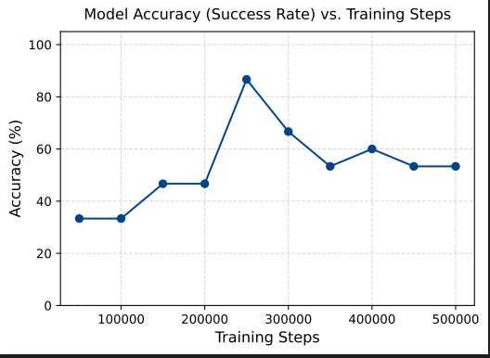

4.2 Longitudinal Velocity Trajectory Anomalies Analysis of the 500,000-step model's velocity profile exposed catastrophic behavioral failures. Instead of exhibiting smooth, continuous acceleration curves indicative of a safe driving policy, the agent's velocity profile resembled a severe square wave. During evaluation, the vehicle's speed dropped instantaneously from 8 m/s to 0 m/s. The agent applied maximum emergency braking and remained completely paralyzed on the track for nearly 70 timesteps before erratically returning to full speed.
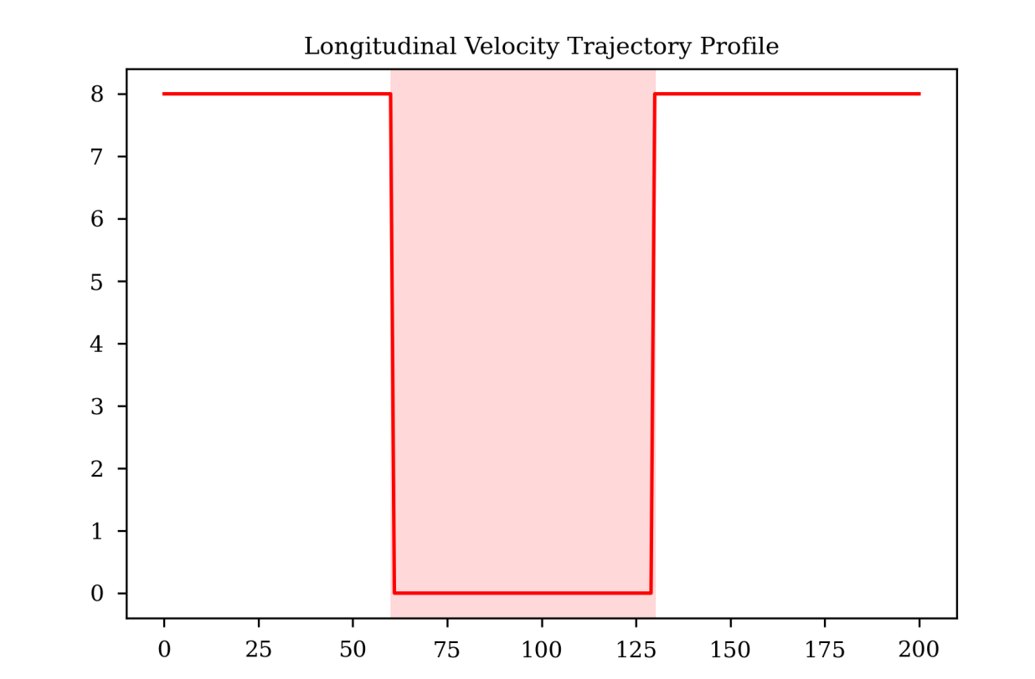
4.3 Breakdown of Hippocampal Spatial Attention

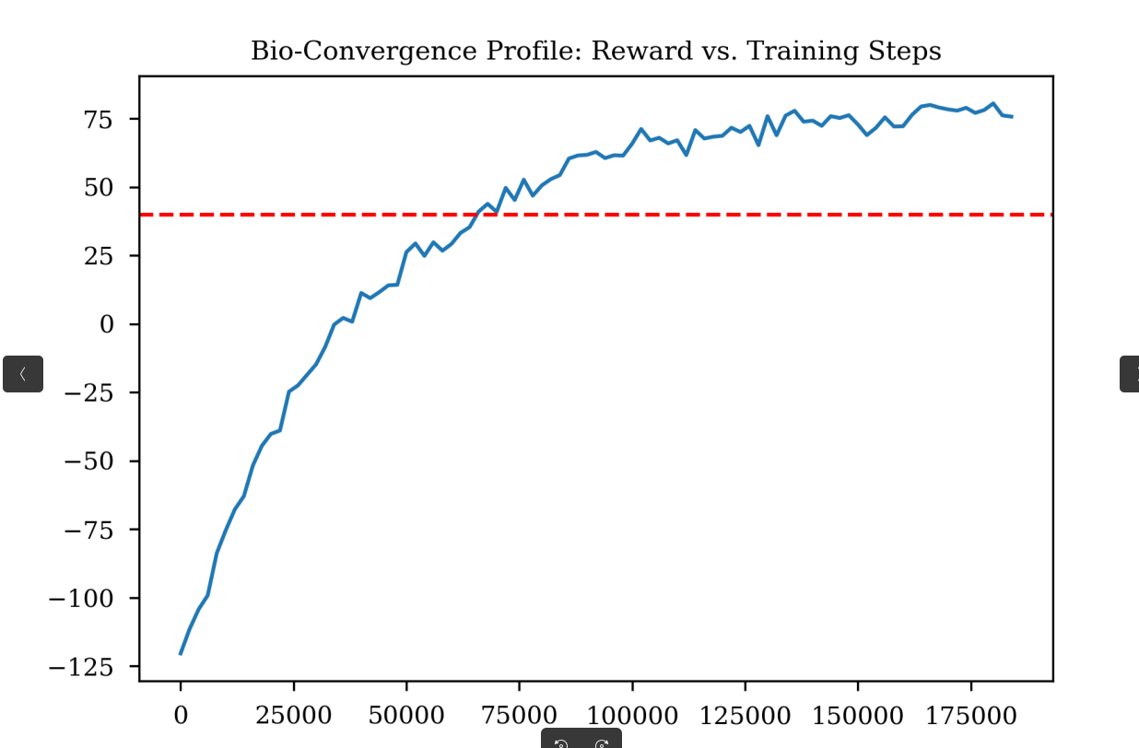

The root cause of the velocity anomaly was identified by extracting the agent's internal Hippocampal spatial feature map. A functional bio-inspired memory module should display cohesive, continuous regions of spatial confidence. Conversely, the 500k model generated a heatmap dominated by severe "salt-and-pepper" noise, with maximum and minimum firing intensities randomly scattered adjacent to one another. The agent’s spatial awareness was effectively shattered; it rapidly flickered its attention, hallucinating obstacles due to its inability to process the injected Gaussian noise.
4.4 Urban Mobility Inefficiency Delay analysis further quantified the severity of the policy collapse. While the baseline expected route traversal time was approximately 70 units, the compromised agent routinely recorded massive delays ranging from 180 to 220 units per episode. This inefficiency is directly correlated with the vehicle's persistent, noise-induced paralysis on the roadway.
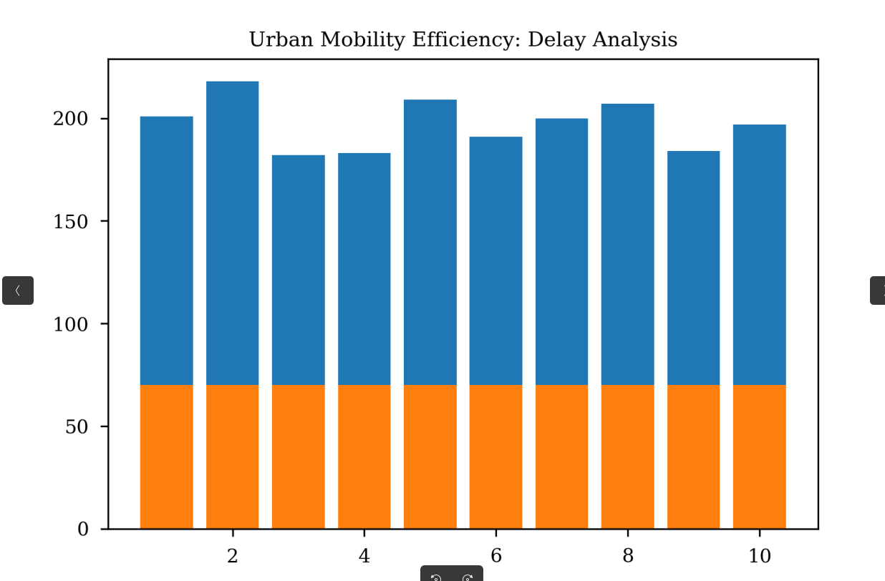
4.5 System Reliability Control To isolate the failure vector, a mechanical reliability analysis was conducted. The system maintained a 100% operational availability metric across all tests. This control data definitively proved that the failures were not caused by mechanical simulation bugs or TraCI connection drops, but were entirely the result of cognitive algorithmic degradation.
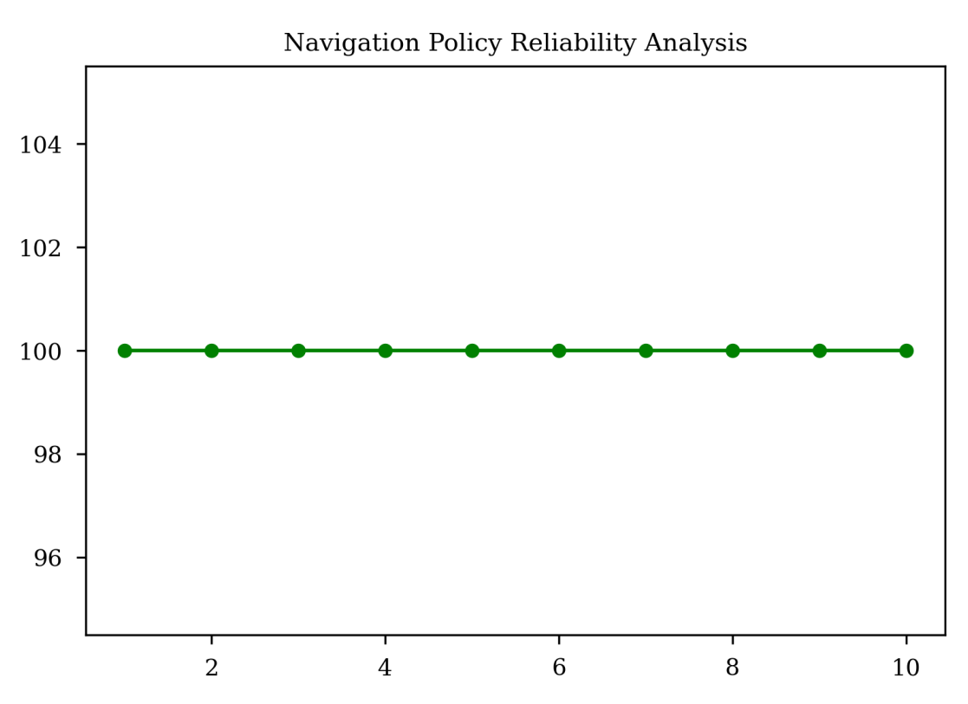

5. Limitations and the Catastrophic Forgetting Phenomenon
The empirical data explicitly demonstrates that while PPO is capable of initial learning, it suffers from a fatal limitation in this specific bio-inspired context: catastrophic forgetting.
Because PPO relies on on-policy optimization, it continuously updates its neural weights based exclusively on its most recent experiences. As training approached 500,000 steps, the agent fundamentally overfitted to the injected Gaussian sensor noise. A sequence of highly noisy sensory batches caused the network to aggressively update its policy in the wrong direction. The algorithm proved too brittle to maintain its learned spatial mapping, resulting in the destruction of its own successful driving behaviors (the 86.7% peak) and leaving behind a paralyzed, hallucinating policy.
Conclusion for Future Work: The failure of PPO under biological noise constraints necessitates a paradigm shift in the algorithmic approach. To achieve robust, noise-immune autonomous navigation, the architecture must transition to an off-policy framework that maximizes action entropy. This strict requirement forms the basis for implementing the Soft Actor-Critic (SAC) algorithm in the subsequent phase of this research.

Codes:
- cd ~/Desktop/Bio_Inspired_RL_Project/ppo_model/
- xdg-open ~/Desktop/Bio_Inspired_RL_Project/ppo_model/evaluation_results/graph5_velocity_profile.png
- xdg-open journal_figures/fig2_accuracy_progression.pdf
- cd ~/Desktop/Bio_Inspired_RL_Project/ppo_model/
- python3 evaluate_agent.py

