Chapter Y: Overcoming Sensor Noise with Maximum Entropy Soft Actor-Critic (SAC)

1. The Necessity for Off-Policy Maximum Entropy Learning
The empirical evaluation of the Proximal Policy Optimization (PPO) agent demonstrated a critical vulnerability within the autonomous navigation framework: susceptibility to catastrophic forgetting when subjected to continuous Gaussian sensor noise. Because PPO is an on-policy algorithm, it updates its neural network weights based strictly on its most recent trajectory data. Consequently, when the agent encountered sequences of highly noisy spatial encodings, the algorithm aggressively updated its policy to overcompensate, irrevocably destroying its previously learned, safe driving behaviors.
To achieve robust urban mobility and immune the bio-inspired architecture against simulated hardware inaccuracies, the learning paradigm necessitates a fundamental shift. The framework requires an algorithm that not only learns optimal pathing but explicitly maintains behavioral flexibility to absorb sensory anomalies without policy collapse. To this end, the Soft Actor-Critic (SAC) algorithm was selected and integrated into the cognitive pipeline.

2. Mathematical Framework of Soft Actor-Critic
SAC is an off-policy, actor-critic deep reinforcement learning algorithm based on the maximum entropy framework. Unlike standard reinforcement learning algorithms (such as PPO) that strictly aim to maximize the expected sum of rewards, SAC alters the core objective function to maximize both the expected return and the expected entropy of the policy.
The augmented objective function is mathematically defined as:
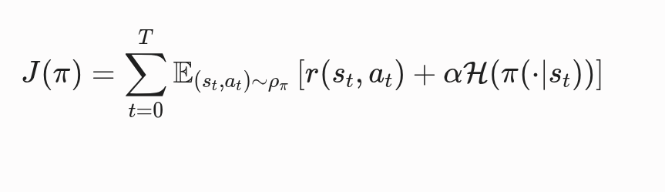

Where:
- $r(s_t, a_t)$ represents the standard environment reward at state $s_t$ given action $a_t$.
- $\mathcal{H}(\pi(\cdot\vert{}s_t))$ is the entropy of the policy $\pi$ at that specific state, representing the randomness or unpredictability of the chosen actions.
- $\alpha$ is the temperature parameter, which determines the relative importance of the entropy term against the primary reward, thereby controlling the algorithm's stochasticity.
3. Mitigation of Catastrophic Forgetting
The structural and mathematical properties of SAC directly neutralize the specific failure vectors observed during the PPO trials.
- Experience Replay (Off-Policy Stability): Unlike PPO, SAC utilizes an extensive Experience Replay Buffer. Instead of learning only from immediate, sequentially noisy states, SAC randomly samples batches of past transitions (state, action, reward, next state) from the buffer. This mechanism breaks the temporal correlation of the Gaussian noise. By learning from a randomized distribution of both pristine and noisy historical data, the neural network avoids overfitting to localized sensory hallucinations, effectively halting catastrophic forgetting.
- Entropy-Driven Robustness: By mathematically incentivizing high entropy, SAC prevents the policy from prematurely converging to a narrow, deterministic action set. In the PPO evaluation, the agent collapsed into a single deterministic failure—paralyzing the vehicle via emergency braking. SAC's entropy formulation ensures that the agent maintains a broader distribution of viable driving commands, allowing it to "smooth out" localized noise spikes without violently altering the vehicle's longitudinal velocity.
4. Integration with the Bio-Inspired Architecture
To implement SAC within the established ROS 2 and SUMO framework, the agent's neural topology was adapted to interface with the biological modules.
- Critic Networks and Spatial Memory: SAC employs dual Q-networks (Critics) to mitigate overestimation bias. These critics receive direct, continuous arrays from the Hippocampal Spatial Map. By processing diverse historical batches from the replay buffer, the critics learn to accurately estimate state-values even when the Hippocampal place-cell firing exhibits the "salt-and-pepper" noise anomalies observed in prior trials.
- Actor Network and the BG Gatekeeper: The SAC Actor outputs a stochastic action distribution (a mean and standard deviation for acceleration/deceleration). Instead of directly passing this to the vehicle interface, the distribution is routed through the Basal Ganglia Gatekeeper. The Gatekeeper evaluates the entropy of the proposed action; if the action is deemed safe despite sensory noise, the BG node executes the optimal continuous control command to the simulated ego vehicle.
Code:
- (venv) pavilion@harita ~/Desktop/Bio_Inspired_RL_Project/ppo_model$ python3 evaluate_sac.py
- python3 compare_ppo_sac.py

