AI-AgroBot Universal AI-based Agriculture Assistant
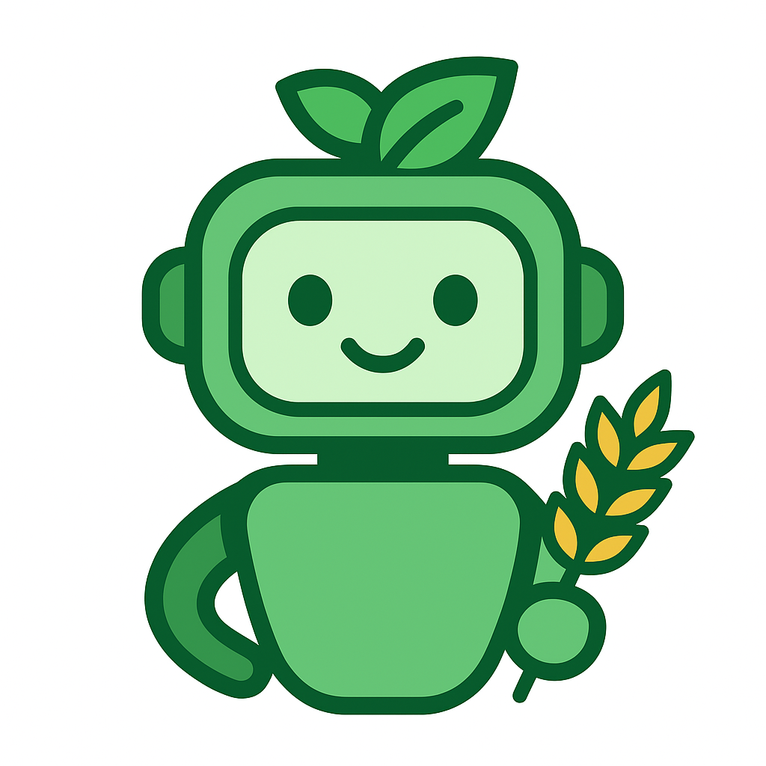

Name : HARITAA DEVI K M
College Name : Kingston Engineering College
Email Id : haritaadevi2812@gmail.com

PROJECT STATEMENT :
Agriculture is the backbone of many economies, particularly in developing regions, yet farmers continue to face persistent challenges that directly impact productivity and livelihood. One of the most pressing issues is the lack of timely and reliable access to agricultural knowledge. Farmers often rely on local experts, government extension officers, or word-of-mouth advice, which may not always be accurate, up-to-date, or available when urgently needed. This delay in receiving critical information can lead to poor decision-making in crop management, pest control, irrigation, and fertilizer application.
Another significant barrier is language and literacy diversity. Agricultural knowledge is often documented in English or a limited set of regional languages, leaving many farmers unable to fully understand or apply the information. This creates a gap between available scientific knowledge and its practical adoption in the field. Without multilingual support, valuable insights remain inaccessible to the very people who need them most.
In addition to knowledge gaps, farmers struggle with early detection of plant health issues. Diseases, nutrient deficiencies, and water stress often manifest visually in crops, but many farmers lack the expertise to interpret these signs accurately. By the time visible symptoms are recognized, the damage may already be severe, leading to reduced yields and financial losses. Traditional methods of diagnosis require expert visits, which are not always feasible in remote or resource-constrained areas.
Furthermore, record-keeping and knowledge management are often overlooked. Farmers may not have a structured way to track their queries, past advice, or crop health history. Similarly, administrators and agricultural experts lack centralized tools to monitor farmer interactions, update knowledge bases, and ensure consistency in advice delivery.
Taken together, these challenges highlight the urgent need for a scalable, intelligent, and farmer-friendly solution. The solution must be capable of delivering accurate agricultural advice in multiple languages, analyzing plant health through simple image uploads, and providing a structured platform for both farmers and administrators. Addressing these problems is not just about improving crop yields—it is about empowering farmers with knowledge, reducing dependency on intermediaries, and fostering sustainable agricultural practices.
Beyond these challenges, farmers also face regional variability in agricultural practices, meaning that advice suitable for one area may not apply to another due to differences in soil type, climate, and crop varieties. Without a system that can adapt to these local contexts, generic recommendations often fail to deliver meaningful results. Moreover, the digital divide remains a barrier, as many farmers have limited access to advanced tools or lack the technical literacy to use complex platforms. A solution must therefore be intuitive, lightweight, and accessible even on basic devices. Additionally, the absence of structured knowledge management leads to repeated queries and inefficiencies, as farmers cannot easily retrieve past advice or track their crop health history. Finally, the growing impact of climate change intensifies these problems, making timely, accurate, and localized agricultural guidance more critical than ever before.

OUTCOMES

The implementation of Al-AgroBot is expected to generate a wide range of positive outcomes that directly address the challenges outlined in the problem statement. At its core, the system provides instant, localized agricultural advice to farmers. Instead of waiting for experts or relying on inconsistent sources, farmers can interact with the chatbot at any time and receive guidance tailored to their crop type, region, and farming practices. This immediacy ensures that critical decisions—such as irrigation schedules, fertilizer application, or pest control—can be made quickly and effectively.
Another major outcome is the removal of language barriers in agricultural knowledge dissemination. By supporting multiple languages within the knowledge base, Al-AgroBot ensures that farmers can access information in their preferred language. This inclusivity empowers communities that were previously excluded due to linguistic limitations, making agricultural knowledge more democratic and widely usable. The multilingual design also makes the system scalable to new regions, as additional languages can be integrated with minimal effort.
The image analysis module delivers a transformative outcome by enabling farmers to detect plant health issues early. Through simple image uploads, the system analyzes color ratios to identify signs of stress, nutrient deficiency, or disease. This empowers farmers to take corrective measures before problems escalate, reducing crop losses and improving yield. The ability to combine textual advice with visual diagnostics makes Al-AgroBot a more holistic assistant compared to traditional chatbot systems.
For administrators and agricultural experts, the system provides a centralized management dashboard. This outcome ensures that user data, chat histories, and knowledge base entries are organized and easily accessible. Administrators can monitor farmer interactions, identify common queries, and update the knowledge base to reflect new agricultural practices or emerging challenges. This structured approach to knowledge management enhances efficiency and ensures consistency in the advice delivered.
Finally, the broader outcome of Al-AgroBot is farmer empowerment and sustainable agricultural growth. By equipping farmers with timely, accurate, and accessible information, the system reduces dependency on external intermediaries and fosters confidence in decision-making. Over time, this contributes to improved productivity, reduced crop losses, and greater resilience against climate change and market fluctuations. The project thus not only addresses immediate agricultural challenges but also lays the foundation for long-term sustainability and digital transformation in farming communities.

MODULES TO BE IMPLEMENTED
The Al-AgroBot system already delivers core functionality, but to make it truly universal and future-ready, several advanced modules can be integrated. These modules are designed to address connectivity gaps, literacy barriers, real-time decision-making needs, and the importance of collective farmer wisdom. Below is a detailed description of each module.

Offline Mode
Purpose: Farmers in rural and remote areas often face unreliable or nonexistent internet connectivity. Offline mode ensures that Al-AgroBot remains usable even without a network connection, providing uninterrupted access to agricultural knowledge.
Technical Design:
- Local Storage: Use SQLite (for mobile apps) or IndexedDB (for PWAs) to store KB entries and chat history.
- Synchronization Protocol: A background service checks for updates when connectivity is restored, ensuring farmers always have the latest advice.
- Compression: KB entries stored in compressed JSON format to minimize storage requirements.
- Conflict Resolution: Define rules for handling cases where KB entries are updated both locally and centrally.
Workflow:
- Farmer downloads KB entries when online.
- Queries are processed offline using cached KB.
- Chat history and updates sync automatically when connectivity returns.
User Scenario: A farmer uploads a photo of a leaf while offline. The assistant analyzes the image using locally cached algorithms and provides a diagnosis. When the device reconnects, the chat history and image metadata sync to the central server.
Challenges:
- Keeping KB lightweight for low-end devices.
- Ensuring synchronization does not overwrite farmer data.
- Handling multilingual KB updates efficiently.
Long-Term Vision: Offline mode could evolve into a hybrid system where basic advice is available offline, while advanced features (like AI-based disease detection) activate when online.

Weather & Market Data Feeds
Purpose: Agricultural decisions depend heavily on weather conditions and market prices. Integrating these feeds makes the assistant proactive and data-driven.
Technical Design:
- Weather APIs: Connect to OpenWeather or IMD feeds for district-level forecasts.
- Market Data: Integrate with government agricultural price databases.
- Data Parsing: Build connectors to fetch, clean, and store external data.
- Decision Logic: Translate raw data into actionable advice (e.g., “Delay irrigation today due to expected rainfall tomorrow”).
Workflow:
- Assistant fetches weather and market data periodically.
- Data is stored in a structured format.
- Queries are matched with relevant data and advice is generated.
User Scenario: A farmer asks, “What is the price of groundnut in Madurai today?” The assistant fetches market data and responds: “Groundnut is selling at ₹5,200 per quintal in Madurai market. Prices are higher than last week.”
Challenges:
- Ensuring reliability of external data sources.
- Translating technical data into simple, actionable advice.
- Handling regional granularity (district-level variations).
Long-Term Vision: This module could evolve into a predictive analytics system, forecasting crop demand and suggesting optimal selling times, thereby maximizing farmer income.

Community Knowledge Sharing
Purpose: Farmers often develop local practices that are effective but undocumented. Community knowledge sharing allows these practices to be captured and shared.
Technical Design:
- Submission Workflow: Farmers submit tips via text, audio, or images.
- Moderation: Admins or experts review contributions before publishing.
- Tagging: Entries are tagged by crop, region, and language for easy retrieval.
- Feedback Loop: Farmers can upvote or endorse useful tips, creating a reputation system.
Workflow:
- Farmer submits a tip or practice.
- Admin reviews and validates the submission.
- Approved entries are added to KB with tags.
- Other farmers can access and endorse the entry.
User Scenario: A farmer shares: “Spraying neem oil helped reduce pest attacks on my brinjal crop.” The admin validates the advice and publishes it in the KB. Other farmers searching for pest control solutions see this tip alongside expert recommendations.
Challenges:
- Preventing misinformation or harmful practices.
- Ensuring moderation is efficient and fair.
- Balancing openness with quality control.
Long-Term Vision: Community sharing could evolve into a farmer social network, where farmers exchange experiences, collaborate on solutions, and build collective resilience.

Personalized Crop Calendar Module
Purpose: Farmers often struggle with planning crop activities across the season — sowing, irrigation, fertilization, pest control, and harvesting. A personalized crop calendar module would generate a dynamic, crop-specific schedule tailored to each farmer’s region, crop type, and season. This ensures farmers receive proactive reminders and guidance rather than only reactive answers.
Technical Design:
- Profile Integration: Pull crop type, region, and season data from the farmer’s profile.
- Calendar Engine: Generate a timeline of key agricultural activities (e.g., sowing dates, irrigation intervals, fertilizer application windows).
- Notification System: Push reminders via SMS, app notifications, or even voice alerts.
- Dynamic Updates: Adjust schedules based on weather forecasts or farmer inputs (e.g., delayed sowing due to rain).
Workflow:
- Farmer registers crop type and sowing date.
- System generates a calendar with recommended activities.
- Farmers receive reminders before each activity.
- Calendar adapts dynamically to weather or market changes.
User Scenario: A farmer growing paddy in Tamil Nadu registers sowing on June 15. The assistant generates a calendar: irrigation every 7 days, fertilizer application at 30 days, pest monitoring at 45 days. If heavy rain is forecast, the irrigation reminder is automatically postponed.
Challenges:
- Ensuring regional accuracy (different states have different crop cycles).
- Keeping reminders simple and actionable.
- Integrating with external data sources (weather, soil sensors).
Long-Term Vision: This module could evolve into a smart farm planner, integrating IoT sensors and predictive analytics to provide hyper-personalized schedules.
ARCHITECTURE DIAGRAM
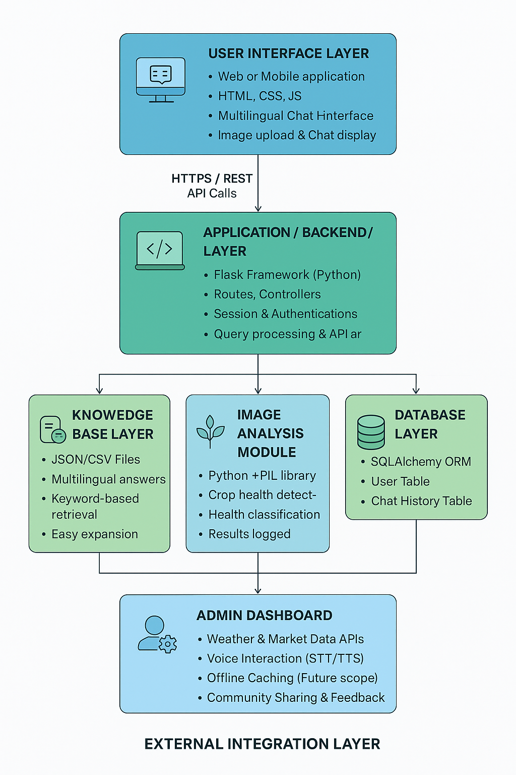

DATABASE SCHEMA
The database schema for Al-AgroBot is designed to store user information, chat histories, knowledge base entries, and administrative data in a structured and secure manner. It uses SQLAlchemy ORM for relational mapping, ensuring flexibility and scalability.

1. User Table
Purpose: Stores farmer and administrator profiles. Fields:
- user_id (Primary Key, Integer, Auto Increment)
- name (String, farmer’s full name)
- email (String, unique, used for login)
- password_hash (String, securely hashed password)
- crop_type (String, e.g., “Paddy”, “Wheat”)
- region (String, e.g., “Tamil Nadu”)
- preferred_language (String, e.g., “ta”, “hi”, “en”)
- role (Enum: “farmer”, “admin”)
- created_at (DateTime, account creation timestamp)
Notes:
- Role-based access control is enforced here.
- Language preference drives chatbot responses.

2. ChatHistory Table
Purpose: Logs all farmer interactions with the chatbot. Fields:
- chat_id (Primary Key, Integer, Auto Increment)
- user_id (Foreign Key → User.user_id)
- query_text (Text, farmer’s question)
- response_text (Text, chatbot’s answer)
- language_used (String, language of response)
- image_uploaded (Boolean, whether an image was part of the query)
- image_analysis_result (Text, plant health classification if image uploaded)
- timestamp (DateTime, when query was made)
Notes:
- Maintains relational integrity with User table.
- Enables analytics (e.g., most common queries, crop trends).

3. KnowledgeBase Table
Purpose: Stores multilingual agricultural advice entries. Fields:
- kb_id (Primary Key, Integer, Auto Increment)
- keyword (String, e.g., “irrigation”, “fertilizer”)
- answer_en (Text, English response)
- answer_hi (Text, Hindi response)
- answer_ta (Text, Tamil response)
- answer_xx (Text, extensible for new languages)
- last_updated (DateTime, when entry was modified)
Notes:
- Supports multilingual expansion seamlessly.
- Admin dashboard directly interacts with this table.

4. ImageAnalysis Table
Purpose: Stores metadata and results of crop image uploads. Fields:
- image_id (Primary Key, Integer, Auto Increment)
- chat_id (Foreign Key → ChatHistory.chat_id)
- file_path (String, location of stored image)
- analysis_result (String, e.g., “Healthy”, “Moderate”, “Stressed”)
- pixel_ratio_data (JSON, detailed color ratio analysis)
- timestamp (DateTime, when image was analyzed)
Notes:
- Linked to ChatHistory for context.
- Enables advanced analytics (e.g., disease trends across regions).

CONCLUSION
The Al-AgroBot project demonstrates how technology can be harnessed to empower farming communities by bridging the gap between expert agricultural knowledge and everyday farmer needs. Through its modular design, multilingual support, image analysis capabilities, and structured knowledge base, the system provides farmers with timely, accessible, and actionable advice. The architecture ensures scalability, while the database schema maintains clarity and extensibility, making the system robust for future growth.
Key Achievements:
- Developed a multilingual chatbot engine capable of delivering advice in multiple languages, ensuring inclusivity across diverse regions.
- Implemented an image analysis module that allows farmers to upload crop images and receive health assessments, making the assistant interactive and diagnostic.
- Designed a secure user management system with role-based access control, ensuring farmers and administrators have tailored experiences.
- Built an admin dashboard for knowledge base management, enabling continuous updates and monitoring of farmer queries.
- Structured a scalable database schema that supports multilingual entries, chat histories, and extensibility for new modules.
Challenges Addressed:
- Tackled the issue of varying literacy levels by planning for voice-based interaction and multilingual KB entries.
- Designed for low-connectivity environments with the proposed offline mode.
- Ensured extensibility by allowing new languages, crops, and modules to be added without disrupting the system.
- Balanced user-centered design with technical rigor, ensuring clarity for both farmers and administrators.
Future Scope:
- Offline Mode: To ensure uninterrupted access in rural areas.
- Voice-Based Interaction: To break literacy barriers and make the assistant conversational.
- Weather & Market Data Feeds: To provide real-time decision support.
- Community Knowledge Sharing: To capture grassroots wisdom and build collective intelligence.
- Personalized Crop Calendars: To proactively guide farmers through seasonal activities.
- IoT Integration: To connect soil sensors and weather stations for data-driven insights.
- AI Disease Detection: To enhance image analysis with deep learning models for precise diagnoses.
Impact:
- Farmers gain confidence and independence by accessing localized, multilingual advice.
- Administrators and policymakers benefit from analytics and insights into farmer needs and trends.
- Communities are strengthened through inclusive design, ensuring no farmer is left behind due to language or connectivity barriers.
- The project lays the groundwork for digital transformation in agriculture, aligning with sustainable development goals and rural empowerment initiatives.
SAMPLE CODE
https://github.com/Haritaa28/Agrobot
OUTPUT
