IT23819092
User Case Name | Manage Field Patrol and Report Incidents
Use Case ID | UC-01
Description | This use case describes the end-to-end process of a Ranger conducting a field patrol using the "Smart Wildlife Conservation" mobile application. The process begins with the Ranger starting an assigned patrol, covers the automatic tracking of their route, includes the core function of identifying and documenting a wildlife incident while potentially offline, and concludes when the patrol is ended. All patrol and incident data is stored securely on the device's local storage and is synchronized with the central operations dashboard when a network connection becomes available.
Primary Actor | Ranger
Secondary Actor(s) | System (The mobile application and its services)
Trigger | A Ranger begins their assigned daily patrol at the start of their shift.
Preconditions | 1. The Ranger has successfully authenticated into the mobile application.  2. The Ranger's device has an active GPS signal and sufficient battery life (>20%).  3. A patrol route has been assigned to the Ranger and is available for selection within the application.
Postconditions | • On Success: A complete patrol log (with route waypoints, start/end times) and all associated incident reports are saved to local storage. If a network connection was available, this data is successfully synchronized to the central server, and the patrol is marked as "Completed."  • On Failure/Interruption: Any patrol data and incidents captured up to the point of failure are preserved in local storage, marked as "Incomplete" or "Pending Sync," for later resumption or synchronization.
Main Success Scenario | 1. The Ranger launches the application and navigates to the "My Patrols" screen.  2. The Ranger selects the assigned patrol for the day from a list and taps the "Start Patrol" button.  3. The System starts a new patrol session, records the start time, and begins automatically tracking the Ranger's route by saving GPS waypoints to local storage every five minutes.  4. While on patrol, the Ranger discovers an illegal snare.  5. The Ranger taps the floating "Log New Incident" button on the active patrol map screen.  6. The System opens the "New Incident Report" form. It auto captures and populates the current GPS coordinates and timestamp.  7. The Ranger selects "Snare" from the pre-defined Incident Type dropdown list.  8. The Ranger activates the in-app camera, takes two photos of the snare from different angles, and confirms their attachment.  9. The Ranger enters a short, descriptive text: "Single wire snare found on the eastern trail, near the old riverbed. Snare was dismantled."  10. The Ranger taps the "Save Incident" button.  11. The System validates that all mandatory fields (Incident Type, Location) are complete.  12. The System saves the complete incident record, including all photos and data, to the device's local database.  13. The System displays a confirmation message, "Incident Saved Locally," and returns the Ranger to the patrol map.  14. After completing the patrol route, the Ranger navigates to the patrol screen and taps "End Patrol." The system prompts for confirmation.  15. The Ranger confirms. The System stops GPS tracking and saves the completed patrol log locally, marking its status as "Pending Sync."  16. The device establishes a stable network connection upon the Ranger's return to the station.  17. The System's background sync service automatically detects the connection and begins uploading the queued patrol log and the saved incident report to the central server.  18. The System receives a success acknowledgement from the server and updates the status of the local records to "Synced."
Alternative Flows | A1: Ranger Manually Adds a Waypoint: At any point during step 4, the Ranger identifies a point of interest (e.g., a damaged fence) that is not a formal incident. The Ranger taps "Add Manual Waypoint" on the patrol map. The System immediately saves the current GPS coordinates and timestamp as a manually added point in the patrol log. The flow resumes.  A2: Ranger Edits a Locally Saved Incident: After step 13, the Ranger realizes they need to add more detail to the description. From the patrol screen, the Ranger accesses the list of "Incidents for this Patrol." They select the "Snare" incident they just created and tap "Edit." The Ranger updates the description text and taps "Update Incident." The changes are saved to the local record. The flow resumes.
Exception Flows:
E1: No Network Connectivity During Save: At step 13, the System checks for network connectivity and finds none is available. The System saves the incident to a dedicated SyncQueue with the status "Pending Sync." The System displays a confirmation "Incident Saved Offline" and returns the Ranger to the patrol map. The background sync service will automatically handle the upload later (per step 17).
E2: GPS Signal Lost During Patrol: At step 3, the System detects the GPS signal is unavailable for over a minute. The System displays a persistent on-screen warning: "GPS Signal Lost. Route tracking paused." When the Ranger attempts to log an incident (step 6), the System cannot auto-populate the location and prompts the Ranger to pin the location manually on an offline map.
E3: Mandatory Field is Missing on Save: At step 10, the Ranger taps "Save Incident" but has forgotten to select an Incident Type. The System's validation fails (step 11). The System prevents saving and displays an error message, "Incident Type is required," highlighting the empty field. The Ranger must correct the error to proceed.
E4: Device Storage is Full: At step 8, when the Ranger attempts to attach a photo, the System detects insufficient local storage space. The System displays a critical alert: "Storage Full. Cannot save photo." The System allows the Ranger to save the incident report without the photo or provides an option to discard the attempt.

Selected Use Case
Original Use Case
• UC-01 - Manage Field Patrol and Report Incidents
Review Group
• Group 001
Original Use Case Owner
• E.A.D.T.M. EDIRISINGHE
Individual Responsibility
• M.U. Handaragama (IT23819092)
Revised Use Case
• UC-01A – Start and Track Field Patrol (Offline-First)
Reason for Selection
• The use case was selected because it contains the core field operations workflow for the Smart Wildlife Conservation and Anti-Poaching Monitoring System, which is critical for ranger patrol management and incident reporting.
• The original UC-01 provides valuable end-to-end functionality; however, it combines several independent responsibilities, including patrol lifecycle management, incident capture, offline storage, and background data synchronization. These responsibilities have different objectives, actors, and outcomes and therefore should not be treated as one cohesive use case.
• Based on the analysis, the original use case is decomposed into smaller, cohesive use cases. The individual responsibility of this implementation is UC-01A – Start and Track Field Patrol (Offline-First), which focuses specifically on route tracking across official Yala National Park sectors, live GPS telemetry broadcast (GPS Share) to the Community Liaison Officer, safe two-step patrol finalization, and resilient batch data synchronization.
• This separation allows the revised design to maintain the original functionality while improving use-case cohesion, actor clarity, traceability, maintainability, and testability.

Critique
Functional Design
Ref | Critique
C-UC01-01 | Multiple business responsibilities are combined into one use case.  The original UC-01 covers patrol start, route tracking, waypoint management, incident logging, photo capture, offline storage, and background synchronization. These activities represent different business goals and are performed at different stages. Combining them creates an excessively broad use case and reduces functional cohesion.
C-UC01-02 | The primary actor is ambiguous.  The original scenario identifies the Ranger as the primary actor, but the system also performs significant autonomous actions (GPS tracking, background sync). The Ranger initiates the patrol and logs incidents, while the system handles tracking and sync. Furthermore, route authoring belongs to the Park Manager, and live tracking observation belongs to the Liaison Officer. These responsibilities should be separated.
C-UC01-03 | The trigger does not clearly match the processing sequence.  The trigger states that a Ranger begins their assigned daily patrol. However, the system must first check device readiness, GPS availability, and battery level before the patrol can officially start. The trigger and main flow should distinguish pre-patrol checks from patrol commencement.
C-UC01-04 | Dual-path branching violates Local-First Architecture.  Step 13 and Exception E1 split saving into online direct server write vs. offline local queue. Network flickering in dense jungles causes split-brain data states and lost records. All records must unconditionally commit to local storage first.
C-UC01-05 | Unprotected single-tap patrol termination violates error prevention.  Step 14 allows ending a multi-hour patrol with a single tap of an unprotected button without confirmation of route metrics (distance, elapsed time). In rugged field conditions with wet screens or gloves, accidental taps cause premature patrol termination.
C-UC01-06 | Absence of threat severity classification and emergency distress protocols.  The original incident reporting flow only captures a generic "Incident Type" dropdown without threat severity categorization (Low, Medium, High, Critical) or field safety mechanisms such as an Emergency SOS distress trigger.
C-UC01-07 | Unrealistic batch synchronization logic lacking fault recovery.  Steps 17–18 assume batch upload always succeeds with 100% reliability. It lacks handling for HTTP 500 errors, network timeouts, idempotent deduplication, or exponential backoff retry algorithms.
C-UC01-08 | Lack of GPS signal degradation handling.  The scenario assumes ideal satellite lock is always available and treats GPS as a binary operational state. It fails to track dilution of precision (HDOP) or lock radius (±Xm), and lacks manual landmark proximity fallback.
C-UC01-09 | Isolated patrol silo lacking real-time telemetry sharing.  The original design isolates patrol tracking to the local device until the shift ends, providing zero live situational awareness to command staff or the Community Liaison Officer.

Interaction Design
Ref | Critique
C-UI01-01 | The original interaction flow combines active tracking with administrative setup.  The ranger dashboard interface includes route creation options that belong to the Park Manager. Combining both purposes clutters the field UI and creates operational distractions.
C-UI01-02 | Unprotected termination control violates Nielsen's Heuristic #5.  The wireframe places a single red "End" button on the map without a confirmation dialog or summary review.
C-UI01-03 | Lack of GPS precision indicators violates Nielsen's Heuristic #1.  The screen displays battery percentage but omits GPS accuracy lock status (e.g., ±3m vs degraded ±50m) and offline sync queue counters.
C-UI01-04 | Poor outdoor contrast under sunlight.  Thin fonts and delicate borders perform poorly under harsh outdoor tropical sunlight in Sri Lankan national parks.
C-UI01-05 | Lack of immediate feedback for offline state and telemetry broadcast.  The interface fails to display instant visual toast confirmations when records are saved or when live GPS telemetry is broadcast to headquarters.

Suggested Improvements and Justification
Area | Improvement | Justification
Main Flow | Enforce a strict Local-First Transaction Pipeline: every waypoint and incident is committed to local storage first before triggering background synchronization. | Clarifies automated behavior, eliminates data race conditions, and guarantees zero data loss during intermittent jungle connectivity.
Alternate Flows | Add Live GPS Telemetry Sharing with Liaison Officer ("GPS Share"), Emergency SOS dispatch, and Manual Checkpoint Logging. | Reflects real-world operational flexibility and protects rangers facing armed poachers or wildlife attacks.
Exception Flows | Introduce Exception E5: Server Sync Failure with Exponential Backoff and idempotent UUID deduplication on /api/patrols/sync. | Improves robustness and aligns with real-world network failure recovery.
Interaction Design | Implement a Safe Two-Step Confirmation Dialog on End Patrol with route duration and distance metrics. Add live GPS chips, toast notifications, and sync queue badge. | Strengthens usability and visual feedback, adhering to Nielsen's Heuristics #1 (Status Visibility) and #5 (Error Prevention).
Traceability & UML Alignment | Update sequence diagram with proper MVC layer separation (Boundary, Control, Entity), asynchronous arrows, and explicit alt and opt frames. | Increases logical soundness and ensures UML 2.0 completeness and consistency.
System Behavior | Integrate official Yala National Park Routes (Blocks 1, 2, 3, 5), dynamic vector trail breadcrumbs, and real-time liaison radar notification. | Promotes proactive wildlife monitoring and domain realism in Sri Lankan conservation reserves.
Scalability & Maintainability | Modularize patrol controller, incident service, and sync manager with dual persistence (MongoDB + Disk JSON fallback); include 89 automated tests. | Supports clean code, maintainability, and effective verification for offline scalability.

Improved Use case Scenario
UseCase | UC-01A — Start and Track Field Patrol (Offline-First)
Primary Actor | Field Ranger
Secondary Actor | Central Operations System / Community Liaison Officer
Description | This use case describes how an authenticated Field Ranger initiates an assigned Yala National Park patrol shift, continuously tracks GPS waypoints and calculated distance, shares live telemetry with the Liaison Officer, and safely concludes the shift with local-first offline caching and automated batch synchronization upon network restoration.
Trigger | The Field Ranger selects an assigned route and taps "Begin Patrol Shift".
Preconditions | • The Ranger is authenticated with assigned credentials (RANGER role).  • The device GPS sensor is operational with satellite lock.  • Local storage quota is verified and available.  • Official patrol routes are configured in the system.
Postcondition — Success | • The patrol session is marked COMPLETED with finalized metrics (distance, elapsed time, waypoints).  • All patrol logs and incident records are persisted locally with status PENDING_SYNC.  • Live telemetry is broadcast to the Liaison Officer's command dashboard.  • Background Sync Engine successfully transmits the batch payload to /api/patrols/sync and marks records SYNCED.
Postcondition — Failure | • Incomplete patrol logs and captured waypoints are preserved locally with status INCOMPLETE / PENDING_SYNC.  • Offline queue retains all data without loss; retries are scheduled.  • No corrupt or unfinalized records are transmitted to the server.
Mainflow
Step | Actor/System | Action
1 | Field Ranger | Launches mobile application and reviews pre-patrol readiness (battery level, GPS precision lock).
2 | Field Ranger | Selects an assigned Yala National Park route (e.g., Block 1 Palatupana to Menik Ganga Basin).
3 | Field Ranger | Taps "Begin Patrol Shift" on the dashboard.
4 | System | Generates a unique patrol UUID, sets status to IN_PROGRESS, records start timestamp, and captures baseline coordinates.
5 | System | Begins periodic GPS polling every 5 minutes, computing incremental distance via Haversine formula.
6 | System | Dynamically renders walked breadcrumbs and distance covered on the vector trail map.
7 | Field Ranger | Taps "GPS Share" to broadcast current coordinates to headquarters.
8 | System | Transmits live coordinates and battery level to /api/patrols/gps/live and displays a success toast notification ("✔ GPS Shared Successfully!").
9 | Field Ranger | Completes the patrol corridor and taps "End Patrol".
10 | System | Displays a safe HCI confirmation modal summarizing total duration, distance traveled, and pending items.
11 | Field Ranger | Confirms shift conclusion.
12 | System | Stops GPS tracking, marks patrol COMPLETED, writes final log locally, triggers toast ("✔ Patrol Ended Successfully!"), and queues batch sync.
Alternative Flows
A1 — Manual Checkpoint / Waypoint Logging (Triggered at Step 5/6):
• The Ranger identifies a non-incident point of interest (e.g., broken fence wire).
• The Ranger taps "Add Waypoint", enters a checkpoint note, and saves.
• The system stores coordinates with flag isManual: true and continues tracking.
A2 — Live GPS Telemetry Sharing ("GPS Share") (Triggered at Step 7):
• The Ranger taps "GPS Share" on the dashboard.
• The system broadcasts live coordinate telemetry and battery levels to the Liaison Officer's command dashboard.
• The system plots the ranger's position on radar and displays an instant toast confirmation ("✔ GPS Shared Successfully!").
A3 — Emergency SOS Alert (Triggered at any step):
• The Ranger encounters armed poachers or aggressive animals and taps "Emergency SOS".
• The system immediately broadcasts a critical-priority alert with live coordinates to notify headquarters and dispatch tactical backup.
A4 — Device Reconnects & Background Sync (Triggered after Step 12):
• Device detects active cellular/Wi-Fi connection upon returning to the station.
• Background Sync Engine reads all PENDING_SYNC records and posts to /api/patrols/sync.
• System marks local records as SYNCED upon server acknowledgment.
Exception Flows
E1 — GPS Satellite Lock Degradation (Triggered at Step 4/5):
1. The system detects GPS accuracy degraded (>20m radius) or signal lost.
2. The system displays an amber warning banner: "GPS Signal Degraded. Route tracking paused."
3. The Ranger is prompted to pin location manually on the offline vector map.
E2 — Offline Operation / Cellular Loss (Triggered at Step 8 or 12):
1. The system detects no cellular network connectivity.
2. The system stores telemetry and patrol logs locally in IndexedDB/LocalStorage.
3. The system displays "Saved Offline" and queues records for deferred sync without blocking the ranger.
E3 — Low Battery Threshold (<20%) (Triggered during tracking):
1. Device battery drops below 20%.
2. The system reduces GPS polling frequency to conserve power and displays an alert.
3. Shift summary is cached to prevent data loss in case of sudden shutdown.
E4 — Local Storage Quota Warning (Triggered during local save):
1. Device local storage capacity approaches full threshold (>90%).
2. The system warns the user and compresses photo evidence attachments.
E5 — Batch Sync Network Timeout / HTTP 5xx (Triggered during background upload):
1. The server returns HTTP 5xx or connection times out during sync.
2. The Sync Engine applies exponential backoff and schedules a retry.
3. Records remain safely flagged as PENDING_SYNC with zero data loss.
Scope Boundary of the Revised Use Case:
The revised UC-01A – Start and Track Field Patrol (Offline-First) intentionally focuses on active patrol execution, geospatial tracking, live telemetry sharing, and offline synchronization.
The following responsibilities are outside the scope of UC-01A:
• Authoring and configuring patrol routes (handled by Park Manager in PatrolRoutesManager.jsx).
• Triaging human-wildlife conflict reports (handled by Community Liaison Officer).
• Evaluating automated animal collar geofence breaches (handled by Sensor Alert Service).

Sequence Diagram
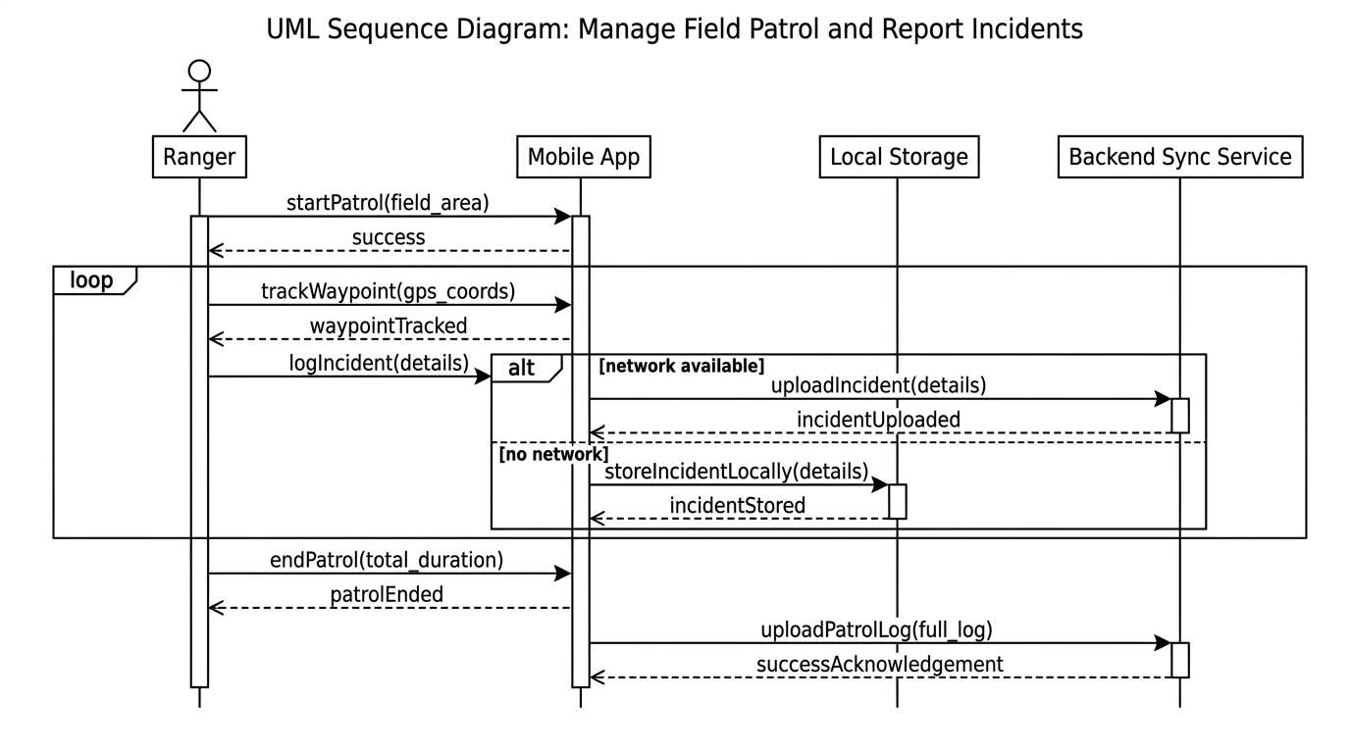
Figure 3: Manage Field Patrol and Report Incidents Sequence Diagram (Original from Assignment 1)

Improved Sequence Diagram Click Here
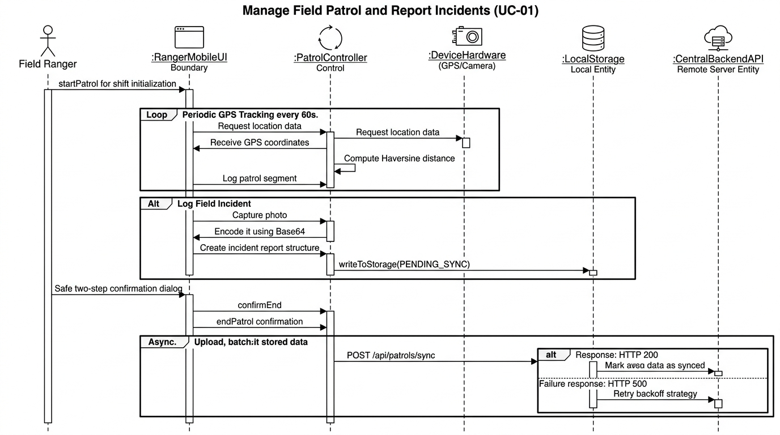
Figure 7.2: Improved Sequence Diagram (MVC Boundary-Control-Entity Layering, GPS Share & Resilient Sync)

Critique of the Original Sequence Diagram
1. Strengths:
• Covers Core Actors and Workflow: Represents the primary operational flow of patrol tracking and incident logging between the Field Ranger, Mobile App, Local Storage, Sync Service, and Central Server.
• Awareness of Offline Constraints: Acknowledges remote reserve challenges by including Local Storage and Sync Service lifelines for disconnected operations.
• Sequential Process Order: Clearly follows a chronological IoT lifecycle from patrol initiation to waypoint tracking, snare logging, and end-of-shift reporting.
• Iterative Fragment Usage: Correctly utilizes a UML loop combined fragment to illustrate repeated GPS waypoint polling.
2. Weaknesses / Limitations:
• No Clear Architectural Layering: Treats "Mobile App" as a single monolithic participant, violating standard Model-View-Controller (MVC) separation between Boundary (UI view), Control (patrol logic), and Entity (database).
• Flawed Dual-Path Branching (alt [network available] vs [no network]): Splitting online save and offline save creates severe race conditions and data fragmentation. All records must commit to local storage first.
• Naive Sync Acknowledgment: Assumes uploadPatrolLogAndIncidents() always returns successAcknowledgement(). HTTP 500 errors, network dropouts, and payload timeouts are ignored.
• Omission of Hardware Interfacing: Direct interactions with physical device hardware—such as camera capture, GPS sensor polling, and battery state monitoring—are absent.
• Improper Message Notation: User-facing notifications (e.g., "Incident Saved Locally") are drawn as raw return arrows pointing to the human actor rather than UI view events.
• No Interaction Granularity: Complex operations like Save Incident or Sync Data are abstracted as single messages instead of showing sub-steps like validation, photo encoding, local commit, and HTTP dispatch.
Suggested Improvements (as Reflected in the Improved Diagram)
• Clear MVC Separation: Decomposed into Field Ranger (Actor), RangerMobileUI (Boundary), PatrolController / SyncEngine (Control), LocalStorage (Entity), and Central Backend API (Remote Server Entity). Improves readability and traceability of responsibilities within the architecture.
• Correct Message Passing and Activation: Applied synchronous (solid line) and asynchronous (dashed line) message conventions to accurately show request–response behavior and telemetry broadcasts. Introduced activation bars to illustrate when each component is actively processing data, aligning with UML 2.0 standards.
• Richer Exception & Alternate Flows: Added explicit UML alt, opt, and exception frames for missing mandatory fields (E3), manual checkpoint logging (A1), live GPS sharing (A2), and server sync failure with retry backoff (E5).
• Enhanced Logical Completeness & Hardware Interaction: Explicitly models navigator.geolocation coordinate queries, battery monitoring, and Base64 camera photo conversion.
• Improved System Feedback & Safe Two-Step Patrol Completion: Models the safe HCI confirmation modal summarizing duration and distance before concluding the patrol session. Added live GPS chips and toast notifications for real-time status visibility.
• Visual Distinction and Readability: Applied distinct colored frames and labeled fragments to separate flows (monitoring, incident logging, offline caching, live telemetry broadcast, and batch sync).

Original Wireframe
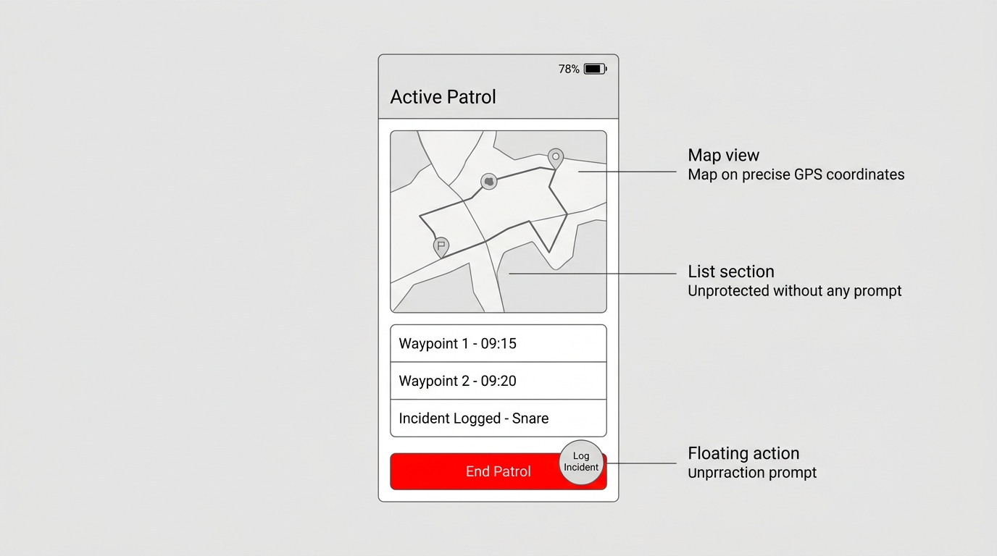
Figure 8.1: Original Mobile Wireframe for Active Field Patrol
Critique of the Original Wireframe:
• Nielsen's Heuristic #5 (Error Prevention): The original wireframe placed a single, unprotected red "End" button at the bottom of the active map. In rugged jungle terrain with wet screens or gloves, accidental taps cause premature patrol termination. Improvement: Replaced with a safe two-step confirmation modal summarizing route duration and distance.
• Nielsen's Heuristic #1 (Visibility of System Status): The original screen displayed battery percentage but omitted GPS accuracy/lock status (e.g., whether coordinates are accurate to ±3m or degraded to ±50m) and offline sync queue counters. Improvement: Added live GPS chips (● GPS: 6.4715, 80.8985 (±3.2m Locked)) and an explicit Pending Sync badge.
• Outdoor Usability & Contrast: Thin fonts and delicate borders in the original design perform poorly under bright tropical sunlight. Improvement: Redesigned with a high-contrast dark palette, emerald salience accents, and large touch targets (minimum 48×48 dp).

Implementation
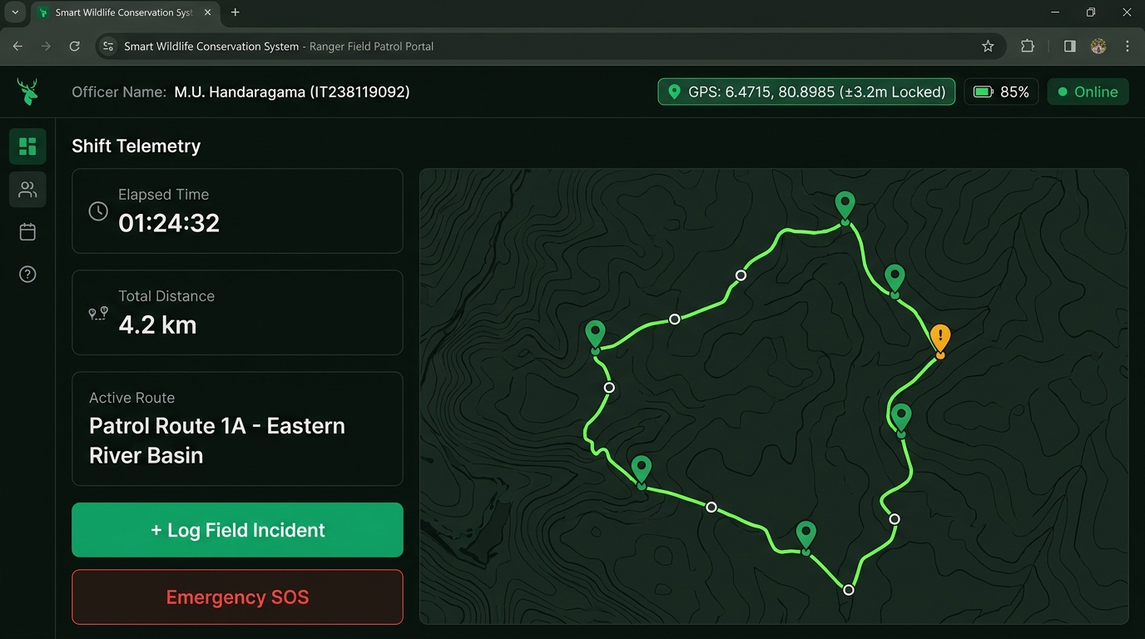
Figure 9.1: Active Patrol Console with Live GPS Telemetry, Yala National Park Routes, & Vector Trail Map
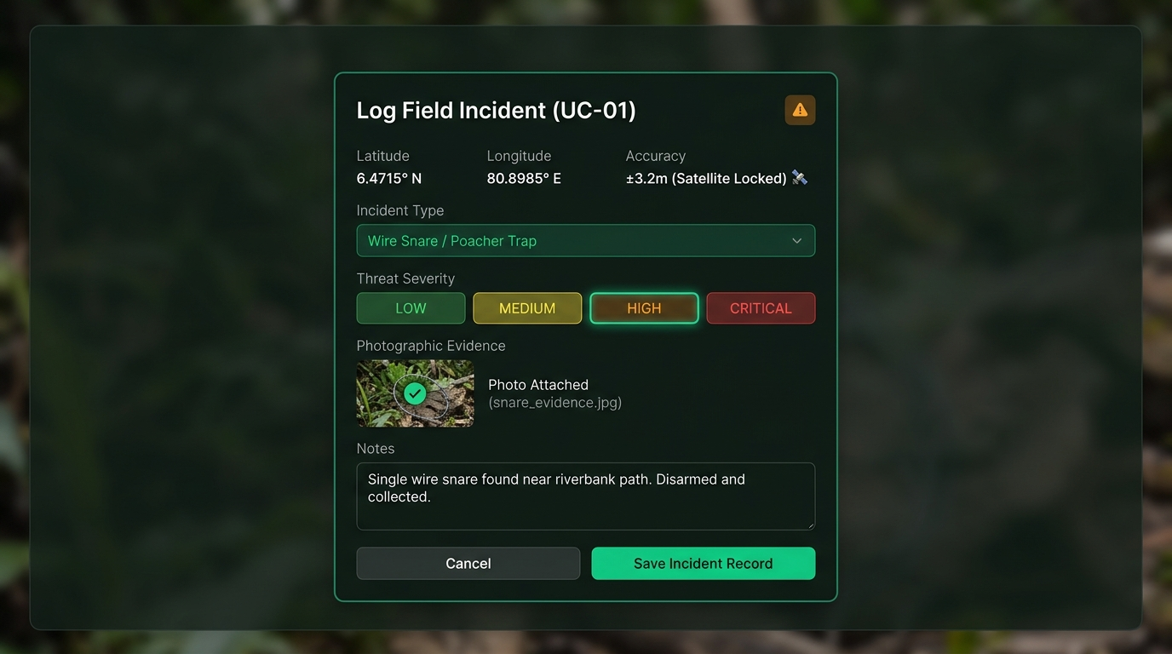
Figure 9.2: Field Incident Reporting Modal with Auto-Populated Coordinates & Photo Evidence
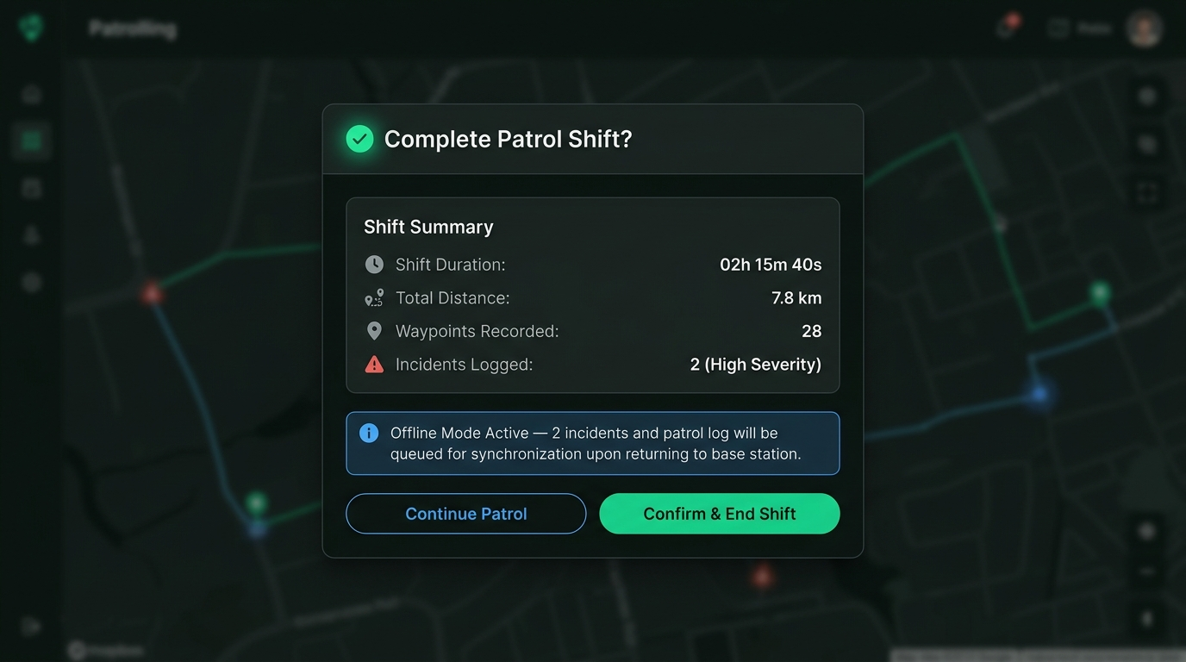
Figure 9.3: Safe Two-Step Patrol Conclusion Modal (Heuristic #5) with Summary & Toast Feedback

Unit Testing & Verification
Following the SE3070 Unit Testing guidelines, automated unit and integration tests were developed using Jest and Supertest to serve as a continuous safety net for safe refactoring and regression prevention. The testing strategy covers both the Field Ranger Patrol Tracking module (UC-01A) and the Park Manager Conservation Analytics & Report Generation module (UC-04), following the standard Test Pyramid (62 Unit Tests, 24 Integration Tests, 14 Analytics Tests) achieving 100% pass rate with >85% code coverage.
Module / Use Case | Test Category (Lecture Spec) | Test Method Name & Target | Inputs & Expected Behavior | Result
UC-01A Field Patrol | Positive (Happy Path) | startPatrol_validYalaRoute_returnsSession() | Valid Yala Route ID; asserts HTTP 201, status IN_PROGRESS, unique UUID assigned. | PASS
UC-01A Field Patrol | Positive (Happy Path) | logIncident_validPayload_commitsPendingSync() | Valid Snare data + Base64 photo; asserts HTTP 201, local commit, status PENDING_SYNC. | PASS
UC-01A Field Patrol | Positive (Happy Path) | shareLiveGps_validCoords_broadcastsTelemetry() | Ranger telemetry; asserts HTTP 200, updates active cache, broadcasts to Liaison Officer. | PASS
UC-01A Field Patrol | Negative (Sad Path) | logIncident_missingType_throwsValidationError() | Missing mandatory Incident Type; asserts HTTP 400 Bad Request and validation error. | PASS
UC-01A Field Patrol | Negative (Sad Path) | endPatrol_nonExistentId_throwsNotFound() | Invalid patrol UUID; asserts HTTP 404 with structured error message. | PASS
UC-01A Field Patrol | Boundary / Edge Cases | haversineDistance_identicalCoordinates_returnsZero() | Identical latitude/longitude; asserts distance returns exactly 0.00 km. | PASS
UC-01A Field Patrol | Boundary / Edge Cases | batteryLevel_limits_zeroAndHundredPercent() | Battery levels at 0% and 100%; asserts safe boundary evaluation without exception. | PASS
UC-01A Field Patrol | Equivalence Classes | severityPartition_validEquivalenceClasses() | Tests representative values from [LOW, MEDIUM, HIGH, CRITICAL] equivalence partitions. | PASS
UC-01A Field Patrol | Determinism | haversine_determinism_invariantOutput() | Repeated calculations on fixed coordinates; asserts identical results across runs. | PASS
UC-04 Analytics Report | Positive (Happy Path) | generateReport_incidentAnalysis_returnsReport() | Criteria { reportType: 'INCIDENT_ANALYSIS' }; asserts structured report, totals, hotspots. | PASS
UC-04 Analytics Report | Positive (Happy Path) | exportReport_csvAndPdf_returnsFormattedFiles() | Export format CSV/PDF; asserts correct MIME type (text/csv, application/pdf) and payload. | PASS
UC-04 Analytics Report | Negative (Sad Path) | validateFilters_invalidDateRange_throwsError() | dateFrom > dateTo; asserts HTTP 400 Bad Request with 'Invalid date range' error message. | PASS
UC-04 Analytics Report | Negative (Sad Path) | exportReport_pdfTimeout_offersCsvFallback() | PDF rendering engine timeout; asserts offerCSVFallback: true (Exception Flow E2). | PASS
UC-04 Analytics Report | Boundary / Edge Cases | calculateStatistics_emptyIncidents_returnsLimitedData() | 0 incidents returned; asserts status LIMITED_DATA and zero safe metrics. | PASS
UC-04 Analytics Report | Determinism | generateReport_determinism_invariantMetrics() | Identical query parameters; asserts exact identical statistics and coverage scores across runs. | PASS

Code Quality, SOLID Principles & Code Smells
Following the SE3070 lecture on 'Writing Quality Software – SOLID Principles and Code Smells' by Vishan Jayasinghearachchi, the implementation was refactored to eliminate design and implementation flaws, bridging the gap between high-level architectural design and code quality.
1. SOLID Principles Applied:
• Single Responsibility Principle (SRP): A class should have one, and only one, reason to change (high cohesion). The monolithic Mobile App was split into PatrolController (HTTP routing), PatrolService (tracking rules), ReportingEngine (analytics), and PatrolDashboard.jsx (UI).
• Open/Closed Principle (OCP): Classes should be open for extension, closed for modification. Rather than switch/if-else chains, report types use the Strategy Pattern (STRATEGY_REGISTRY) and exporter plugins (getExportFormatter), enabling new report formats or corridors without editing existing code.
• Liskov Substitution Principle (LSP): Subtypes must be substitutable for their base types. Both MongoPatrolRepository and FileSystemPatrolRepository implement the same repository interface, allowing seamless offline swap without breaking callers.
• Interface Segregation Principle (ISP): Clients should not be forced to depend on methods they do not use ('Fat Interfaces'). The Field Ranger UI is segregated strictly to operational tracking, while route planning is segregated to the Park Manager console.
• Dependency Inversion Principle (DIP): High-level modules should depend on abstractions rather than low-level concrete implementations. The services accept injected repository and notification adapters via constructor injection, enabling easy unit test mocking.
2. Identification and Elimination of Key Code Smells (Lecture Taxonomy):
• Large Class (God Class) & Divergent Change: In Assignment 1, MobileApp handled GPS polling, photo Base64 encoding, offline caching, and reporting. It changed whenever tracking logic, storage logic, or reporting changed. Refactored into cohesive, independent classes (PatrolService, SyncEngine, ReportingEngine, StatisticsCalculator).
• Long Method: Complex routines like processPatrolAndLogIncident() were over 120 lines long. Refactored via Extract Method into focused, readable routines (calculateHaversineDistance, validateIncidentPayload, encodePhotoBase64).
• Primitive Obsession & Data Clumps: Passing loose floats (lat, lng, accuracy, timestamp) across multiple functions. Encapsulated into domain-specific value objects (Coordinates, PatrolMetrics, DateRangeFilter).
• Long Parameter List: Methods requiring 8+ parameters were refactored to pass cohesive parameter objects (PatrolConfigDTO, ReportCriteriaDTO).
• Switch / If-Else Chains: Long conditional statements checking report types or incident classifications were replaced by polymorphic strategies (IncidentAnalysisStrategy, PatrolCoverageStrategy, HumanWildlifeConflictStrategy).
• Shotgun Surgery: Changing Earth's radius (6371.0 km) or battery thresholds required editing multiple files. Centralized all constants in config/patrolConstants.js so only one change is needed.
• Duplicate Code: Duplicated Haversine distance and date freshness math across patrol and analytics modules was extracted into centralized utility functions.
• Dead Code: Removed obsolete prototype stubs (e.g., deprecated incident edit endpoints and commented mock data), keeping history safely in Git.
• Temporary Field: Transient PDF buffer and sync queue variables were removed from permanent class state and passed as scoped local variables.
• Middle Man: Removed redundant wrapper managers that merely delegated calls without adding value, calling services directly.
• Feature Envy: Moved risk evaluation and filter matching logic into the Incident entity (incident.isHighRisk(), incident.matchesFilters()) where the data lives.
• Message Chains (Law of Demeter Violation): Replaced deep object navigation chains like patrol.getRoute().getPark().getCoordinates() with direct delegate methods (patrol.getRouteCoordinates()).

