**Lab 08**

**Github link-** https://github.com/HarithRajapaksha/DL-Lab-08.git

Question 1

* Markov Decision Process (PolicyIteration) notebook:

* GridWorld (QLearning) notebook:

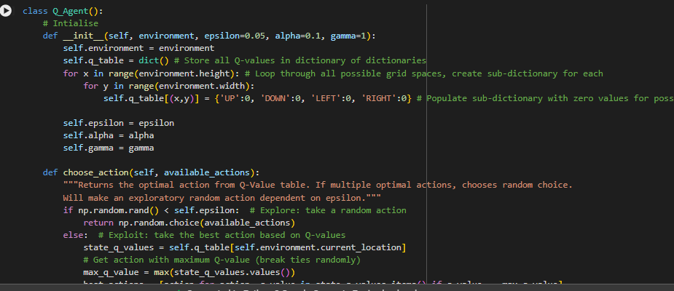

Question 2

2.

* Model-based algorithms can plan and make decisions based on future state and reward predictions because they have access to or have learned a model of the environment.
* Instead of using a model, model-free algorithms learn by doing; they adjust their policies or value functions in response to observable rewards and state transitions.

3.

Question 3



