*IT21192050*

**Lab 04**

Question7.

**Why there are 1783 boxes?** – ‘yolo_filter_boxes’ function filters the boxes using the confidence threshold to filter out the low-confidence boxes. This reduces the total number of boxes to 1783 which have confidence scores greater than or equal to 0.5. Also the mean and the stddev can effect the box_confidence , increasing the mean or decreasing the standard deviation will result in higher confidence scores. Also adjusting those will also affect class probability distribution. If we increase the threshold the number of retained boxes will be decreased as the confidence requirement is higher. I changed those values and observed the changes of the number of boxes.

**Maximum number of boxes** – 1805, maximum number of boxes is determined by the grid size and number of anchors per cell. For a grid with 19 * 19 cels with 5 anchors each the number of boxes can be calculated by, 19 * 19 * 5 =1805.

**Minimum number of boxes** – 0, minimum number theoretically can be low as 0 if none of the boxes meet the confidence threshold.

Question8.

**advantage of using such anchor boxes** –

* Anchor boxes improve the efficiency of the YOLO model by reducing the complexity of predicting bounding boxes directly.
* The use of anchor boxes enables the detection of multiple objects in the same grid cell.
* Detect objects with various dimensions by multiple aspect ratios of anchor boxes.

**Method used -** K-Means clustering

Question10.

Original Image

Output Image

The bus has been correctly identified and the bounding box is right as well, but the truck, traffic lights and the jeep haven’t been identified. Also there is a car in the right side of the pic that haven’t been identified.

Original image

Output image

Cars on the left and right sides of the picture haven’t been identified.

Question11.

* No changes after changing(increased) the **max_boxes** value in the yolo_eval function

After changing(decreased) the **score_threshold** there was a significant change

**Picture 1**

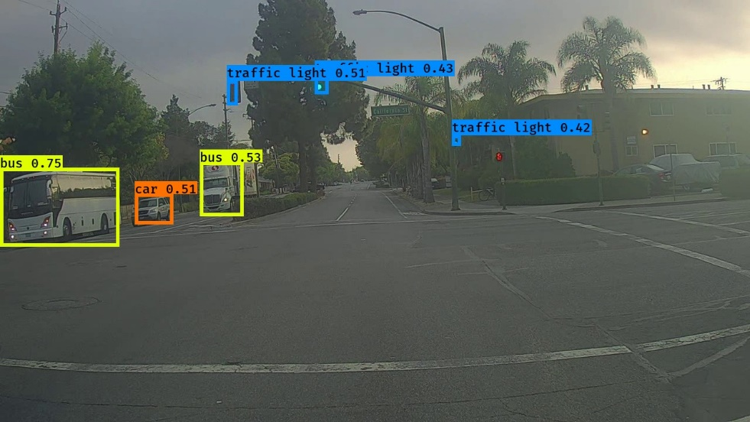

Output was significantly increased it has detected the car, truck and traffic lights but the truck was identifies as a bus.

**Picture 2**

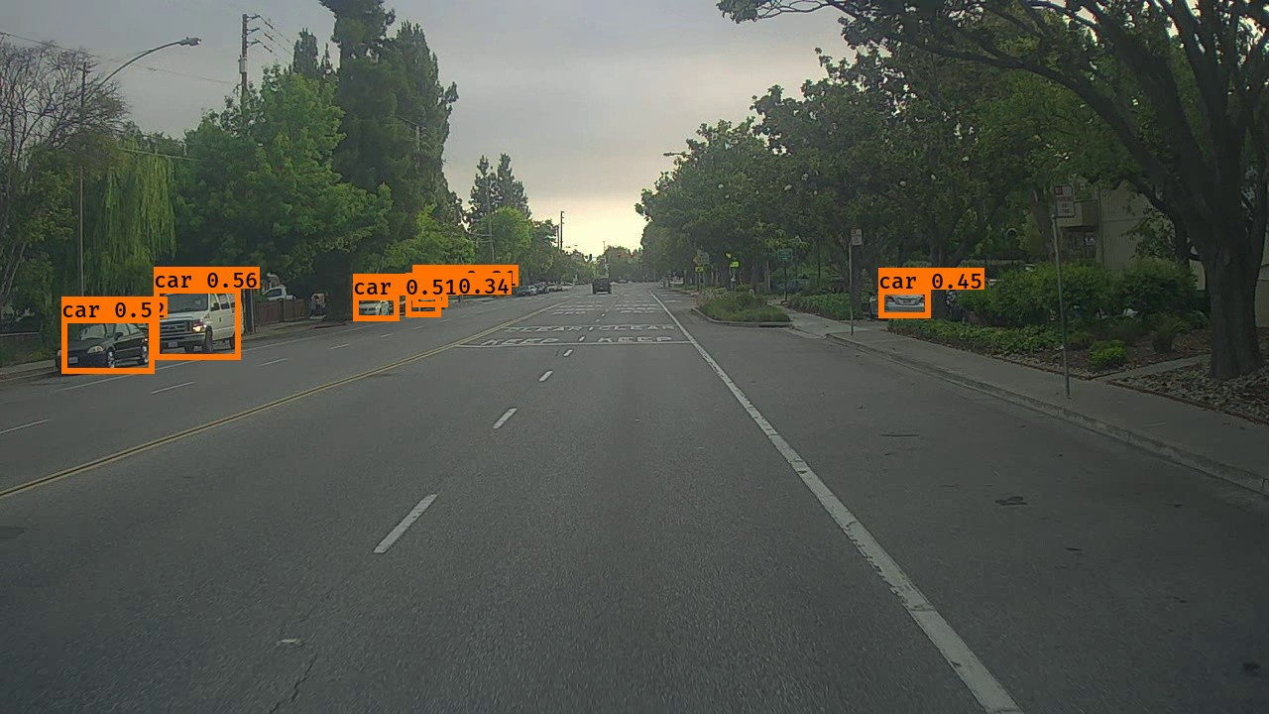

Output has significantly increased it has identified almost all the cars.

* No changes after changing(increased) the **iou_threshold** value in the yolo_eval function
* In the code where detecting the objects in all autonomous driving dataset images in the images directory I had a trouble having detecting a something else other than images in the images directory, it was “.ipynb_checkpoints”, as I kept the collab and started after a bit it had saved a checkpoint so I edited the code to ignore that. Just for your information. Highlighted below the part I added to the code.

new_path = 'lab_5/images'

for file_name in os.listdir(new_path):

**if file_name.startswith('.'):**

**continue**

  # if file_name[0] == '0': # images from [ 0100.jpg , 0120.jpg ]

  out_scores, out_boxes, out_classes = predict_(sess, file_name)