**Tomcat installation in Redhat linux** (JDK 7+ is pre-requisite)

1. sudo wget https://dlcdn.apache.org/tomcat/tomcat-9/v9.0.56/bin/apache-tomcat-9.0.56.zip
2. unzip apache-tomcat-9.0.56.zip

1. vi apache-tomcat-9.0.56/webapps/manager/META-INF/context.xml

Uncomment the last section from valve as shown in fig

1. 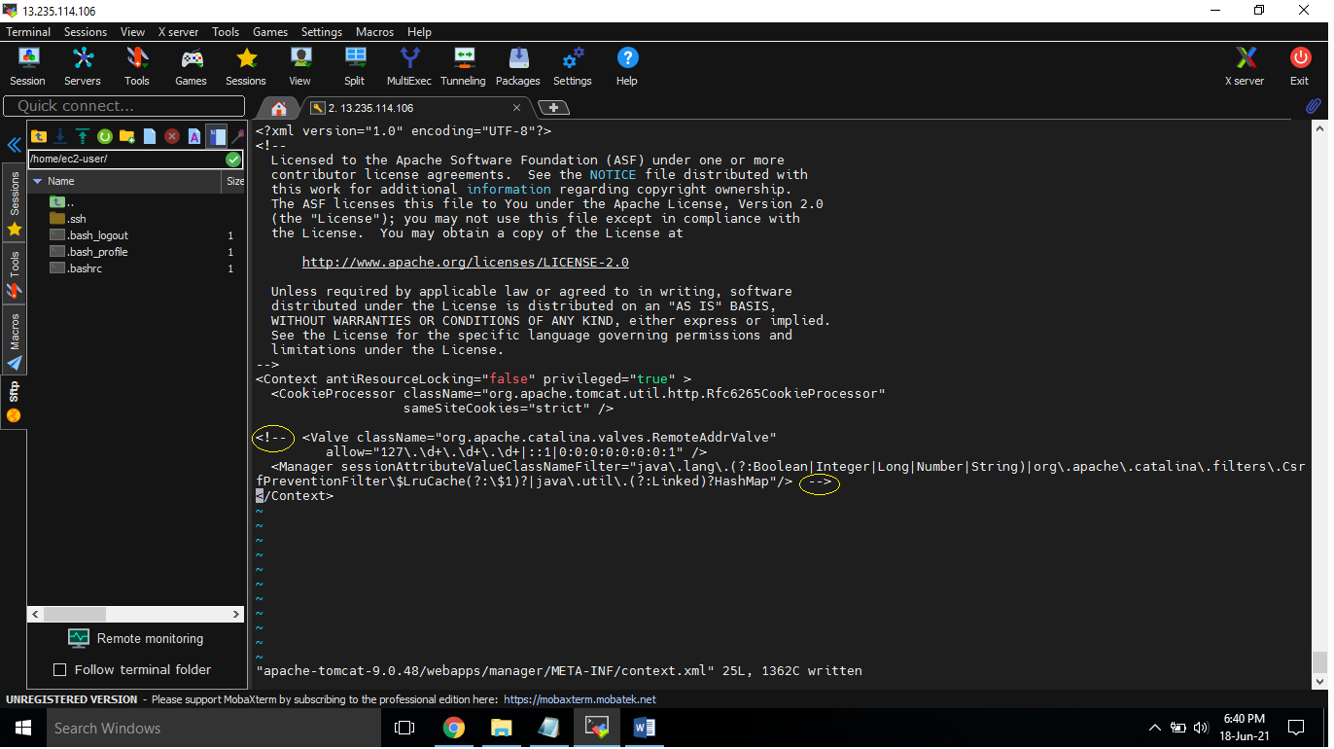cd /apache-tomcat-9.0.56/conf/
2. give permission for file “tomcat-users.xml” to edit and add roles and authentication
3. Inside tomcat-users.xml add roles & authentication credentials at last
4. get inside bin and start the tomcat using startup.sh file

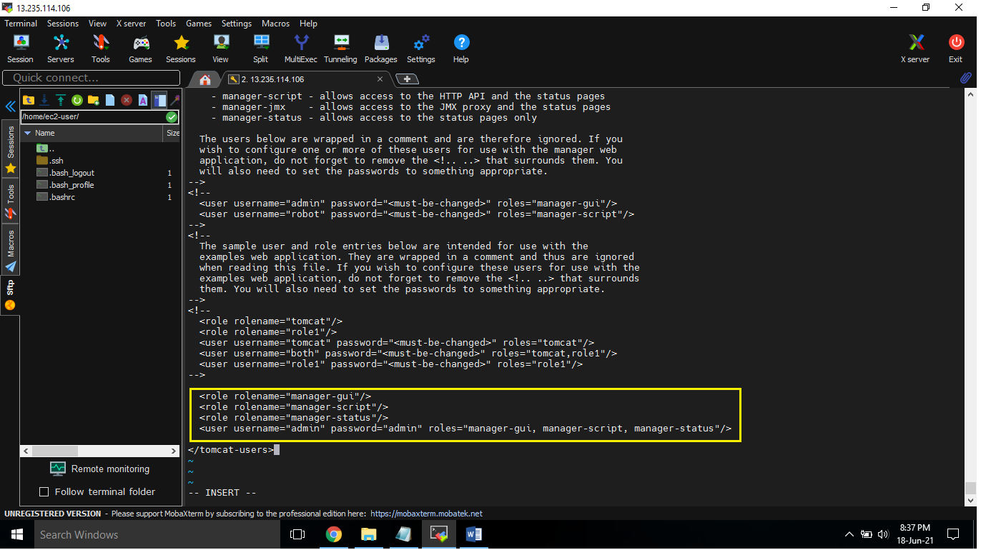 - cd /apache-tomcat-9.0.56/bin/

**Tomcat deployment config from Jenkins**

1) Install "Deploy to container" pligun in Jenkins

2)Goto "Project Configuration" --> "Add post build action" --> Deploy war/ear to a container --> "**/*.war --> "Add Containers" --> add "credentials"(uname & pswd) --> provide "Tomcat URL" ->save

Note:- Make sure tomcat is up & running

3) Build project

4) check in Tomcat server

<role rolename="manager-gui"/>

<role rolename="manager-script"/>

<role rolename="manager-status"/>

<user username="admin" password="admin" roles="manager-gui, manager-script, manager-status"/>

Tomcat port change:

1. Go to tomcat>conf folder.
2. Edit server.xml.
3. Search "Connector port"
4. Replace "8080" by your port number.
5. Restart tomcat server.