**UNIT-3**

**1. Forms of Business Organizations, Features, advantages, and disadvantages?**

An **organization** is a group of people who work together, like a neighborhood association, a charity, a union, or a corporation.

**The organization** is also the act of forming or establishing something. It can also refer to a system of arrangement or order or a structure for classifying things.

1. Sole proprietorship

2. Partnership

3. Joint-stock company

4. Public enterprises

**1.Sole proprietorship**

Definition: 'sole’ means ‘only one and ‘proprietorship’ implies ‘ownership’. Hence, a sole proprietorship is a form of business organization, wherein a single person owns, manages and controls, all the business activities and the individual who operates the business is called as a sole proprietor or, a sole trader.

**Characteristics of a sole proprietorship:**

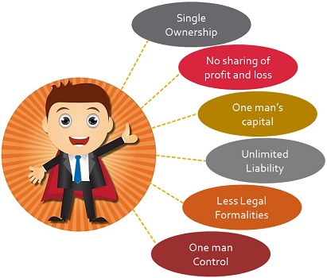

**Advantages of Sole Proprietorship**

* Easy formation and closure
* Direct motivation
* Maintenance of business secrets
* Quick decision and prompt action
* Better control
* Flexibility in operation
* Least record keeping
* Close personal relation

**Disadvantages of Sole Proprietorship**

* Limited resources
* Limited managerial ability
* Lack of continuity
* Limited size
* Unlimited liability

**2. Partnership?**

A partnership is a kind of business where a formal agreement between two or more people is made and agreed to be the co-owners, distribute responsibilities for running an organization and share the income or losses that the business generates.

Indian Partnership Act, of 1932 defines partnership as the relationship between two or more persons who agree to share the profits of the business carried on by all or any one of them acting for all.

**“The Central Government is given the authority to specify the maximum number of partners in a firm under Section 464 of the Companies Act 2013, number of partners cannot exceed 50.**

**Types of Partners:**

**Active Partner**: As the name suggests he takes active participation in the business of the firm. He contributes to the capital, has a share in the profit, and also participates in the daily activities of the firm. His liability in the firm will be unlimited. And he often will act as an agent for the other partners.

**Sleeping Partner**: he will not participate in the daily functioning of the business. But he will still have to make his share of the contribution to the capital. In return, he will have a share in the profits. His liability will also be unlimited.

**Secret Partner**: Here the partner’s association with the firm is not public knowledge. He will not represent the firm to outside agents or parties. Other than this his participation with respect to capital, profits, management, and liability will be the same as all the other partners.

**Nominal Partner**: This partner is only a partner in the name. He allows the firm to use the name of his firm, and the attached goodwill. But he in no way contributes to the capital and hence has no share in the profits. He does not involve himself in the firm’s business. But his liability too will be unlimited.

**Characteristics /Features of Partnership:**

**1. Agreement between Partners:**  The agreement (accord) becomes the basis of the association between the partners. Such an agreement is in written form. In order to avoid controversies, it is always good, if the partners have a copy of the written agreement.  
**2. Two or More Persons:** In order to manifest a partnership, there should be at least two (2) persons possessing a common goal. To put it in other words, the minimal number of partners in an enterprise can be two (2). However, there is a constraint on the maximum number of people.

**3. Sharing of Profit:** Another significant component of the partnership is, the accord between partners to share the gains and losses of a trading concern. However, the definition held in the Partnership Act elucidates – a partnership is an association between people who have consented to share the gains of a business, the sharing of loss is implicit. Hence, sharing of gains and losses is vital.  
**4. Business Motive:** It is important for a firm to carry some kind of business and should have a profit-gaining motive.  
**5. Mutual Business:** The partners are the owners as well as the agent of their firm.  Any act performed by one partner can affect other partners and the firm. It can be concluded that this point acts as a test of partnership for all the partners.

**Advantages of a partnership:**

* Easy to form
* Availability of large resources – More Capital Available
* Better decisions – Combined Talent, Judgment, and Skill
* Flexibility in operations
* Sharing risks
* Benefits of specialization

**Dis Advantages of a partnership:**

* Unlimited Liability
* Uncertain Life
* Lack of Harmony
* No Transferability of Share
* Lack of Continuity
* Public distrust

**Joint stock company?**

The simplest way to describe a joint stock company is that it is a business organization that is owned jointly by all its shareholders. All the shareholders own a certain amount of stock in the company, which is represented by their shares.

**Company Defined (1956 Act)**

 Lord Justice Lindley explained the concept of the joint stock company form of organization as ‘an association of many persons who contribute money or money’s worth to a common stock and employ it for a common purpose.

**Formation of Joint Stock company**

 There are two stages in the formation of a joint stock company. They are:

**1. Certificate of Incorporation**: The certificate of Incorporation is just like a ‘date of birth certificate. It certifies that a company with such and such a name is born on a particular day.

**2. Certificate of commencement of Business**: A private company need not obtain the certificate of commencement of business. It can start its commercial operations immediately after obtaining the certificate of Incorporation.

**3. Memorandum of Association**: The Memorandum of Association is also called the charter of the company. It outlines the relations of the company with outsiders.

* (i) Name clause
* (II) situation clause
* (iii) objects clause
* (iv) Capital clause and
* (vi) subscription clause duly executed by its subscribers.

**4. Articles of association**: Articles of Association furnishes the laws or internal rules governing the internal conduct of the company.

* a.The list of names and addresses of the proposed directors and their willingness, in writing to act as such, in case of registration of a public company.
* b.A statutory declaration that all the legal requirements have been fulfilled. The declaration has to be duly signed by any one of the following: Company secretary in the whole practice, the proposed director or, legal solicitor, the chartered accountant in whole time practice or the advocate of the High court.

**Characteristics /Features of Joint Stock company:**

**1.Artificial person:** The Company has no form or shape. It is an artificial person created by law. It is intangible, invisible and existing only, in the eyes of law.

**2. Separate legal existence**: it has an independence existence; it separates from its members. It can acquire assets. It can borrow from the company.

**3. Voluntary association of persons**: The Company is an association of voluntary association of persons who want to carry on business for profit. To carry on business, they need capital. So they invest in the share capital of the company.

**4. Limited Liability**: The shareholders have limited liability i.e., liability limited to the face value of the shares held by them. In other words, the liability of a shareholder is restricted to the extent of his contribution to the share capital of the company.

**5. Capital is divided into shares**: The total capital is divided into a certain number of units. Each unit is called a share. The price of each share is priced so low that every investor would like to invest in the company.

**6. Transferability of shares**: In the company form of an organization, the shares can be transferred from one person to the other. A shareholder of a public company can sell his holding of shares at his will. However, the shares of a private company cannot be transferred. A private company restricts the transferability of shares.

**7. Common Seal**: As the company is an artificial person created by law and has no physical form, it cannot sign its name on paper; so, it has a common seal on which its name is engraved. The common seal should affix every document or contract; otherwise, the company is not bound by such a document or contract.

**Advantages of Joint-stock Company:**

**1. Mobilization of larger resources:** A joint stock company provides an opportunity for investors to invest, even small sums, in the capital of large companies. The facilities rising of larger resources.

**2. Separate legal entity:** The Company has a separate legal entity. It is registered under the Indian Companies Act, of 1956.

**3. Limited liability:** The shareholder has limited liability in respect of the shares held by him. In no case, does his liability exceed more than the face value of the shares allotted to him.

**4. Transferability of shares:** The shares can be transferred to others. However, private company shares cannot be transferred.

**5. Inculcates the habit of savings and investments**: Because the share face value is very low, this promotes the habit of saving among the common man and mobilizes the same towards investments in the company.

**6. Economics of large-scale production**: Since the production is on a scale with large funds at high production volumes.

**Disadvantages of Joint-stock Company:**

**1. Formation of the company is a long-drawn procedure**: Promoting a joint stock company involves a long-drawn procedure. It is expensive and involves a large number of legal formalities.

**2. High degree of government interference**: The government brings out a number of rules and regulations governing the internal conduct of the operations of a company such as meetings, voting, audit, and so on, and any violation of these rules results in statutory lapses, punishable under the companies act.

**3. Delays in decision-making**: As the size of the organization grows, the number of levels in the organization also increases in the name of specialization. The more the number of levels, the more the delay in decision-making. Sometimes, so-called professionals do not respond to the urgencies as required. It promotes delay in administration, which is referred to ‘red tape and bureaucracy’.

**4. Lack of initiative**: In most cases, the employees of the company at different levels show slack in their personal initiative with a result, the opportunities once missed do not recur and the company loses revenue.

**5. Lack of responsibility and commitment**: In some cases, the managers at different levels are afraid to take risks and more worried about their jobs rather than the huge funds invested in the capital of the company losing the revenue.

**4.Public enterprises?**

public enterprise, a business organization wholly or partly owned by the state and controlled through a public authority. Some public enterprises are placed under public ownership because, for social reasons, it is thought the service or product should be provided by a state monopoly.

 i. Departmental Undertaking

ii. Public Corporation

iii.Government Company

## **I. Departmental Undertaking:**

The departmental undertaking is the oldest and traditional form of an organization of the public sector enterprise. It is organized, financed and controlled in such a manner that any other government organization. The undertaking is under the control of a minister who is responsible to the parliament. Some examples of departmental undertakings is Indian Railways, Post and Telegraph, All India Radio, Door darshan etc.

## **Advantages of Department Undertaking**

* These allow the government to take control of all operation efficiently.
* These assure public accountability
* The revenue collected by the business is directly credited to the treasury which becomes a source of income for the government
* It has direct authority and guidance of the ministry, therefore, for national security, it is the best kind of undertaking

## **Disadvantages of Department Undertaking**

* It doesn’t have flexibility which is essential for a business to run smoothly
* Employees are not allowed to take an independent decision. Therefore, it leads to a delay in decision making
* They cannot take advantage of business opportunities as they do not want to take a risk in new venture
* Unnecessary political interference
* They are insensitive to customer needs and do not give sufficient services to them

**ii.Public Corporation:** A public corporation is that form of public enterprise which is created as an autonomous unit, by a special Act of the Parliament or the State Legislature. Since a public corporation is created by a Statute; it is also known as a statutory corporation.

Advantages:

* Bold Management due to Operational Autonomy
* Legislative Control
* Qualified and Contented Staff
* Disadvantages
* Autonomy and Flexibility, Only in Theory
* Misuse of Monopolistic Power

**iii.Government Company**

Government Company is a company or an organization in which at least 51% of the paid up share capital is held by the central government or the state government or partly by both central and state government. These are many government companies, few of them are, Steel Authority of India Limited, Bharat Heavy Electricals Limited, Coal India Limited, State Trading Corporation of India, etc.

### **Advantages of Government Company**

To incorporate a government company, all the provisions of the Companies Act are to be followed.

The government organization enjoys all autonomy in management decisions and flexibility in day-to-day activities.

These companies control the local market and sustain it to curb the unhealthy business practices.

### **Limitations of a Government Company**

These companies face a lot of government interference and involvement of government officials, ministers, and politicians.

As these companies are financed by the government, so these companies evade all constitutional responsibilities of not answering to the parliament.

The efficient operations of the company are hampered, as the board of the company comprises mainly of politicians and civil servants, who have more emphasis and interest in pleasing their political party co-workers or owners and less concentrated on growth and development of the company.

**2. Market structures, and characteristics of the market?**

Market structure refers to the nature and degree of competition in the market for goods and services. The structures of the market both for goods market and service (factor) market are determined by the nature of competition prevailing in a particular market.

**Determinants:**

There are a number of determinants of market structure for a particular good.

**They are:**

(1) The number and nature of sellers.

(2) The number and nature of buyers.

(3) The nature of the product.

(4) The conditions of entry into and exit from the market.

(5) Economies of scale.

Types of market competition

**1. Perfect competition 2. Imperfect competition**

a. Monopoly (Single seller)

b. Duopoly (two sellers)

c. Oligopoly ( Few sellers)

monopolistic competition.(No of sellers)

**i.Perfect market Competition?**

Perfect Competition is a market structure where a large number of buyers and sellers are present, and all are engaged in the buying and selling of homogeneous products at a single price in the market.

**Features of Perfect Market Competition.**

· Large Number of Buyers and Sellers

· Homogeneity of the Product

· Free Entry and Exit of Firms

· Perfect Knowledge of the Market

· Perfect Mobility of the Factors of Production and Goods.

Price and out put determination in perfect competition:

Price and output determination in short-run:

**Price and out put determination in perfect competition, short-run:**

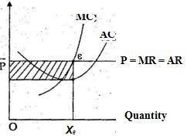Conditions:

1.MR=MC

2. MC Curve should be cut under the MR curve

**Price and output determination in long-run:**

Conditions:

1.MC=AC

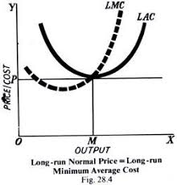

**ii. Monopoly Meaning?**

**Monopoly** means a single seller many buyers, A firm with no competitors in its industry. Examples: Microsoft and Windows,

The word monopoly has been derived from the combination of two words i.e., ‘Mono’ and ‘Poly’. Mono refers to a single and poly to control.

In this way, monopoly refers to a market situation in which there is only one seller of a commodity.

Monopolist has full control over the supply of the commodity

**Features of monopoly:**

**1. One Seller and a Large Number of Buyers:**

The monopolist’s firm is the only firm; it is an industry. But the number of buyers is assumed to be large.

**2. No Close Substitutes:**

There shall not be any close substitutes for the product sold by the monopolist. The cross elasticity of demand between the product of the monopolist and others must be negligible or zero.

**3. Difficulty of Entry of New Firms:**

There are either natural or artificial restrictions on the entry of firms into the industry, even when the firm is making abnormal profits.

**Price and output determination in Monopoly:**

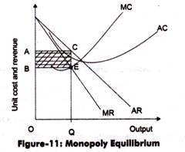

**iv. Monopolistic competition**?

Monopolistic competition refers to where an industry in which many firms offer products or services that are similar, but not perfect substitutes.

Barriers to entry and exit in a monopolistic competitive industry are low, and the decisions of any one firm do not directly affect those of its competitors.

**Features of Monopolistic Competition**

1. a Large Number of Buyers and Sellers

2. Free Entry and Exit of Firms

3. Product Differentiation

4. Selling costs

5. Lack of Perfect Knowledge

7. More Elastic Demand

**Price and output determination in short-run:**

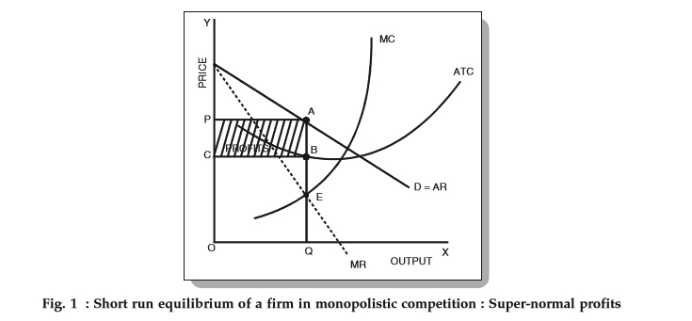

**Price and output determination in long-run:**

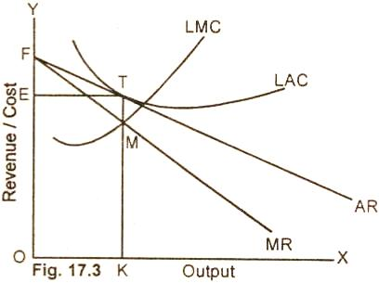

**v.Duopoly Market?**

Duopoly refers to there being only two sellers. Both the sellers are completely independent and no agreement exists between them. Even though they are independent, a change in the price and output of one will affect the other and may set a chain of reactions. A seller may, however, assume that his rival is unaffected by what he does, in that case, he takes only his own direct influence on the price.

**Features of Duopoly:**

 1. Existence of only two sellers

2.  Interdependence

3.  Presence of monopoly elements

4. They fix the price for their product with a view to maximizing their profit.

**vi. Oligopoly Market?**

The term oligopoly is derived from two Greek words: ‘oligo’ means few and ‘pole in’ means to sell. Oligopoly is a market structure in which there are only a few sellers (but more than two) of homogeneous or differentiated products. So, oligopoly lies in between monopolistic competition and monopoly. In India, markets for automobiles, cement, steel, aluminum, etc, are examples of an oligopolistic market. In all these markets, there are few firms for each particular product.

**1. Few firms:**

Under an oligopoly, there are few large firms. The exact number of firms is not defined. Each firm produces a significant portion of the total output. There exists severe competition among different firms and each firm tries to manipulate both prices and volume of production to outsmart the other. For example, the market for automobiles in India is an oligopolist structure as there are only few producers of automobiles.

**2. Interdependence:**

Firms under oligopolies are interdependent. Interdependence means that the actions of one firm affect the actions of other firms. A firm considers the action and reactions of rival firms while determining its price and output levels. A change in output or price by one firm evokes a reaction from other firms operating in the market.

**3. Non-Price Competition:**

Under an oligopoly, firms are in a position to influence prices. However, they try to avoid price competition for the fear of a price war.

If a firm tries to reduce the price, the rivals will also react by reducing their prices. However, if it tries to raise the price, other firms might not do so. It will lead to a loss of customers for the firm, which intended to raise the price. So, firms prefer non-price competition instead of price competition.

**4. Barriers to Entry of Firms:**

The main reason for few firms under oligopoly is the barriers, which prevent the entry of new firms into the industry. Patents, a requirement of large capital, control over crucial raw materials, etc, are some of the reasons, which prevent new firms from entering into the industry. Only those firms that enter into the industry which is able to cross these barriers. As a result, firms can earn abnormal profits in the long run.

**5. Role of Selling Costs:**

due to severe competition ‘and interdependence of the firms, various sales promotion techniques are used to promote sales of the product. Advertisement is in full swing under oligopoly, and many times advertisements can become a matter of life and death. A firm under an oligopoly relies more on non-price competition. Selling costs are more important under an oligopoly than under monopolistic competition.

**6. Nature of the Product:**

The firms under oligopoly may produce homogeneous or differentiated products.

i. If the firms produce a homogeneous product, like cement or steel, the industry is called a pure or perfect oligopoly.

ii. If the firms produce a differentiated product, like automobiles, the industry is called a differentiated or imperfect oligopoly.

**1. Pricing methods and Strategies?**

Pricing can be defined as the process of determining an appropriate price for the product, or it is an act of setting a price for the product. Pricing involves a number of decisions related to setting the price of a product. Pricing policies are aimed at achieving various objectives.

Pricing is a fundamental aspect of financial modeling and is one of the four Ps of the marketing mix, the other three aspects being product, promotion, and place.

**Objectives of pricing:**

1. To Get maximum profit

2. To Increase Market Share

3. To overcome the competition

4. To get Customer satisfaction

5. Survival and Growth for a long period of time

**Pricing Methods/ strategies are:**

**1. Cost Plus pricing strategy:** cost-plus pricing a percentage of the entire cost of producing an item is added to the price of an item to set the final price. The amount added on is the profit that’s desired. It’s easy to calculate the price since little information is needed. It also guarantees sellers from any unexpected cost adjustments. The problem, though, is that it doesn’t take into account the pricing strategies that rivals are using and the impact of customers.

**2. Demand-based pricing strategy:** This pricing method helps determine the price of an item depending on the demand for it. When there’s a lot of demand, then the price is raised because the company understands that consumers are willing to purchase the item regardless of the price. This is when a profit is made because consumers are paying a lot more than the item is worth. However, when there isn’t much demand, then the price is decreased with the hopes of gaining the attention of potential buyers.

**3. Competitive Pricing:**Consumers have many choices and are generally willing to shop around to get the best price. Retailers considering a competitive pricing strategy need to provide outstanding customer service to stand above the competition.

**4. Vendor Pricing:**Manufacturer-suggested retail price (MSRP) is a common strategy used by smaller retail shops to avoid price wars and still maintain a decent profit. For any products you resell, you'll find some suppliers have minimum advertised prices (MAP) and may not let you continue to sell their products if you try to price below their MAP.

**5. Value-Based Pricing:** Pricing is based on the estimated or perceived value of the product to the consumer, value-based pricing is a strategy often used by companies creating products with low production costs. For those industries such as fashion and prestige where emotions often drive purchases.

**6. Skimming Pricing:**Designed to help businesses maximize sales on new products and services, price skimming involves setting rates high during the introductory phase. One of the benefits of skimming prices is that it allows businesses to maximize profits on early adopters before dropping prices to attract more price-sensitive consumers.

**7. Penetration Pricing:** The strategy which sits opposite to skimming is called penetration pricing. With penetration pricing, the price is set low intentionally, and retailer sacrifice profits in order to quickly grab a larger share of the market. The reason this strategy work is that once consumer loyalty has been established, businesses can slowly raise their prices.

**8. Bundle Pricing:**With a bundle pricing strategretailerser sell multiple products for a lower rate than consumers would face if they purchased each item individually. Not only is bundling goods an effective way of moving unsold items that are taking up space in your facility, but it can also increase the value perception in the eyes of your customers.

**9. Block pricing:** it is the pricing strategy in which identical products are packaged together in order to enhance profits by forcing customers to make the decision to purchase.