**UNIT-5**

**CAPITAL AND CAPITAL BUDGETING**

**Capital Meaning?**

Capital means the money, a company needs money to operate and to expand the business. Typical examples of capital include cash at hand and accounts receivable, near cash, equity and capital assets such as building, plant and machinery. Capital assets are significant, long-term assets not intended to be sold as part of your regular business.

**Capital can divide in to Fixed capital and Working capital.**

**Fixed capital:**

Fixed capital are assets of a business that are permanent in nature and are not intended to be disposed of by a business. These assets include land, buildings, plant, machinery, fixed equipment, furniture, fixtures, vehicles, livestock, etc.

**Working capital:**

Working capital, also known as net working capital (NWC), is the difference between a company's current assets—such as cash, accounts receivable/customers' unpaid bills, and inventories of raw materials and finished goods—and its current liabilities, such as accounts payable and debts.

**Woking Capital Cycle?**

It is the time to taken to convert net assets and net liabilities into cash. There are several day-to-day business activities which required readily available cash. A working capital cycle can be long and short depending upon the time taken to convert into cash.

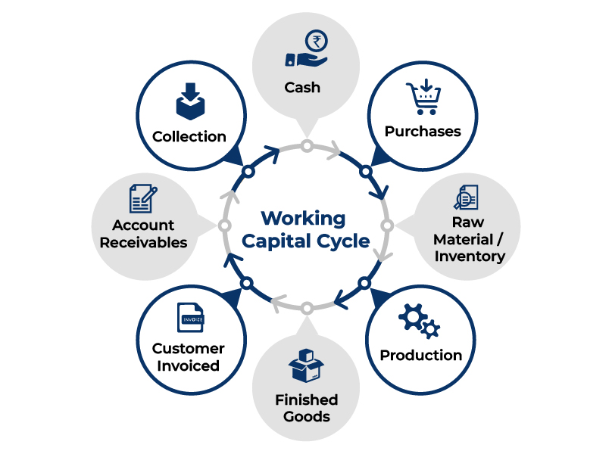

**Sources of short-run and long-run Capital?**

**1. Retained Earnings:**

In most cases, a company does not release all of its earnings or share its profits with its shareholders as dividends. A part of the net earnings may be retained in the company for future use. This is known as retained earnings. It is a source of internal finance, self-financing, or profit ploughing. The profit available for reinvestment in an organisation is dependent on a variety of factors, including net profits, dividend policy, and the age of the organisation.

**2. Trade Credit:**

Trade credit is credit given by one trader to another for the purchase of products and services. Trade credit facilitates the purchase of goods without the need for immediate payment. Such credit shows in the buyer of goods’ records as ‘sundry creditors’ or ‘accounts payable.’ Business organisations frequently utilise trade credit as a form of short-term finance.

**3. Lease Financing:**

A lease is a contractually enforceable arrangement whereby a one party, the owner of an asset, grants the other party the right to use the asset in exchange for a monthly payment. In other terms, it is the rental of an asset for a certain amount of time. The party who owns the assets is known as the ‘lessor,’ while the party who utilises the assets is known as the ‘lessee.’ The lessee pays the lessor a predetermined periodic sum known as lease rental in exchange for the usage of the asset.

**4. Public Deposits:**

Public deposits are deposits gathered from the public by organisations. Interest rates on public deposits are often higher than those on bank deposits. Anyone who wants to make a monetary contribution to an organisation can do so by filling a specified form.

In return, the organisation gives a deposit receipt as proof of payment. A business’s medium and short-term financial needs can be met through public deposits. Deposits are beneficial to both the depositor and the organisation. While depositors receive higher interest rates than banks, the cost of deposits to the corporation is lower than the cost of borrowing from banks. Companies often seek public deposits for up to three years.

**5. Commercial Papers:**

Commercial Paper (CP) is an unsecured promissory note. It was first created in India in 1990 to allow highly rated corporate borrowers to diversify their sources of short-term borrowings and to give investors an additional instrument.

**6. Issue of Shares:**

A share is the smallest unit of a company’s capital. The firm’s capital is split into small units and issued to the public as shares. The capital gained via the issuance of shares is referred to as ‘Share Capital.’ It’s a kind of Owner’s Fund.

There are two kinds of shares that can be issued:

**Equity Shares:** These are shares that do not pay a fixed dividend, but do have ownership and voting rights. Owner of the firm refers to the company’s equity shareholders. They do not get a set dividend, but are paid dependent on the company’s profitability.

**Preference Shares:** Preference shares are shares that have a slight preference over equity shares. Preference Shareholders get a set dividend rate and have the right to receive their capital before equity shareholders in case of liquidation. They do not, however, have any voting rights in the company’s management.

**7. Debentures:**

Debentures are an effective instrument for raising long-term debt capital. A firm can raise capital by issuing debentures with a fixed rate of interest. A firm’s debenture is a recognition that the company has borrowed a specified amount of money, which it commits to repay at a later period. Debenture holders are part of the company as the company’s creditors. Debenture holders get a definite stated amount of interest at predetermined periods, such as six months or a year.

**8. Commercial Banks:**

Commercial banks play an important role in providing finances for a variety of purposes and time periods. Banks provide loans to businesses in a variety of ways, including cash credits, overdrafts and term loans.

**9. Financial Institutions:**

The government has established many financial institutions in the country to give financing to businesses. They provide both owned and loan capital for long- and medium-term needs. These organisations are often known as ‘Development Banks’ since they aim to promote a country’s industrial development. In addition to financial help, these institutes conduct surveys and provide organisations with technical assistance and management services. Financial institutions provide funds for the expansion, reorganisation and modernisation of an enterprise.

**10 Government support**: Government supporting to business organisations in terms of loans with lowest rate of interest, subsidy-based loans and land for establishing the building and machinery.

**What Is Capital Budgeting?**

Capital budgeting is the process a business undertakes to evaluate potential major projects or investments. Construction of a new plant or a big investment in an outside venture are examples of projects that would require capital budgeting before they are approved or rejected.

**Objectives of Capital budgeting:**

Capital expenditures are huge and have a long-term effect. Therefore, while performing a capital budgeting analysis an organization must keep the following objectives in mind:

**1. Selecting profitable projects:**

An organization comes across various profitable projects frequently. But due to capital restrictions, an organization needs to select the right mix of profitable projects that will increase its shareholders’ wealth.

**2. Capital expenditure control:**

Selecting the most profitable investment is the main objective of capital budgeting. However, controlling capital costs is also an important objective. Forecasting capital expenditure requirements and budgeting for it, and ensuring no investment opportunities are lost is the crux of budgeting.

**3. Finding the right sources for funds:**

Determining the quantum of funds and the sources for procuring them is another important objective of capital budgeting. Finding the balance between the cost of borrowing and returns on investment is an important goal of Capital Budgeting.

**Capital Budgeting Process?**

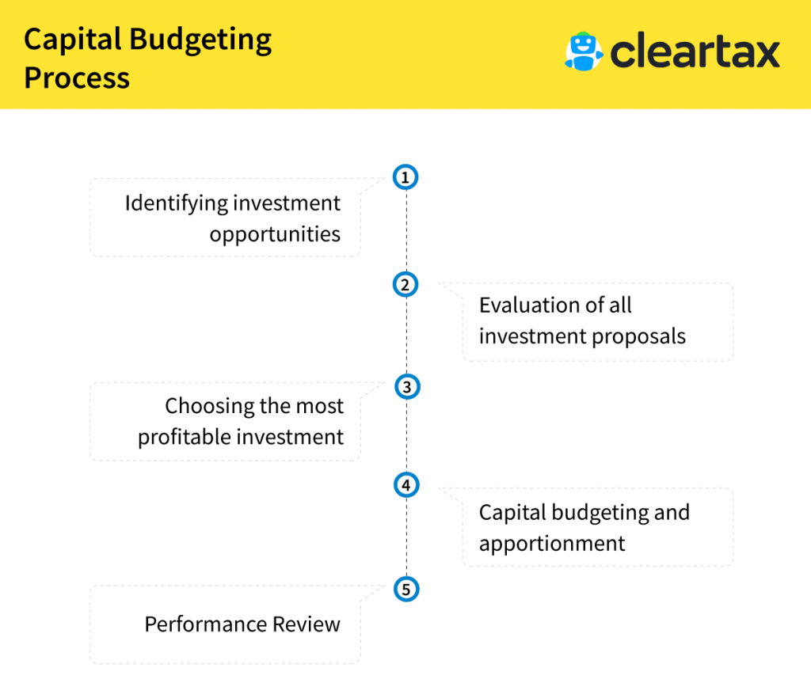

. **Capital Budgeting Methods/Techniques?**

[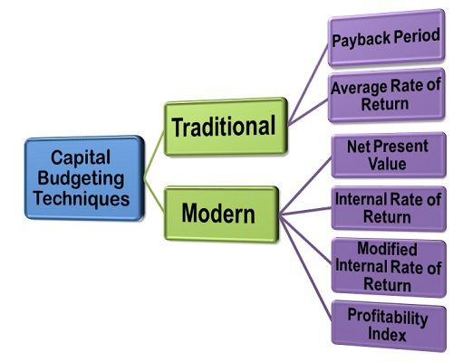](https://businessjargons.com/wp-content/uploads/2015/11/capital-budgeting-techniques.jpg)

**1.Pay Back Period Method(PBP):**

Payback period refers to the number of years it takes to recover the initial cost of an investment. Therefore, it is a measure of liquidity for a firm. Thus, if an entity has liquidity issues, in such a case, shorter a project’s payback period, better it is for the firm. Formula given below.

|  |  |
| --- | --- |
| **Cash inflows are the same for all the years** | **Different cash inflows** |
| PBP = (Investment / Average Returns) | PBP = L1 + (A/B)  L1 = Lower years  A = Required cash inflows after L1 year  B= total cash inflows during L2 years  L2 Higher year |

**2.Average Rate of Return Method (ARR):**

The accounting rate of return, also known as average rate of return, ARR is a financial ratio used in capital budgeting. The ratio does not take into account the concept of time value of money. ARR calculates the return, generated from net income of the proposed capital investment.

**ARR = (Average Returns / Average Investment) *100**

**Average returns = (total returns / No. of years)**

**Average investment= (total investment / 2)**

## 3. **Net Present Value (NPV):**

NPV, or net present value, is how much an investment is worth throughout its lifetime, discounted to today’s value.

Net present value is used to determine whether or not an investment, project, or business will be profitable down the line. NPV is used primarily in corporate finance. For example, investment bankers may compare net present values to determine which merger or acquisition is worth the investment.

**NPV = Discounted cash inflows – Investment**

**4.Profitable Index (PI):**

The profitability index is an appraisal technique applied to potential capital outlays. The method divides the present value of cash inflows and the present value of cash outflows to determine the profitability of a project.

**Profitability index = Discounted cash inflows / investment**

**5. The internal rate of return (IRR):**

IRR also called trail run error method. Internal rate of return is a capital budgeting calculation for deciding which projects or investments under consideration are investment-worthy and ranking them.

IRR is compared with the cost of the capital. If the IRR is more than the cost of capital the project is profitable, otherwise it is not considerable. Where there are two projects with different IRRs, select the project with higher IRR.

**NPV @ Lower Discount Rate**

**IRR = L1 + ------------------------------------------------------------- (L2-L1)**

**NPV @ Lower Discout – NPV @ Higher Disc**

**L1= Lower discounted rate, L2 = Higher discout rate.**