CAN-FD Master-Slave Hardware Setup

1. Hardware Specification
Component | Specification
Master | Ubuntu PC/Laptop
CAN Interface | USB-to-CAN FD Adapter
Slave | NXP FRDM-A-S32K344 Evaluation Board

2. Hardware Block Diagram

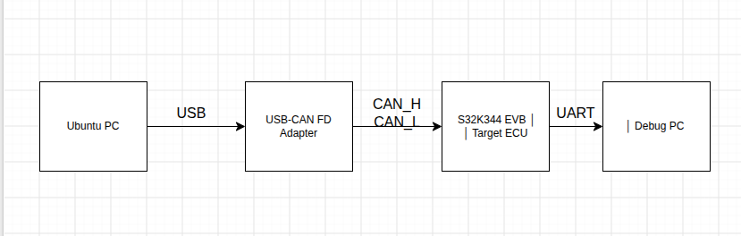

3. Connection Picture

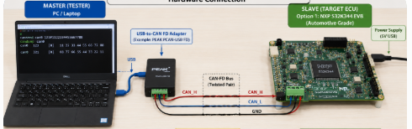

NXP FRDM-A-S32K344 Evaluation Board : Supporting CAN-FD

