CAN-FD Master-Slave Hardware Setup

1. Hardware Specification
Component | Specification
Master | Ubuntu PC/Laptop
CAN Interface | USB-to-CAN FD Adapter (e.g., PEAK PCAN-USB FD, Kvaser Leaf Light HS v2, CANable FD)
Slave | NXP FRDM-A-S32K344 Evaluation Board (Target ECU)
CAN Bus | CANH, CANL, GND with 120 Ω termination at both ends
Debug | OpenSDA/MCU-Link USB (UART Debug)

2. Block Diagram
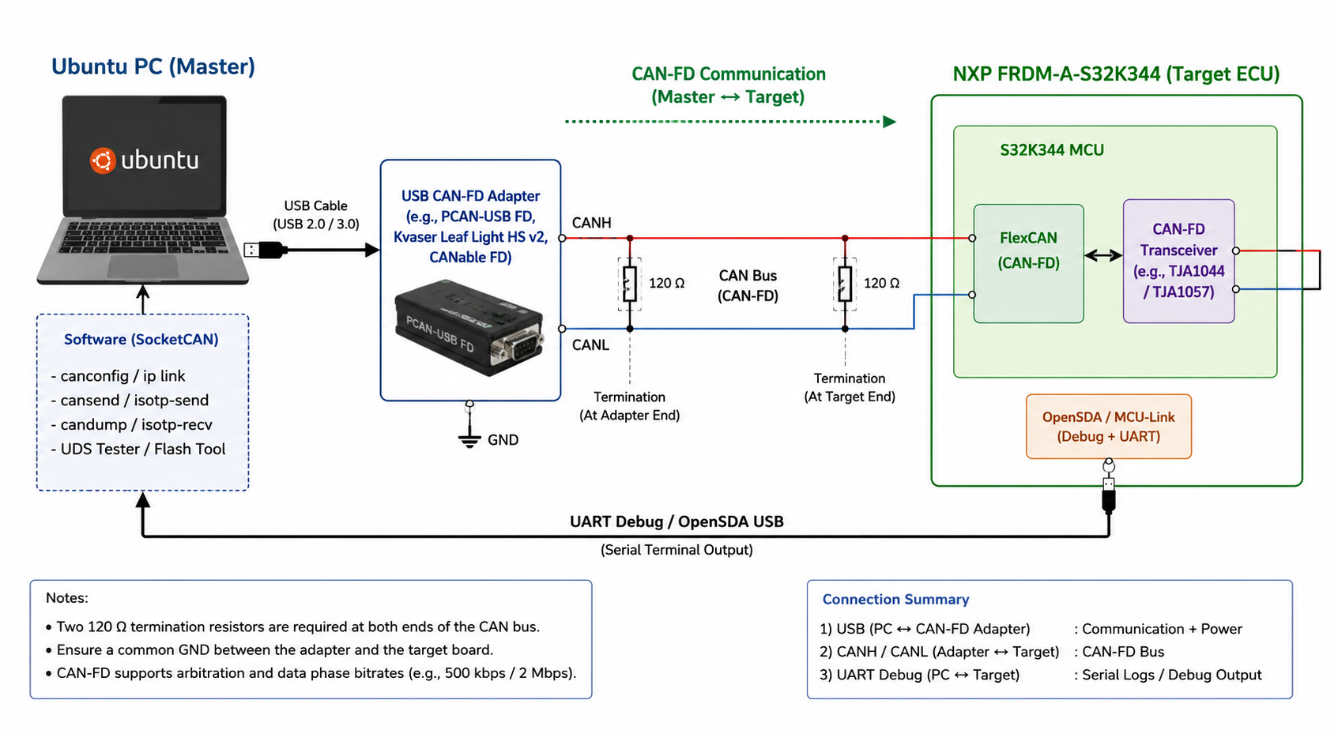
Figure: PC (Master) connected to the NXP FRDM-A-S32K344 Target ECU through a USB-to-CAN FD adapter. The CANH and CANL lines form the CAN-FD bus with 120 Ω termination resistors at both ends. A separate OpenSDA/UART USB connection is used for debugging and serial logs.

