**Frontend Development with React.js**

**Project Documentation for Cryptoverse Dashboard**

**Introduction**

**Project Title:** Cryptoverse Dashboard  
**Team Members:**

* **Haritha R.** (Team Leader) - [haritha082005@gmail.com](mailto:haritha082005@gmail.com)
* **Priyanka S.** - [priyankasivakumarvmb@gmail.com](mailto:priyankasivakumarvmb@gmail.com)
* **Shahin Taj F.** - [shahin27.5.2005@gmail.com](mailto:shahin27.5.2005@gmail.com)
* **Sakthi V.** - [sakthivijayakumar4812@gmail.com](mailto:sakthivijayakumar4812@gmail.com)

**Project Overview**

**Purpose**

The Cryptoverse Dashboard is an advanced cryptocurrency tracking application built with React.js. It provides users with real-time market data, historical trends, and a side-by-side comparison tool for cryptocurrencies.

**Features**

* **Global Market Statistics**: Displays aggregated market data.
* **Searchable & Paginated Crypto List**: Allows users to explore various cryptocurrencies.
* **Detailed Coin Profiles**: Provides historical price charts and market insights.
* **Comparison Tool**: Enables side-by-side analysis of two cryptocurrencies.
* **Responsive UI**: Dark-themed interface with neon accents.
* **State Management**: Utilizes Redux Toolkit for efficient data handling.
* **Dynamic Visualizations**: Interactive charts powered by Chart.js.

**Architecture**

**Component Structure**

The project follows a modular component-based architecture:

* Home.jsx - Displays global market statistics.
* CryptoList.jsx - Lists all cryptocurrencies with pagination and search.
* CryptoDetails.jsx - Provides a detailed view of a selected cryptocurrency.
* CryptoCompare.jsx - Compares two cryptocurrencies with price trends.
* Navbar.jsx - Sidebar navigation and search functionality.

**State Management**

* **Redux Toolkit** is used for managing application state efficiently.
* State slices:
  + coins: Stores the cryptocurrency market data.
  + coinDetails: Contains information about a specific coin.
  + history: Maintains historical price trends.
  + globalData: Stores global crypto statistics.
  + searchTerm: Filters the cryptocurrency list.

**Routing**

React Router is used for navigation between pages:

* / - Home (Global statistics)
* /cryptos - List of all cryptocurrencies
* /crypto/:id - Individual coin details
* /compare - Comparison of two cryptocurrencies

**Setup Instructions**

**Prerequisites**

* **Node.js & npm**: [Download here](https://nodejs.org/en/download/)
* **React.js**: Install via npx create-react-app cryptoverse-dashboard
* **Git**: Version control ([Download here](https://git-scm.com/downloads))
* **Editor**: Visual Studio Code recommended ([Download here](https://code.visualstudio.com/))

**Installation**

1. **Clone the Repository:**
2. git clone https://github.com/HarithaR/Crypto
3. cd cryptoverse-dashboard
4. **Install Dependencies:**
5. npm install
6. **Start the Development Server:**
7. npm start
8. **Access the Application:**  
   Open [http://localhost:3000](http://localhost:3000/) in a browser.

**Folder Structure**

cryptoverse-dashboard/

├── public/

│ ├── index.html

│ ├── favicon.ico

├── src/

│ ├── components/

│ │ ├── Home.jsx

│ │ ├── CryptoList.jsx

│ │ ├── CryptoDetails.jsx

│ │ ├── CryptoCompare.jsx

│ │ ├── Navbar.jsx

│ ├── features/

│ │ ├── cryptoSlice.js

│ ├── App.js

│ ├── index.js

│ ├── store.js

│ ├── App.css

│ ├── index.css

├── .gitignore

├── package.json

├── README.md

**Running the Application**

To start the frontend server, run:

npm start

**Component Documentation**

**Key Components**

* **Home.jsx** - Displays market stats and trending cryptocurrencies.
* **CryptoList.jsx** - Lists cryptocurrencies with pagination and search.
* **CryptoDetails.jsx** - Provides detailed analysis and historical data.
* **CryptoCompare.jsx** - Allows comparison of two cryptocurrencies.
* **Navbar.jsx** - Provides navigation and search functionality.

**Reusable Components**

* **CryptoCard.jsx** - Represents individual cryptocurrency cards.
* **ChartComponent.jsx** - Handles chart rendering with zoom capabilities.

**State Management**

**Global State**

Managed using Redux Toolkit:

* Store (store.js) initializes and combines reducers.
* cryptoSlice.js defines API calls and reducers.
* Redux actions fetch and store cryptocurrency data globally.

**Local State**

Managed using React's useState where necessary for UI-related updates.

**User Interface**

**Styling**

* **CSS Frameworks/Libraries**: Custom CSS with a dark theme and neon accents.
* **Key Styling Features**:
  + .sidebar: Fixed 250px width with neon-colored buttons.
  + .crypto-grid: Responsive layout for crypto listings.
  + .card: Hover scaling and shadow effects.

**Testing**

**Testing Strategy**

* Uses @testing-library/react for unit testing.
* Jest and React Testing Library ensure UI correctness.

**Code Coverage**

* Test cases for key components like CryptoList.jsx and CryptoDetails.jsx.

**Screenshots or Demo**

**Demo Link: (** [**https://drive.google.com/file/d/1KEDQ3UsPc-pIsMIUuXAgdB1kFCFo1nkU/view?usp=drivesdk**](https://drive.google.com/file/d/1KEDQ3UsPc-pIsMIUuXAgdB1kFCFo1nkU/view?usp=drivesdk) **)**

**Screenshots**

* **Home Page**:

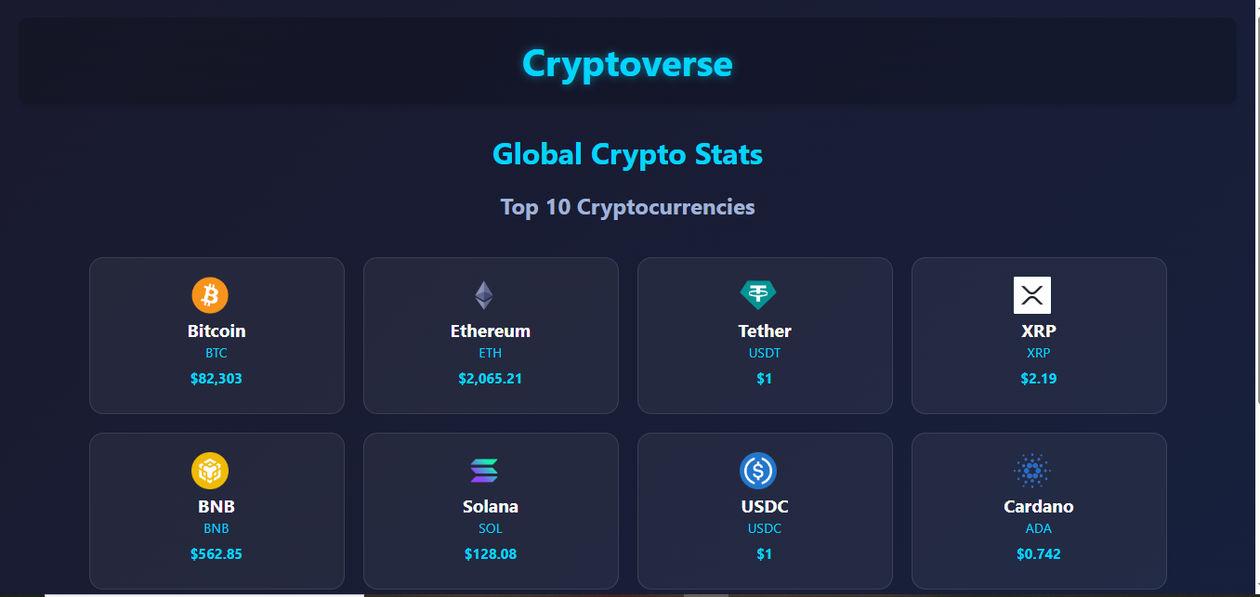

* **All Currencies Page:**

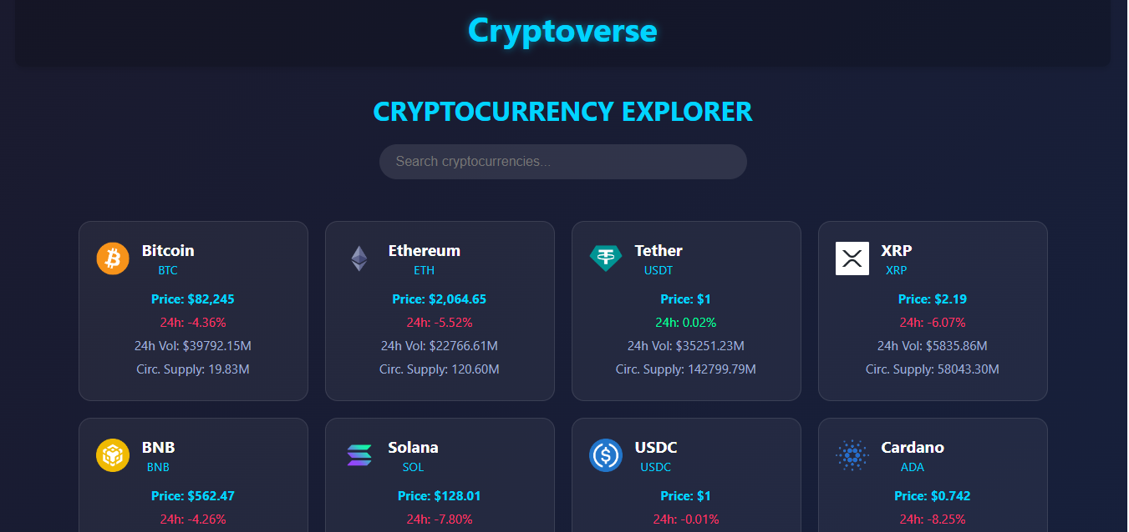

* **Crypto Details Page**:

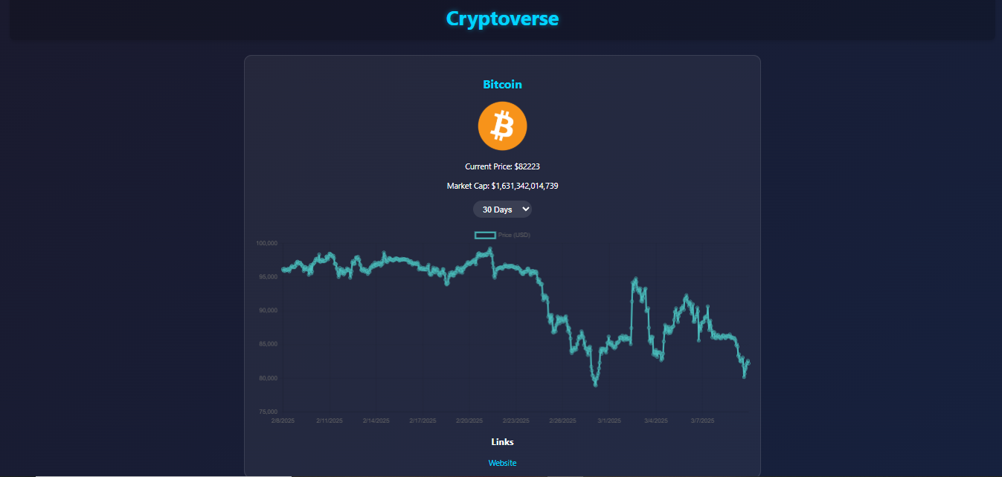

**Known Issues**

* API rate limits may impact data updates.
* UI responsiveness improvements needed for smaller screens.

**Future Enhancements**

* **User Authentication**: Enable user accounts and watchlists.
* **Portfolio Tracking**: Allow users to track their crypto investments.
* **Push Notifications**: Real-time alerts for price changes.

**References**

* **React.js Documentation**: [React Official Docs](https://reactjs.org/)
* **Redux Toolkit**: [Redux Toolkit Docs](https://redux-toolkit.js.org/)
* **CoinGecko API**: [CoinGecko API Docs](https://www.coingecko.com/en/api/documentation)
* **Chart.js**: [Chart.js Docs](https://www.chartjs.org/docs/latest/)
* **React Router**: [React Router Docs](https://reactrouter.com/)

**Conclusion**

The Cryptoverse Dashboard provides an intuitive and feature-rich cryptocurrency tracking platform using React.js, Redux, and Chart.js. With real-time data visualization and market analytics, this project serves as an essential tool for crypto investors and enthusiasts. Future enhancements such as portfolio tracking and authentication will further elevate its capabilities.