**HEXAWARE TRAINING**

**DAY 2 : 18-07-2025**

**MONGO DB**

* It is a No SQL Database.
* Stored data in flexible JSON like documents.

**NEED FOR NOSQL:**

* SQL Stores data’s in table format and are fixed.
* These data’s are to be joined to get a useful information.
* NoSQL offers Scalability and Flexibility.
* No different tables are needed. All are clustered.

**EXAMPLE:**

|  |  |
| --- | --- |
| **SQL** | **NoSQL** |
| * Structured data * In form of tables.(rows/columns) * Fixed Schema * Supports complex Joins * Vertical Scalability * MySQL/ MSSQL is used * EX: customer, product, order in different tables | * Unstructured/semi – structured data * Document based * Dynamic Schema * Supports limited joins * Horizontal Scalability * MongoDB is used * EX: customer{   Product{  Order{}  }  } |

**WHY MONGO DB:**

* Schema – less: No predefined structure needed.
* Scalable: Good for big and real time data.
* Flexible: Supports powerful filters and indexing.
* Document – Oriented: Easier to represent real time data.

**COMPARISION OF TERMS BETWEEN SQL AND NoSQL:**

| **SQL Term** | **NoSQL Term (MongoDB)** |
| --- | --- |
| Database | Database |
| Table | Collection |
| Row | Document |
| Column | Field / Key |
| Schema | Dynamic (Schema-less) |
| Primary Key | _id (default) |
| Foreign Key | Reference |
| JOIN | $lookup (Aggregation) |
| Index | Index |
| INSERT INTO table | db.collection.insert() |
| SELECT * FROM table | db.collection.find() |
| UPDATE table SET | db.collection.update() |
| DELETE FROM table | db.collection.delete() |

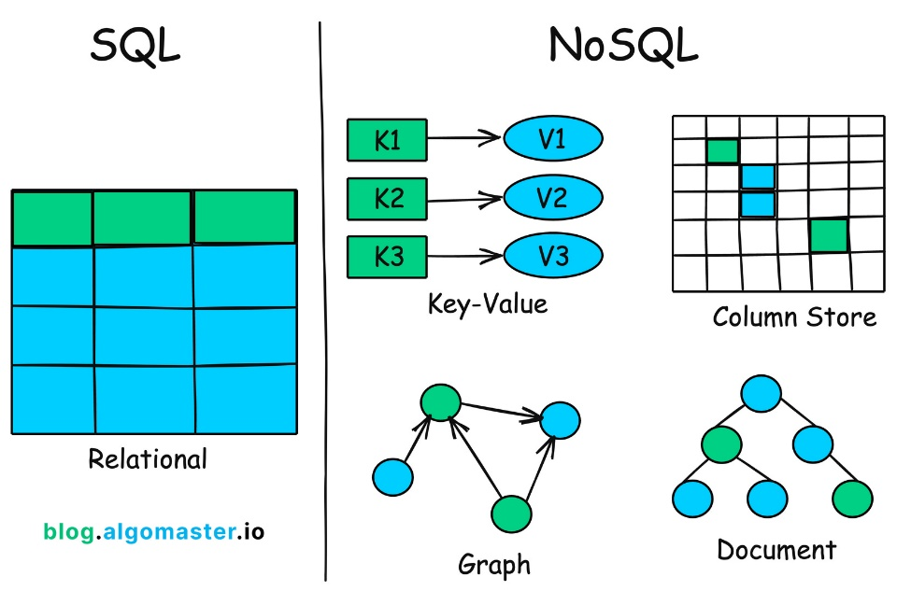

**History of NoSQL**

1. **1970s–1980s**
   * SQL and relational databases (like Oracle, MySQL) became popular.
   * Data was stored in tables with fixed schemas.
2. **Late 1990s**
   * The internet and web apps grew fast.
   * Relational databases struggled to handle huge, unstructured, and fast-changing data.
3. **Early 2000s**
   * Big companies like Google and Amazon needed faster, more flexible databases.
   * They created custom solutions like Google Bigtable and Amazon Dynamo.
4. **2009 – The Term "NoSQL" Was Coined**
   * A developer named Johan Oskarsson organized a meetup using the term "NoSQL" to describe non-relational databases.
5. **2010s – NoSQL Databases Rise**
   * Databases like MongoDB, Cassandra, CouchDB, Redis became popular.
   * Developers used them for scalability, speed, and flexibility in modern web apps.
6. **Today**
   * NoSQL is widely used in social media, real-time apps, IoT, big data, and cloud computing.
   * Many systems now use both SQL + NoSQL (Polyglot Persistence) depending on the need.

**HORIZONTAL AND VERTICAL SCALING:**

|  |  |
| --- | --- |
| HORIZONTAL SCALING | VERTICAL SCALING |
| * Add more computers * Used by NoSQL * Data stored across machines * Adding more servers * One fail = other can help * More complex to manage | * Make a computer more powerful * Used by SQL * Data is stored on one machine * Upgrading RAM * One fail = total system down * Easier to manage |

