DATA SCEINCE & MACHINE LEARNING:
LAB CYCLE 1
- Program to Print all non-Prime Numbers in an Interval

Program
first=int(input("enter the lowerlimit:"))
last=int(input("enter the upperlimit:"))
for num in range(first,last + 1):
if num > 1:
for i in range(2,num):
if(num % i == 0):
print(num)
break
Output
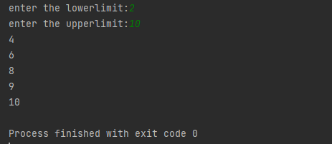

- Program to print the first N Fibonacci numbers.
Program
n = int(input("Enter the value of n: "))
a = 0
b = 1
sum = 0
count = 1
print("Fibonacci Series: ", end = " ")
while(count <= n):
print(sum, end = " ")
count += 1
a = b
b = sum
sum = a + b
Output
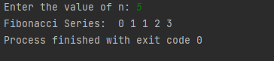

- Given sides of a triangle, write a program to check whether given triangle is an isosceles, equilateral or scalene.
Program
x=int(input("enter the side 1"))
y=int(input("enter the side 2"))
z=int(input("enter the side 3"))
if x == y == z:
print("Equilateral Triangle")
elif x == y or y == z or z == x:
print("Isosceles Triangle")
else:
print("Scalene Triangle")
Output
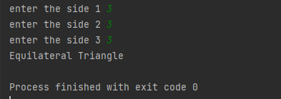
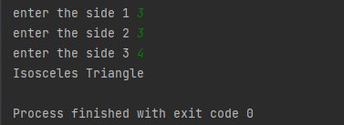
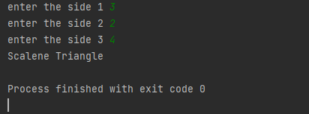

- Program to check whether given pair of number is coprime
Program

def __gcd(a, b):

if (a == 0 or b == 0): return 0

if (a == b): return a

if (a > b):
return __gcd(a - b, b)

return __gcd(a, b - a)
def coprime(a, b):
if (__gcd(a, b) == 1):
print("Co-Prime")
else:
print("Not Co-Prime")

a = int(input("Enter the number:"))
b = int(input("Enter the number:"))
coprime(a, b)

Output
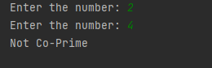

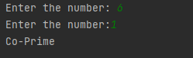

- Program to find the roots of a quadratic equation(rounded to 2 decimal places)

Program
from math import sqrt

print("Quadratic function : (a * x^2) + b*x + c")
a = float(input("a: "))
b = float(input("b: "))
c = float(input("c: "))

r = b**2 - 4*a*c

if r > 0:
num_roots = 2
x1 = (((-b) + sqrt(r))/(2*a))
x2 = (((-b) - sqrt(r))/(2*a))
print("There are 2 roots: %f and %f" % (x1, x2))
elif r == 0:
num_roots = 1
x = (-b) / 2*a
print("There is one root: ", x)
else:
num_roots = 0
print("No roots, discriminant < 0.")
exit()
Output
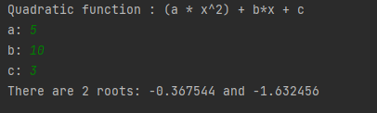

- Program to check whether a given number is perfect number or not(sum of factors =number)
Program

- Program to display amstrong numbers upto 1000
Program
for num in range(1,1000):
temp=num
sum=0
while temp>0:
digit=temp%10
sum=sum+digit**3
temp=temp//10
if sum==num:
print (num)
Output
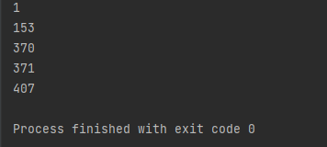
- Store and display the days of a week as a List, Tuple, Dictionary, Set. Also demonstrate different ways to store values in each of them. Display its type also.
Program
list = ["Sun","Mon","Tue","Wed","Thu","Fri","Sat"]
print(type(list))
print(list)
tuple = ("Sun","Mon","Tue","Wed","Thu","Fri","Sat")
print(type(tuple))
print(tuple)
set = {"Sun","Mon","Tue","Wed","Thu","Fri","Sat"}
print(type(set))
print(set)
dict = {
"d1" : "Sun",
"d2" : "Mon",
"d3" : "Tue",
"d4" : "Wed",
"d5" : "Thu",
"d6" : "Fri",
"d7" : "Sat"
}
print(type(dict))
print(dict)

Output
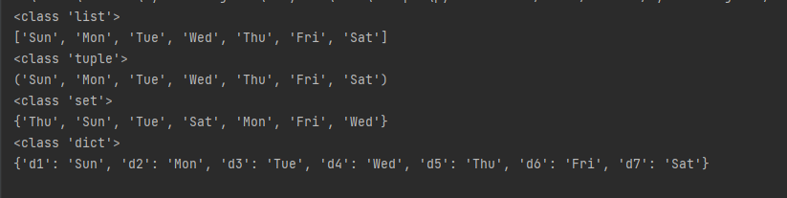
- Write a program to add elements of given 2 lists
Program
n = int(input("Enter the size of the list1 "))
lt1 = list(int(num) for num in input("Enter the list items separated by space ").strip().split())[:n]
n = int(input("Enter the size of the list2 "))
lt2 = list(int(num) for num in input("Enter the list items separated by space ").strip().split())[:n]
print(" Python list 1 : " , lt1)
print("Python list 2 : " ,lt2)
res_lt = [lt1[x] + lt2[x] for x in range(len(lt1))]
print(" Addition of the list lt1 and lt2 is: " + str(res_lt))
Output
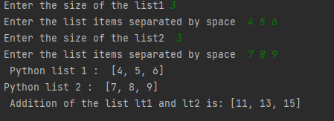
- Write a program to find the sum of 2 matrices using nested List.
Program
r=int(input("Enter the number of rows:"))
c=int(input("Enter the number of columns:"))

print("Enter the elements of First Matrix:")
m1= [[int(input()) for i in range(c)] for i in range(r)]

print("Enter the elements of Second Matrix:")
m2=[[int(input()) for i in range(c)] for i in range(r)]

print("First Matrix is: ")
for n in m1:
print(n)

print("Second Matrix is:")
for n in m2:
print(n)

r=[[0 for i in range(c)] for i in range(r)]

print("Matrix After Addition:")
for i in range(len(m1)):
for j in range(len(m2)):
r[i][j] = m1[i][j] + m2[i][j]

for n in r:
print(n)
Output
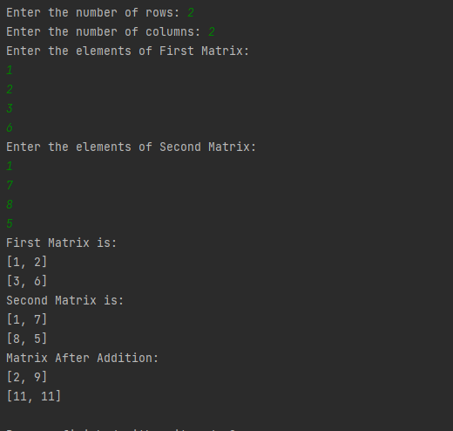

- Write a program to perform bubble sort on a given set of elements.
Program
def bubble_sort(list1):

for i in range(0, len(list1) - 1):
for j in range(len(list1) - 1):
if (list1[j] > list1[j + 1]):
temp = list1[j]
list1[j] = list1[j + 1]
list1[j + 1] = temp
return list1

n = int(input("Enter the size of the list1 "))
list1 = list(int(num) for num in input("Enter the list items separated by space ").strip().split())[:n]
print("The unsorted list is: ", list1)
print("The sorted list is: ", bubble_sort(list1))
Output
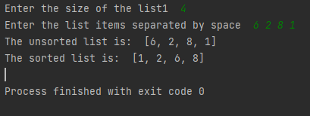
- Program to find the count of each vowel in a string(use dictionary)
Program
vowels = 'aeiou'
user_input = input("Enter a string: ")
string = user_input.casefold()
count_vowels = {}.fromkeys(vowels, 0)
for x in string:
if x in count_vowels:
count_vowels[x] += 1

print("Total number of vowels - ", count_vowels)
Output
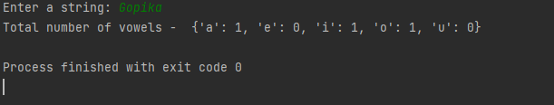
- Write a Python program that accept a positive number and subtract from this number the sum of its digits and so on. Continues this operation until the number is positive

Program
def repeat_times(n):
s = 0
n_str = str(n)
while (n > 0):
n -= sum([int(i) for i in list(n_str)])
n_str = list(str(n))
s += 1
return s
print(repeat_times(9))
print(repeat_times(21))
Output
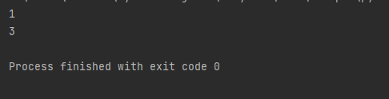

- Write a Python program that accepts a 10 digit mobile number, and find the digits which are absent in a given mobile number
Program
mobile = input('Please enter a mobile number: ' )
all = '0123456789'
print('missing digits are ', set(all) - set(mobile))
Output
