## Hardware Requirements

The following hardware components have been incorporated to design the network.

1. Routers: These network devices operate on layer 3 of the OSI model; their primary function is to route data packets between different computer networks. The CISCO2811/K9 router is the router of choice for this project.

1. Switches: These network devices operate on layer 2 of the OSI model. Their primary function is to connect devices within the same local area network (LAN). The Cisco Catalyst 2950T 24 Switch is the switch of choice for this project.

1. End Devices: End devices refer to any device on the network that serves as the ultimate source or destination data. This project makes use of laptops, desktop computers, and servers as end devices.

1. Cables: The right cable must be used to connect different network devices. This project uses copper cross-over, straight-through, and serial DCE cables.

|  |  |  |
| --- | --- | --- |
| Device Name | Model | Quantity |
| Router | CISCO 2811/K9 | 4 |
| Switch | 2950T 24 | 60 |
| Cables | Copper cross-over, Copper straight-through, DCE | As per requirement |
| Servers | SERVER-PT | 8 (Including backups) |
| PCs | PC-PT | 1664 |

# Network Topologies in the Design:

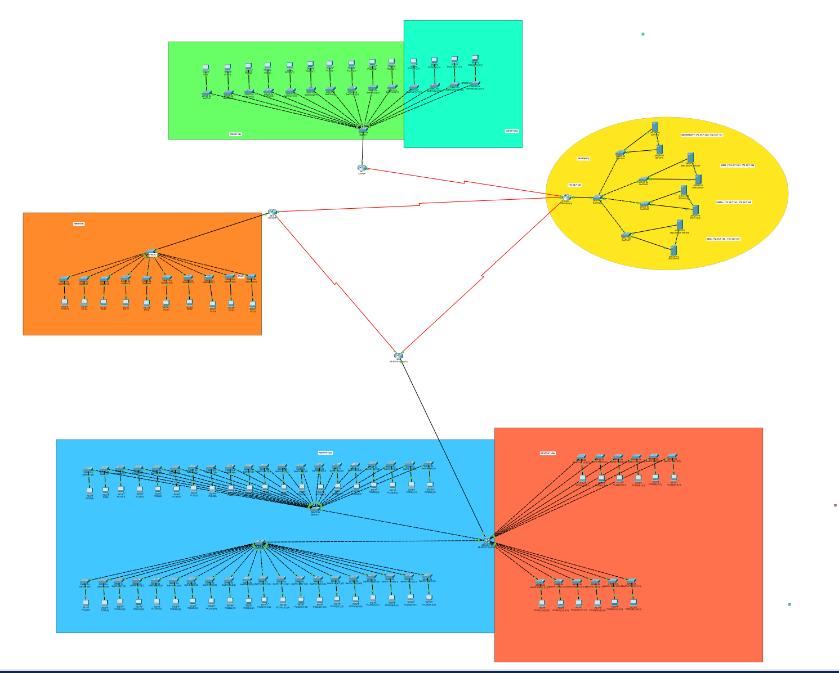

In the network design of the network for the Faculty of Science and Technology, a mix of star  and hierarchical topologies are used to promote the blended teaching for both on-campus  and online lab sessions.The faculty's labs are all equipped with these topologies to guarantee effective connectivity, scalability, and security.

1. Hierarchical Topology: The network is arranged into several layers or levels according to a hierarchical topology used in the network design. In the network hierarchy, the Hatchcroft, College, and Ritterman buildings are the three buildings that make up the faculty. The network can be better managed, organised, and scaled as a result to its hierarchical structure.

The advantages of the hierarchical topology are as follows:

- Simple network management: Since each building can be handled independently, it is simpler to keep an eye on and address network problems in particular locations.

- Scalability: New labs can be added to the hierarchical structure without affecting the operation of the network as a whole. The current network infrastructure can be easily integrated with the ten additional labs that are planned—six of which will be located in the Ritterman building and four in the College building.

- Effective resource allocation: The hierarchical design makes it possible to distribute services and resources in accordance with the unique requirements of every lab and building.

2. Star Topology: A star topology is used within every lab. Every device, like a terminal, is linked to a central networking device, like a switch or router, in a star topology. The hub for communication between the lab's devices is this central device.

The following advantages of the star topology are offered:

- Effective data transmission: Quick and dependable communication between lab equipment is made possible by the central hub. Efficient transmission is ensured because data can move straight between the devices and the central hub without going via any other devices.

- Simplified troubleshooting: The star topology facilitates the identification and isolation of the troubling device without compromising the network's overall performance in the event of any problems or failures.

- Easy management: By offering a single point of configuration and control, the central hub makes managing separate labs easier.

3. Internetworking and Isolation: The network infrastructure of the upcoming new lab additions will be internetworked with the current labs housed in the same building. The old and new labs can communicate and share resources with ease thanks to this internetworking.

In addition, every faculty lab is cut off from the corporate network of the university. Sensitive information and resources are protected by this isolation, which makes sure the lab network stays distinct and safe from the corporate network. To ensure that every room has the essential connectivity to the corporate network as well as the Internet, a controlled connection is set up. The controlled connection keeps the environment safe and controlled while guaranteeing that the labs have access to the resources they need.

To sum up, the Faculty of Science and Technology's network architecture combines star and hierarchical topologies. The network is divided into building nodes by the hierarchical topology, which allows for efficient management and scalability. A star topology is used in every lab to facilitate effective communication and easy management. Along with isolating labs from the university's corporate network and ensuring internetworking between the old and new labs, the network design also offers a controlled connection for essential access. The faculty requirements are met by this combination of topologies, which supports blended learning for online classes as well as on-campus lab sessions.