EXP 8 - Configuring User Management and Role-Based Access Control (RBAC) in a Zoho Creator Application — Hotel Management System

1. AIM
To configure user management and role-based access control (RBAC) for the "Hotel Management" application in Zoho Creator, so that every category of staff — Manager, Front Office Executive, Housekeeping Executive, Executive Chef, Restaurant Cashier, Waiter, and portal-based staff — is assigned an appropriately scoped role and permission profile, record visibility follows the reporting hierarchy, and the application interface is localized correctly for each user, without granting any user access beyond what their role requires.

2. Procedure

2.1 Defining Roles and the Role Hierarchy
1. Open the application in Zoho Creator and go to Settings > Permissions > User Permissions > Roles tab. Select the "Manager" role, set "Reports to" as CEO, and add a description such as "Manages and reviews hotel booking records".
2. Enable "Share Data with Peers" so that users placed under the same role can view each other’s records, and under the Role Hierarchy table enable role hierarchy for the "Hotel_Booking_Form" module with Record Owner set to "Added User".
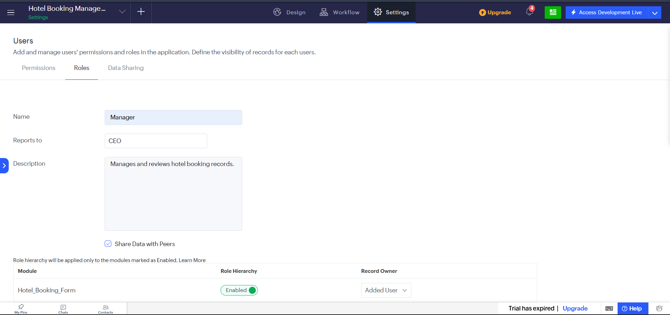
Fig 2.1: Roles tab — Manager role configured with reporting hierarchy and module-level role hierarchy
Explanation: The "Reports to" field builds the reporting chain (Manager → CEO) that Zoho Creator uses to decide which records a role can see above its own. Enabling role hierarchy on "Hotel_Booking_Form" means a Manager automatically inherits visibility over booking records owned by the staff reporting to them, while "Share Data with Peers" extends that visibility sideways to others holding the same role — together this defines the vertical and horizontal reach of the Manager role’s access.

2.2 Creating Permission Profiles for Each Staff Category
3. Go to Settings > Permissions > User Permissions > Permissions tab and click "Add Permission" to create a separate permission profile for every staff category that uses the application — Executive Chef, Front Office Executive, Housekeeping Executive, Manager, Manager_Permission, Restaurant Cashier, Staff_Permission, and Waiter — each with its own descriptive profile name.
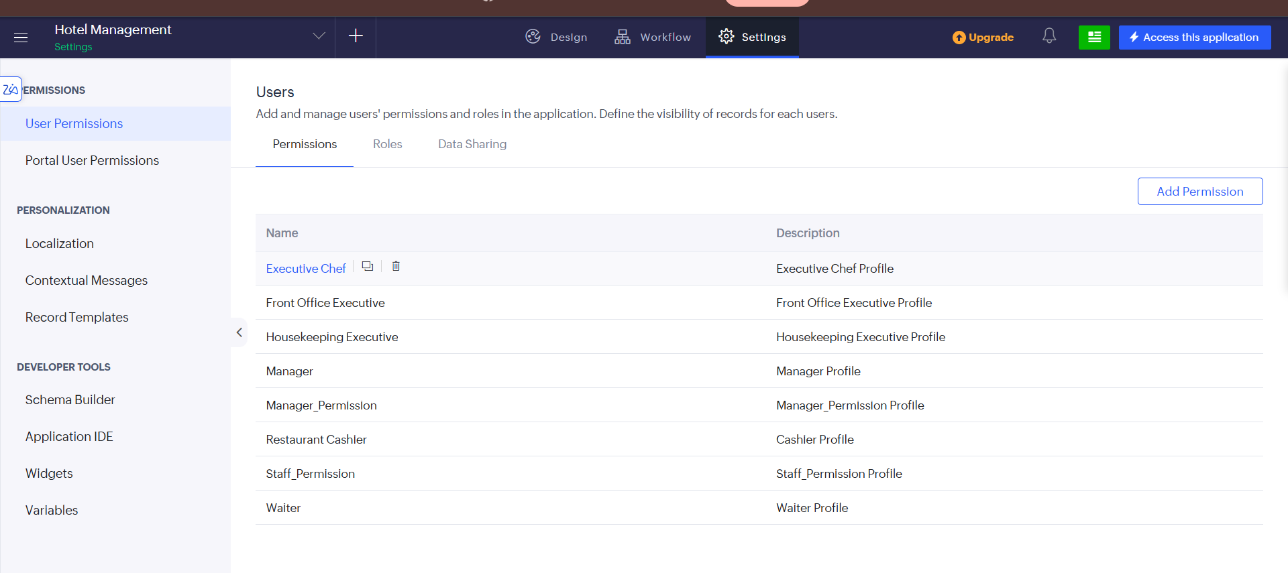
Fig 2.2: Permissions tab listing the individual permission profiles created for each staff role
Explanation: Each permission profile is an independently editable set of module-level and field-level access rights. Splitting staff into named profiles such as Executive Chef, Front Office Executive and Restaurant Cashier — rather than using one shared profile — ensures each role sees and can act on only the forms and reports relevant to its function, which is the core of role-based access control.

2.3 Setting Portal User Permissions
4. Go to the "Portal User Permissions" tab to manage access for portal users — staff or guests who interact with the application from outside the core organisation. Here the "Manager_Permission" and "Staff_Permission" profiles are exposed as portal-level permissions.
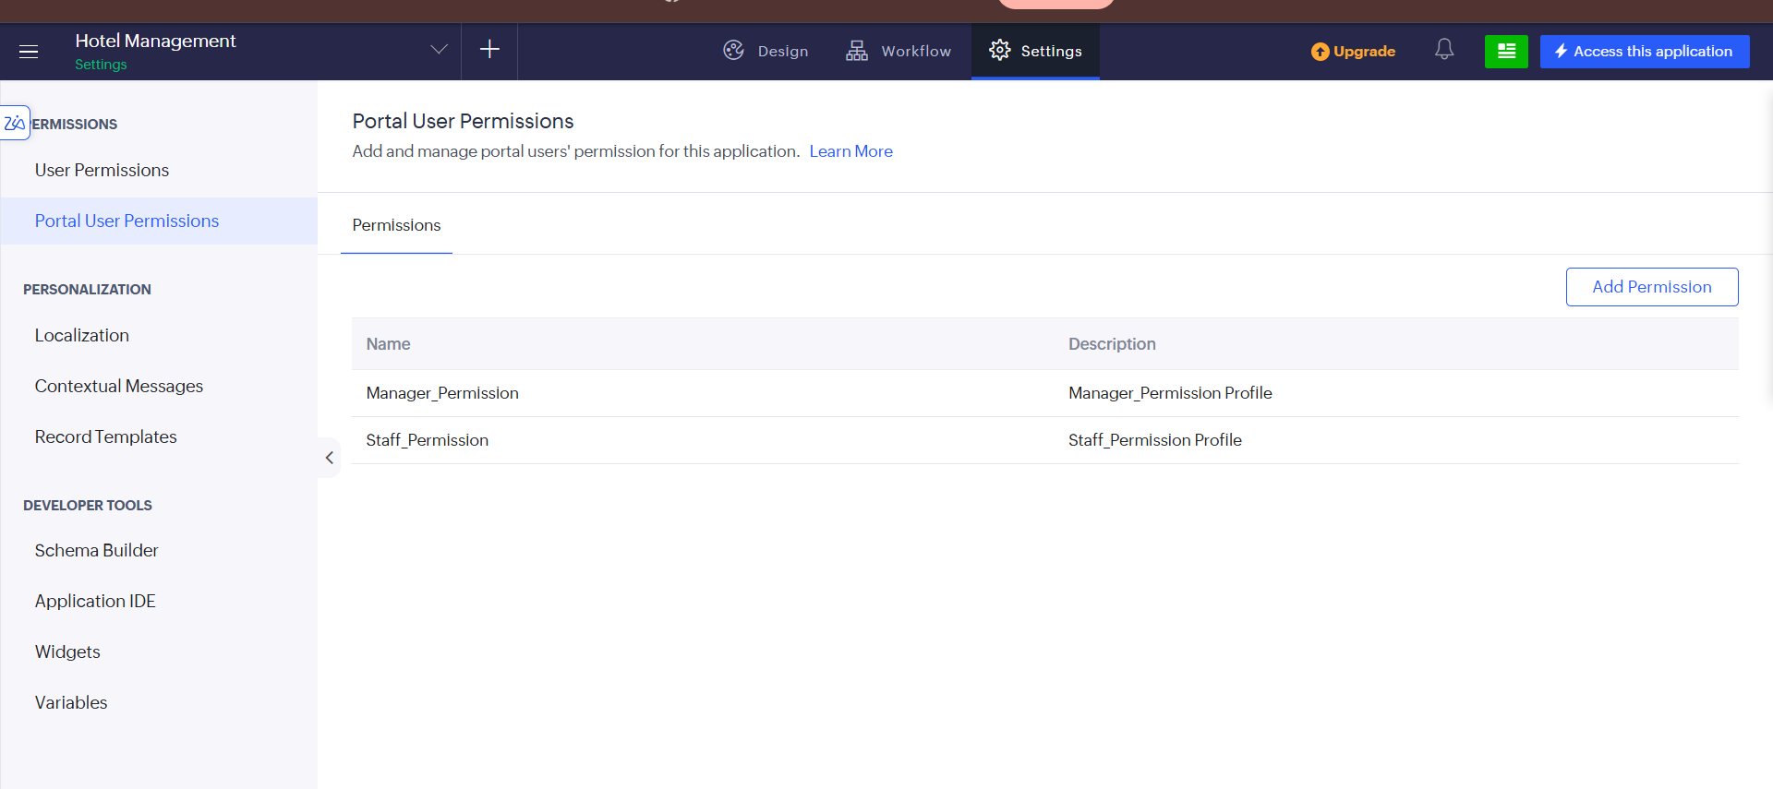
Fig 2.3: Portal User Permissions tab showing the profiles available to portal users
Explanation: Portal users are kept separate from internal application users so that external staff or guest-facing accounts can be granted a restricted subset of permissions — here limited to the Manager_Permission and Staff_Permission profiles — without exposing the full set of internal roles or developer-facing settings.

2.4 Configuring Application Localization
5. Go to Settings > Personalization > Localization and choose which language the application should use. "User’s browser language" is selected, alongside the option to fall back to English as the default language.
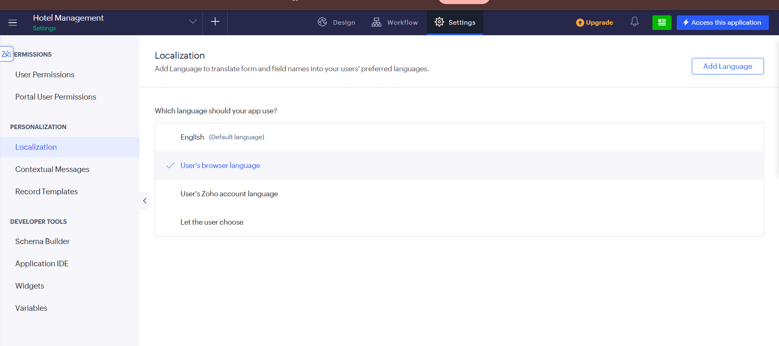
Fig 2.4: Localization settings for the application
Explanation: Localization works alongside RBAC to make the application usable for every role: once a user’s permission profile determines what they can access, the localization setting determines the language in which that form or field content is displayed to them, based on their browser, their Zoho account language, or a language they choose themselves.

2.5 Verifying Workflow Automations Under the Configured Roles
6. Go to the Workflow tab > Form workflows to confirm that the automations tied to role-driven actions — such as "Add Tax Type" and "Add Check In" — remain Enabled and continue to run correctly regardless of which permitted role triggers them.
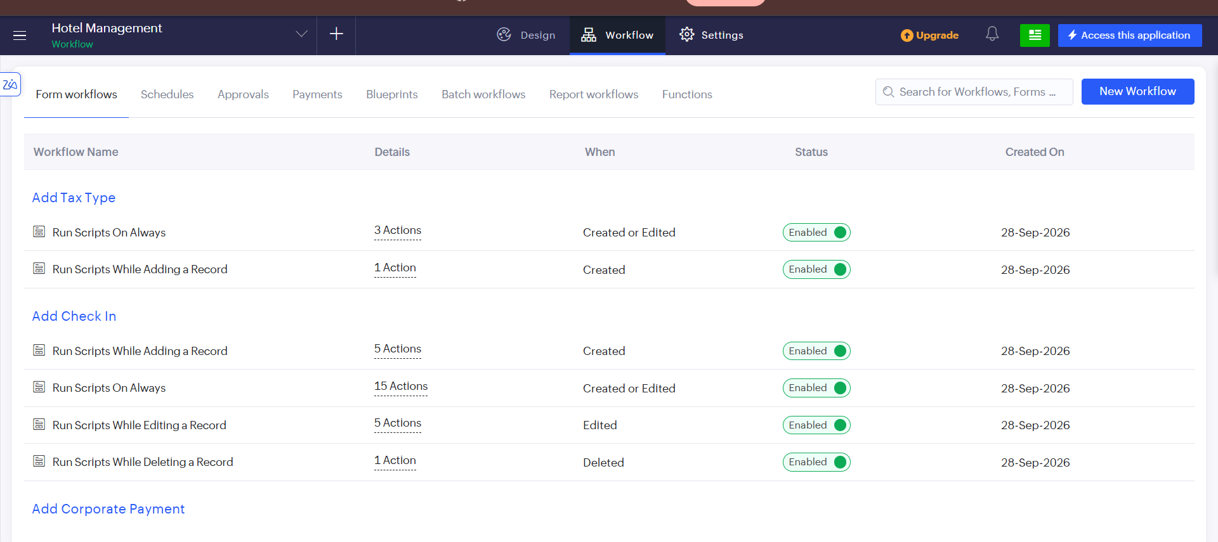
Fig 2.5: Form workflows list showing the automations enabled for the booking and check-in modules
Explanation: Workflows such as "Run Scripts While Adding a Record" and "Run Scripts On Always" fire on Created, Edited, or Deleted record events. Because these automations sit beneath the permission and role layer, they execute consistently no matter which authorised role (Manager, Front Office Executive, and so on) performs the create, edit, or delete action, confirming that RBAC and workflow automation operate together without conflict.

3. Output
Once the roles, permission profiles, portal permissions, and localization settings were saved, the Settings home page consolidated the full access-control configuration for the application into a single dashboard.
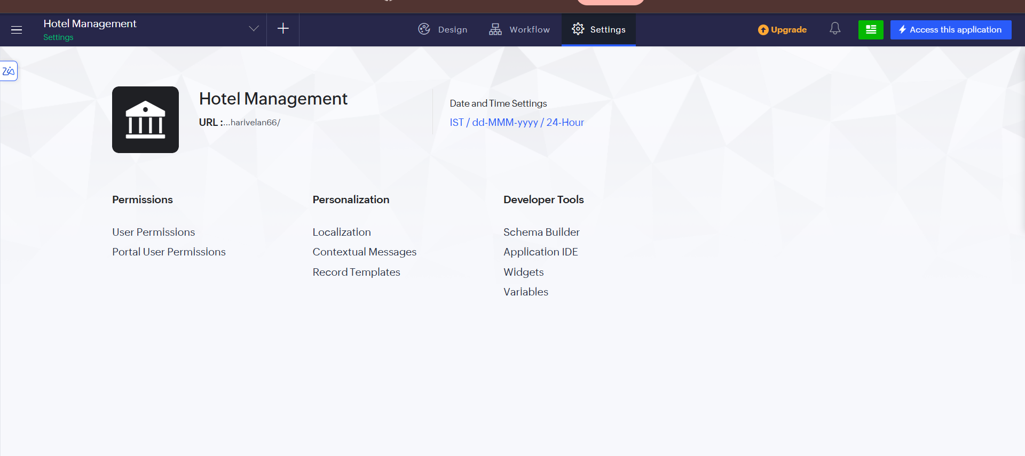
Fig 3: Settings overview showing Permissions, Personalization, and Developer Tools for the Hotel Management application
Explanation: This overview page confirms that User Permissions and Portal User Permissions are configured under Permissions, Localization is set under Personalization, and the Schema Builder, Application IDE, Widgets, and Variables remain available under Developer Tools for further customisation — giving a single point from which the application’s entire RBAC and personalization setup can be reviewed or modified.

4. Result
Role-based access control was successfully configured for the "Hotel Management" application in Zoho Creator. Distinct roles and permission profiles were created for each staff category, a reporting hierarchy was established for the Manager role with module-level record visibility, portal users were restricted to a limited set of permission profiles, and the application interface was localized to the user’s browser language. This ensures every user interacts only with the data and features appropriate to their role, while workflow automations continue to run correctly underneath the configured access layer.

