**Procure To Pay(P2P) process**

**PROJECT REPORT**

***Submitted by***

# S. HARI VISWESH

# (2019272009)

***submitted to the faculty of***

**INFORMATION AND COMMUNICATION ENGINEERING**

***In partial fulfillment of the requirement for the degree***

***of***

**MASTER OF COMPUTER APPLICATIONS**



**DEPARTMENT OF INFORMATION SCIENCE AND TECHNOLOGY COLLEGE OF ENGINEERING, GUINDY**

**ANNA UNIVERSITY**

**CHENNAI 600025**

**May 2022**

# ANNA UNIVERSITY, CHENNAI

## BONAFIDE CERTIFICATE

Certified that this Report titled “**Procure to pay(P2P) process**” is the bonafide work of **S. Hari viswesh (2019272009)** who carried out the work under my supervision. Certified further that to the best of my knowledge the work reported herein does not form part of any other thesis or dissertation on the basis of which a degree or award was conferred on an earlier occasion on this or any other candidate.

**PLACE**: CHENNAI KANIMOZHI.S

**DATE**: 23/05/2022 TEACHING FELLOW

PROJECT GUIDE

DEPARTMENT OF IST,CEG

ANNA UNIVERSITY

CHENNAI 600025

**COUNTERSIGNED**

**Dr. S. SRIDHAR**

**HEAD OF THE DEPARTMENT**

**DEPARTMENT OF INFORMATION SCIENCE AND TECHNOLOGY**

**COLLEGE OF ENGINEERING, GUINDY**

**ANNA UNIVERSITY**

**CHENNAI 600025**

**ACKNOWLEDGEMENT**

Its my privilege to express my sincere thanks to my project guide **Ms.S.KANIMOZHI**, TEACHING FELLOW, Department of Information Science and Technology, College of Engineering, Guindy, Anna University, Chennai for her keen interest, inspiring guidance, constant encouragement and support with my work during all the stages, to bring this thesis into fruition.

I deeply express my sincere thanks to **Dr. S. SRIDHAR**, Professor and Head of the Department, Department of Information Science and Technology, College of Engineering, Guindy, Anna University, Chennai for extending support.

I would like to express my sincere thanks to the project committee members, **Dr.SASWATI MUKHERJEE**, PROFESSOR, **Dr.M.VIJAYALAKSHMI**, ASSOCIATE PROFESSOR, **Dr.E.UMA**, ASSISTANT PROFESSOR, **MS.C.M.SOWMYA**, TEACHING FELLOW, **MS.P.S.APIRAJITHA**, TEACHING FWLLOW, Department of Information Science and Technology, Anna University, Chennai for giving their valuable suggestions, encouragement and constant motivation throughout the duration of my project.

S.HARI VISWESH

## TABLE OF CONTENTS

|  |  |  |
| --- | --- | --- |
| **CHAPTER NO.**  1 | **TITLE**  **ABSTRACT**  **INTRODUCTION** | **PAGE NO.**  7 |
|  | 1.1 General | 8 |
|  | 1.2 Problem Statement | 8 |
|  | 1.3 Objective  1.4 Technologies used | 9  9 |
| 2 | **LITERATURE REVIEW** |  |
|  | 2.1 Hybrid Recommendation | 10 |
|  | 2.2 Recommendation System | 11 |
| 3 | **OVERALL ARCHITECTURE**  3.1 Architecture design  3.2 List of Modules | 12  14 |
|  |  |  |
| 4 | **DETAILED DESIGN**  4.1 Maintaining Vendor Details  4.2 Maintaining Vendor Site BU  4.3 Mapping NDC with Vendor Site and BU  4.4 Defining Vendor Site BU & NDC Price | 15  16  17  18 |
| 5 | **IMPLEMENTATION AND RESULTS** | 19 |
| 6 | **CONCLUSION AND FUTURE WORK**  **REFERENCES** | 25  26 |

# LIST OF FIGURES

3.1 Over-all Architecture 13

3.1.1. Recommendation Architecture diagram 15

3.1.2 Forecasting analysis architecture diagram 16

4.1 vendor maintenance flow diagram 17

4.2 vendor BU map flow diagram 18

4.3 vendor NDC map flow diagram 19

4.4 vendor NCD price map flow diagram 20

5.1 Vendor main screen 21

5.2 Vendor BU mapping basic info 22

5.2.1 Vendor BU mapping other info 23

5.3 Vendor NCD mapping screen 24

5.4 Vendor site NCD price mapping screen 25

# LIST OF ABBREVIATIONS

SCM Supply Chain Management

# ABSTRACT

P2P platform will be platform enabling determining appropriate Inventory needs based on demand/forecast and the subsequent Procurement, Invoicing and Payment processes. Demand forecasting is the process of using analysis of historical data to estimate and predict customers' future demand for a product. Demand forecasting helps the business make better-informed supply decisions that estimate the total sales and revenue for a future period of time. Based on Demand forecasting output and vendor recommendation, Procurement system will process of sourcing and purchasing goods from an external source, like a third-party vendor or supplier. It will help to procure goods with limited resources and reduced capabilities. Finally accounting system controlled all invoice & Payment documents between third-party vendor or supplier and P2P. It will produce discrepancies and shows 3-way match like quantity ordered, received, and billed.

# CHAPTER 1

# INTRODUCTION

* 1. **General**

Procure-to-pay is the process of integrating purchasing and accounts payable systems to create greater efficiencies. It exists within the larger procurement management process and involves four key stages: selecting goods and services enforcing compliance and order; receiving and reconciliation; invoicing and payment

* 1. **Problem Statement**

Rushing to Place Orders

* In some cases, your purchasing department might place an order with a preferred vendor without checking with others to look for discounts or special offers.
* If this is the case, your business might be spending more on essentials items than it needs to pay. You want to have a way for your company to price check your top purchases and comparison shop vendors without wasting a lot of time or sacrificing quality.

Negotiating With Vendors

* When you need materials or stock in your warehouse, it’s easy to just place the order and move on. However, as part of the procure to pay cycle, you want to get the supplies and raw materials for a price that helps you get the most bang for your budget.

Mistakes in Ordering

* Whether your warehouse manager places orders online or handwrites them as the first step in the procure to pay cycle, there is always the chance that the wrong item can get ordered. It’s possible that the wrong number of an item gets ordered.
* This crucial first step in the procure to pay cycle can have an effect on the other steps if not resolved immediately. It helps to have a good working relationship with all of your suppliers to resolve a mistake without it turning into a big deal.
  1. **Objective**

The procure-to-pay (P2P) is the process to procure goods or services from vendor based on the recommendation and Demand forecasting output and ends with the payment for those goods or services. the recommendation system recommends the vendor based on product requirement from the user and product price, product delivery time and previous vendor behavior of each and every vendor

* 1. **Technologies used**

**Programming Language:**  Java, Jsp, Jsp servlet

**Front-end Technologies:** HTML, CSS and JS

**Database:** MySQL

**IDE:** Eclipse IDE

**CHAPTER 2**

**LITERATURE REVIEW**

This Chapter explains about the literature survey made on the existing system, analyzing the problem statements and issues with the existing system and proposed objectives for the new system.

**2.1 Hybrid Recommendation**

A Hybrid Recommendation System for Marine Science with the development of ocean exploration technology and the rapid growth in the amount of marine science observation data, people are faced with a great challenge to identify valuable data from the massive ocean observation data. A recommendation system is an effective method to improve retrieval capabilities to help users obtain valuable data. The two most popular recommendation algorithms are collaborative filtering algorithms and content-based filtering algorithms, which may not work well for marine science observation data given the complexity of data attributes and lack of user information. In this study, an approach was proposed based on data similarity and data correlation. Data similarity was calculated by analyzing the subject, source, spatial, and temporal attributes to obtain the recommendation list. Then, data correlation was calculated based on the literature on marine science data and ranking of the recommendation list to obtain the re-rank recommendation list. The approach was tested by simulated datasets collected from multiple marine data sharing websites, and the result suggested that the proposed method exhibits better effectiveness. Recommendation systems have become more important and popular in many application areas such as music, movies, e-commerce, advertisement and social networks. Recommendation systems use either collaborative filtering, content-based filtering or hybrid filtering in order to propose items to users, and each type has its weaknesses and strengths. In this paper, we present the results of a literature review that focuses specifically on hybrid recommendation systems. The objective of this review is to identify the problems that hybrid filtering tends to solve and the different techniques used to this end.

**2.2 Recommendation System**

A Survey of Recommendation Systems reviews the research trends that link the advanced technical aspects of recommendation systems that are used in various service areas and the business aspects of these services. First, for a reliable analysis of recommendation models for recommendation systems, data mining technology, and related research by application service, more than 135 top-ranking articles and top-tier conferences published in Google Scholar between 2010 and 2021 were collected and reviewed. Based on this, studies on recommendation system models and the technology used in recommendation systems were systematized, and research trends by year were analyzed. In addition, the application service fields where recommendation systems were used were classified, and research on the recommendation system model and recommendation technique used in each field was analyzed. Furthermore, vast amounts of application service-related data used by recommendation systems were collected from 2010 to 2021 without taking the journal ranking into consideration and reviewed along with various recommendation system studies, as well as applied service field industry data. As a result of this study, it was found that the flow and quantitative growth of various detailed studies of recommendation systems interact with the business growth of the actual applied service field. While providing a comprehensive summary of recommendation systems, this study provides insight to many researchers interested in recommendation systems through the analysis of its various technologies and trends in the service field to which recommendation systems are applied.

**CHAPTER 3**

**OVERALL ARCHITECTURE**

# 

# 3.1 Architecture design

# 

# Figure 3.1: Overall Architecture design

In fig 3.1 explain overall system architecture. The user can create every requirement based on forecasting analysis or third-party web services. User can have already decided the vendor to procure the product. The user can able to assign the vendor directly to the particular product. if the user doesn’t have any idea about assigning a vendor for the product the system recommends some vendor based on the requirement created by the vendor. After assigning the vendor. A purchase order will be generated and send to the vendor The vendor send that product to the warehouse assigned by the user. After getting confirmation from the warehouse regarding the product received user can proceed with the payment process. every requirement can be created by the user or product requirement can be get from the third-party web services from the user based on the user requirement this application recommend some vendor procure the product from the vendor based on the previous vendor transaction between the client after getting vendor. Then the client can send the purchase request to the vendor and purchase order can be created and send to the vendor and send to the warehouse to cross-check the purchase order when the vendor send the product to the warehouse

# Recommendation flow diagram:

# 

# Figure 3.1.1: Recommendation flow diagram

In fig 3.1.1 explain the recommendation system flow vendor recommendation can be done based on the product requirement from the user and product price, product delivery time and previous vendor transaction. Based on the data user can easily find their vendor and procure best product from the vendor with in the time limit. Vendor recommendation can be recommended based on the product requirement from the user and product price, product delivery time and previous vendor transaction

# 

# Forecasting analysis flow diagram:

# 

# Figure 3.1.2: Forecasting analysis flow diagram

In fig 3.1.2 explain forecasting analysis system flow. User can view the forecasting analysis by analyse the history data of total sales, revenue, each product sales, each product requirement, no of purchase order issued, and vendor transaction and that can be represent to the user in from graphical statistics using graphs for better understanding to the user. Based on the result user can find the future demand for the product and easy get product from the vendor in advance before it gets sold out. In the forecasting analysis the system analyse history of total sales, revenue, each product sales, each product requirement, no of purchase order issued, and vendor transaction and represent to the user in from graphical statistics using graphs for better understanding of the user.

# 3.2 LIST OF MODULES:

* Vendor product Mapping
* Vendor Recommendation
* Forecasting Analysis
* User management
* Purchase order creation

**CHAPTER 4**

**DETAILED DESIGN**

# 

# 4.1 Maintaining Vendor Details

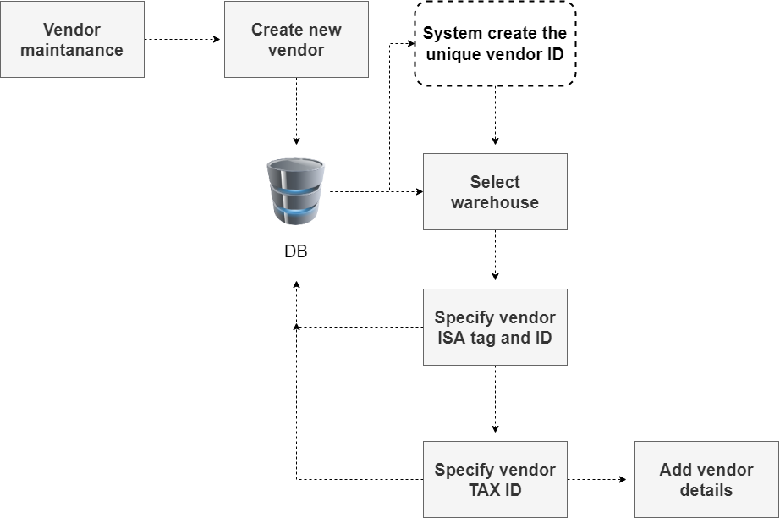

Figure 4.1 vendor maintenance flow diagram

In fig 3.4.1 explain the creating and maintaining the vendor (vendor group) details, which will be used to group the vendor sites. user can create a new Vendor The system automatically generates the Vendor ID. Warehouse can be selected against the Vendor has to be created. Specify unique Vendor ISA Tag / Receiver ID for the Vendor. Specify the Vendor Tax Id. On clicking Submit, the system displays the defined Vendor details in the grid.

# 4.2 Maintaining Vendor Site BU (Business Unit) Map Details:

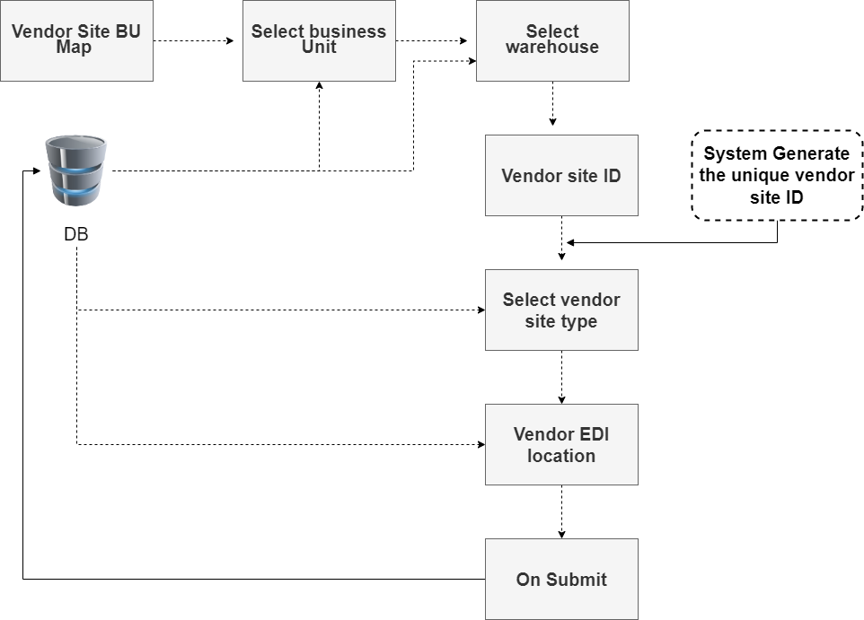

Figure 4.2 vendor BU map flow diagram

In fig 3.4.2 explain the vendor site BU (Business unit) for mapping a Vendor with a Site and maintaining individual vendor details user can select the Business Unit, Warehouse and Site to which the Vendor belongs and click new to create the new Vendor Site ID and specify the description. The system automatically generates the Vendor Site ID. The Select the Vendor Site Type and Vendor Site Sub Type to indicate whether the Vendor Site is of ‘Internal’, ‘Manufacturer’ or ‘Vendor’. The Select the Schedule Method as ‘Morning’, ‘Evening’ or ‘Both’ to indicate whether the inventory computation scheduler must be run only in the morning, evening, or both for the NDCs that are mapped with the Business Unit and Vendor Site. Specify the EDI Location ID. And then Click near Address and specify/select the address of the Vendor Site.

**4.3 Mapping NDC with Vendor Site and BU (Business Unit):**

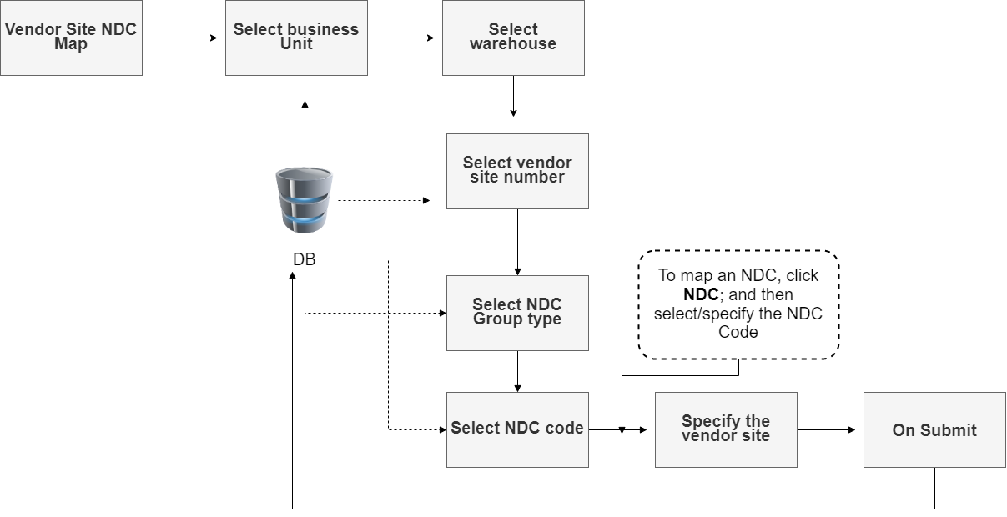

Figure 4.3 vendor NDC mapping flow diagram

In fig 3.4.3 explain vendor site BU (Business Unit) NDC (National Drug Code) mapping an NDC Group/NDC with Vendor Site and BU. Select the Business Unit, Warehouse and Site to which the Vendor belongs. To map a NDC Group, and then click NDC Group Type and select the desired NDC Group Type from the list; and then select/specify the NDC Group Code. To map an NDC, click NDC; and then select/specify the NDC Code. And specify/select the Vendor Site Number to which the selected NDC Group or NDC must be mapped. On clicking Submit, the system displays the defined Vendor Site, BU and NDC mapping details in the grid.

**4.4 Defining Vendor Site BU (Business Unit) NDC Price:**

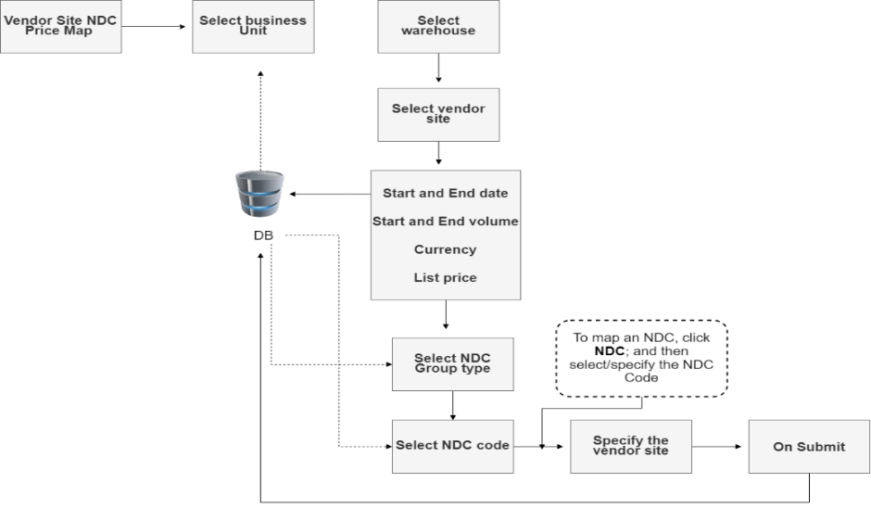

Figure 4.4 vendor maintenance flow diagram

In fig 3.4.4 explain vendor site NDC BU price mapping for defining the NDC price for a specific period against a vendor site and BU. User can Select the Business Unit, Warehouse and Site to which the NDC belongs. Do any one of the following to define price for an NDC or NDC Group: To define price for an NDC, and click NDC and then select/specify the NDC Code. Then Specify/select the Vendor Site Number against which the price must be defined. And select the date range (Start Date and End Date) until which the price is applicable. Specify the Start Volume and End Volume up to which the price is applicable. Select the Currency Cd (Currency Code). Specify the List Price of the NDC. Select the UOM to be used for the list price.

# LIST OF COMPLETED MODULES

**Vendor product mapping:**

* Maintaining Vendor Details
* Maintaining Vendor Site BU (Business Unit) Map Details
* Mapping NDC with Vendor Site and BU (Business Unit)
* Defining Vendor Site BU (Business Unit) NDC Price

**CHAPTER 5**

**IMPLEMENTATION AND RESULTS**

**5.1 Maintaining Vendor Details:**

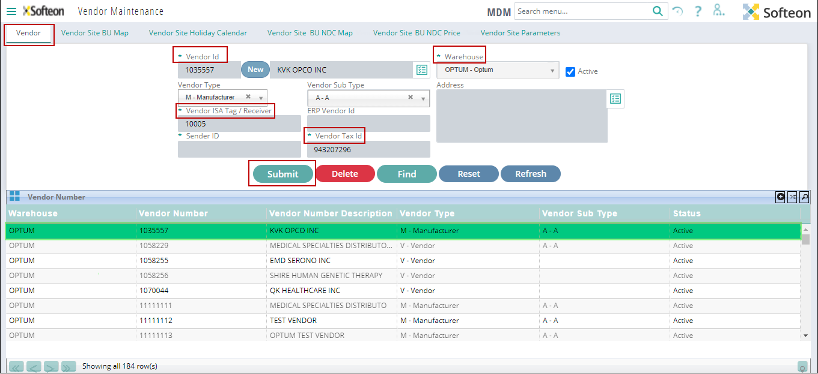

# Figure 5.1: Vendor main screen

In fig 4.1 shows the vendor screen for creating and maintaining the vendor (vendor group) details, and display the created vendor in the grid table. user can use this screen to create and update the vendor details like vendor type, vendor sub type, warehouse, address, Vendor tag, sender id and vendor tax id. vendor can also have access to this page to enter their information through vendor login. In the vendor maintenance page user can able to manage vendor information in order to proceed the future product procurement from the vendor. Based on the valid information from the vendor then only vendor can get order form the client. If any information can wrongly enter that request can be put on hold.

* User can create a new Vendor by click new button
* The system automatically generates the Vendor ID.
* Warehouse can be selected against the Vendor has to be created.
* Specify unique Vendor ISA Tag / Receiver ID for the Vendor.
* Specify the Vendor Tax Id.
* On clicking Submit, the system displays the defined Vendor details in the grid.

**5.2 Maintaining Vendor Site BU (Business Unit) Map Details:**

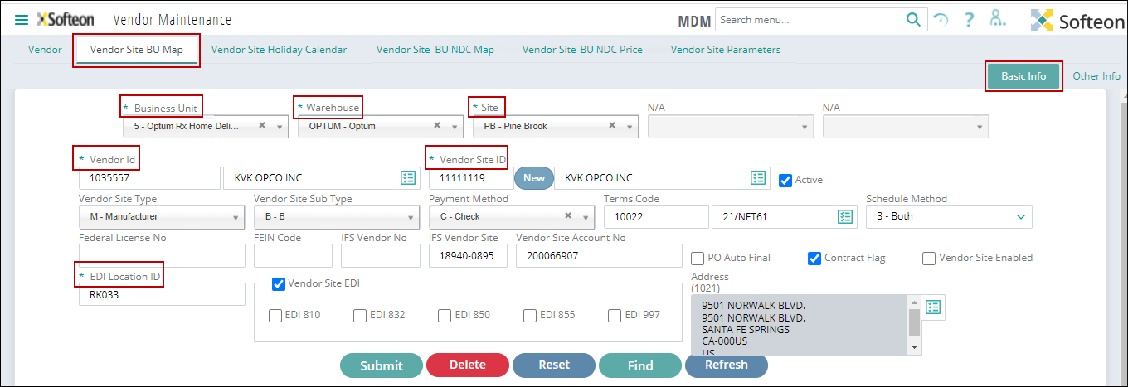

# Figure 5.2: Vendor BU mapping basic info

In fig 4.2 shows the vendor site BU (Business unit) map screen for mapping a Vendor with a Site and Business unit and also maintaining individual vendor details. By click new to create the new vendor site. User can use this page to map vendor with corresponding business unit vendor belongs. vendor can also have access to this page to update their information through the separate vendor login

* Select the Business Unit, Warehouse and Site to which the Vendor belongs
* Click New to create the new Vendor Site ID and specify the description.
* The system automatically generates the Vendor Site ID.
* Select the Vendor Site Type and Vendor Site Sub Type to indicate whether the Vendor Site is of ‘Internal’, ‘Manufacturer’ or ‘Vendor’.
* Select the Schedule Method as ‘Morning’, ‘Evening’ or ‘Both’ to indicate whether the inventory computation scheduler must be run only in the morning, evening, or both for the NDCs that are mapped with the Business Unit and Vendor Site.
* Specify the EDI Location ID.
* Click near Address and specify/select the address of the Vendor Site.

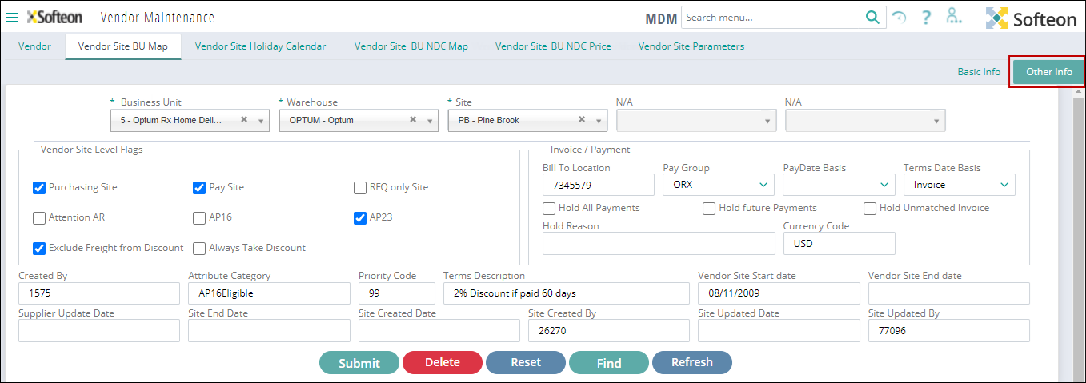

# Figure 5.2.1: Vendor BU mapping other info

In fig 4.2.1 shows the vendor site BU (Business unit) map screen other info for mapping a Vendor with a Site and maintaining individual vendor details user can select the appropriate flag for the vendor belongs and user need to enter the invoice and payment related information like bill to location, pay group, pay date and currency code vendor can also have access to this page to update their information through the separate vendor login

* Select the flag under vendor site level flags section, select the required flags that are applicable for the vendor site.
* Under Invoice/Payment section, specify/select the following:
* Bill To Location
* Currency Code
* Pay Group
* Pay Date Basis
* Terms Date Basis

**5.3 Mapping NDC with Vendor Site and BU (Business Unit):**

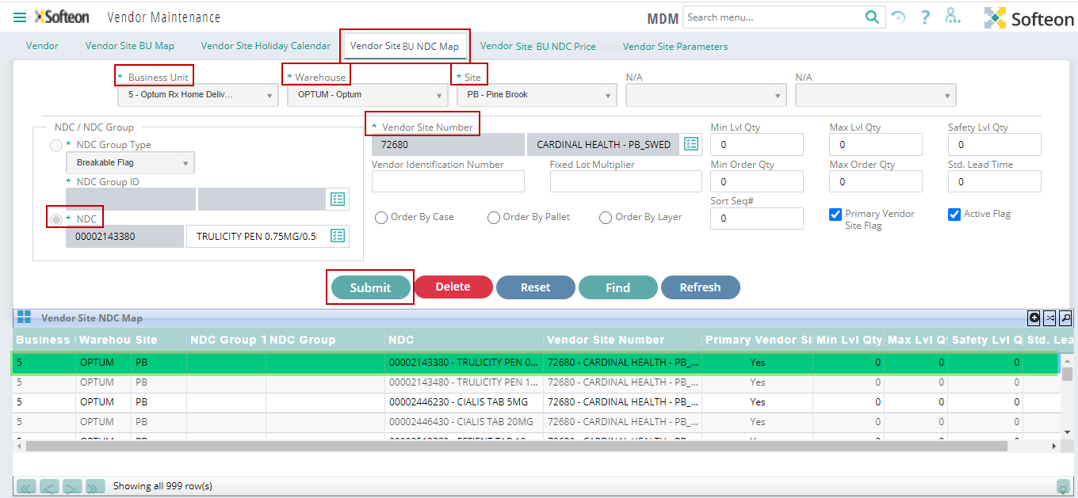

# Figure 5.3: Vendor NDC mapping screen

In fig 4.3 shows the vendor site BU (Business Unit) NDC (National Drug Code) Map screen for mapping an NDC Group/NDC with Vendor Site and BU. user can use this page to map the each NDC or SKU (Stock Keeping Unit) to the corresponding vendor site business unit by entering the SKU id to map each SKU (Stock Keeping Unit) with the business unit vendor can also have access to this page through the vendor login portal. And mapped vendor details can be show in the grid table

* Select the Business Unit, Warehouse and Site to which the Vendor belongs
* To map a NDC Group, click NDC Group Type and select the desired NDC Group Type from the list; and then select/specify the NDC Group Code.
* To map an NDC, click NDC; and then select/specify the NDC Code.
* Specify/select the Vendor Site Number to which the selected NDC Group or NDC must be mapped.
* On clicking Submit, the system displays the defined Vendor Site, BU and NDC mapping details in the grid.

**5.4 Defining Vendor Site BU (Business Unit) NDC Price:**

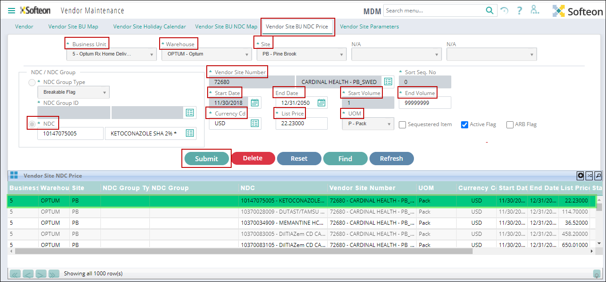

# Figure 5.4: Vendor site NDC price mapping screen

In fig 4.4 shows the vendor site NDC (National Drug Code) BU (Business Unit) Price screen for defining the NDC price for a specific period against a Vendor Site and BU. User can use this page to map the each NDC or SKU with the price against the corresponding vendor site in order manage the vendor SKU price information. Vendor can also have access to this page to update their product price information

* Select the Business Unit, Warehouse and Site to which the NDC belongs.
* Do any one of the following to define price for an NDC or NDC Group:
* To define price for an NDC, click NDC; and then select/specify the NDC Code.
* Specify/select the Vendor Site Number against which the price must be defined.
* Select the date range (Start Date and End Date) until which the price is applicable.
* Specify the Start Volume and End Volume up to which the price is applicable.
* Select the Currency Cd (Currency Code).
* Specify the List Price of the NDC.
* Select the UOM to be used for the list price.
* If required, you can mark the NDC by selecting the ARB Flag check box. PO consolidation logic utilizes the ARB flag to group all lines which are marked for ARB Flag so that they get into a single PO.
* On clicking Submit, the system displays the defined Vendor Site BU NDC price details in the grid.

**CHAPTER 6**

**CONCLUSION AND FUTURE WORK**

**Conclusion:**

The procure-to-pay (P2P) process combines a company’s procurement and accounts payable functions. The process starts when the need arises for goods or services and ends with the payment for those goods or services. Its aim is to make the entire production resources chain as fast, secure, and cost-effective as possible and very useful to client to get better vendor to procure the product in the best price

**Future Work:**

The future implementation of Procure to pay process to develop application with features of fully automation verification process without any manual operation

# REFERENCES

* Song, X., Guo, Y., Chang, Y., Zhang, F., Tan, J., Yang, J., & Shi, X. (2020). A hybrid recommendation system for marine science observation data based on content and literature filtering. Sensors, 20(22), 6414.
* Forouzandeh, S., Rostami, M., & Berahmand, K. (2022). A Hybrid Method for Recommendation Systems based on Tourism with an Evolutionary Algorithm and Topsis Model. Fuzzy Information and Engineering, 1-25.
* Ko, H., Lee, S., Park, Y., & Choi, A. (2022). A Survey of Recommendation Systems: Recommendation Models, Techniques, and Application Fields. Electronics, 11(1), 141.
* Trabelsi, F. Z., Khtira, A., & El Asri, B. (2021). Hybrid Recommendation Systems: A State of Art. In ENASE (pp. 281-288).
* <https://smartbusiness.digital/?gclid=CjwKCAjwve2TBhByEiwAaktM1IQIusKumVdAa0RnH_a8VhjmVb-8bAaYCYH4brAjtMzvS2RKduYC5RoCLtsQAvD_BwE>
* <https://medium.com/analytics-vidhya/7-types-of-hybrid-recommendation-system-3e4f78266ad8>
* <https://towardsdatascience.com/introduction-to-recommender-systems-6c66cf15ada>
* <https://www.gartner.com/en/information-technology/glossary/procure-to-pay-solution>
* https://tipalti.com/procure-to-pay/