Student Management System –
Student Login Module

Document control
Item | Details
Document title | Jira and Xray QA Testing Portfolio
Project | Student Management System
Module under test | Student Login
Testing approach | Manual testing
Environment | QA (as specified in the assignment)
Release / version | 1.0 (assignment context)
Tools | Jira Cloud, Xray, GitHub
Document status | Portfolio template – update evidence and execution outcomes before publishing

Contents
- 1. Project overview
- 2. Objectives and scope
- 3. Tools and environment
- 4. Test design and test cases
- 5. Xray test management workflow
- 6. Test execution and result recording
- 7. Defect management and retesting
- 8. Test summary and reporting
- 9. Jira–GitHub integration
- 10. GitHub repository structure and publishing
- 11. Evidence checklist
- 12. Skills demonstrated and conclusion

1. Project overview
The project focuses on manual testing of the Student Login module in a Student Management System. The module is expected to authenticate students using valid credentials and provide appropriate feedback when credentials are missing or invalid. Jira is used to organize and track work items, while Xray is used to manage preconditions, test cases, test sets, test plans, test executions, and testing evidence.
Project attribute | Description
Application | Student Management System
Feature | Student Login Functionality
Module | Student Login
Testing type | Manual functional testing
Test environment | QA – replace with the actual URL/build details if shareable
Target release | Version 1.0
Primary objective | Assess login behaviour for valid, invalid, and incomplete input

2. Objectives and scope

2.1 Objectives
- Understand the login requirements and convert them into testable scenarios.
- Create and organize test assets in Jira and Xray.
- Execute manual test steps and record actual outcomes in Xray.
- Report defects with reproducible steps and supporting evidence.
- Retest fixes and record the final defect status.
- Produce a traceable summary of test coverage and execution results.
- Publish sanitized project documentation and evidence in GitHub.

2.2 In-scope areas
- Login with valid credentials.
- Login with an invalid username or email.
- Login with an incorrect password.
- Submission with empty username/email and password fields.
- Validation and error-message behaviour.
- Password field masking and basic form behaviour, where supported by the application.

2.3 Out of scope
Performance, security penetration testing, accessibility certification, database validation, and integration testing are not claimed unless they were separately performed and evidenced.

3. Tools and environment
Tool | Purpose in this portfolio
Jira Cloud | Track the story/requirement, tasks, defects, and project work.
Xray Test Management | Create and organize preconditions, test cases, test sets, test plans, and test executions.
GitHub | Version-control and publish sanitized documentation, test assets, and selected evidence.
Microsoft Word | Prepare this editable portfolio document.

3.1 Jira/Xray setup
The prior assignment work indicates that Jira Cloud administration access was available and Xray installation/setup was completed. The exact Jira project key and final issue identifiers should be copied from the live Jira project.
Work item | Known detail | Verification to complete
Story | Student Login Functionality | Insert actual Jira issue key and link.
Precondition | PRE01 | Verify the precondition name, setup, and teardown in Xray.
Test case | TC01 – Verify student login with valid credentials | Verify test issue key and all saved manual steps.
Other test assets | Not confirmed in this document | Add actual test case, set, plan, and execution keys.

4. Test design and test cases
Test cases should be based on the agreed requirements. The table below contains a confirmed test case title and a suggested coverage matrix. Only mark a test as executed after recording its actual result in Xray.

4.1 Confirmed test case record
Field | Details
Test case ID | TC01 (confirm the exact Xray issue key)
Title | Verify student login with valid credentials
Related story | Student Login Functionality
Precondition | PRE01 – verify the saved precondition in Xray
Test data | Use an authorized test account; do not include a real password in this public document.
Expected result | The user is authenticated and redirected to the appropriate student landing page/dashboard.
Actual result | [Enter the observed result from the test execution]
Status | [Not Run / PASS / FAIL – verify in Xray]

4.2 Suggested functional coverage matrix
ID | Scenario | High-level steps | Expected result | Portfolio status
TC01 | Valid credentials | Enter a valid student account and submit. | Successful authentication and expected landing page. | Verify actual Xray result
TC02 | Invalid username/email | Enter an unregistered username/email and valid-format password. | Login is rejected with an appropriate message. | Create/verify in Xray
TC03 | Incorrect password | Enter a registered username/email with an incorrect password. | Login is rejected; no authenticated session is created. | Create/verify in Xray
TC04 | Both fields empty | Submit the form without entering either field. | Required-field validation is displayed. | Create/verify in Xray
TC05 | Username/email empty | Enter a password and leave username/email empty. | Username/email validation is displayed. | Create/verify in Xray
TC06 | Password empty | Enter username/email and leave password empty. | Password validation is displayed. | Create/verify in Xray
TC07 | Leading/trailing spaces | Enter credentials with surrounding spaces, according to requirements. | Input is handled consistently with the specification. | Create/verify in Xray
TC08 | Password masking | Type into the password field. | Password characters are masked by default, if required. | Create/verify in Xray
TC09 | Error-message behaviour | Trigger an invalid login attempt. | Message is clear and does not expose sensitive information. | Create/verify in Xray
TC10 | Repeated invalid attempts | Attempt multiple invalid logins, within the approved test policy. | Behaviour follows the documented lockout/rate-limit requirement. | Create/verify in Xray

TC02–TC10 are suggested portfolio coverage, not a claim that these cases were created or executed in the assignment. Keep only the cases that match the application requirements and your actual Xray records.

4.3 Manual test case template
Step | Action | Test data | Expected result | Actual result
1 | Navigate to the Student Login page. | [QA URL] | Login page is displayed. | [Fill after execution]
2 | Enter the student username/email. | [Approved test account] | Input is accepted. | [Fill after execution]
3 | Enter the password. | [Do not publish secret] | Password is masked. | [Fill after execution]
4 | Select Login/Submit. | N/A | Expected behaviour for the scenario occurs. | [Fill after execution]

Execution status: [Not Run / PASS / FAIL] Executed by: [Name] Date: [YYYY-MM-DD]

5. Xray test management workflow
Use the following workflow to explain how the test assets relate to one another. Confirm the actual asset names and issue keys in your Jira project before adding screenshots.
- Requirement/story: records the feature being tested (Student Login Functionality).
- Precondition: defines the setup required before a test can run (PRE01).
- Test: contains the objective, test data, steps, and expected results.
- Test Set: groups related tests for convenient organization.
- Test Plan: defines the scope of testing for a release or cycle.
- Test Execution: records the execution of selected tests and their results.
- Defect/Bug: records a mismatch between expected and actual behaviour, when one is observed.

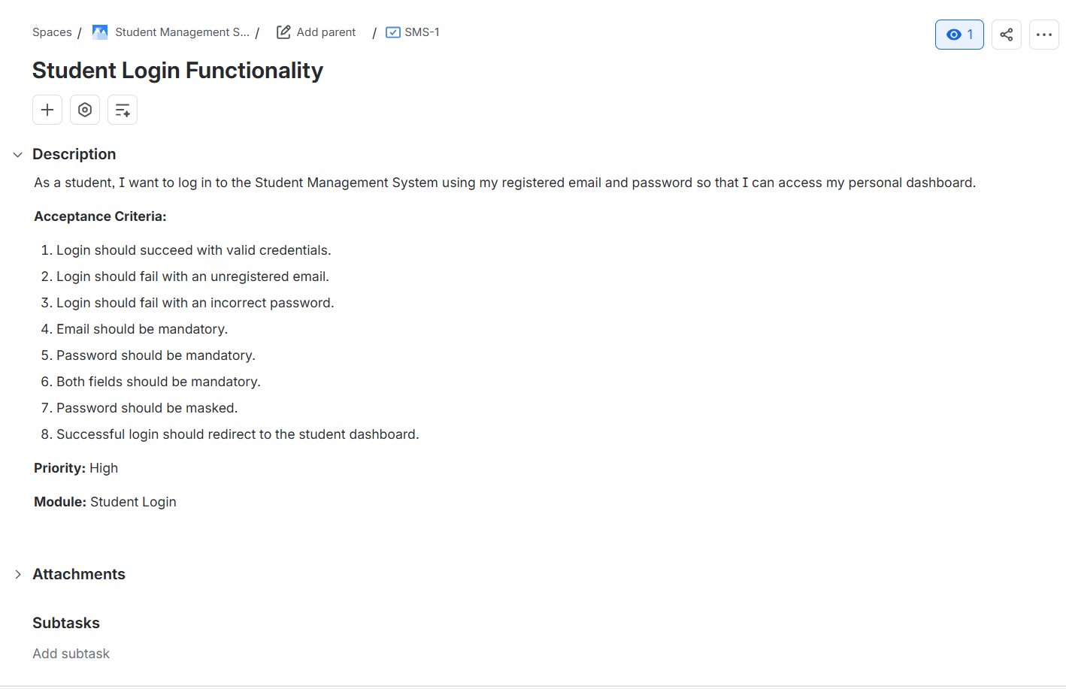
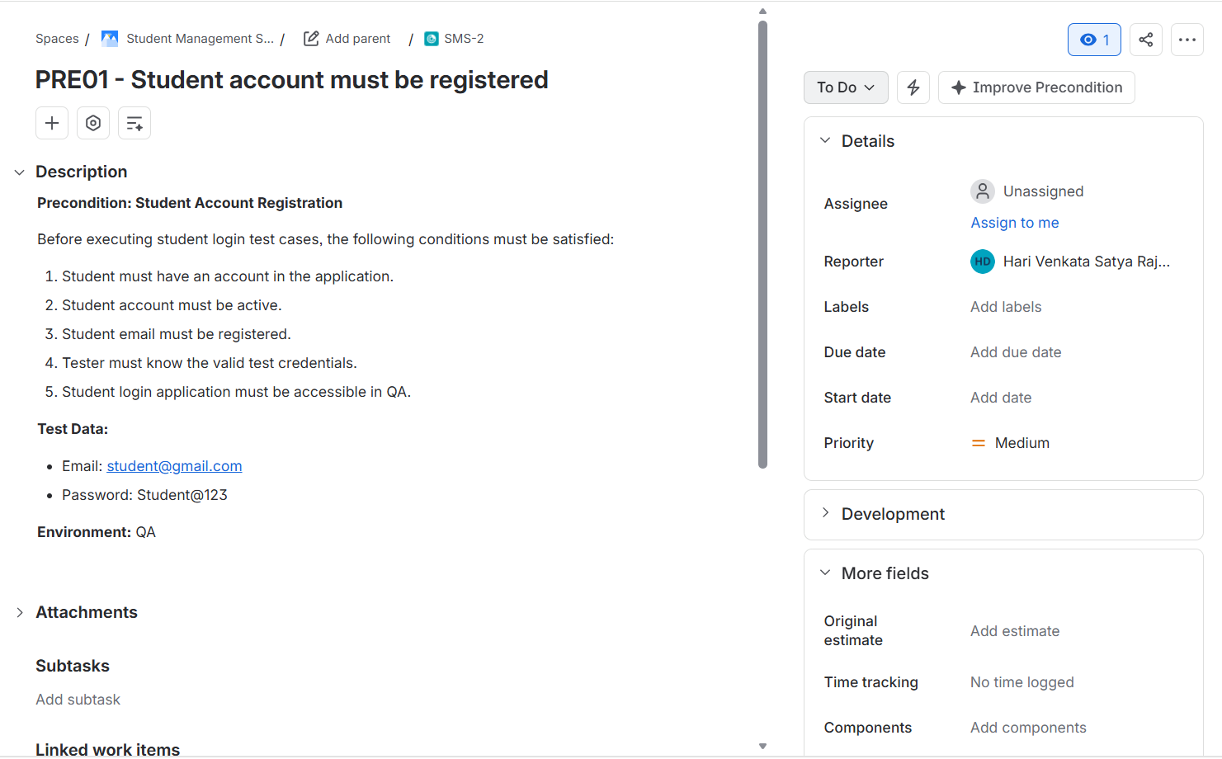

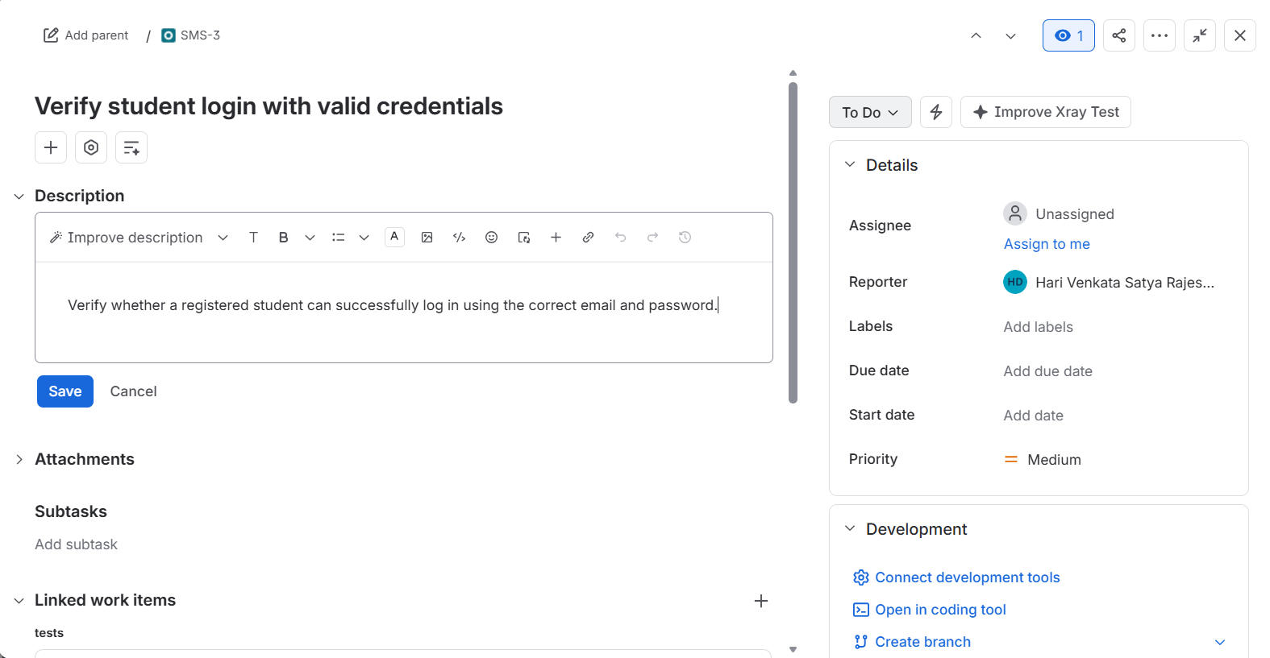

6. Test execution and result recording
For each execution, select the relevant tests in Xray, run each manual step, record the actual result, attach sanitized evidence where appropriate, and set the status based on observed behaviour. Do not infer a PASS result from an expected result alone.

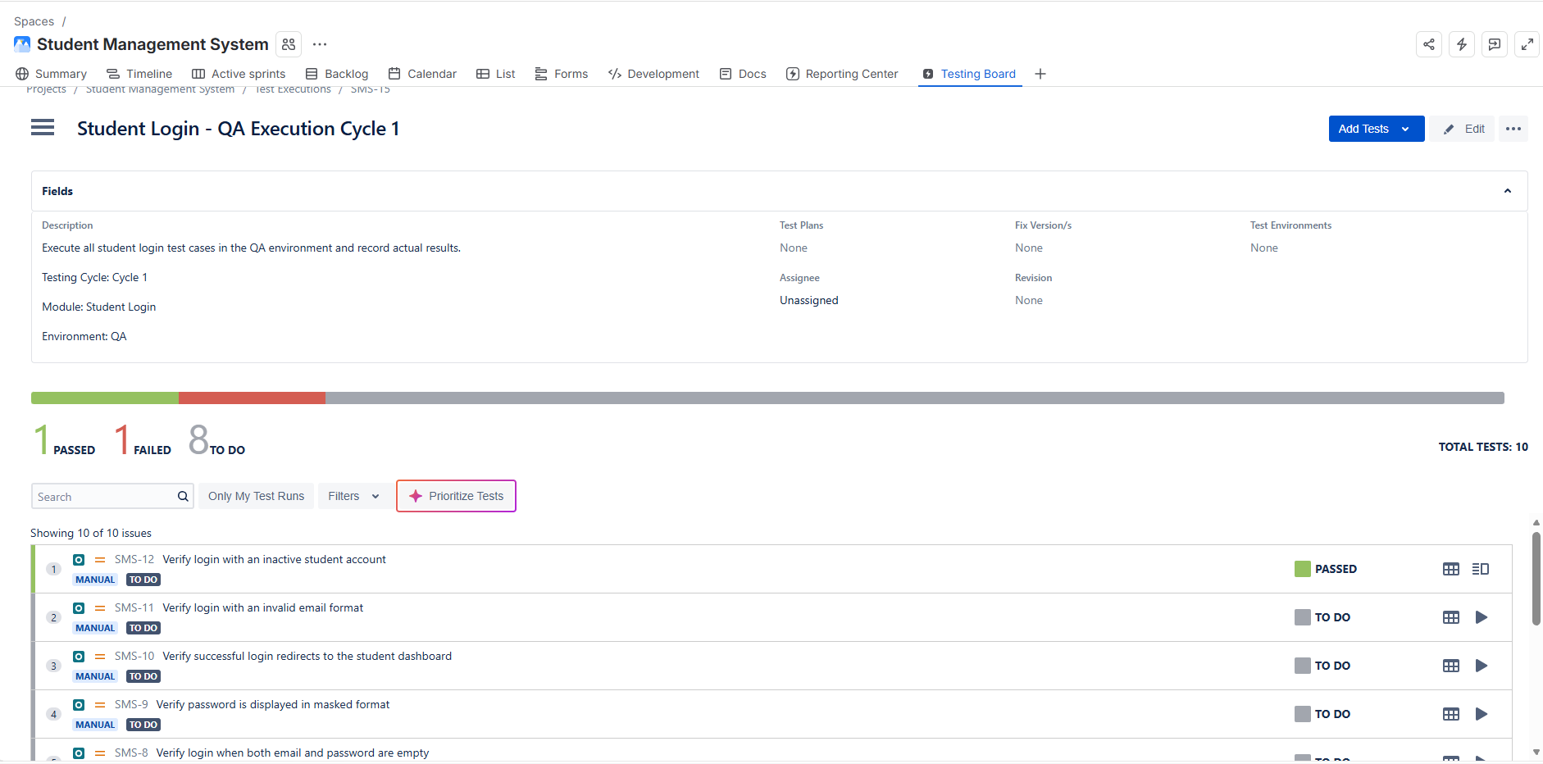

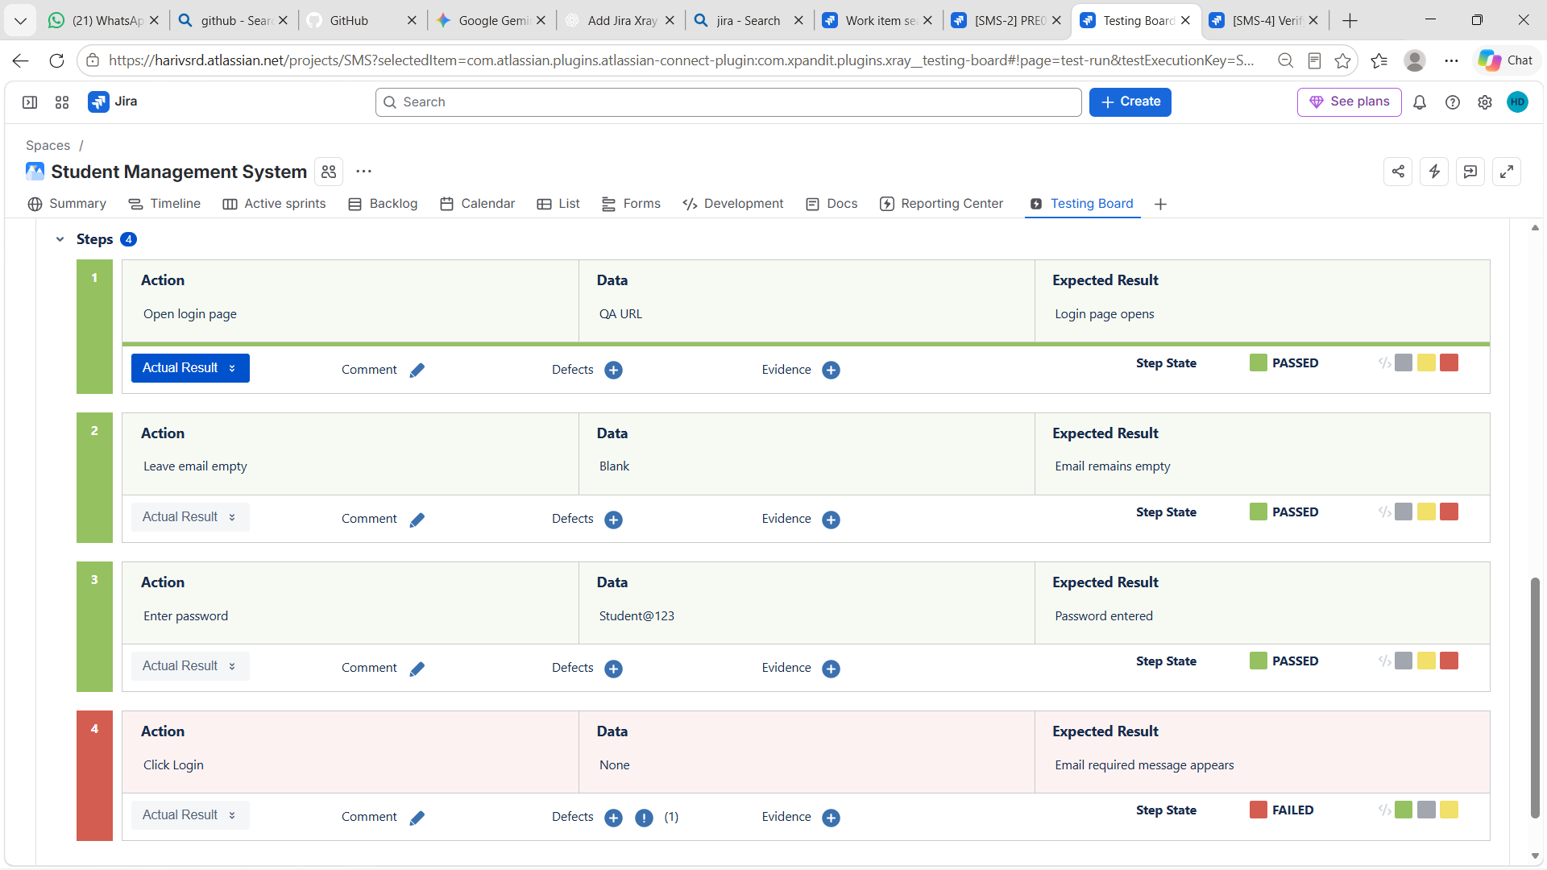

7. Defect management and retesting
Create a defect only when the observed actual result differs from the expected result or another requirement is violated. A failed test and a defect are related but are not interchangeable: record a defect when the issue is reproducible and sufficiently described.

Retesting workflow
- Confirm that the fix is available in the intended QA build.
- Re-run the failed test using the original reproducible steps.
- Record the new actual result and attach fresh evidence.
- If the expected behaviour is now observed, update the test result and move the defect through the approved workflow.
- If the issue remains, record the failure and return the defect to the appropriate status.
- Run relevant regression tests when required.
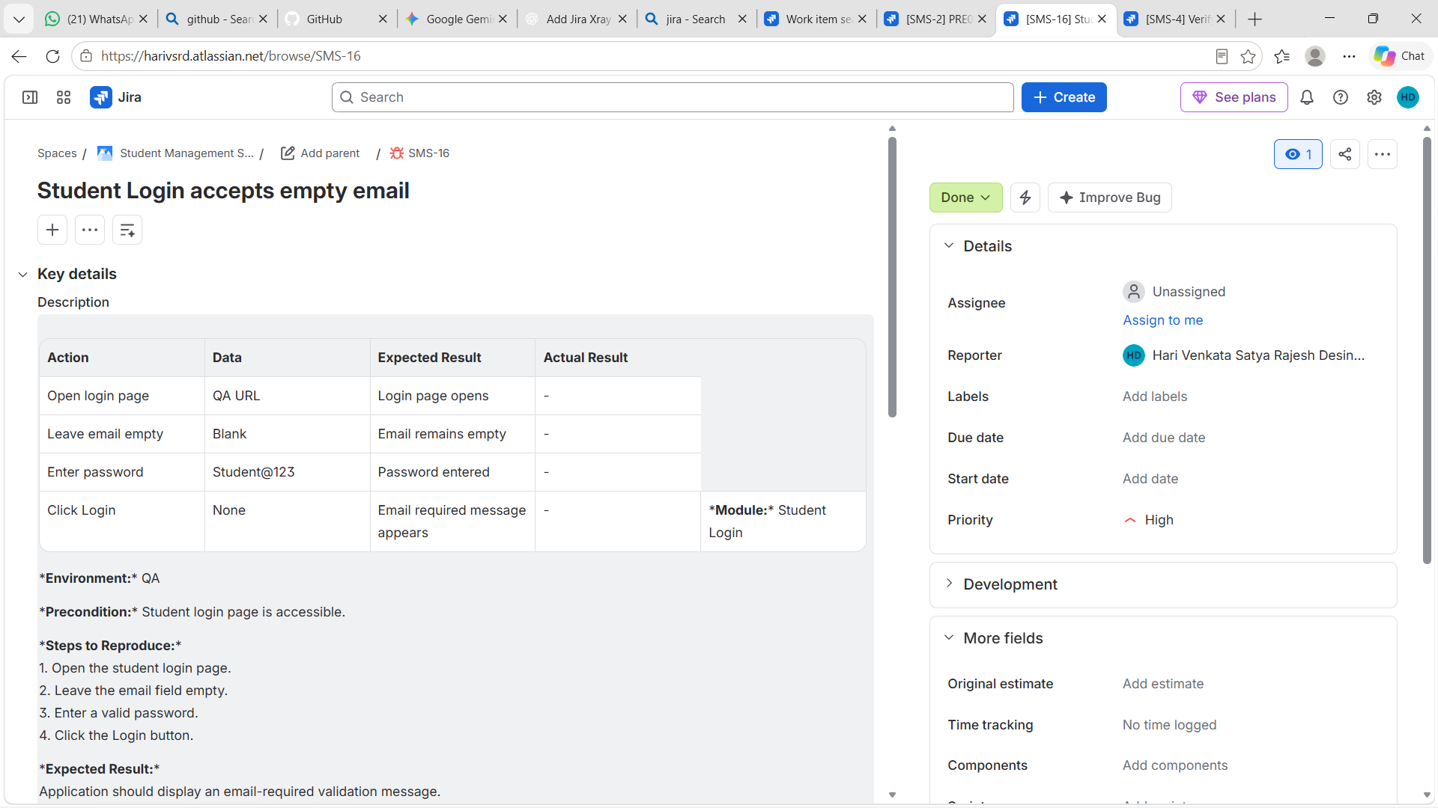

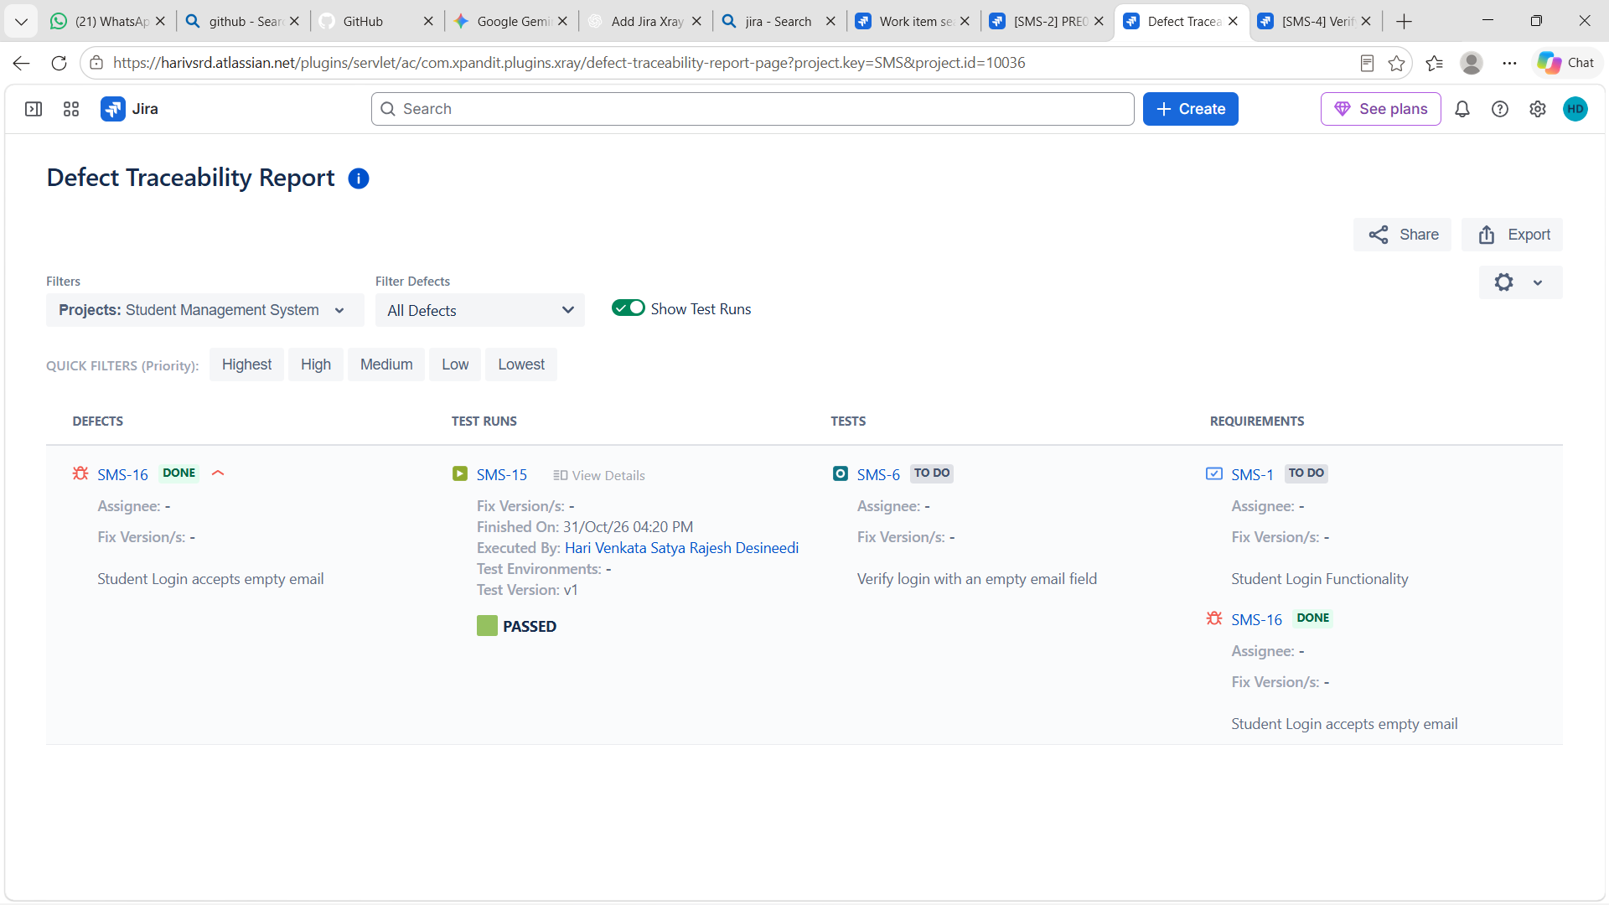

8. Test summary and reporting
Use Xray reports or Jira dashboards to summarize test progress. Populate the following table from the final execution report; do not estimate or invent counts.
Metric | Final value
Total tests in scope | [Enter verified count]
Passed | [Enter verified count]
Failed | [Enter verified count]
Blocked | [Enter verified count]
Not run | [Enter verified count]
Defects raised | [Enter verified count]
Defects closed | [Enter verified count]
Execution completion | [Calculate from verified report]

Suggested interpretation: explain what was tested, what passed or failed, which defects remain open, any blocked areas, and the release risk. State limitations such as unavailable test environments or incomplete test data. 

