

**Computer Graphics** Project Trimester I, 2015/16

**FACULTY OF COMPUTING AND INFORMATICS**

**TGD2151 Computer Graphics Fundamentals**

**TCS2111 Computer Graphics**

**TRIMESTER 1 2015/2016**

**PROJECT**

**Report**

**Lecture Section : TC 101**

**Tutorial Section : TT 01**

**For:**

**Dr. Wong Ya Ping**

**From:**

|  |  |  |  |
| --- | --- | --- | --- |
| **Student ID** | **Name** | **Email Address** | **Phone No.** |
| 1112701371 | Hariz bin Mohamed Mustafa | HarizzMustafa@gmail.com | 013-3642393 |

**Introduction**

The purpose of this program is to learn about OpenGL using C++. This program can generate random terrain, has a moving gate, toggle lights on/off and move around the camera.

**Documentation of Virtual Environment**

**Castle:** Consists of 1 pyramids as the main roof, 4 cylinders act as the castle towers, 4 cones act as the tower roofs and 4 cubes as the castle walls. Several smaller cubes act as extra protection for the castle. “GL_TRIANGLE_FAN” was used to create the base for the cylinders. The smaller cubes are created and placed through “for loops”.

**Fortress:** The fortress is made of several cubes and cylinders. The cubes and cylinders acted as walls and were designed in 1x1, 2x1, 2x2 and 3x2 sizes. 1x1 means 1 tower and 1 wall while 3x2 means 3 towers and 2 walls. 2 Triangle planes and 1 Cylinder act as the body and roof for the Fortress Gate.

**Army Barracks and Castle Supplies:** The army barracks and castle supplies are created using cylinders and triangle planes.

**Cannons:** The cannons are created using cylinders, spheres and tori.

**Gate:** The gate is created from a cube and moves downwards before going up to its default position.

**Island:** Is made out of one giant cube.

**Sea:** Consists of quads in a 2-dimensional array. By using a nested for loop and rand() function to input random coordinates for the vertices of x, y and z we can create rough randomized terrain that changes each second. This creates the illusion of waves moving. On very old PC’s this may cause long compile time. If compilation takes a long time then it is recommended to comment out “drawTerrain()” in “Assignment.cpp” line 102 .

**Lighting:** Default OpenGL lighting.

**User Manual**

Move world: W, A, S, D, Q, E

Rotate world: Arrow keys

Restore default position: Home key

Exit: Escape key

Toggle wire-frame mode: F1

Toggle rendering of axis: F2

Toggle lighting : F3

**Screenshots**

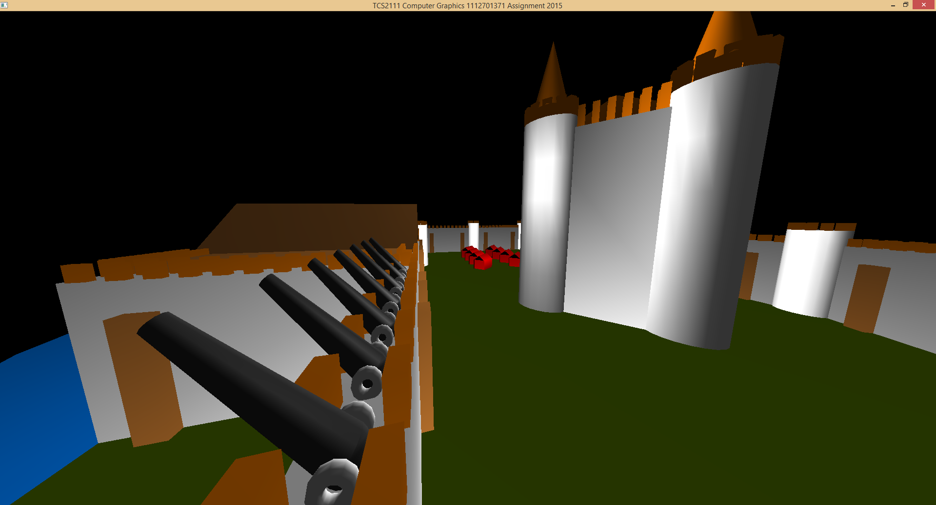

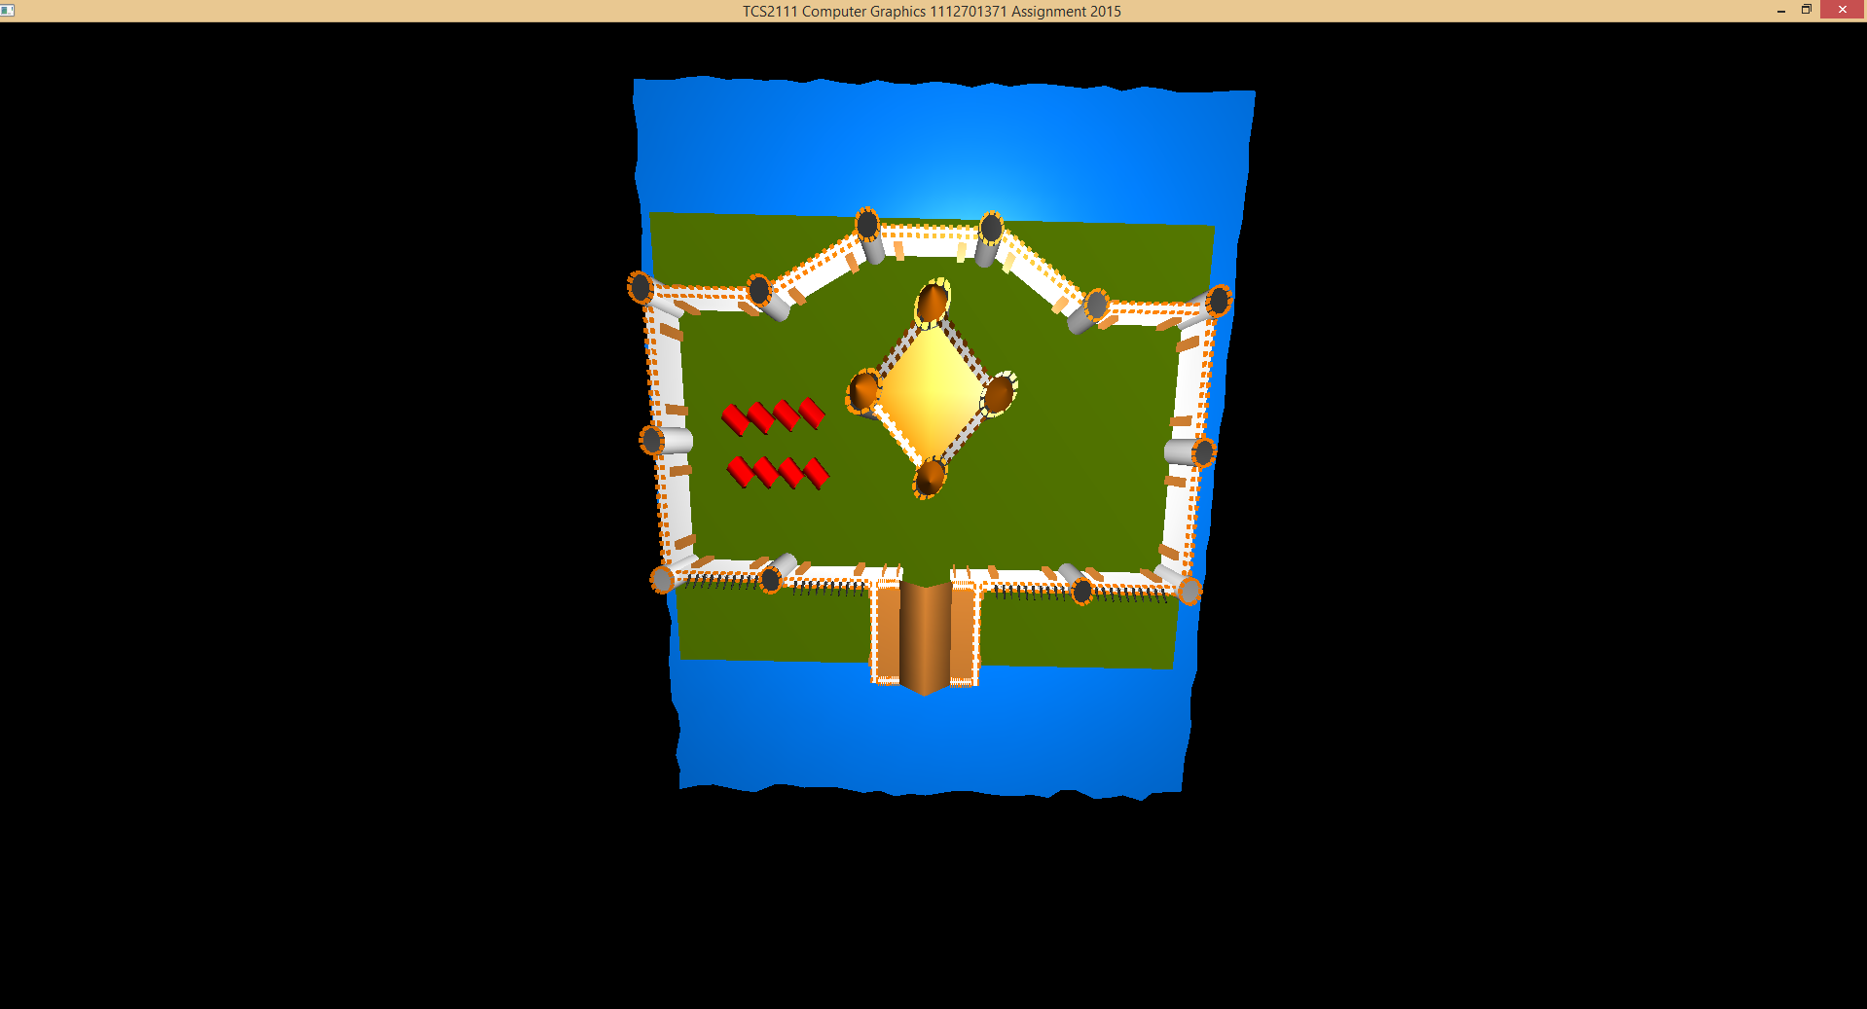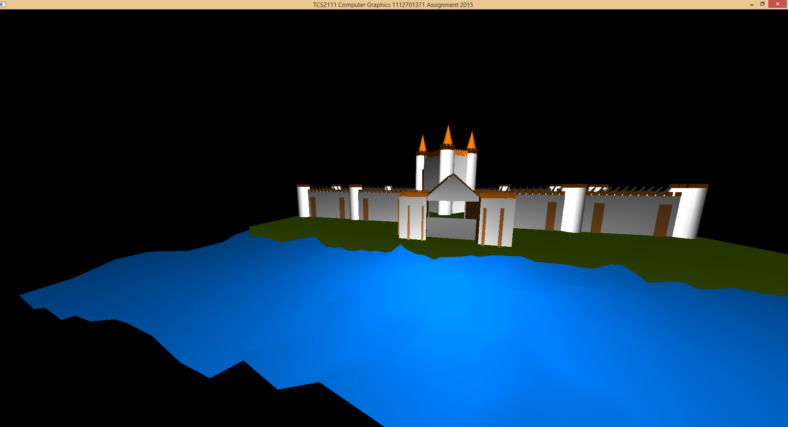

**Acknowledgement**

I would like to thank the tutors for teaching during the lab sessions which helped me do the assignment.

**References**

Randomized terrain: <http://talkera.org/opengl/lesson-12-terrain-generation-and-rendering/>

