# Telecom Infra Images are Image No 1 , 2 and 3 :-

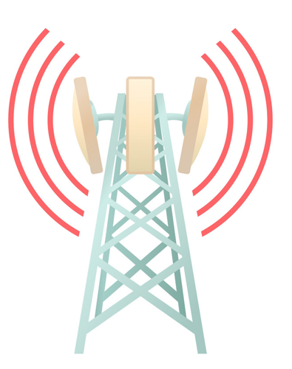

Image No 1 – Self Support Tower Image ( A Telecom Infra)

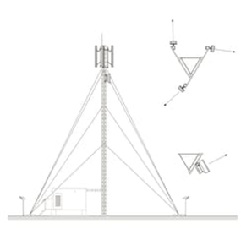

Image No 2 – Guyed Tower Image ( A Telecom Infra)

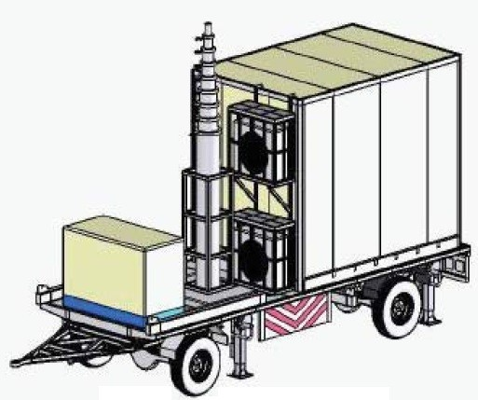

Image No 3 – Cell on Wheels ( A Telecom Infra)

-------------------------------------------------------------------------------------------------------------------

# Pre Engineered Building Image is Image No 4 only :-

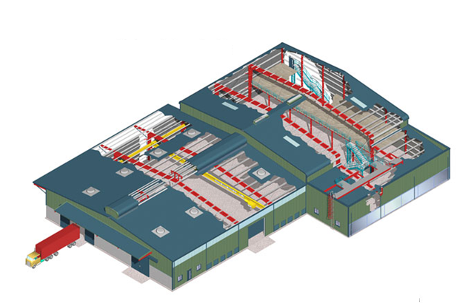

Image No 4

# RCC Building Image is Image No 5 Only :-

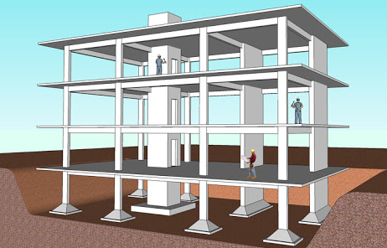

Image No 5

----------------------------------------------------------------------------------------------------

# RCC Bridge Image Is Image No 6 only :-

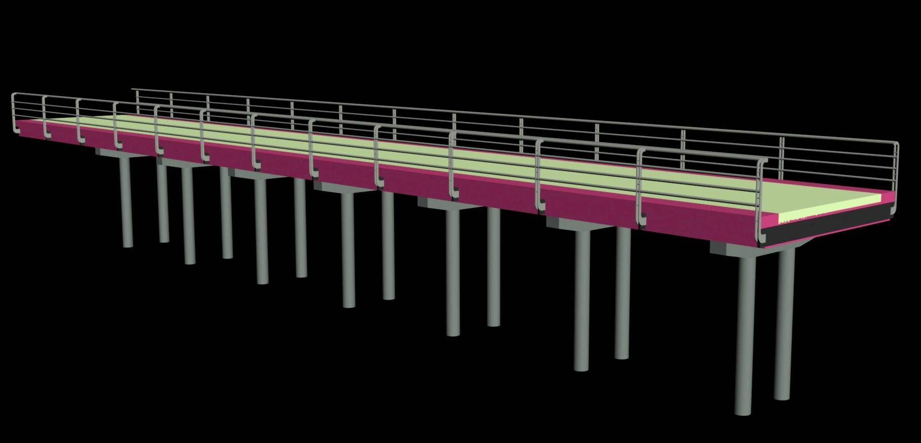

Image No 6

# Granary Silo Image is Image No 7 and 8 only :-

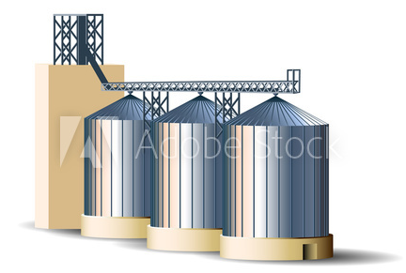

Image No 7

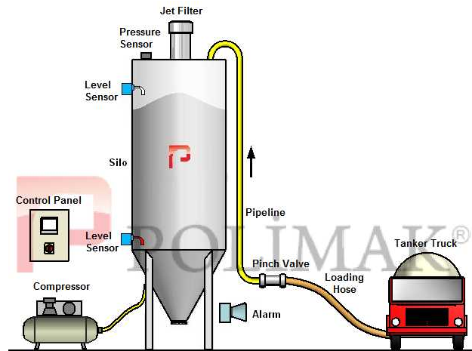

Image No 8

