Exp no: 6 implement program to apply moving average smoothing for data preparation and time series forecasting.

Date: 20/03/25

Objectives:

The objective of this experiment is to apply smoothing techniques to forecast stock prices and analyze trends in time series data. Seasonal differencing is used to make the series stationary, and models like Simple Exponential Smoothing (SES) and Holt-Winters Exponential Smoothing (HWES) are used to generate forecasts. Moving averages are also computed to analyze short- and long-term price movements.

**Background/Scope:**

Smoothing is a technique used in time series forecasting to reduce noise and highlight trends. Exponential smoothing assigns exponentially decreasing weights to past observations. Simple Exponential Smoothing (SES) is suitable for series without trend or seasonality, while Holt-Winters method (HWES) can handle both trend and seasonality. This experiment also includes the use of moving averages to detect market signals.

**Steps for Time Series Forecasting Using Smoothing Techniques:**

**Step 1: Load the Dataset**

```python

import pandas as pd

# Load the dataset

df = pd.read_csv("market.csv")

# Display first few rows

df.head()

```

**Step 2: Data Cleaning and Preprocessing**

```python

# Convert Date column to datetime format

df['Date'] = pd.to_datetime(df['Date'])

# Remove missing and duplicate values

df.dropna(subset=['Date', 'Close', 'Adj Close', 'Open', 'High', 'Low', 'Volume'], inplace=True)

df.drop_duplicates(subset=['Date', 'Ticker'], inplace=True)

# Remove outliers using IQR

Q1 = df['Close'].quantile(0.25)

Q3 = df['Close'].quantile(0.75)

IQR = Q3 - Q1

df = df[(df['Close'] >= (Q1 - 1.5 * IQR)) & (df['Close'] <= (Q3 + 1.5 * IQR))]

```

**Step 3: Seasonal Differencing**

```python

# Apply seasonal differencing

df['seasonal_first_difference'] = df['Volume'] - df['Volume'].shift(12)

df['seasonal_first_difference'].fillna(0, inplace=True)

```

**Step 4: Simple Exponential Smoothing (SES)**

```python

from statsmodels.tsa.holtwinters import SimpleExpSmoothing

# Apply SES

df['SES'] = SimpleExpSmoothing(df['seasonal_first_difference']).fit(smoothing_level=0.5, optimized=False).fittedvalues

```

**Step 5: Holt-Winters Exponential Smoothing (HWES)**

```python

from statsmodels.tsa.holtwinters import ExponentialSmoothing

# Apply HWES

df['HWES'] = ExponentialSmoothing(df['seasonal_first_difference'], trend='add', seasonal='add', seasonal_periods=7).fit().fittedvalues

```

**Step 6: Visualization of Smoothing Techniques**

```python

import matplotlib.pyplot as plt

# Original data

plt.figure(figsize=(12, 6))

plt.plot(df['Volume'], label='Original')

plt.title('Original Volume Data')

plt.legend()

plt.show()

# SES

plt.figure(figsize=(12, 6))

plt.plot(df['SES'], label='Simple Exponential Smoothing', color='red')

plt.title('Simple Exponential Smoothing')

plt.legend()

plt.show()

# HWES

plt.figure(figsize=(12, 6))

plt.plot(df['HWES'], label='Holt-Winters Exponential Smoothing', color='green')

plt.title('Holt-Winters Exponential Smoothing')

plt.legend()

plt.show()

```

**Step 7: Weekly Resampling**

```python

# Resample data by week

weekly_data = df.resample('W', on='Date').mean(numeric_only=True)

weekly_data.head()

```

**Step 8: Moving Averages (SMA 20 and SMA 50)**

```python

# Calculate moving averages

sma_20 = df['High'].rolling(window=20).mean()

sma_50 = df['High'].rolling(window=50).mean()

# Create a combined DataFrame

priceSma_df = pd.DataFrame({

'High': df['High'],

'SMA 20': sma_20,

'SMA 50': sma_50

})

# Plot SMAs

priceSma_df.plot(figsize=(12, 6))

plt.title('SMA 20 vs SMA 50')

plt.xlabel('Date')

plt.ylabel('High Price')

plt.grid(True)

plt.show()

```

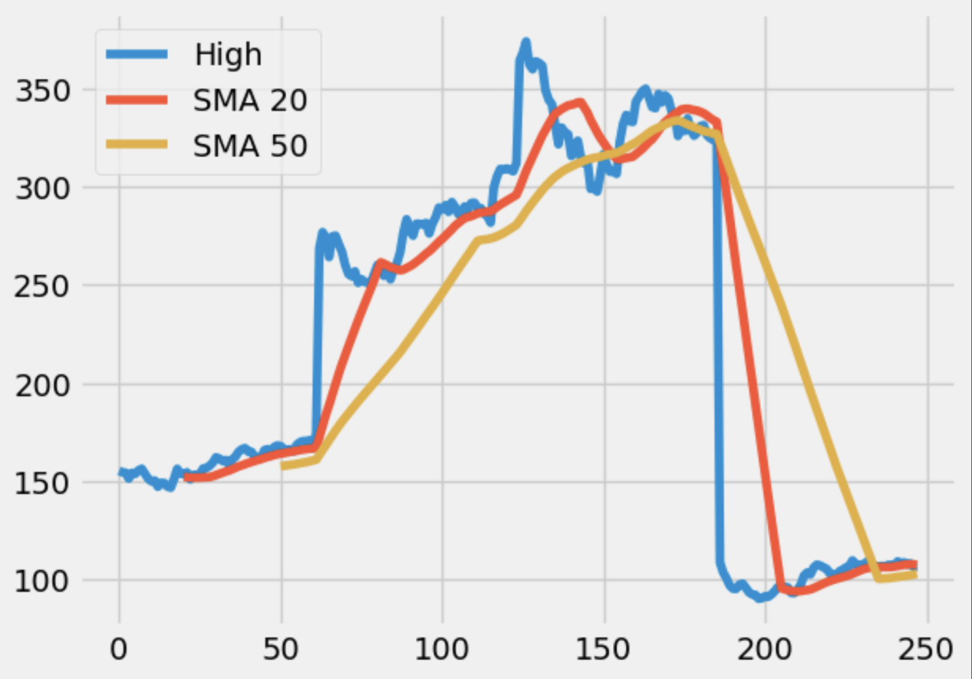

**Result:**

Thus, smoothing techniques such as SES and HWES were successfully implemented for time series forecasting. Moving averages provided additional insights into stock behavior, helping to visualize both short-term and long-term trends effectively.