**ExNo:2 221501040**

**01/02/25**

**Implement programs for visualizing time series data.**

**Aim:** To implement visualisation programs on time series datasets.

**Code :**

#Import necessary libraries

import pandas as pd

import matplotlib.pyplot as plt

import seaborn as sns

# Load the cleaned dataset

df = pd.read_csv("cleaned_sales_data.csv")

# Convert Order Date to datetime format

df["Order Date"] = pd.to_datetime(df["Order Date"], format='%Y-%m-%d', errors='coerce')

# Set Order Date as index

df.set_index("Order Date", inplace=True)

# Scatter Plot of Sales Over Time

plt.figure(figsize=(10, 4))

plt.scatter(df.index, df["Sales"], color='blue', alpha=0.5)

plt.title("Scatter Plot of Sales Over Time")

plt.xlabel("Year")

plt.ylabel("Sales")

plt.xticks(rotation=45)

plt.show()

# Bar Chart (Yearly Aggregation)

df_yearly = df.resample('Y').sum()

plt.figure(figsize=(10, 4))

plt.bar(df_yearly.index.year, df_yearly["Sales"], color='green', alpha=0.7)

plt.title("Yearly Total Sales")

plt.xlabel("Year")

plt.ylabel("Total Sales")

plt.show()

# Histogram of Sales Distribution

plt.figure(figsize=(8, 4))

plt.hist(df["Sales"], bins=30, color='purple', alpha=0.7)

plt.title("Distribution of Sales")

plt.xlabel("Sales")

plt.ylabel("Frequency")

plt.show()

# Box Plot (Monthly Sales Trends)

df["Month"] = df.index.month

plt.figure(figsize=(10, 4))

sns.boxplot(x=df["Month"], y=df["Sales"], palette="coolwarm")

plt.title("Monthly Distribution of Sales")

plt.xlabel("Month")

plt.ylabel("Sales")

plt.show()

# Line Plot of Monthly Sales Trends

df_monthly = df.resample('M').sum()

plt.figure(figsize=(12, 5))

plt.plot(df_monthly.index, df_monthly["Sales"], marker='o', linestyle='-', color='red', alpha=0.7)

plt.title("Monthly Sales Trends Over Time")

plt.xlabel("Year")

plt.ylabel("Total Sales")

plt.xticks(rotation=45)

plt.grid(True, linestyle='--', alpha=0.6)

plt.show()

**OUTPUT:**

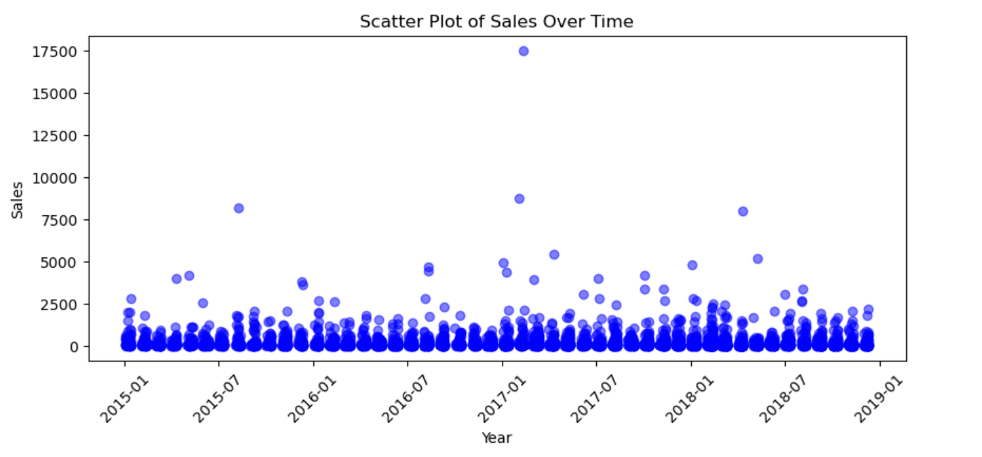

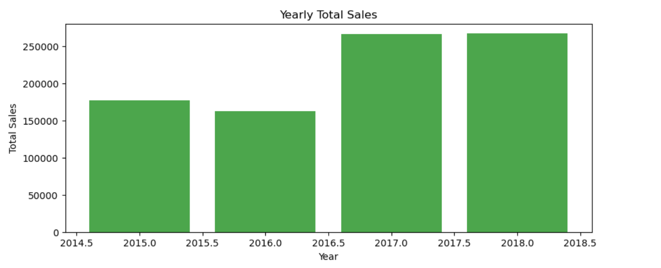

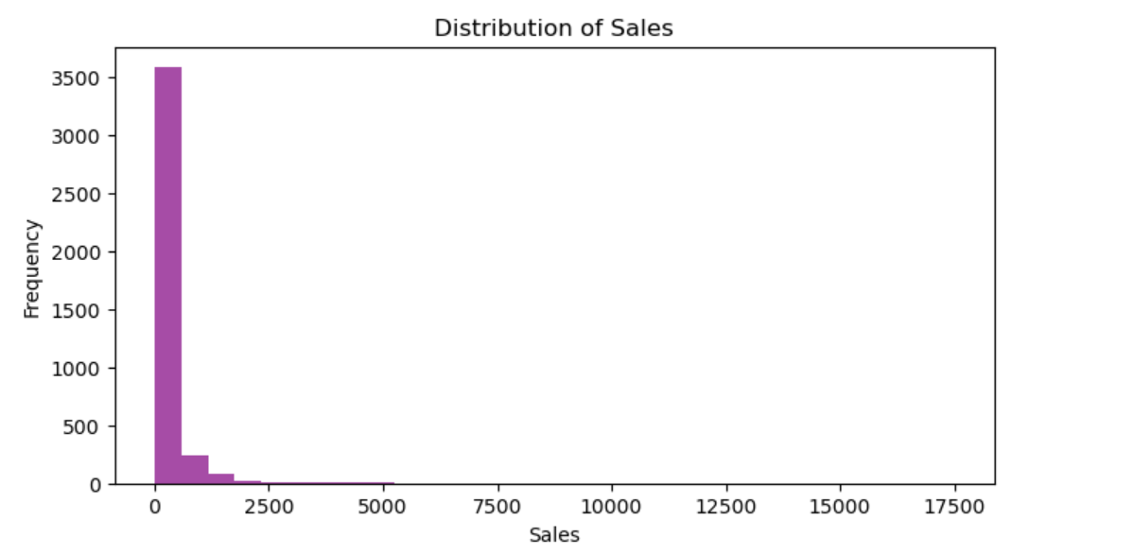

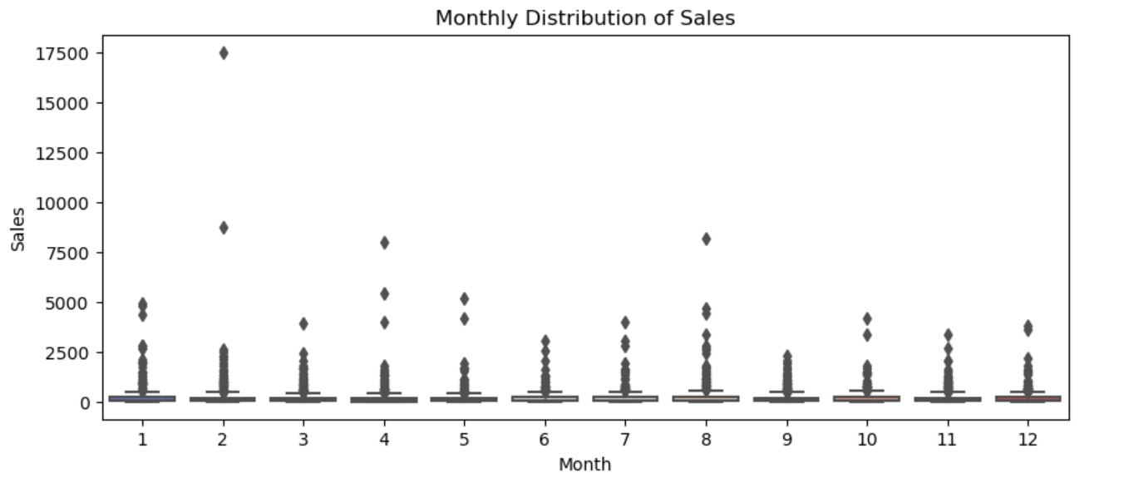

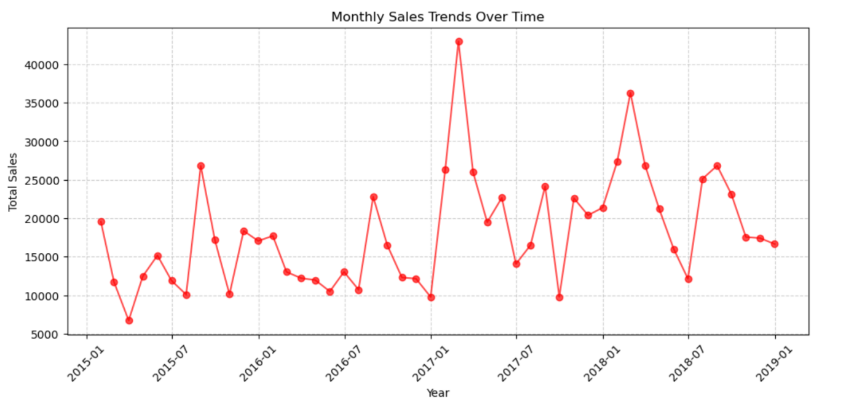

**RESULT :** Thus time series visualisation has been implemented successfully.