**NAME:- HARPAL SINGH**

**LEVEL :- 6**

**ASSIGNMENT**

**STUDENT INFO SYSTEM**

**STUDENT INFO SYSTEM**

Student Info System is a website developed for keeping records (Sid ,Name , Age , Salary , Phone ,Email , DOB , Address etc) of students . In this website SId is automatically generated . No two students have the same Id.

1. First of all a main screen opens where different menus like Home(for Main page),Search (to search any student record using either email or DOB or Phone or Sid),Login (for User),Admin Login(for Admin)is present.
2. User can Update his/her details after Login.He/She is also eligible to create new user but not able to update his/her(new user)details.
3. Admin can create ,Update or delete any user after login. He is also eligible to see whole student record present in the database.

**Pre-requisite**

This project developed in asp.net using Visual Studio 2010 and CSharp as a code Behind language.

1)**C#** :- C# (pronounced C sharp) is a general-purpose, multi-paradigm programming language encompassing strong typing, imperative, declarative, functional, generic, object-oriented (class-based), and component-oriented programming disciplines. It was developed around 2000 by Microsoft within its .NET initiative and later approved as a standard by Ecma (ECMA-334) and ISO (ISO/IEC 23270:2006). C# is one of the programming languages designed for the Common Language Infrastructure.

2) **Visual Studio** :- Microsoft Visual Studio is an integrated development environment (IDE) from Microsoft. It is used to develop computer programs, as well as websites, web apps, web services and mobile apps. Visual Studio uses Microsoft software development platforms such as Windows API, Windows Forms, Windows Presentation Foundation, Windows Store and Microsoft Silverlight. It can produce both native code and managed code. Visual Studio includes a code editor supporting IntelliSense (the code completion component) as well as code refactoring. The integrated debugger works both as a source-level debugger and a machine-level debugger. Other built-in tools include a code profiler, forms designer for building GUI applications, web designer, class designer, and database schema designer. It accepts plug-ins that enhance the functionality at almost every level—including adding support for source control systems (like Subversion and Git) and adding new toolsets like editors and visual designers for domain-specific languages or toolsets for other aspects of the software development lifecycle (like the Team Foundation Server client: Team Explorer).

3)**Bootstrap:**

* Bootstrap is a free front-end framework for faster and easier web development
* Bootstrap includes HTML and CSS based design templates for typography, forms, buttons, tables, navigation, modals, image carousels and many other, as well as optional JavaScript plugins
* Bootstrap also gives you the ability to easily create responsive designs

4) **Html 5** : Hypertext Markup Language revision 5 (HTML5) is markup language for the structure and presentation of World Wide Web contents. HTML5 supports the traditional HTML and XHTML-style syntax and other new features in its markup, New APIs, XHTML and error handling.

There are three organizations that are currently in charge of the specification of HTML5:

1. Web Hypertext Application Technology Working Group (WHATWG) created the HTML5 specification and is in charge of the HTML5 development that provides open collaboration of browser vendors and other involved parties.
2. World Wide Web Consortium (W3C) is in charge with delivering the HTML5 specification.
3. Internet Engineering Task Force (IETF) is in charge of the development of HTML5 WebSocket API.

5) **CSS** :-Cascading Style Sheets (CSS) is a stylesheet language used for describing the presentation of a document written in a markup language like HTML . CSS is a cornerstone technology of the World Wide Web, alongside HTML and Javascript.

CSS is designed to enable the separation of presentation and content, including layout,colours and fonts .This separation can improve content accessibility, provide more flexibility and control in the specification of presentation characteristics, enable multiple web pages to share formatting by specifying the relevant CSS in a separate .css file, and reduce complexity and repetition in the structural content.

Separation of formatting and content also makes it feasible to present the same markup page in different styles for different rendering methods, such as on-screen, in print, by voice (via speech-based browser ), and on Braille-based tactile devices. CSS also has rules for alternate formatting if the content is accessed on a mobile device .

The name *cascading* comes from the specified priority scheme to determine which style rule applies if more than one rule matches a particular element. This cascading priority scheme is predictable.

**SCREENSHOTS :**

1) Home Page

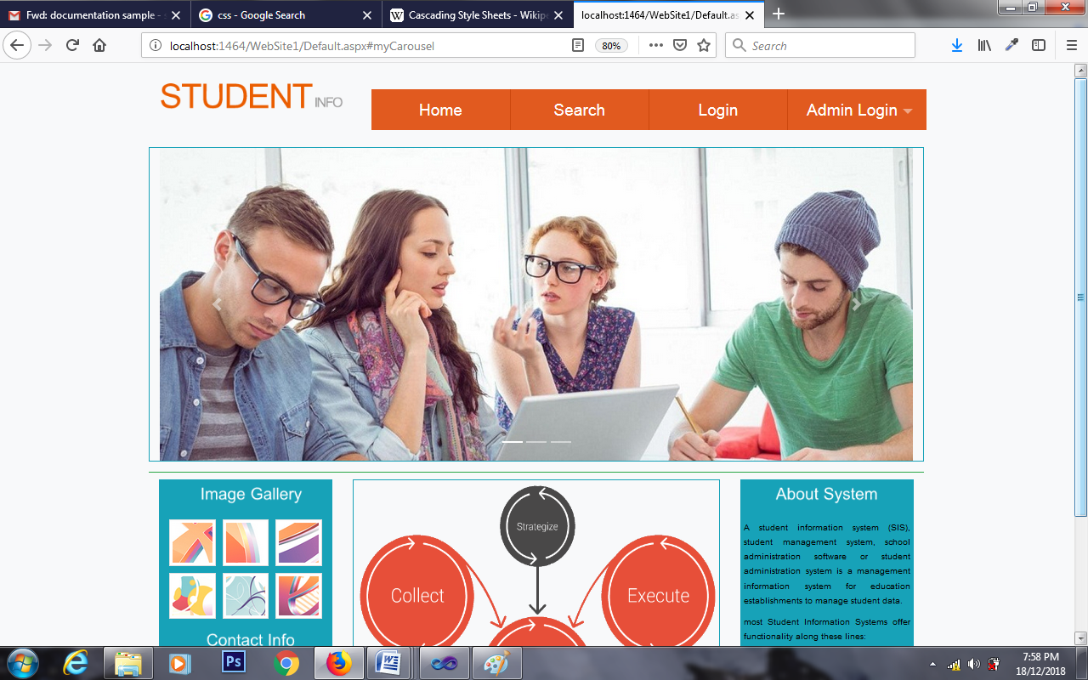

2) Search Page

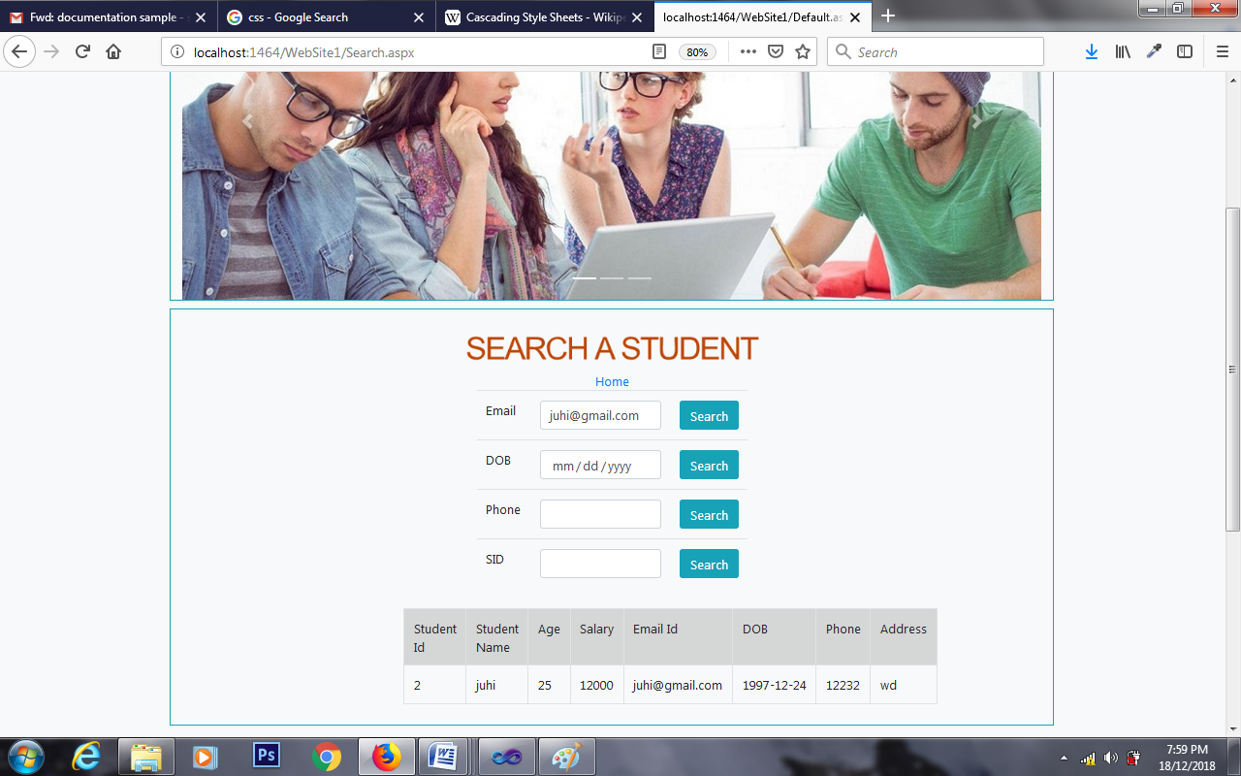

3)User Login

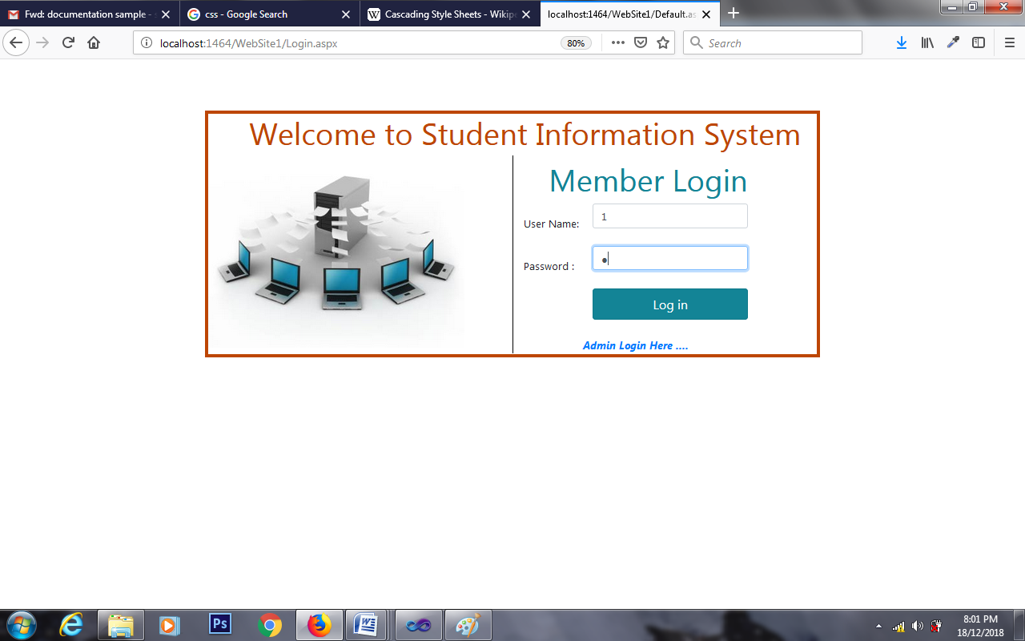

4) User DashBoard

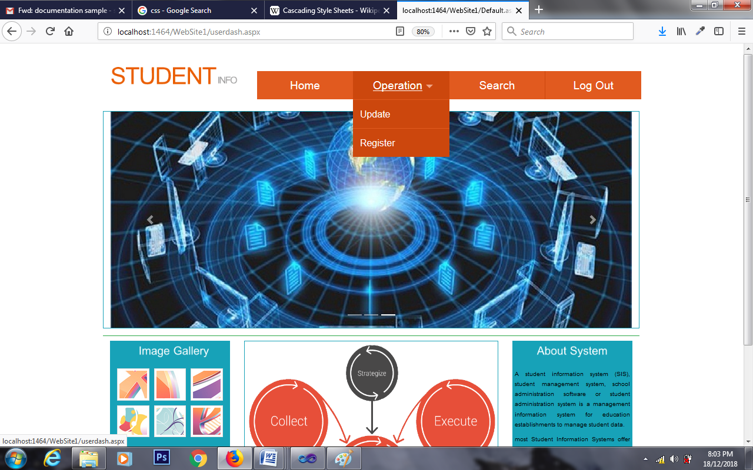

5) User Update

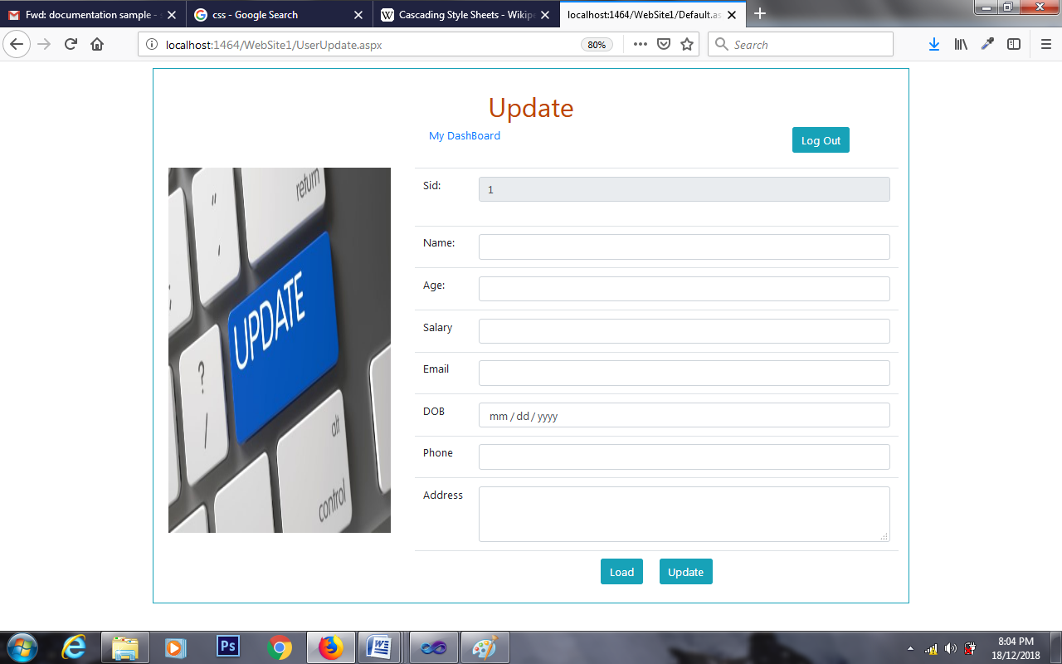

6) User Register :

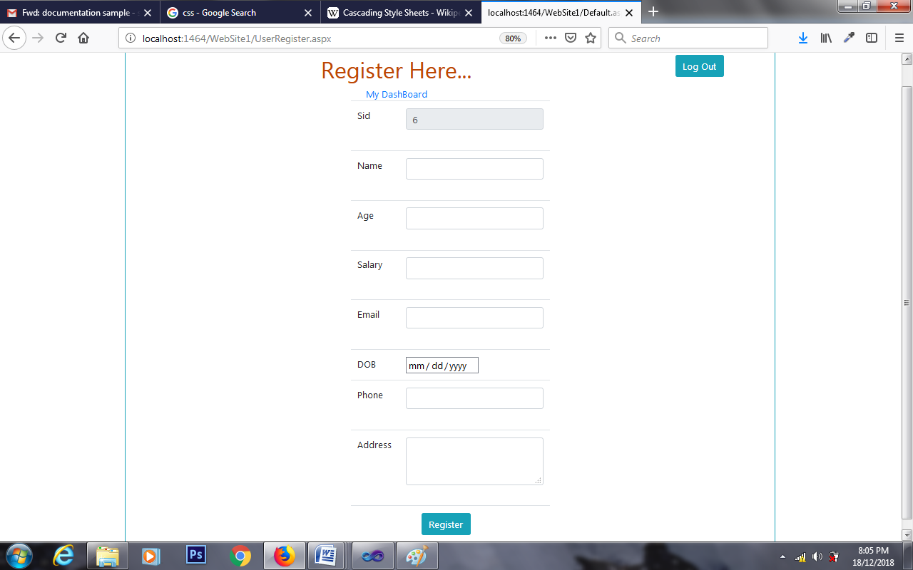

7) Admin Login

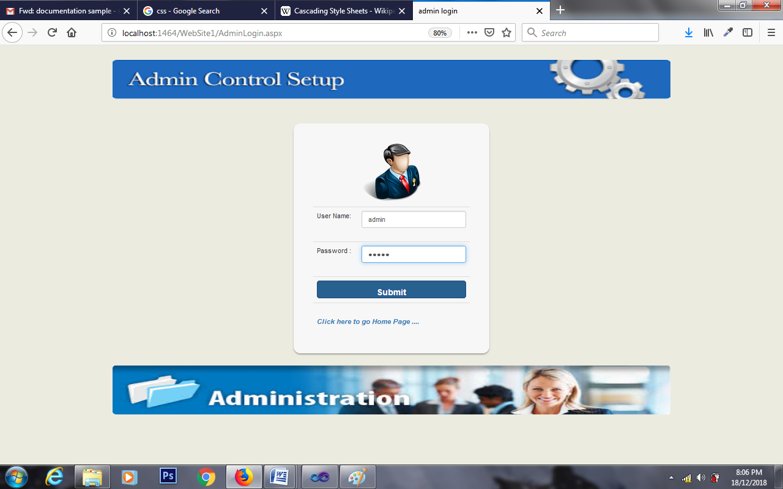

8)Admin DashBoard

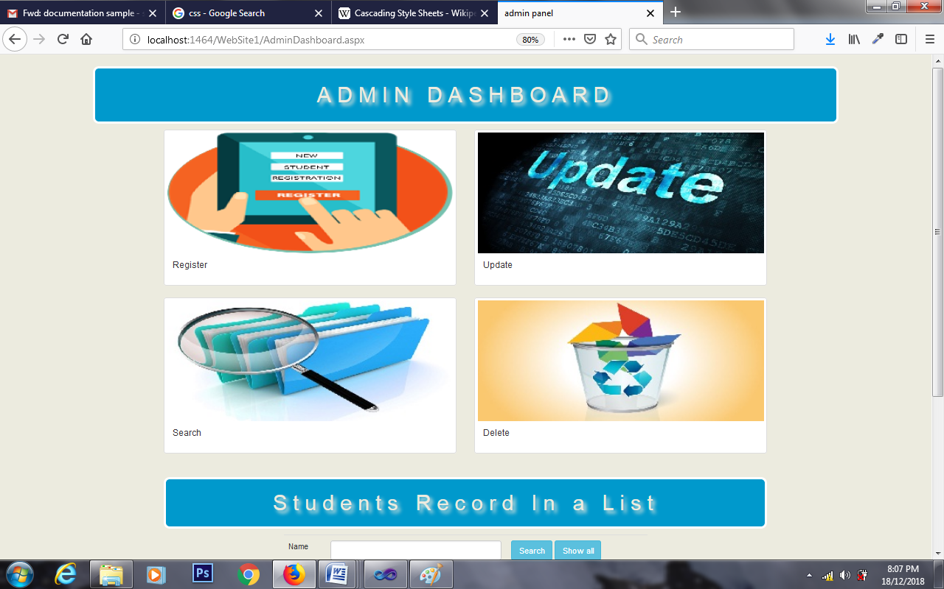

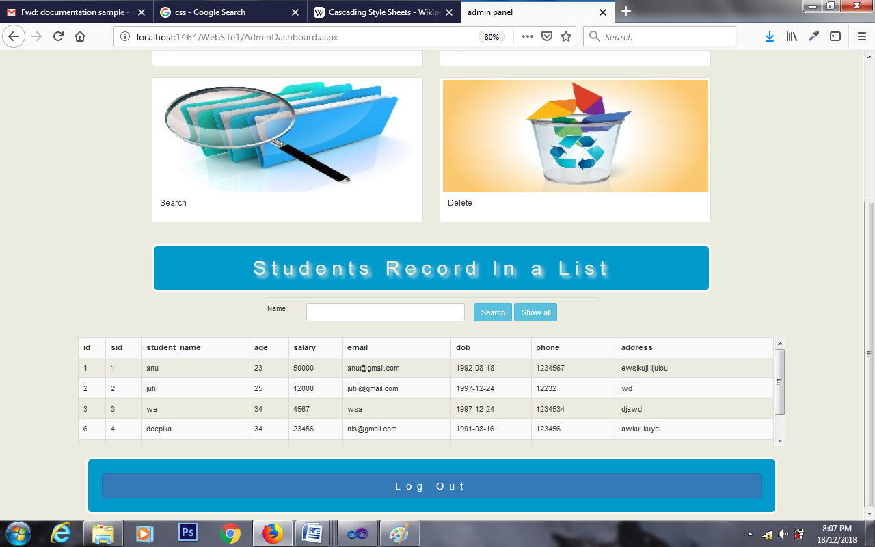

9) Delete

