**Explore Earth’s Crust**

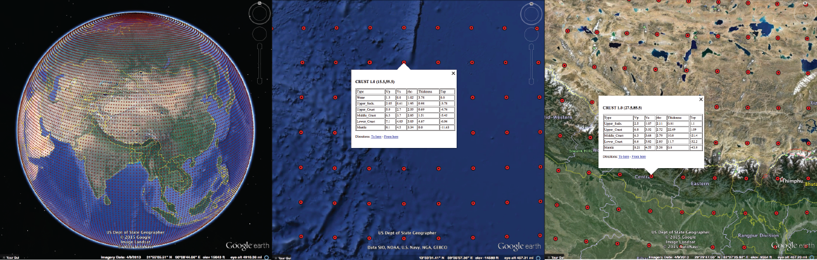

**Free Download: www.github.com/jrleeman/Crust1.0**

* **Transitional Crust - from Continent to Ocean:** Look at the crustal structure along the continental margin of the coast of the [United States](https://en.wikipedia.org/wiki/United_States) east of Florida. Explore the crustal structure beneath regions of flooded continental material such as the [Persian Gulf](https://en.wikipedia.org/wiki/Persian_Gulf), southeast [Asia](https://en.wikipedia.org/wiki/Asia), north of Russia near [Novaya Zemlya](https://en.wikipedia.org/wiki/Novaya_Zemlya). What differences can you find? How does the crust change from continental to oceanic crust?
* **Large Plateaus and Deep Valleys:** Describe the crustal structure beneath the [Tibetan Plateau](https://en.wikipedia.org/wiki/Tibetan_Plateau). Then examine the crust beneath the [Altiplano of Bolivia](https://en.wikipedia.org/wiki/Altiplano). Contrast that structure with that centered on [Death Valley](https://en.wikipedia.org/wiki/Death_Valley) in the central [Basin and Range](https://en.wikipedia.org/wiki/Basin_and_Range_Province), the [Dead Sea](https://en.wikipedia.org/wiki/Dead_Sea) Rift in the Middle East, and the [Salton Trough](https://en.wikipedia.org/wiki/Salton_Trough) of Southern California.
* **Mountain Ranges:** Explore patterns in crustal thickness beneath active mountain regions such as the [Himalayas](https://en.wikipedia.org/wiki/Himalayas), the [Alps](https://en.wikipedia.org/wiki/Alps), the [Zagros](https://en.wikipedia.org/wiki/Zagros_Mountains), the [Tien Shan](https://en.wikipedia.org/wiki/Tian_Shan), and the [Rocky Mountains](https://en.wikipedia.org/wiki/Rocky_Mountains).
* **Platforms and Shields:** Compare the crustal structure beneath the [shield regions of Canada](https://en.wikipedia.org/wiki/Canadian_Shield) and the sediment-covered regions of the northern [Great Plains of the United States](https://en.wikipedia.org/wiki/Great_Plains). Then compare the crust beneath the [Arabian shield](https://en.wikipedia.org/wiki/Arabian-Nubian_Shield) and platform across [Saudi Arabia](https://en.wikipedia.org/wiki/Saudi_Arabia). What is the primary difference between the crust in these regions?
* **Rifts:** Compare the crust beneath actively extending continental regions such as the western conterminous United States, the [east African Rift](https://en.wikipedia.org/wiki/East_African_Rift), the [Lake Baikal](https://en.wikipedia.org/wiki/Lake_Baikal) region. How does it compare to stable regions?