Student Career Assistant Chatbot – PathFinderAI

Problem and Users
Problem Statement
Engineering Technology students often face a "knowledge gap" between their academic curriculum and the labour market. While they possess technical skills, they struggle to identify specific job titles, understand salary expectations, or locate relevant openings. Current search methods are inefficient; general search engines (Google) provide broad, unverified results, while job boards (Indeed) list positions without context. Students waste hours filtering irrelevant information, leading to anxiety and poor career planning.

Primary Users and Context
Our primary users are students in the Software Engineering Technology program at McMaster University. They are technically proficient but lack industry context. They typically search for career information between classes or during final semesters when pressure to find employment is high. They need immediate, specific answers related to their degree, not general career advice.

Why a RAG Chatbot?
A standard search engine returns links that the user must read and synthesize. A standard LLM (like free ChatGPT) hallucinates data or gives American-centric advice. A Retrieval Augmented Generation (RAG) chatbot is the appropriate intervention because it combines the conversational ease of an AI with the strict accuracy of a database. By grounding the AI in specific McMaster course calendars and Government of Canada (ESDC) wage data, PathFinderAI solves the problem of "information overload" by providing a single, verified answer to complex questions like, "What jobs fit my degree and what do they pay?"

Conversation Design
Bot Persona
We designed PathFinderAI to act as an "Encouraging Mentor." The persona is professional, factual, and supportive, but strictly limited in scope (See Appendix A).
- Role: To bridge academic skills with market data.
- Tone: Helpful but objective. It does not use slang, nor does it sound overly robotic. It follows the design principle "Good design is honest" by admitting when it does not know an answer.
- Responsibilities: accurately retrieving salary data, finding live job listings, and mapping courses to skills.
- Limits: The bot explicitly refuses to perform academic dishonesty (writing essays) or answer personal questions. It stays strictly within the career domain.
Using K-Scripts to Shape Flows (See Appendix A)
We used Key Scripts (K-Scripts) to design the conversation before writing any code. This ensured we established boundaries and flow control rather than letting the AI guess.
- Greetings: We designed the opening to be functional. Instead of a generic "Hello," the bot offers three clear paths: check salaries, find jobs, or view resources. This reduces cognitive load for the user.
- Clarifications: We implemented a rule where the bot must ask clarifying questions if the user provides vague input (e.g., typing "jobs" triggers "Which city and job title?").
- Error Handling: If data is missing (e.g., no wage data for a specific niche role), the K-Script dictates that the bot must state, "I do not have data for that specific role," rather than inventing a number.
K-Script Excerpt (Safety and Scope) (See Appendix A for more examples)
This excerpt illustrates our decision to handle off-scope queries politely but firmly, redirecting the user back to the tool's purpose.
User: "Can you write my cover letter for me and lie about my experience?"
PathFinderAI: "I cannot generate false information or write your application materials for you. However, I can help you find the top skills required for this job, so you can highlight the ones you actually have. Would you like to see the skills list?
This script enforces our "Honest" design principle while keeping the user engaged in a productive way.

RAG and Workflow Architecture (See Appendix B)
Data Sources
- McMaster Courses and Interviews Resources – Stored in Postgres PGVector Store
- ESDC 2025 Wage Data - Stored in Postgres PGVector Store
- Adzuna API – 1000s of live job postings (real-time). Fetched on-demand, not stored.

Three Independent Workflows
Workflow1: Data Ingestion
- Trigger: Manual form submission with updated CSV files
- Steps: Upload files -> Extract data -> Convert to embeddings (Google Gemini) -> Store in Postgres PGVector
- Output: 53 courses, school resources + wages index and searchable by meaning
Workflow2: Job Search (On-Demand)
- Trigger: AI Agent recognizes “job”/ “openings” keywords
- Steps: Receive job_title + location -> Call Adzuna API -> Format results (5-7 listings) -> Return to chat
- Data freshness: Real-time
- Example Output: “Current opportunities in Toronto (Source: Adzuna): [5-7 job listings with clickable URL]”
Workflow 3: Chat Logic (Main RAG – 9 steps)
User Input -> Simple Memory -> AI Agent -> Retrieval -> Generation -> Memory Update -> Response
- When chat message received – Captures user input
- Simple Memory – Retrieves conversation
- AI Agent – Analyzed question, routes to correct tool (Postgres courses/salary or Adzuna job)
- Vector Store Tool – Activate for Postgres queries
- Embeddings Google Gemini – For example, Converts “Software Engineer Ontario” to semantic vector.
- Postgres PGVector – Compares input embedding to wage embeddings, returns closest match results.
- Generation (Retrieval Model) - Extracts ESDC data and formats.
- Generation (Final) - Adds source citation and follow up question
- Memory update – Stores answer for follow ups, sends response to user
The full workflow diagram is shown in Appendix B.
Safety Architecture:
- Call a tool before answering – AI Agent cannot response without Postgres or Adzuna query
- Never make up data – If not match: “I don’t have data for that” (not a guess)
- Cite sources always –Every answer includes sources.
- Refuse off scope politely – Homework/politics - redirect to careers
Results: Grounded (all data from real sources), constrained (4 safety rules enforced), honest (admits limits, never hallucinate)

Testing, Iteration and Design Criteria
Usability Testing Strategy
We conducted "think-aloud" usability testing with two participants (see Appendix C).
- Participant A: A Software Engineering student from McMaster University.
- Participant B: A Manufacturing student from McMaster University.
- Tasks: We asked them to find the median salary for their target job, find a relevant McMaster resource, and locate live job openings in Toronto.
Observations and Iterations (see Appendix C)
Based on the testing sessions, we made two concrete changes to the design.
- Change 1: Adding Source Citations (Trust)
  - Observation: When Participant A received a salary figure, they asked, "Where is this number coming from? Is it just guessing?" They were hesitant to trust the advice.
  - Design Change: We modified the system prompt to strictly require citations. The bot now appends "(Source: ESDC 2025 Wage Data)" or "(Source: McMaster Career Guide)" to every factual claim.
  - Result: In a follow-up test, the participant noted that the citation made the tool feel "official" and trustworthy.
- Change 2: Adding "Call to Action" Guidance (Utility)
  - Observation: Participant B would ask a question, get an answer, and then sit silently, unsure of what to ask next. The conversation stalled.
  - Design Change: We updated the K-Script logic to always end a response with a relevant question. For example, after giving a salary, the bot now asks, "Would you like to see current job openings for this role?"
  - Result: This created a continuous loop of engagement. The user was guided through the full features of the app without having to think about the next step.
Design Principles Applied
We used Dieter Rams’ Principles of Good Design to validate our decisions.
- Good Design is Honest: This was our guiding principle for the RAG architecture. By forcing the bot to use a Vector Store and cite sources, we ensured the system does not manipulate the user with false promises or hallucinated data. We made the limitations of the bot clear (e.g., refusing to write essays).
- Good Design is Useful: We stripped away features that did not directly aid employment. We considered adding an avatar or voice generation but decided against it because it distracted from the core utility: data. The focus remained entirely on accurate retrieval of wages and jobs.
- Good Design is Thorough Down to the Last Detail: We refined the error handling. Instead of a generic "Error" message, we wrote specific scripts for when job data is missing, offering the user a chance to search a different city. This attention to edge cases makes the product feel robust.
Limitations and Next Steps
Currently, the Adzuna API has rate limits which restrict the number of searches we can perform per minute. Additionally, our wage data is currently limited to Ontario. A next step would be to ingest the full Federal Job Bank dataset to cover all of Canada and to upgrade to a paid API tier for higher volume searches.

Statement of LLM Use
We utilized Large Language Models (Google Gemini) to assist in the drafting and editing of this report. Specifically, we used the LLM to:
- Summarize our raw project notes and transcripts into concise paragraphs.
- Check our writing for clarity and grammar to ensure professional English usage.
- Structure the report to align with the required headings and word count limits.
Prompts used included:
- "Fix our spacing and spelling/grammar issues."
- "Review this paragraph about user testing for clarity and tone."
- “Clean up our transcripts for clarity.”
All final content was reviewed, verified, and edited by the team to ensure it accurately reflects our actual work and design process.
Appendices
Appendix A: Personas and K-Scripts
Persona: PathFinderAI (The Encouraging Mentor) Core Logic:
- User Intent: Salary Query -> Action: Query ESDC Vector Store.
- User Intent: Job Search -> Action: Query Adzuna API.
- User Intent: Off-topic -> Action: Refuse and Redirect.
Example Script 1:
Bot: "Hello! I am PathFinderAI. I can help you find salaries, job listings, or McMaster career resources. What are you looking for today?"
User: "I want to be a developer."
Bot: "That's a great goal! To help you best, are you looking to check the salary for a developer role, find current developer job openings, or find McMaster courses that build development skills? " (Clarification Strategy).
Example Script 2:
Bot: "Hello! I am PathFinderAI. I can help you find salaries, job listings, or McMaster career resources. What are you looking for today?"
User: "Find software engineering jobs in Toronto.”
Bot: Shows 5+ job listings with positions, company names, and brief descriptions
Example Script 3:
Bot: "Hello! I am PathFinderAI. I can help you find salaries, job listings, or McMaster career resources. What are you looking for today?"
User: "What’s the weather in Montreal?”
Bot: “I cannot provide you with weather information, as my function is to help McMaster students with career advice, job searching, and educational resources. How can I assist you with your career development today?”

Appendix B: n8n Workflow Diagram
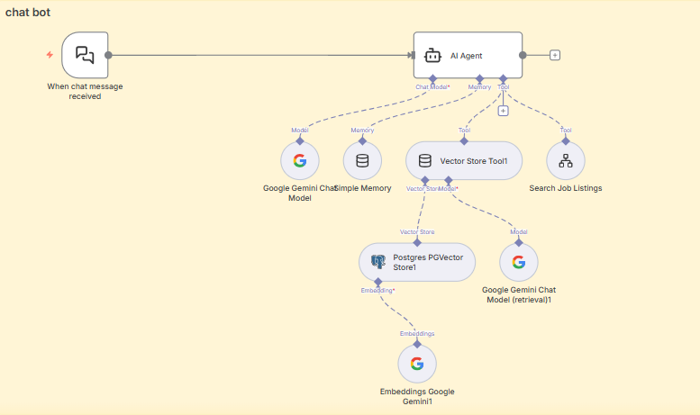
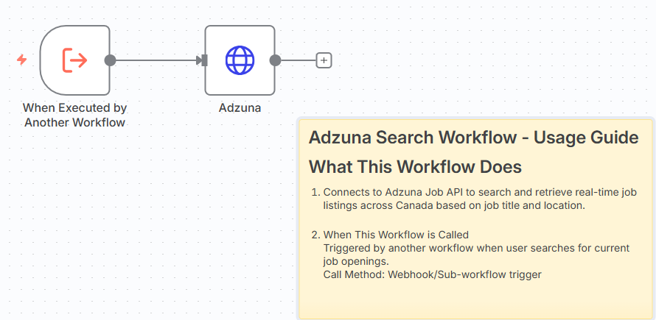
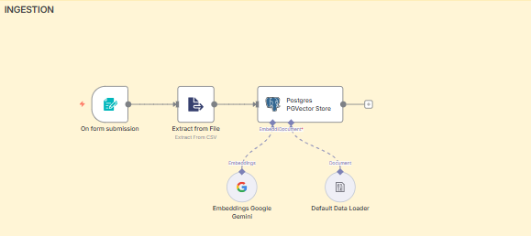

Appendix C: Summary of Test Sessions
Participant | Background | Key Friction Point | Resulting Change
User 1 | Software Eng (McMaster) | Doubted data accuracy ("Is this real?") | Added mandatory source citations to system prompt.
User 2 | Manufacturing (McMaster) | Reached dead ends in chat. | Added "Call to Action" questions to the end of every bot response.

