**COLLABORATIVE FILTERING BASED RECOMMENDATION SYSTEMS**

**Introduction to Recommendation Systems**

Recommendation systems, often known as recommender systems, are sophisticated software engines meticulously designed to suggest items to users based on their historical preferences, interactions, and behaviors with various products. They serve as vital tools in sustaining user engagement by consistently presenting personalized recommendations. These systems span across diverse domains, facilitating user discovery and engagement in movies, TV shows, digital products, books, articles, and services. Beyond user satisfaction, their impact reverberates in driving increased sales and fostering sustained business growth. For instance, on platforms like Amazon, the overwhelming array of products becomes navigable due to recommendation systems that streamline user experiences and ensure ease of access.

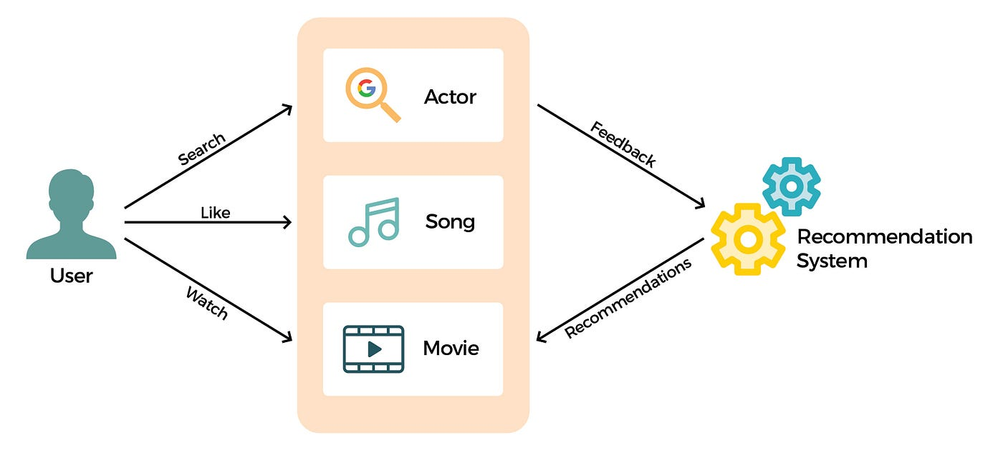

Figure 1: Basic idea of recommendation system

Understanding the core functioning of recommendation systems requires delving into the depth of their data filtering engines, integrating intricate algorithms grounded in deep learning principles. These algorithms meticulously identify patterns within consumer behavior towards specific services or products. Data collection varies across platforms, encompassing review ratings on e-commerce websites and user interactions with videos on platforms like YouTube. The crux lies in deciphering user preferences to fuel the recommendation engines, ensuring accuracy and relevance in their suggestions.

**Why Recommender Systems Are Essential**

In 2006, Netflix spurred innovation by challenging tech enthusiasts to devise collaborative algorithms predicting user ratings for unwatched films based on previous movie preferences. This quest to understand user behavior remains a driving force behind e-commerce giants' endeavors. The relentless pursuit stems from the substantial benefits these systems yield. Predicting user preferences not only drives sales but significantly enriches the overall customer experience. Recommendations bridge the gap between user desires and unexpressed needs, providing tailored suggestions that expedite their search process. The adaptability of these systems to evolving consumer tastes ensures continued relevance and sustained engagement.

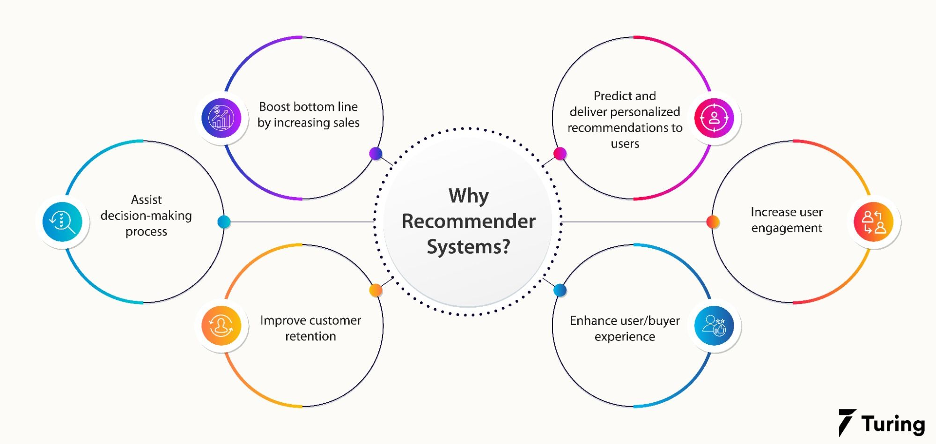

The profound impact of modern recommendation algorithms lies in their ability to extract implicit feedback, ensuring continual alignment with evolving customer preferences. This adaptability allows businesses to pivot alongside changing consumer tastes, ensuring that the system remains relevant even as preferences shift over time.

**The Lifecycle of Recommendation Systems**

Understanding the intricate lifecycle of recommendation systems unveils the strategic process involved in their development and deployment. This lifecycle, a meticulous seven-step journey, begins with the identification and collection of relevant data—reviews, ratings, and user interactions. This data, a treasure trove of insights, is then stored in proprietary data warehouses or third-party cloud services for efficiency. To enhance model accuracy, data undergoes filtration, addressing problematic values and refining the dataset. Subsequently, machine-learning or deep learning algorithms analyze the data, uncovering hidden patterns and insights. The model undergoes rigorous evaluation and testing, with adjustments made as necessary. Once primed, the model is deployed into practical use, with ongoing monitoring and tuning ensuring optimal performance. The integration of online machine learning post-deployment facilitates continuous improvement, ensuring the longevity and effectiveness of the recommendation system.

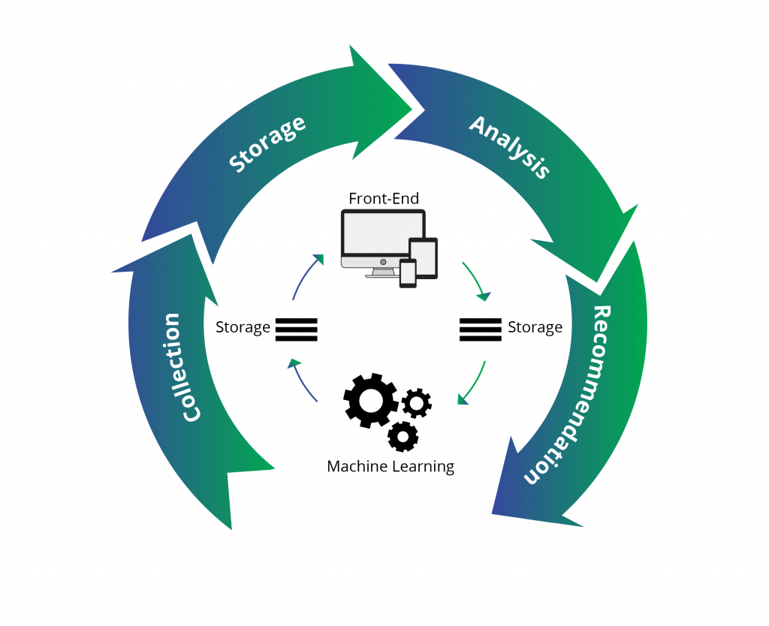

*Figure: Lifecycle of Recommendation Systems*

This systematic approach ensures that recommendation systems are not static entities but dynamic, continuously adapting to user behavior and preferences. The integration of machine learning post-deployment is akin to the system learning from its own experiences, a crucial element in today's ever-evolving digital landscape.

.

**Types of Recommendation Systems**

Machine learning, with its versatility, finds a prominent application in solving complex problems, and among its various applications, recommending products stands out. Understanding recommendation systems requires a grasp of the three primary types: Collaborative Filtering, Content-Based Filtering, and Hybrid Recommendation Systems.

1. **Collaborative filtering**

Collaborative filtering recommends items to users based on the preferences of other users. It identifies users who have similar preferences and recommends items that one user likes to other users with similar tastes.

Collaborative filtering doesn’t rely on item attributes; instead, it focuses on user behavior patterns, recommending items based on similarities between users' preferences. It can provide serendipitous recommendations by identifying patterns in user behavior and preferences.

For example, in a movie recommendation system, collaborative filtering would recommend movies to a user based on the ratings and preferences of other users with similar movie tastes.

However, it may suffer from the "cold start" problem, where new items or users with limited interaction history have insufficient data for accurate recommendations .

Two kinds of collaborative filtering techniques used are:

* User-User collaborative filtering : This technique creates groups of similar users (nearest neighbors) based on interactions, recommending items popular in these groups but new to the target user.
* Item-Item collaborative filtering : This approach selects recommendations based on the old interactions of the target user. It considers items the user has already liked, computes similar products, and suggests new items from these clusters.

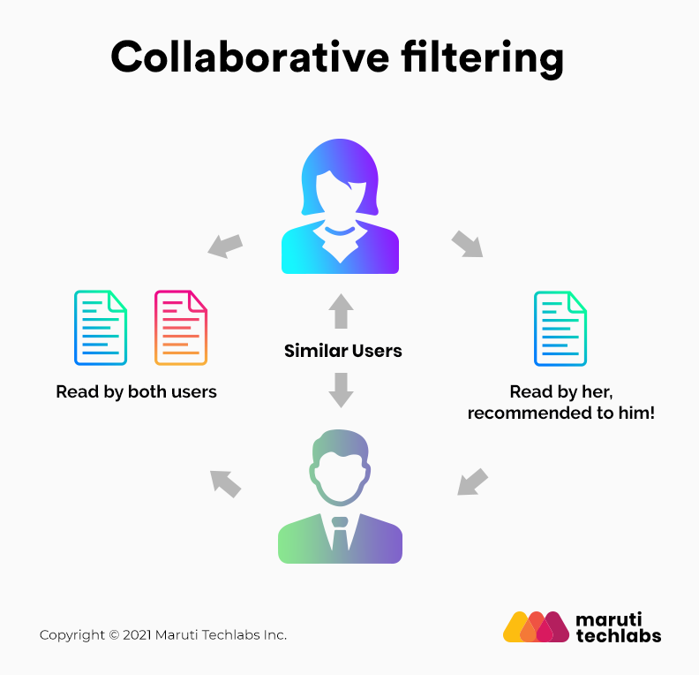

One notable advantage of collaborative filtering is its ability to recommend complex items precisely without requiring an understanding of the items themselves.

1. **Content-Based Filtering**

Content-based filtering recommends items to users based on the attributes and features of the items themselves. It focuses on the characteristics of the items and the user's historical interactions with similar items. It does not require the preferences of other users and can provide personalized recommendations even for new items.

For example, in a movie recommendation system, content-based filtering would recommend movies to a user based on the genre, actors, director, and plot of the movies they have liked in the past. The central assumption of content-based filtering is that a user will likely enjoy a similar item if they like a particular one. This approach focuses on aligning recommendations with individual preferences. Unlike collaborative filtering, content-based filtering doesn't rely on user interactions but rather focuses on item attributes to make recommendations.

However, it may suffer from the "filter bubble" effect, where users are only recommended items similar to what they have already liked, potentially limiting serendipitous discovery.

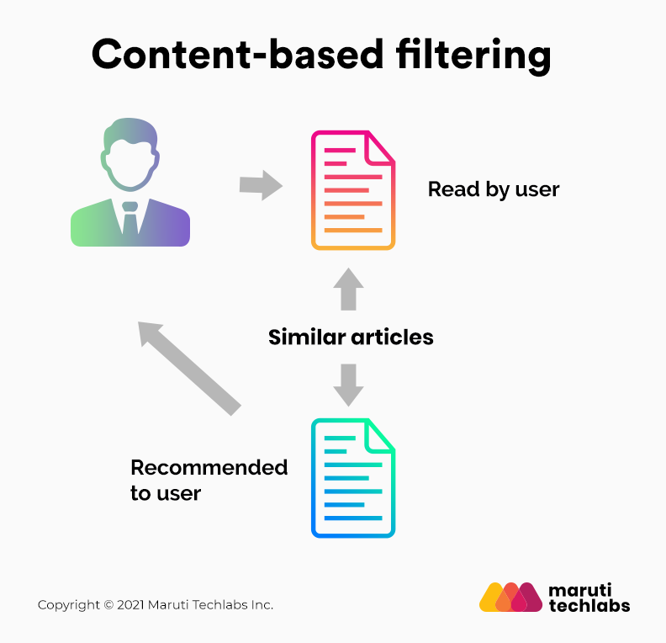

**Comparison between content based and collaborative:**

* Content-based filtering is based on the characteristics of items and the user's historical interactions, while collaborative filtering is based on the preferences of other users.
* Content-based filtering can provide personalized recommendations for new items, while collaborative filtering relies on the collective wisdom of users.
* Content-based filtering may lead to a narrower range of recommendations, while collaborative filtering can offer more diverse and unexpected suggestions.
* Content-based filtering does not require data on other users, while collaborative filtering requires a sufficient amount of user interaction data to make accurate recommendations.

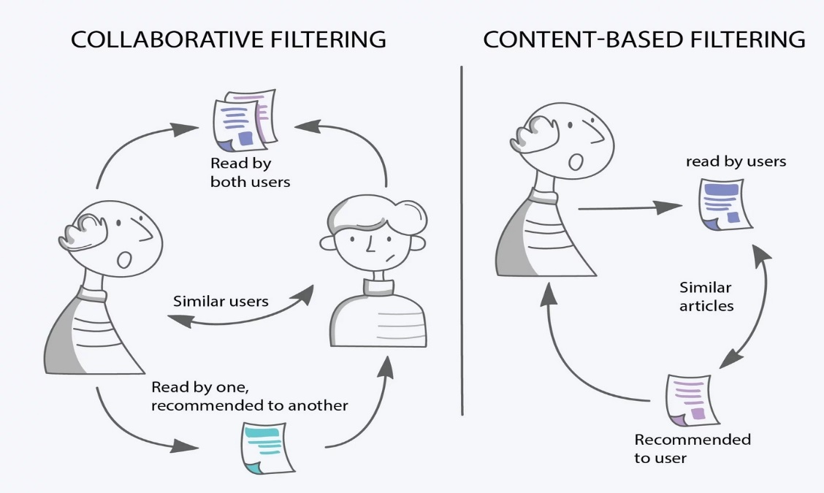

1. **Hybrid Recommendation Systems**

Hybrid Recommendation Systems leverage both content-based and collaborative filtering to offer a broader range of product recommendations. Platforms like Netflix exemplify this approach, combining user watching and searching habits (collaborative filtering) with content similarities (content-based filtering). To understand, Imagine User A shows preferences for action movies. Instead of solely relying on collaborative filtering to find users with similar tastes, the system also considers specific movie attributes, such as actors or directors, similar to content-based filtering. By combining both approaches, it offers recommendations that align with User A’s genre preferences and shared characteristics with other users.

For example, Netflix is an excellent case in point of a hybrid recommendation system. It makes recommendations by juxtaposing users’ watching and searching habits and finding similar users on that platform. This way, Netflix uses collaborative filtering. By recommending such shows/movies that share similar traits with those rated highly by the user, Netflix uses content-based filtering. They can also veto the common issues in recommendation systems, such as cold start and data insufficiency issues.

Hybrid systems are considered up-and-coming, providing more accurate recommendations than standalone approaches. They address common issues in recommendation systems, such as the cold start problem and data insufficiency.

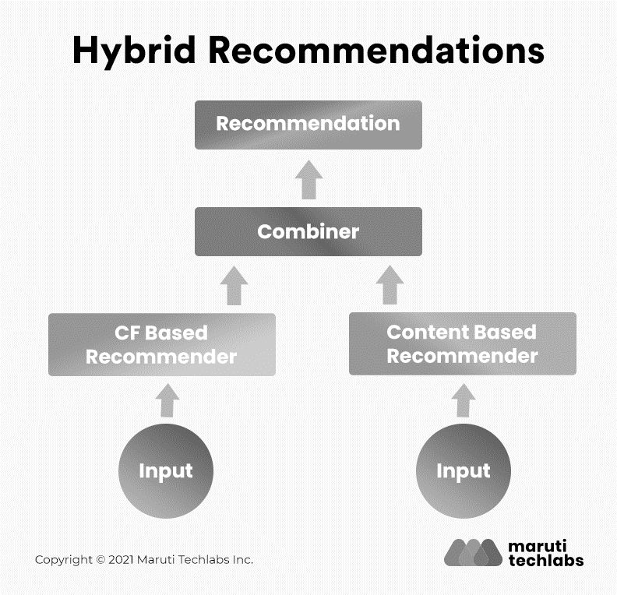

Recent advancements in recommendation systems have seen innovative adaptations and combinations, expanding beyond the three primary types mentioned above. Emerging techniques like context-aware recommendation systems and knowledge-based recommendation systems leverage additional information such as contextual cues, user context, or explicit knowledge to refine and personalize recommendations further. Additionally, deep learning-driven recommendation systems have surfaced, employing neural networks to extract intricate patterns and features for more accurate predictions

The topics discussed till here provide a comprehensive exploration of the three main types of recommendation systems, setting the stage for a deeper understanding of collaborative filtering in subsequent topics.

**Understanding collaborative filtering**

Collaborative filtering is a mechanism that leverages interactions and data collected from users, operating on the principle that individuals who concurred in their assessments of certain items are likely to concur again in the future.

This concept can be likened to seeking movie recommendations from friends. Naturally, we tend to trust recommendations from friends with similar tastes. Collaborative filtering systems often employ a similarity index-based technique. In the neighborhood-based approach, a group of users is chosen based on their similarity to the active user. Inference for the active user is derived by calculating a weighted average of the ratings from selected users.

In collaborative filtering, we ignore the features of an individual item. Instead, we focus on a similar group of people using the item and recommend other items that the group likes.

Similar users are divided into small clusters and are recommended new items according to the preferences of that cluster.

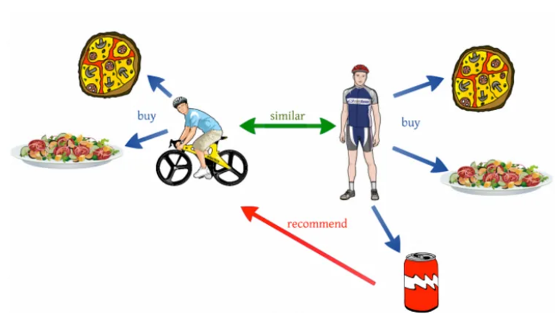

**User-Item Interaction Matrix: Deciphering Preferences**

At the heart of collaborative filtering lies the user-item interaction matrix, revealing the preferences of users for different items. This matrix forms the foundation for understanding the relationships between users and items.

Consider a scenario where users interact with a music streaming platform, and their preferences are recorded in a user-item interaction matrix as shown below:

| User | Pop | Rock | Jazz | Hip-hop |
| --- | --- | --- | --- | --- |
| A | 5 | 4 | 0 | 3 |
| B | 0 | 4 | 5 | 0 |
| C | 3 | 0 | 0 | 5 |
| D | 4 | 0 | 3 | 4 |

This matrix represents users A, B, C, and D, and their ratings (on a scale of 1-5) for different music genres—Pop, Rock, Jazz, and Hip-hop, respectively.

From this matrix, we can derive various insights about user preferences and their potential recommendations based on collaborative filtering:

* User A appreciates Pop and Rock music, liking Rock the most. They haven't shown interest in Jazz and moderately like Hip-hop.
* User B enjoys Rock and Jazz but not Pop or Hip-hop.
* User C prefers Pop and appreciates Hip-hop but doesn’t favor Rock or Jazz.
* User D enjoys a mix of Pop, Jazz, and Hip-hop but dislikes Rock music.

This matrix forms the basis for collaborative filtering, allowing the system to make recommendations based on users' preferences and similarities in their tastes for different music genres.

**Types of Collaborative filtering**

Collaborative filtering encompasses two fundamental approaches:

* Memory-Based Collaborative Filtering
* Model-Based Collaborative Filtering.

These methods employ different strategies to provide users with personalized recommendations based on their historical interactions.

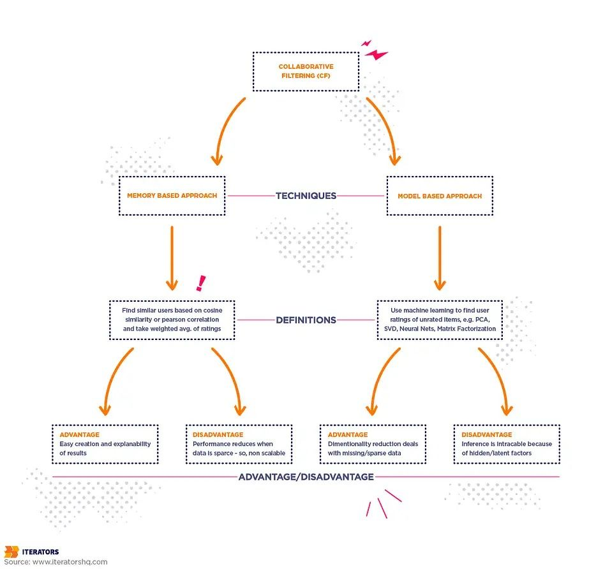

1. **Memory-Based Collaborative Approach**

Memory-based collaborative filtering relies solely on the user-item interaction matrix for generating recommendations. This approach centers around users' past ratings and interactions, employing two distinct methods: user-based collaborative filtering and item-based collaborative filtering.

1. **User-Based Collaborative Filtering**

In user-based collaborative filtering, new recommendations for a specific user stem from a group of similar users, often referred to as nearest neighbors. This group's interactions guide the suggestions, emphasizing items popular within the group yet undiscovered by the target user. Rating of the item is done using the rating of neighbouring users. In simple words, It is based on the notion of users’ similarity.

Example: Imagine three children, A, B, and C, who purchased fruits. If A bought all four fruits, and B bought only strawberries, C, being similar to A, might be recommended grapes and oranges, aligning with A's choices.

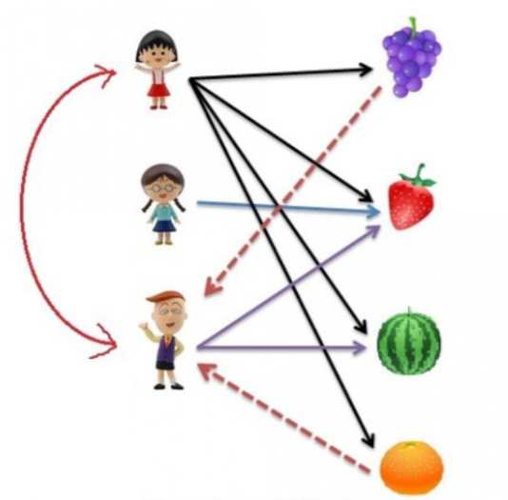

1. **Item-Based Collaborative Filtering**

Contrarily, item-based collaborative filtering selects new recommendations based on the target user's previous interactions. The process involves considering the items the user has already liked, identifying similar products, and forming clusters of nearest neighbors. Suggestions then arise from these clusters.

Example: Consider a scenario where a user expresses a preference for action movies. Item-based collaborative filtering may recommend other action films that align with the user's taste, enhancing their viewing experience.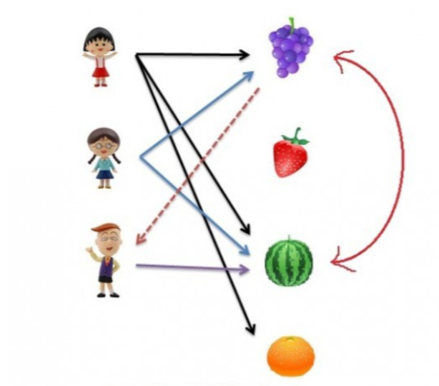

1. **Model-Based Collaborative Approach**

The model-based collaborative approach employs machine learning models to predict and rank interactions between users and items. These models, trained on existing interaction data, leverage algorithms like matrix factorization, deep learning, and clustering.

**Matrix Factorization**

Matrix factorization, a prevalent technique within model-based collaborative filtering, aims to derive latent features by decomposing the sparse user-item interaction matrix. The decomposition results in smaller, denser matrices representing user and item entities.

Example: Consider a sparse matrix with user ratings for movies. Matrix factorization helps uncover latent features distinguishing between preferences for good and bad movies. The model learns these features, contributing to the creation of user and item matrices.

This model-driven approach eliminates the need for explicit feature provision, allowing the system to autonomously discover relevant features that enhance its predictive capabilities.

**Implementation of collaborative filtering recommendation system**

**Data Preprocessing**

Preprocessing data for collaborative filtering involves organizing and structuring the data in a way that allows for effective analysis and recommendation generation. Here's a step-by-step guide on how to preprocess data for collaborative filtering:

**1. Data Loading and Understanding:**

First, load your dataset and understand its structure and contents. Commonly, collaborative filtering involves user-item interactions (e.g., user ratings on movies, product purchases, etc.).

import pandas as pd

# Load your dataset (assuming it's in CSV format)

data = pd.read_csv('your_dataset.csv')

# Display the first few rows to understand the structure

print(data.head())

**2. Data Cleaning and Handling Missing Values:**

Clean the dataset and handle any missing or inconsistent data:

# Check for missing values

print(data.isnull().sum())

# Fill or handle missing values (if any)

data.fillna(0, inplace=True) # For example, filling missing values with 0

**3. Creating a User-Item Matrix:**

Create a matrix where rows represent users, columns represent items, and the values are interactions (ratings, purchases, etc.).

# Create a user-item matrix using pivot_table

user_item_matrix = data.pivot_table(index='user_id', columns='item_id', values='rating').fillna(0)

# Display the user-item matrix

print(user_item_matrix.head())

1. **Normalization:**

Usually while assigning a rating, individuals tend to give either a high rating or a low rating, across all parameters. Normalization usually helps in balancing and evens out such measures. This is done by taking an average of rating available and subtracting it with the individual rating(x- x̅)  
Example:

To understand the normalization process , let’s take an example of movie ratings given by four individuals (Person A, B, C, and D) for four movies (Movie 1, Movie 2, Movie 3, and Movie 4):

**Original Movie Ratings:**

| **Individual** | **Movie 1** | **Movie 2** | **Movie 3** | **Movie 4** |
| --- | --- | --- | --- | --- |
| Person A | 4 | 1 | 2 | 1 |
| Person B | 1 | 4 | 2 | 3 |
| Person C | 3 | 2 | 5 | 4 |
| Person D | 2 | 3 | 4 | 2 |

**Calculate Mean Ratings for Each Person:**

* Person A: (4 + 1 + 2 + 1) / 4 = 2
* Person B: (1 + 4 + 2 + 3) / 4 = 2.5
* Person C: (3 + 2 + 5 + 4) / 4 = 3.5
* Person D: (2 + 3 + 4 + 2) / 4 = 2.75

**Normalize Ratings by Subtracting Mean Ratings:**

* Person A: 4 - 2, 1 - 2, 2 - 2, 1 - 2 = 2, -1, 0, -1
* Person B: 1 - 2.5, 4 - 2.5, 2 - 2.5, 3 - 2.5 = -1.5, 1.5, -0.5, 0.5
* Person C: 3 - 3.5, 2 - 3.5, 5 - 3.5, 4 - 3.5 = -0.5, -1.5, 1.5, 0.5
* Person D: 2 - 2.75, 3 - 2.75, 4 - 2.75, 2 - 2.75 = -0.75, 0.25, 1.25, -0.75

**Normalized Ratings:**

| **Individual** | **Movie 1** | **Movie 2** | **Movie 3** | **Movie 4** |
| --- | --- | --- | --- | --- |
| Person A | 2 | -1 | 0 | -1 |
| Person B | -1.5 | 1.5 | -0.5 | 0.5 |
| Person C | -0.5 | -1.5 | 1.5 | 0.5 |
| Person D | -0.75 | 0.25 | 1.25 | -0.75 |

**Similarity Measures**

In Collaborative Filtering (CF), similarity measures play a vital role in establishing relationships between users or items based on their interactions or ratings. Two key measures, the Pearson Correlation Coefficient and Cosine Similarity, are fundamental in assessing likeness or resemblance:

* **Pearson Correlation Coefficient:**

This measure quantifies the linear correlation between two variables, often used to determine the similarity in rating behavior between users. The range lies between -1 and 1, with 1 indicating a perfect positive correlation, -1 indicating a perfect negative correlation, and 0 signifying no linear correlation. The formula for Pearson Correlation Coefficient (r) is:

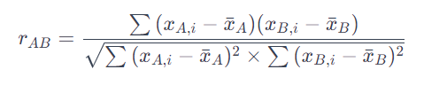

Where:

* and are ratings of Person A and Person B for the same item i.
* *x*ˉ*A*​ and *x*ˉ*B*​ are the mean ratings of Person A and Person B, respectively.
* **Cosine Similarity:**

Assessing the cosine of the angle between two non-zero vectors, Cosine Similarity evaluates the similarity in direction irrespective of magnitude. The formula for Cosine Similarity (cosine *θ*) is:

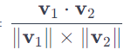**Where:**

Cosine Similarity=

* V1​ and v2​ are vectors representing ratings.
* v1​⋅v2​ is the dot product of vectors v1​ and v2​.
* ∥v1​∥ and ∥v2​∥ are the magnitudes of vectors v1​ and v2​, respectively.

Two primary approaches within collaborative filtering used for making recommendations:

**User-User Collaborative Filtering:**

Dive into the technical details of user-user collaborative filtering, including how to calculate user similarities, select nearest neighbors, and generate predictions for target users based on their neighbors' preferences.

The steps involve:

1. Calculating User Similarities:
   * Compute Pearson Correlation Coefficient between users' rating patterns.
2. Identifying Nearest Neighbors:
   * Select users with the highest similarity to the target user.
3. Generating Recommendations:
   * Aggregate ratings from nearest neighbors to suggest unrated items to the target user.

**Item-Item Collaborative Filtering:**

Discuss the technical aspects of item-item collaborative filtering, including similarity calculation between items, selecting similar items, and generating predictions for users based on their preferences for similar items.

The steps encompass:

1. Computing Item Similarities:
   * Evaluate Cosine Similarity between movies based on user ratings.
2. Identifying Similar Items:
   * Determine movies with the highest similarity to recommend similar ones.
3. Making Recommendations:
   * Recommend items analogous to those highly rated by the user.

**Comparison:**

* **User-User CF:** Focuses on finding users similar to the target user and recommending items based on what those similar users have liked or rated highly.
* **Item-Item CF:** Recommends items to a user based on the similarity between items themselves, suggesting items akin to those the user has already shown a preference for.

Both methods aim to provide personalized recommendations by leveraging either user similarity or item similarity, offering different perspectives and advantages in different scenarios.

Applying the above concepts to the normalized ratings,

| **Individual** | **Movie 1** | **Movie 2** | **Movie 3** | **Movie 4** |
| --- | --- | --- | --- | --- |
| Person A | 2 | -1 | 0 | -1 |
| Person B | -1.5 | 1.5 | -0.5 | 0.5 |
| Person C | -0.5 | -1.5 | 1.5 | 0.5 |
| Person D | -0.75 | 0.25 | 1.25 | -0.75 |

User-User Collaborative Filtering for Person A:

To predict Person A's rating for Movie 3 using User-User Collaborative Filtering, we take the weighted sum of Movie 3 ratings by the nearest neighbors (Person B and Person C), weighted by their similarities to Person A, and then normalize it by the sum of similarities.

1. Assuming Pearson Correlation Coefficients between Person A and other users (B, C, D):

Pearson(A, B) = 0.8, Pearson(A, C) = 0.6, Pearson(A, D) = 0.4

1. Nearest Neighbors:

Nearest Neighbors for Person A based on highest similarity: B (similarity: 0.8), C (similarity: 0.6)

1. Predicted Rating for Movie 3 by Person A:



Rating(Movie 3 by A) =

= (1.5 * 0.8 + 1.5 * 0.6) / (0.8 + 0.6) ≈ 1.25

Item-Item Collaborative Filtering for Person A:

For Item-Item Collaborative Filtering, we predict Person A's rating for Movie 2 by considering its similarity with Movie 3 and other movies rated by Person A. We compute a weighted sum of Person A's ratings for similar movies (Movies 1 and 2) weighted by their similarities to Movie 3, then normalize it by the sum of similarities.

1. Assuming Cosine Similarities:

Cosine(Movie 3, Movie 1) = 0.5,

Cosine(Movie 3, Movie 2) = 0.6,

Cosine(Movie 3, Movie 4) = 0.4

1. Identify Similar Movies :

Similar movies for Movie 3 based on highest similarity:

Similar Movies: Movie 2 (similarity: 0.6), Movie 1 (similarity: 0.5)

1. Predicted Rating for Movie 2 by Person A:

Rating(Movie 2 by A) = (1.5 * 0.6 - 1 * 0.5) / (0.6 + 0.5) ≈ 0.53

Evaluation metrics for collaborative filtering

In the context of collaborative filtering, several evaluation metrics are commonly used to assess the performance of recommendation systems. These metrics help measure how well the system is able to predict user preferences and provide accurate recommendations. Here are some key evaluation metrics for collaborative filtering:

1. Mean Absolute Error (MAE):

MAE measures the average absolute difference between the predicted ratings and the actual ratings given by users. It is calculated as the average of the absolute differences between the predicted ratings (P) and the actual ratings (A) for a set of user-item pairs:



Lower MAE values indicate better predictive accuracy.

2. Root Mean Squared Error (RMSE):

RMSE is another popular metric that measures the square root of the average of the squared differences between predicted ratings and actual ratings. It is calculated as:

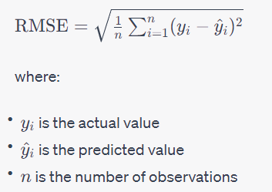

Like MAE, lower RMSE values indicate better predictive accuracy.

3. Precision and Recall:

Precision and recall are commonly used in the context of top-N recommendation evaluation. Precision measures the proportion of recommended items that are relevant to the user, while recall measures the proportion of relevant items that are recommended to the user.

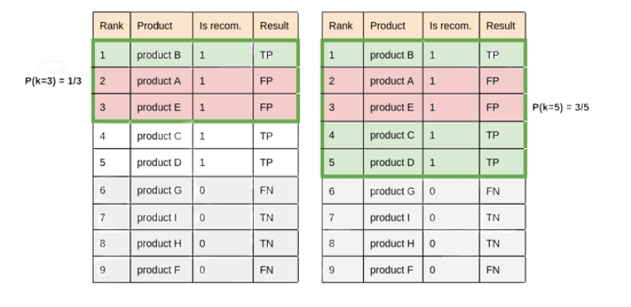

4. F1 Score:

The F1 score is the harmonic mean of precision and recall and provides a single metric that balances both precision and recall. It is calculated as:

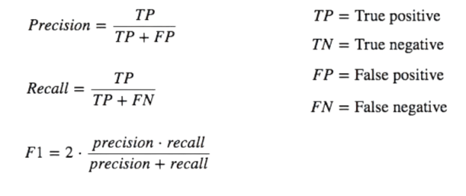

5, Average Precison:

The average precision (AP) is the mean of the precision values at each relevant item's rank position. It is calculated as:

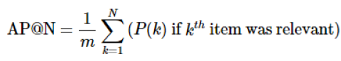

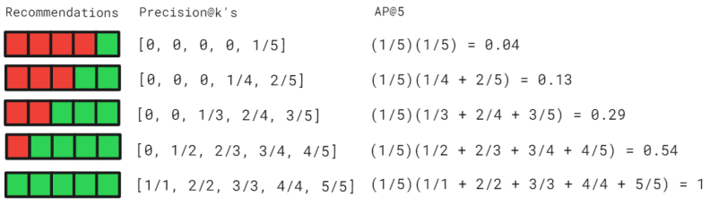

6. Mean Average Precision (MAP):

MAP is a metric used to evaluate the quality of a ranked list of recommendations. It considers the average precision at each relevant item's rank position and then averages these precisions across all users.

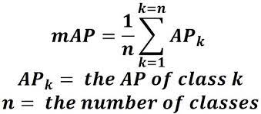

7. Normalized Discounted Cumulative Gain (NDCG):

NDCG is a metric commonly used in information retrieval and recommendation systems to evaluate the ranking quality of recommended items. It considers both the relevance and the position of the recommended items in the ranked list.

These evaluation metrics provide a comprehensive way to assess the performance of collaborative filtering-based recommendation systems. When implementing collaborative filtering, it's important to consider these metrics to ensure that the system is providing accurate and relevant recommendations to users.

**Real world use cases of collaborative filtering based recommendation systems**

A few case studies that highlight the application and effectiveness of collaborative filtering in various domains:

1. **Netflix Prize Case Study:**
   * Netflix held a competition known as the Netflix Prize, offering a reward for improving its recommendation system's accuracy by 10%. Several teams used collaborative filtering techniques and machine learning algorithms to enhance recommendation quality. The winning solutions greatly improved Netflix's ability to predict user preferences and provide more accurate movie and TV show suggestions.
2. **Amazon’s Product Recommendations:**
   * Amazon utilizes collaborative filtering extensively in its recommendation engine. By analyzing user behavior, such as past purchases, browsing history, and product ratings, Amazon suggests personalized product recommendations to users. This strategy significantly contributes to increased sales and customer satisfaction by offering relevant and personalized suggestions.
3. **Spotify’s Music Recommendations:**
   * Spotify employs collaborative filtering to create personalized music recommendations for its users. By analyzing listening history, preferred genres, and user-generated playlists, Spotify suggests new songs and playlists that align with users' music preferences. This approach enhances user engagement and promotes discovery of new music.
4. **LinkedIn’s People You May Know Feature:**
   * LinkedIn uses collaborative filtering to suggest potential connections to its users. By analyzing users' profiles, mutual connections, and professional networks, LinkedIn recommends new connections that users might know or want to connect with. This feature has significantly improved user networking and engagement on the platform.
5. **YouTube’s Video Recommendations:**
   * YouTube employs collaborative filtering algorithms to suggest videos to its users based on their viewing history, likes, and interactions. By analyzing user behavior and similarities with other users, YouTube recommends relevant and engaging videos, contributing to longer watch times and increased user engagement on the platform.

These case studies showcase the effectiveness and versatility of collaborative filtering in delivering personalized recommendations across various domains, ultimately enhancing user experiences and platform engagement.

**Challenges:**

1. **Cold Start Problem:** New users or items lacking sufficient interaction data pose a challenge, making it challenging to provide accurate recommendations.
2. **Scalability:** Handling vast datasets and ensuring real-time responsiveness in large-scale systems can be complex.
3. **Data Sparsity:** Sparse user-item interaction matrices can lead to limited collaborative signals, impacting recommendation quality.
4. **Diversity and Serendipity:** Striking a balance between providing personalized recommendations and introducing diversity remains a challenge.
5. **Privacy Concerns:** Collaborative Filtering relies on user data, raising privacy concerns. Striking a balance between personalization and user privacy is crucial.

**Conclusion**

In conclusion, collaborative filtering emerges as a powerful technique for providing personalized recommendations to users. Its ability to leverage user interactions and preferences has made it a cornerstone in recommendation systems. As we look to the future, addressing challenges such as the cold start problem and scalability issues, while incorporating contextual information, will be crucial for advancing the capabilities of collaborative filtering. With its wide-ranging applications in e-commerce, streaming services, and social media platforms, collaborative filtering continues to shape the landscape of personalized recommendations, promising a future of enhanced user experiences and engagement.

**-**