**FanCode Assignment**

Harkirat Kaur

19 December, 2024

|  |  |  |
| --- | --- | --- |
| Project Name | Technology | Version |
| FanCode_BE | **ASP.NET Core Web API** | 8.0 |
| FancodeProject | **Angular** | 18 |
|  | **Npm** | 10.8.2 |
|  | **Node** | 20.17.0 |

**.Net Core Project Structure-**

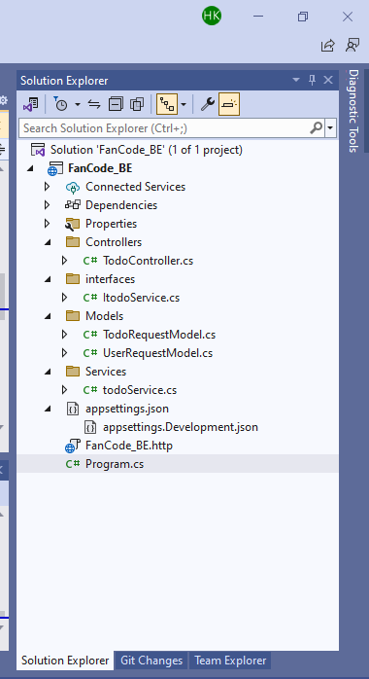

**Steps to Run .Net (Backend) project-**

1. Click on build in the top menu.
2. Once the build is successful, Press F5 or click the green Start Debugging button at the top.

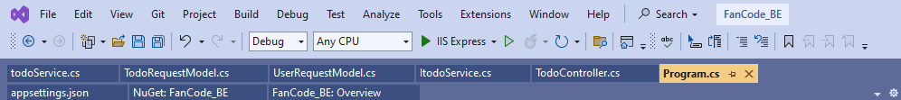

1. Visual Studio will compile and start the application.

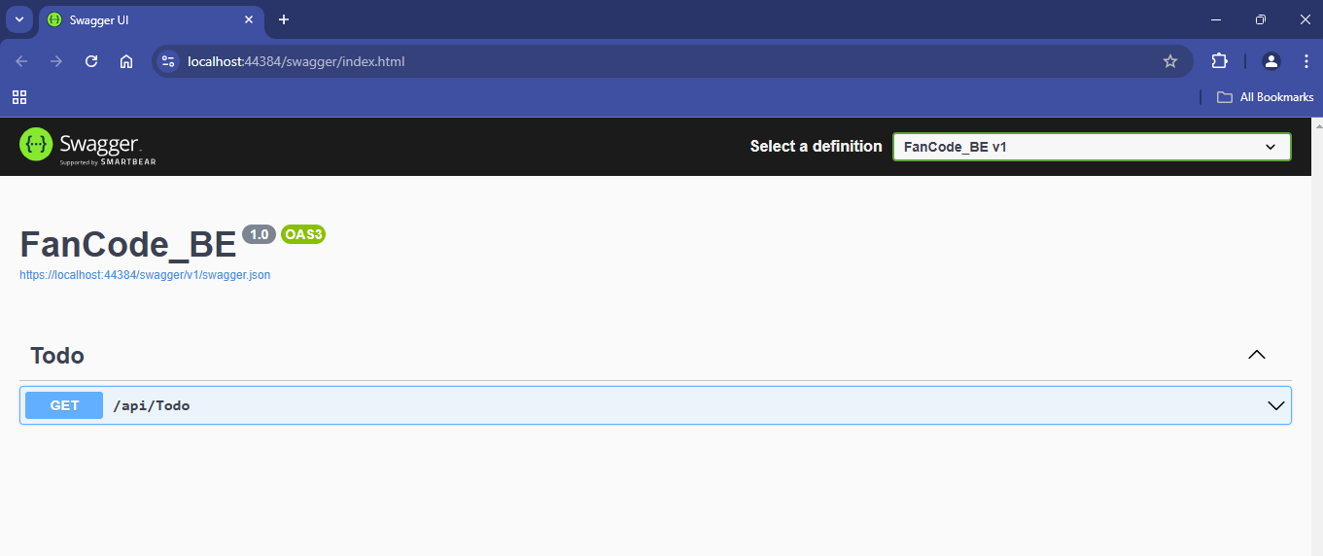

**Angular Project Structure-**

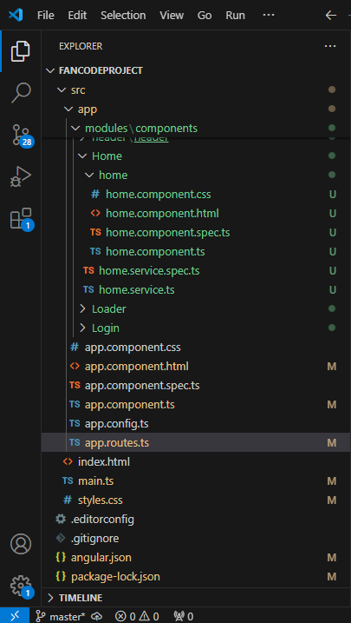

**Steps to Run Angular (Frontend) project-**

1. To run angular project, use following cmd,

Ng serve

Or

Ng serve –o

After you run the project, it will take you to localhost Url, below screen will appear-

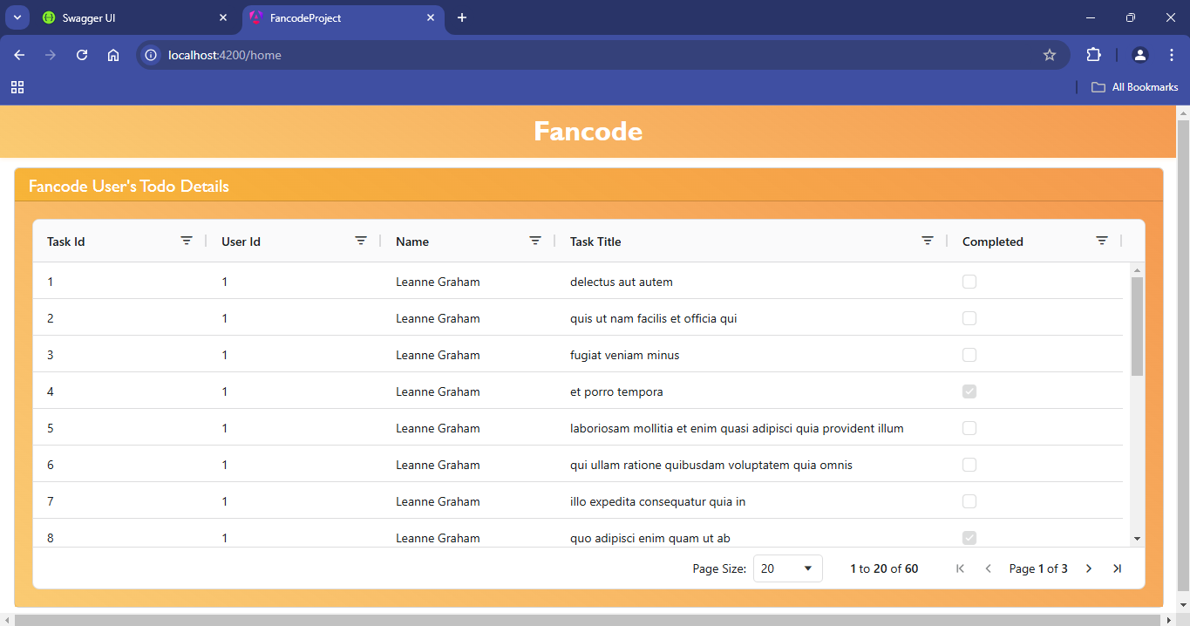

This project uses **AG-Grid** to manage and display tabular data with advanced features such as sorting, filtering, and pagination. It provides features like:

- Sorting and filtering

- Pagination

- Row grouping

- Cell editing

- Custom styling