

MICROSTRATEGY

Version 0.1

Netezza performance portal

Prepared For: DATA MANAGEMENT TEAM

Prepared By: HARKIRAT GHOTRA (CO-OP STUDENT)

Date: 2016-31-03

1. Get an access

* First get an access for Netezza performance portal from DBA (Herb Farr).
* Once you get access, just use this link and enter your credentials “<https://172.30.133.235/com.netezza.portal.Portal/index.html#PORTAL%20ADMINISTRATION>
* Then main page will open.

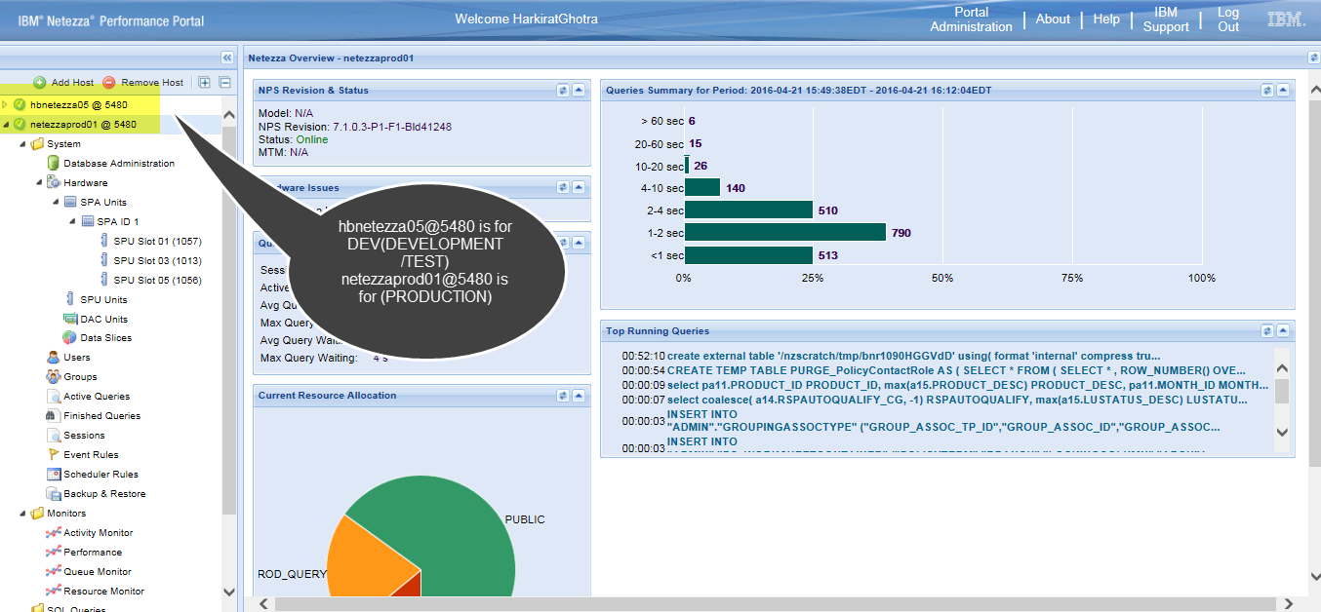

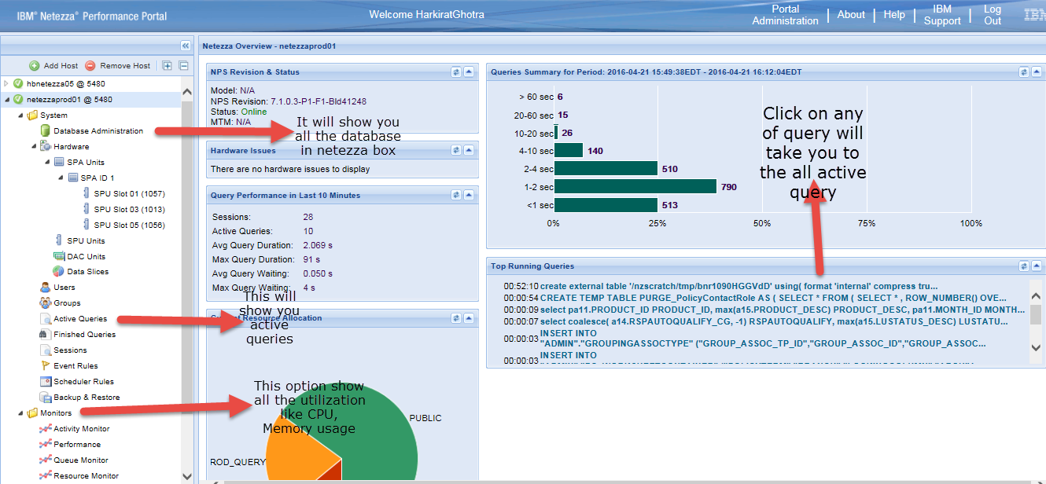

1. Database Administration

* Just click on database administration to check all the datasets in Netezza prod box and on the click of any database , its tables , views can be visible

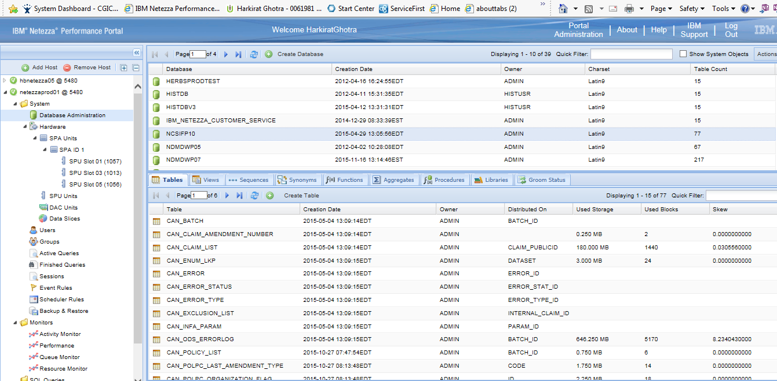

1. Click on the Action button and it will show you three option that is “show table skew”, “show storage”, “and show locks”.

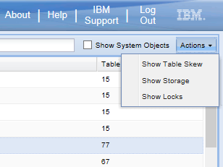

* After that just click on first option that is “ table skew” , a new window will show.

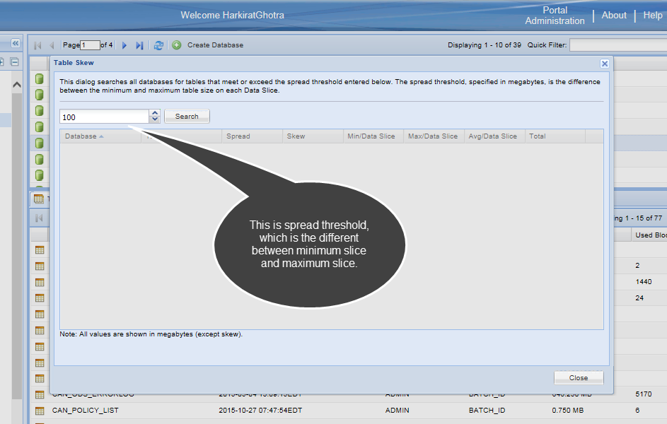

* Then just click on search button and this will give number of tables with skew count. If the skew is near to zero then that mean the distribution of data in that table is equal otherwise, the distribution of data is not equal.

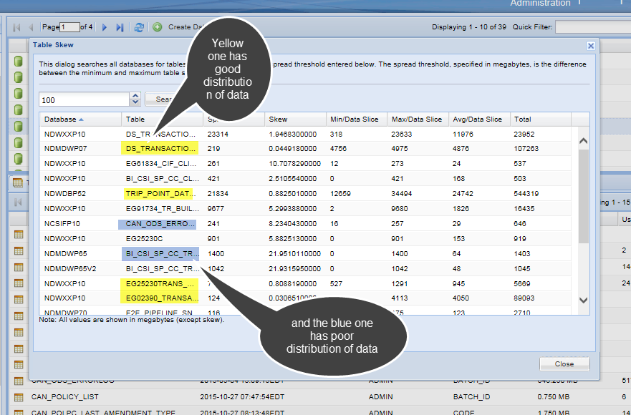

* By clicking on next button that is “Show Storage”, you can see a separate screen, which will show the memory utilization by both database and user.

1. Monitor: Through monitor, we can check long running query. Just click on monitor folder and then click on resource monitor and certain graphs will show up.

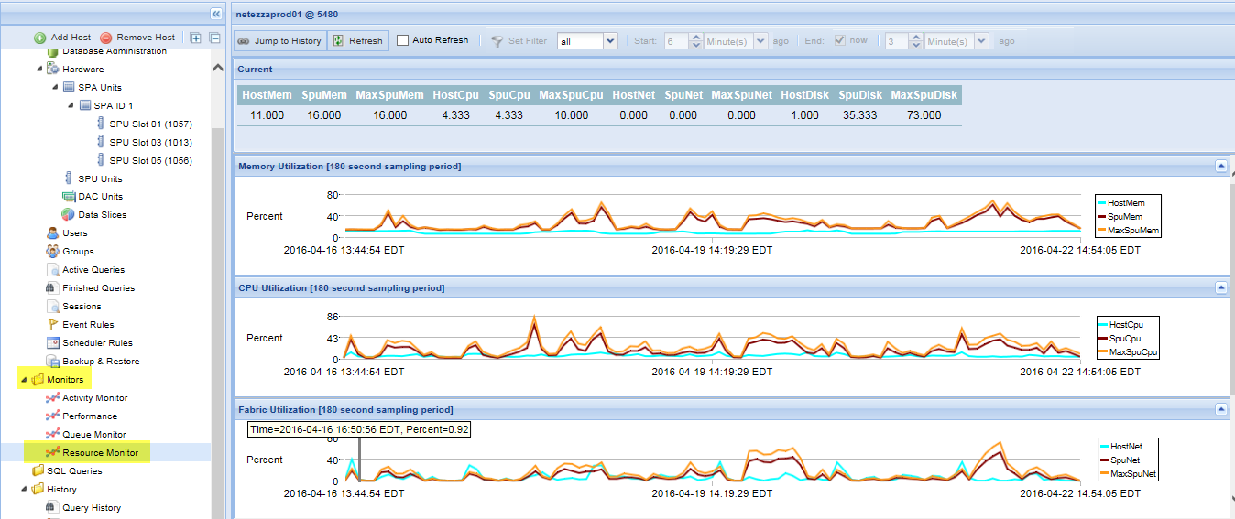

* Then just select any two interval from the graph, let’s say you select a graph between two peaks. Then it will show you the narrow version of that interval.
* Then just click on “jump to History” and then select prod connection, which will take you to another window, which will show all the queries.