Basic functions:

import streamlit as st

# Run application on your system:

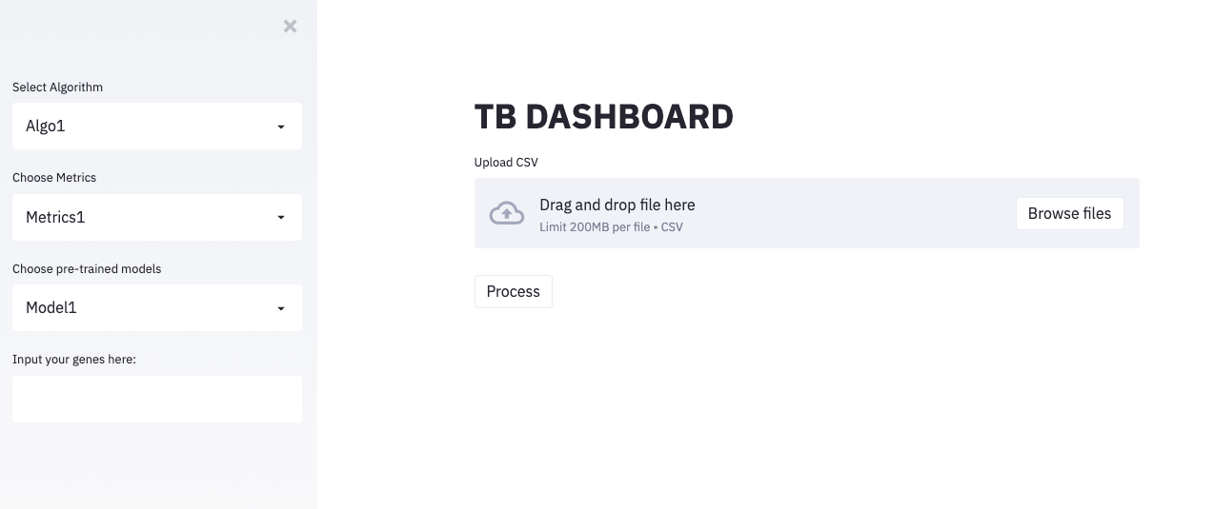streamlit run app.py

st.function_name for keeping elements in main area

st.sidebar.function_name for keeping elements in sidebar area

Example:

If we want to put this dropdown in sidebar area:

st.sidebar.selectbox("Select Algorithm", ("Algo1", "Algo2", "Algo3", "Algo4", "Algo5"))

If we want to put this dropdown in main area:

algo = st.selectbox("Select Algorithm", ("Algo1", "Algo2", "Algo3", "Algo4", "Algo5"))