Four Weeks Industrial Training Project Report on

SMART FOOD DELIVERY & RESTAURANT INSIGHT

DASHBOARD Submitted in partial fulfillment of the requirement for the award of degree of
Bachelor of Technology (B.Tech)
in
Computer Science and Engineering & AI
Batch
(2025-2026)



Submitted To:
Department of Computer Science and Engineering
DAV University, Jalandhar
Submitted By:
Harleen Kaur Jabal (12401619)

Training Organization:
O7 Services, Jalandhar

ACKNOWLEDGEMENT
I would like to express my sincere gratitude to my training coordinator, ____________, for providing me the opportunity to undergo four weeks of industrial training at O7 Services, Jalandhar.
I am thankful to all the faculty members of the Department of Computer Science and Engineering, DAV University, for their guidance, encouragement, and support throughout the training period.
I would also like to thank my trainer, Harkirat Singh, and all the staff members of O7 Services for sharing their knowledge and helping me understand various concepts related to data analysis and dashboard development.
The experience gained during this training has been valuable and has enhanced my technical and professional skills.
Harleen Kaur

DECLARATION
I, Harleen Kaur, hereby declare that the project titled “Smart Food Delivery & Restaurant Insight Dashboard” submitted in partial fulfillment of the requirements for the award of Bachelor of Technology degree in Computer Science and Engineering is an authentic record of my own work carried out during my industrial training at O7 Services, Jalandhar.
To the best of my knowledge, the work presented in this report has not been submitted elsewhere for the award of any degree or diploma.
Harleen Kaur
Roll No. 12401619

ABSTRACT
The food delivery industry generates a large amount of data every day. Restaurants, delivery partners, and customers interact through online platforms, creating valuable information that can be analyzed to improve business performance.
The Smart Food Delivery & Restaurant Insight Dashboard is a data analytics project developed using Python and Streamlit. The project focuses on analyzing restaurant performance, customer ratings, food categories, pricing patterns, and delivery trends.
The dashboard provides interactive visualizations and filtering options that allow users to explore restaurant data efficiently. Various charts and graphs have been used to identify trends and generate business insights.
The project demonstrates the practical application of data science concepts such as data cleaning, data transformation, exploratory data analysis, and dashboard development. The final dashboard helps decision-makers understand customer behavior and restaurant performance through a user-friendly interface.

Table of Contents-:

Sr. No. | Section / Topic
1 | Introduction
2 | Company Profile
3 | Project Overview
4 | Objectives
5 | Dataset Description
6 | Tools and Technologies Used
7 | System Design
8 | Implementation
9 | Dashboard Modules
10 | Data Analysis and Visualizations
11 | Key Insights
12 | Challenges Faced
13 | Learning Outcomes
14 | Conclusion
15 | Future Scope
16 | References
17 | Appendix

CHAPTER 1: INTRODUCTION

1.1 Background
The rapid growth of online food delivery services has transformed the restaurant industry. Customers now have access to thousands of restaurants through mobile applications and websites.
These platforms generate large volumes of data related to restaurant ratings, customer reviews, pricing, food categories, and delivery times. Analyzing this data helps businesses make informed decisions and improve operational efficiency.

1.2 Need for the Project
Managing restaurant data manually is difficult because of the large number of records and multiple performance indicators.
A dashboard can help:
- Monitor restaurant performance
- Analyze customer preferences
- Compare food categories
- Identify high-performing restaurants
- Support business decision-making

1.3 Problem Statement
Businesses often struggle to convert raw restaurant data into meaningful insights. Traditional spreadsheets make it difficult to identify trends and patterns.
The project aims to solve this problem by providing an interactive dashboard that presents data through visualizations and analytics.

1.4 Project Scope
The dashboard focuses on:
- Restaurant performance analysis
- Customer rating analysis
- Delivery time analysis
- Food category analysis
- Pricing insights
- Business recommendations

CHAPTER 2: COMPANY PROFILE

2.1 About O7 Services
O7 Services is a technology-focused organization that provides software development, web development, digital solutions, and IT-related services.
The company encourages practical learning through industrial training programs and helps students gain real-world experience in software development and data analytics.

2.2 Training Objectives
The primary objectives of the industrial training were:
- Understand data analysis techniques
- Learn dashboard development
- Work with real-world datasets
- Improve Python programming skills
- Develop problem-solving abilities

2.3 Training Duration
Training Organization: O7 Services, Jalandhar
Duration: Four Weeks
Technology Domain: Python & Data Science

CHAPTER 3: PROJECT OVERVIEW

3.1 Project Title
Smart Food Delivery & Restaurant Insight Dashboard

3.2 Project Description
The Smart Food Delivery & Restaurant Insight Dashboard is a data analytics project developed to analyze restaurant and food delivery data in an interactive and meaningful way. The project focuses on transforming raw restaurant data into visual insights that can help businesses understand customer behavior, restaurant performance, pricing trends, and delivery efficiency.
The dashboard has been designed using Python and Streamlit, providing users with an easy-to-use interface for exploring large amounts of data. Through various charts, graphs, filters, and statistical summaries, users can quickly identify important patterns and trends within the dataset. The project demonstrates the practical application of data analytics techniques in solving real-world business problems.
3.3 Purpose of the Project
The main purpose of this project is to simplify the analysis of restaurant and food delivery data. Businesses often collect large amounts of information, but extracting useful insights from that data can be challenging. This dashboard helps users analyze data efficiently and make informed decisions based on facts and trends.
The project also aims to provide a centralized platform where restaurant performance, customer ratings, delivery times, and cuisine popularity can be monitored and evaluated through interactive visualizations.

3.4 Key Features of the Dashboard
The dashboard includes the following features:
- Interactive filtering by city and food category.
- Dynamic charts and visualizations.
- Restaurant performance analysis.
- Customer rating analysis.
- Delivery time monitoring.
- Statistical summaries.
- Downloadable filtered dataset.
- Business insights and recommendations.

3.5 Benefits of the Project
Some major benefits of the dashboard are:
- Simplifies data analysis.
- Improves decision-making processes.
- Identifies top-performing restaurants.
- Helps understand customer preferences.
- Supports business growth strategies.
- Provides interactive and user-friendly visualizations.

CHAPTER 4: OBJECTIVES OF THE PROJECT
The Smart Food Delivery & Restaurant Insight Dashboard was developed with the objective of utilizing data analytics techniques to understand restaurant and food delivery operations more effectively. The project aims to transform raw restaurant data into meaningful information that can support business decisions and improve operational efficiency.

Objectives
- To analyze restaurant performance based on customer ratings and reviews.
- To identify the most popular food categories and cuisines.
- To evaluate delivery time patterns and efficiency.
- To compare restaurant performance across different cities
- To provide interactive visualizations for better understanding of data.
- To generate business insights and recommendations.
- To develop a user-friendly dashboard using Streamlit.
- To apply data science concepts to a real-world dataset.

CHAPTER 5: DATASET DESCRIPTION

5.1 Introduction
Data serves as the foundation of any analytics project. The success of a dashboard largely depends on the quality and structure of the dataset being used. For this project, a food delivery dataset containing information about restaurants, customer ratings, delivery performance, and pricing was utilized.
The dataset contains approximately 8,680 records and 10 attributes, making it suitable for performing exploratory data analysis and generating meaningful business insights.

5.2 Dataset Attributes
Attribute | Description
ID | Unique identifier of restaurant
Restaurant | Name of restaurant
City | City where restaurant operates
Area | Area or locality of restaurant
Food Type | Cuisine offered by restaurant
Price | Average cost of food
Average Rating | Customer rating score
Total Ratings | Number of customer reviews
Address | Restaurant location details
Delivery Time | Estimated delivery duration

5.3 Data Collection
The dataset was collected from publicly available restaurant and food delivery records. It contains information about restaurants operating in multiple cities and includes important metrics related to customer engagement and operational performance.
The dataset provides valuable information that can be used to understand customer preferences, restaurant popularity, and delivery trends.

5.4 Data Preprocessing
Before analysis, the dataset was cleaned and prepared to ensure accuracy and consistency. Data preprocessing is a crucial step because raw datasets often contain missing values, duplicate entries, and formatting inconsistencies.
The following preprocessing steps were performed:
- Removal of duplicate records.
- Handling of missing values.
- Standardization of column names.
- Data type conversion where required.
- Formatting of textual data.
- Verification of numerical values.
- Preparation of data for visualization.

These preprocessing steps improved data quality and ensured reliable analysis results.

5.5 Importance of the Dataset
The dataset plays a significant role in understanding restaurant and food delivery operations. It provides insights into customer preferences, restaurant performance, cuisine popularity, pricing trends, and delivery efficiency.
By analyzing this dataset, businesses can identify strengths and weaknesses, improve customer satisfaction, and make data-driven decisions that contribute to growth and profitability.

Dataset Screenshot-:

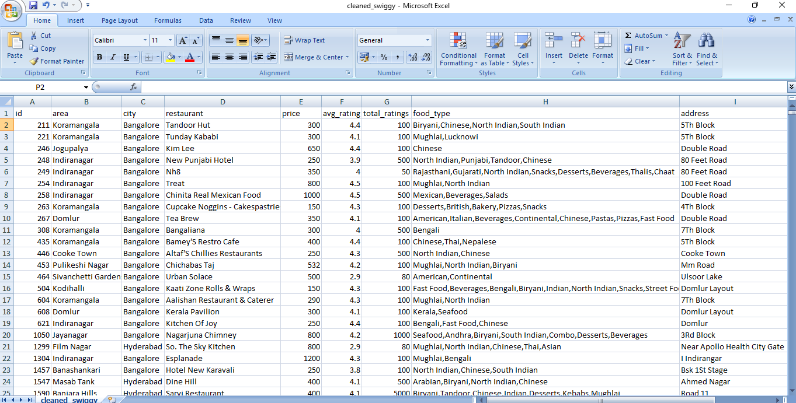

CHAPTER 6: TOOLS AND TECHNOLOGIES USED

6.1 Introduction
Several tools and technologies were used during the development of the Smart Food Delivery & Restaurant Insight Dashboard. These technologies helped in data cleaning, analysis, visualization, and dashboard development.

6.2 Python
Python was used as the primary programming language for this project. It is widely used in data science because of its simplicity, readability, and extensive library support. Python was responsible for handling data processing, visualization, and dashboard functionality.

6.3 Technologies Used
The following technologies were used during the project:
Technology | Purpose
Python | Programming Language
Pandas | Data Cleaning and Analysis
Streamlit | Dashboard Development
Plotly | Interactive Visualizations
Matplotlib | Data Visualization
Seaborn | Statistical Analysis
GitHub | Version Control

6.4 Pandas
Pandas is a powerful data analysis library in Python. It provides DataFrame structures that make it easier to organize, clean, filter, and analyze large datasets. Pandas was extensively used for data manipulation and preprocessing tasks throughout the project.

6.5 Streamlit
Streamlit is an open-source framework used for building web-based data applications. It allows developers to create interactive dashboards with minimal code. Streamlit was used to design the dashboard interface and integrate all visualizations into a single platform.

6.6 Plotly
Plotly is a visualization library that provides highly interactive charts and graphs. It was used to create bar charts, scatter plots, pie charts, histograms, and other visualizations that helped users explore the dataset effectively.

6.7 Matplotlib and Seaborn
Matplotlib and Seaborn were used for exploratory data analysis. These libraries helped in understanding trends, identifying patterns, and creating statistical visualizations during the initial stages of development.

6.8 GitHub
GitHub was used for version control and project management. It allowed project files to be stored securely and helped track changes made during the development process.

6.9 Advantages of the Selected Technologies

The technologies selected for this project provided several advantages:
- Easy implementation and development.
- Efficient data processing.
- Interactive visualizations.
- User-friendly dashboard interface.
- Better code management and version control.
- Scalability for future improvements.

CHAPTER 7: SYSTEM DESIGN

7.1 Introduction
System design plays an important role in the successful development of any software application. It provides a structured approach for organizing project components and defining the interaction between different modules. For this project, the dashboard was designed in a modular manner to ensure maintainability, scalability, and ease of use.
The Smart Food Delivery & Restaurant Insight Dashboard follows a simple workflow where raw data is loaded, processed, analyzed, and finally displayed through interactive visualizations. The dashboard enables users to explore restaurant-related information using filters and dynamic charts.

7.2 System Architecture
The project follows a four-stage architecture:

1. Data Collection Layer
This layer contains the restaurant dataset which serves as the primary source of information. The dataset includes restaurant names, ratings, delivery times, food categories, prices, and location details.

2. Data Processing Layer
In this layer, the dataset is cleaned and transformed using Python and Pandas. Missing values are handled, duplicate records are removed, and data is prepared for analysis.

3. Analytics Layer
The processed data is analyzed using various statistical techniques. Aggregations, groupings, and calculations are performed to generate meaningful insights.

4. Visualization Layer
The final layer displays the analyzed information using interactive charts and dashboard components created with Streamlit and Plotly.

7.3 Workflow of the System
The workflow of the dashboard can be summarized as follows:
- Load dataset.
- Clean and preprocess data.
- Apply user-selected filters.
- Perform calculations and aggregations.
- Generate visualizations.
- Display insights and recommendations.

7.4 Advantages of the Design
The designed system offers several advantages:
- Easy navigation and usability.
- Interactive data exploration.
- Faster analysis of large datasets.
- Modular and scalable architecture.
- Real-time filtering and visualization.

CHAPTER 8: IMPLEMENTATION

8.1 Introduction
Implementation is the phase where the project design is transformed into a working application. During this phase, various modules of the dashboard were developed using Python and integrated into a single Streamlit application.
The implementation process involved dataset preparation, dashboard creation, visualization development, and testing of different features.

8.2 Data Loading
The dataset was loaded using the Pandas library. DataFrames were used to store and manipulate the dataset efficiently.
The loading process ensured that all records were available for further analysis and visualization.

8.3 Data Cleaning
Data cleaning was performed before creating visualizations. The following tasks were completed:
- Missing values were checked.
- Duplicate records were removed.
- Text formatting was standardized.
- Column names were cleaned.
- Data types were verified.
These steps improved the quality and reliability of the dataset.

8.4 Dashboard Development

The dashboard was developed using Streamlit because of its simplicity and ability to create web applications using Python.
The dashboard consists of multiple pages:
- Home Page
- Data Explorer Page
- Analysis Page
- Insights & Recommendations Page
- About Page

8.5 Visualization Development
Different types of visualizations were implemented to represent data effectively. Plotly was used to create interactive charts that allow users to explore data dynamically.
The visualizations help users identify trends, compare performance metrics, and understand customer behavior.

8.6 Testing
After implementation, the dashboard was tested to ensure proper functionality.
Testing activities included:
- Checking filter operations.
- Verifying chart accuracy.
- Testing navigation between pages.
- Validating calculations.
- Ensuring responsiveness of the dashboard.
The dashboard performed successfully during testing and produced accurate results.

CHAPTER 9: DASHBOARD MODULES

9.1 Introduction
The dashboard consists of multiple modules designed to provide a complete analytical view of restaurant and food delivery data. Each module serves a unique purpose and contributes to better understanding of business performance.

9.2 Home Page
The Home Page serves as the landing page of the dashboard. It provides an overview of the project and displays important business metrics.
The page contains:
- Welcome banner
- Project description
- Key Performance Indicators (KPIs)
- Navigation menu
- Dashboard highlights

Key Features
- Attractive user interface
- Summary of restaurant data
- Quick overview of performance indicators
- Easy navigation to other sections

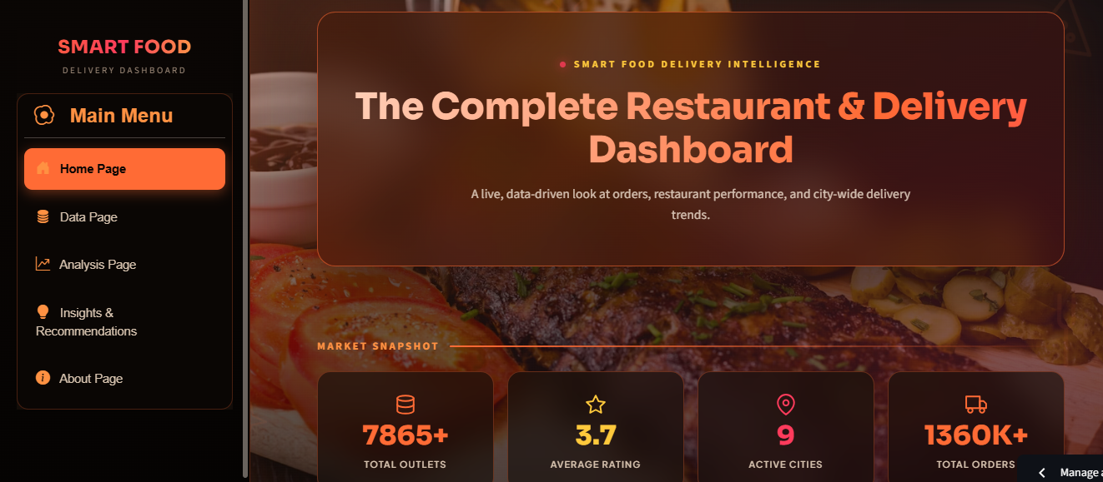
9.3 Dataset Explorer Page
The Dataset Explorer Page allows users to interact directly with the dataset. Users can view records, apply filters, and download filtered data.

Key Features
- Search functionality
- City-wise filtering
- Cuisine-wise filtering
- Interactive data table
- CSV download option

Benefits

This module helps users inspect raw data and perform customized analysis based on their requirements.

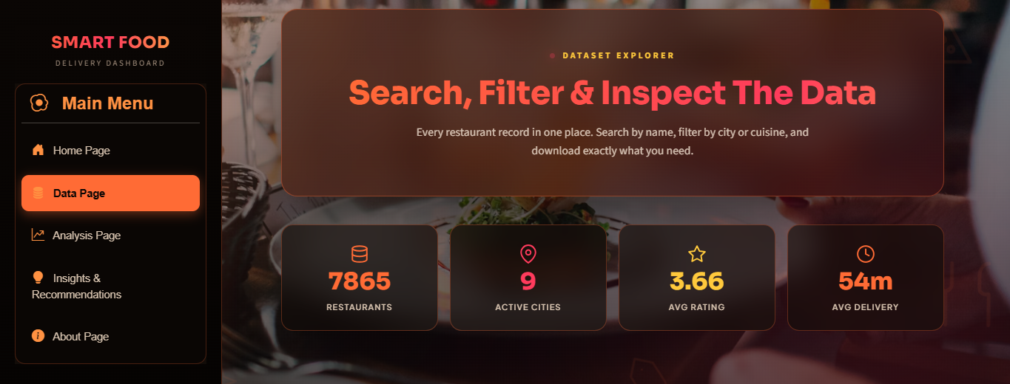

9.4 Analysis Page
The Analysis Page contains multiple charts and visualizations that help users understand different aspects of restaurant performance.

Key Features
- Restaurant performance analysis
- Customer rating analysis
- Cuisine popularity analysis
- Pricing insights
- Geographic analysis
Benefits
The visualizations help identify trends and support decision-making processes

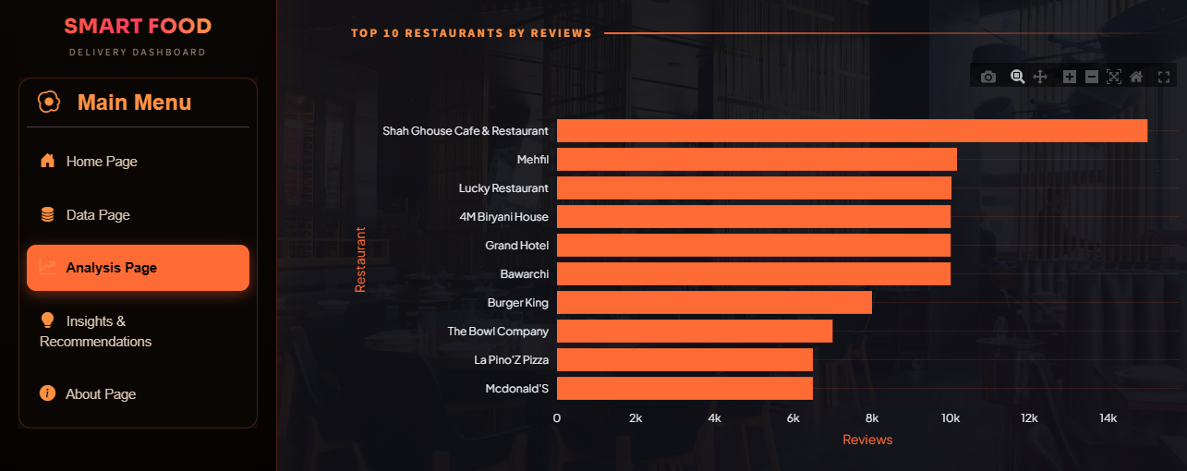

9.5 Insights & Recommendations Page
This page summarizes important findings obtained from the analysis.

Key Features
- Business insights
- Strategic recommendations
- Key observations
- Performance highlights 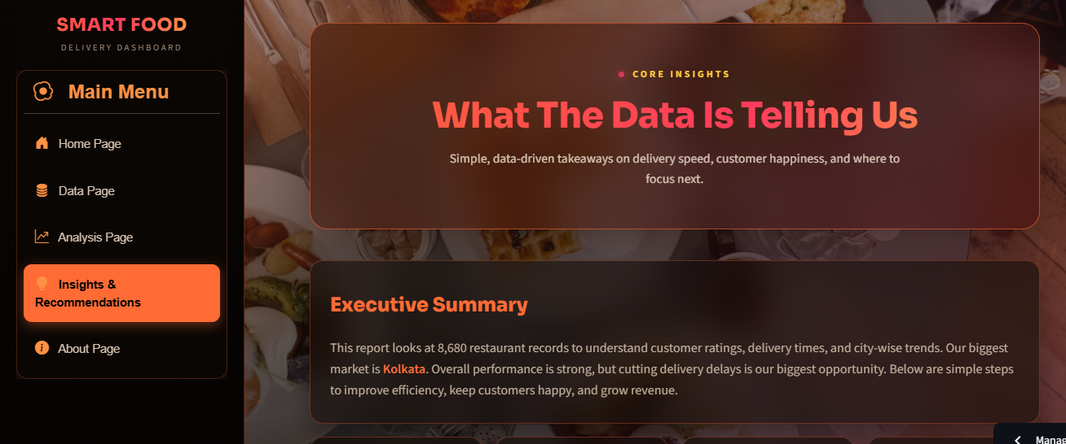

Benefits
The page converts raw analytical findings into actionable recommendations that can be used by businesses.

9.6 About Page
The About Page provides information regarding the project, objectives, technologies used, and developer details.

Information Included
- Project overview
- Technology stack
- Dashboard modules
- Developer information

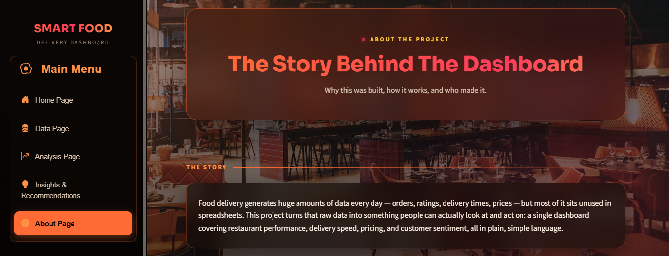

CHAPTER 10: DATA ANALYSIS AND VISUALIZATIONS

10.1 Introduction
Data visualization is one of the most important aspects of analytics because it converts numerical information into graphical representations that are easier to understand.
Several charts were created in this project to analyze restaurant performance, customer behavior, pricing patterns, and delivery efficiency.

10.2 Restaurant Performance Analysis
Restaurant performance was evaluated using customer ratings and total ratings.The analysis revealed that restaurants with higher customer ratings generally received greater customer engagement and positive feedback.

Observations
- Highly rated restaurants attract more customers.
- Popular restaurants receive a larger number of reviews.
- Customer satisfaction influences restaurant success.

10.3 Cuisine Analysis
Cuisine analysis was performed to identify the most preferred food categories.
The dashboard compared different cuisine types based on ratings and popularity.

Observations
- Certain cuisines dominate customer demand.
- Popular cuisines tend to receive more reviews.
- Customer preferences vary across cities.

10.4 Delivery Time Analysis
Delivery time is an important factor influencing customer satisfaction.
The analysis focused on understanding delivery performance across restaurants.

Observations
- Faster deliveries generally receive better ratings.
- Long delivery times can reduce customer satisfaction.
- Delivery efficiency is an important competitive factor.

10.5 Pricing Analysis
Pricing analysis was conducted to understand the relationship between food prices and customer ratings.

Observations
- Higher prices do not always guarantee better ratings.
- Customers value service quality alongside pricing.
- Competitive pricing attracts a larger customer base.

10.6 Geographic Analysis
Geographic analysis was used to compare restaurant activity across different cities.

Observations
- Major cities contain the highest concentration of restaurants.
- Customer demand varies by location.
- Business expansion opportunities exist in less saturated regions.

10.7 Importance of Visualizations
The visualizations developed in this project provide several advantages:
- Simplify complex data.
- Improve decision-making.
- Help identify trends.
- Support business planning.
- Enhance understanding of customer behavior.

CHAPTER 11: KEY INSIGHTS AND FINDINGS

11.1 Introduction
After analyzing the dataset through various visualizations and statistical techniques, several important insights were identified. These findings provide valuable information regarding customer preferences, restaurant performance, delivery operations, and business opportunities. The insights generated through the dashboard can help restaurant owners and food delivery platforms make informed decisions.

11.2 Restaurant Performance Insights
Restaurant ratings are one of the most important indicators of customer satisfaction. The analysis revealed that restaurants with higher ratings generally received a larger number of customer reviews and interactions.

Key Findings
- Highly rated restaurants attract more customers.
- Restaurants with ratings above 4.0 tend to receive greater engagement.
- Customer reviews significantly influence restaurant popularity.
- Consistent service quality contributes to better ratings.
These findings suggest that maintaining service quality is essential for long-term restaurant success.

11.3 Cuisine Popularity Insights
The food category analysis helped identify the most preferred cuisines among customers. Certain food categories consistently showed higher customer demand and engagement.

Key Findings
- Popular cuisines receive a larger number of customer reviews.
- Customer demand is concentrated in a few major cuisine categories.
- Food preferences vary across different cities.
- Restaurants offering popular cuisines generally attract more customers.

11.4 Customer Rating Insights
Customer ratings provide direct feedback regarding restaurant performance and customer satisfaction.

Key Findings
- Better-rated restaurants usually receive more positive customer engagement.
- Low-rated restaurants often experience reduced visibility and customer interest.
- Customer ratings play a significant role in influencing purchasing decisions.
- Ratings serve as an important measure of service quality.
These observations highlight the importance of customer satisfaction in the food delivery industry.

11.5 Delivery Performance Insights
Delivery efficiency directly affects customer experience. The analysis focused on identifying trends related to delivery times and customer ratings.

Key Findings
- Faster deliveries generally result in higher customer satisfaction.
- Long delivery times may negatively impact restaurant ratings.
- Delivery efficiency varies across restaurants and locations.
- Operational improvements can significantly enhance customer experience.
Efficient delivery systems contribute to better customer retention and business growth.

11.6 Pricing Insights
Pricing analysis was conducted to understand the relationship between food prices and customer ratings.

Key Findings
- Expensive restaurants do not always receive better ratings.
- Customers value food quality and service alongside pricing.
- Reasonable pricing improves customer attraction.
- Pricing strategies should balance affordability and profitability.
11.7 Geographic Insights
The geographic analysis compared restaurant activity across different cities.

Key Findings
- Restaurant activity is concentrated in major urban areas.
- Certain cities show significantly higher customer engagement.
- Growth opportunities exist in less saturated regions.
- Geographic trends influence customer preferences and business strategies.
The analysis indicates that location plays a crucial role in restaurant performance.

11.8 Summary of Findings
The analysis clearly demonstrates that restaurant success depends on multiple factors, including customer ratings, delivery efficiency, cuisine popularity, and pricing strategies. Businesses that focus on these factors are more likely to achieve higher customer satisfaction and sustainable growth.

CHAPTER 12: CHALLENGES FACED DURING DEVELOPMENT

12.1 Introduction
During the development of the Smart Food Delivery & Restaurant Insight Dashboard, several challenges were encountered. These challenges provided valuable learning experiences and helped improve problem-solving skills.

12.2 Data Cleaning Challenges
One of the initial challenges involved preparing the dataset for analysis. Raw datasets often contain inconsistencies, missing values, and formatting issues.

Problems Faced
- Missing values in certain fields.
- Inconsistent text formatting.
- Duplicate records.
- Data type mismatches.

Solutions Implemented
- Data cleaning techniques were applied using Pandas.
- Missing values were handled appropriately.
- Data formats were standardized.
- Duplicate entries were removed.

12.3 Dashboard Design Challenges
Creating an attractive and user-friendly dashboard required multiple design iterations.

Problems Faced
- Maintaining a professional user interface.
- Organizing multiple visualizations effectively.
- Ensuring easy navigation between pages.

Solutions Implemented
- Custom CSS styling was used.
- Consistent design elements were maintained.
- Dashboard components were arranged logically.

12.4 Visualization Challenges
Choosing suitable visualizations for different types of data was another challenge.

Problems Faced
- Selecting appropriate chart types.
- Avoiding visual clutter.
- Ensuring readability of graphs.

Solutions Implemented
- Different chart types were tested and evaluated.
- Interactive Plotly visualizations were utilized.
- Graph layouts were optimized for clarity.

12.5 Performance Challenges
Large datasets and multiple visualizations occasionally affected dashboard performance.

Problems Faced
- Slow loading times.
- Delays in rendering complex charts.
- Increased memory usage.

Solutions Implemented
- Efficient filtering mechanisms were introduced.
- Heavy visualizations were avoided.
- Data processing operations were optimized.
12.6 Learning from Challenges
Every challenge contributed to a deeper understanding of dashboard development, data analytics, and problem-solving. Overcoming these difficulties improved both technical and analytical skills.

CHAPTER 13: LEARNING OUTCOMES

13.1 Introduction
The development of this project provided valuable practical experience in data analytics, dashboard development, and business intelligence. The project helped bridge the gap between theoretical concepts and real-world implementation.

13.2 Technical Skills Acquired
Throughout the project, several technical skills were developed and strengthened.

Skills Learned
- Python Programming
- Data Cleaning Techniques
- Exploratory Data Analysis
- Dashboard Development
- Data Visualization
- GitHub Version Control
- Streamlit Application Development
These skills are highly relevant in the field of data science and analytics.

13.3 Analytical Skills Developed
The project also improved analytical thinking and data interpretation abilities.

Analytical Learning Outcomes
- Understanding business requirements.
- Identifying meaningful patterns in data.
- Drawing conclusions from visualizations.
- Generating business recommendations.
13.4 Professional Development
Apart from technical skills, the project also enhanced professional competencies.

Professional Skills Improved
- Problem-solving ability.
- Project management.
- Documentation skills.
- Presentation skills.
- Time management.

13.5 Overall Learning Experience
The project provided a comprehensive learning experience by combining programming, analytics, visualization, and reporting. It demonstrated how data can be transformed into valuable insights that support business decision-making.

CHAPTER 14: CONCLUSION
The Smart Food Delivery & Restaurant Insight Dashboard successfully achieved its objectives by transforming raw restaurant data into meaningful business insights. The dashboard provides an interactive platform where users can explore restaurant performance, customer ratings, delivery efficiency, pricing trends, and cuisine popularity.
Through the use of data analytics techniques and interactive visualizations, the project demonstrates the practical application of data science in solving real-world business problems. The dashboard enables users to identify trends, evaluate performance, and make informed decisions based on data.
The analysis revealed that customer ratings, delivery efficiency, pricing strategies, and cuisine popularity significantly influence restaurant success. Businesses can utilize these insights to improve customer satisfaction, optimize operations, and enhance overall performance.
Overall, the project successfully combines data analysis, visualization, and business intelligence into a single platform, providing valuable insights for decision-making and strategic planning.

CHAPTER 15: FUTURE SCOPE
Although the dashboard provides extensive analytical capabilities, several enhancements can be incorporated in future versions to increase its functionality and effectiveness.

Future Improvements
- Integration with real-time food delivery data sources.
- Development of predictive analytics models.
- Advanced customer behavior analysis.
- Personalized recommendation systems.
- Real-time performance monitoring.
- Mobile-responsive dashboard design.
- Automated report generation.
- Cloud deployment for wider accessibility.
- Multi-language support.
- Enhanced business intelligence features.

Future Benefits
The implementation of these enhancements would make the dashboard more powerful, scalable, and useful for businesses operating in the food delivery industry.
In the future, the dashboard can evolve into a complete business intelligence solution capable of supporting strategic planning, operational optimization, and customer experience management.

CHAPTER 16:REFERENCES
The following resources and technologies were used during the development of the Smart Food Delivery & Restaurant Insight Dashboard:
- Python Software Foundation. Python Programming Language.
- Streamlit Documentation for dashboard development.
- Pandas Documentation for data manipulation and analysis.
- Plotly Documentation for interactive data visualization.
- Matplotlib Documentation for graphical representation.
- Seaborn Documentation for statistical data visualization.
- GitHub Platform for version control and project management.
- Online tutorials and learning resources related to Data Science and Dashboard Development.
- Restaurant dataset provided for analysis and visualization purposes.
- Course materials and guidance provided during the industrial training program at O7 Services, Jalandhar.

CHAPTER 17:APPENDIX

Appendix A: Dataset Description
The dataset used in this project contains information related to restaurants and food delivery services. It includes a total of 8,680 records and 10 attributes.

Dataset Attributes
Attribute | Description
id | Unique identification number
area | Area where restaurant is located
city | City name
restaurant | Restaurant name
price | Average price information
avg_rating | Average customer rating
total_ratings | Total number of ratings
food_type | Type of cuisine offered
address | Restaurant address
delivery_time | Estimated delivery time

Appendix B: Software Requirements
The following software was used during project development:
- Python 3.x
- Streamlit
- Pandas
- Plotly
- Matplotlib
- Seaborn
- Visual Studio Code
- GitHub

Appendix C: Hardware Requirements

Minimum Hardware Requirements
- Processor: Intel Core i3 or higher
- RAM: 4 GB or above
- Storage: 10 GB free space
- Internet Connection
- Windows Operating System

Appendix D: Dashboard Modules
The dashboard consists of the following modules:

Home Page
Provides an overview of the project and key performance indicators.

Data Explorer
Allows users to explore and filter dataset records.

Analysis Page
Contains visualizations and analytical charts.

Insights & Recommendations
Provides business insights and strategic recommendations.

About Page
Contains project information, objectives, and technology details.

Appendix E: Project Features
The Smart Food Delivery & Restaurant Insight Dashboard includes the following features:
- Interactive user interface
- Dynamic filtering options
- Restaurant performance analysis
- Customer rating analysis
- Cuisine trend analysis
- Pricing and cost analysis
- Geographic insights
- Business recommendations
- Downloadable dataset
- Responsive dashboard design

Appendix F: Learning Outcomes
During the development of this project, the following skills were learned and improved:
- Data Cleaning and Preprocessing
- Exploratory Data Analysis
- Data Visualization
- Dashboard Development
- Python Programming
- Version Control using GitHub
- Business Intelligence and Reporting
- Problem Solving and Analytical Thinking

