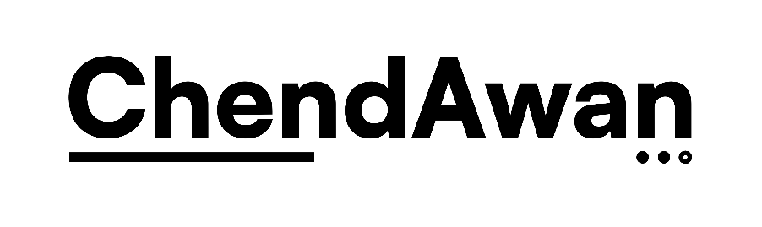  TEAM CHENDAWAN VENTURES  Sole Proprietorship • Software & Payroll Remediation Services | Quotation

PREPARED FOR  [Client Company Name]  [Attention / Contact Person] | Quotation No. [e.g. TCV-2026-001]  Date [DD Month YYYY]  Valid Until [DD Month YYYY]
Project: [Project Name]
Project Summary
[2-4 sentence overview of the scope, deliverables, and structure of the engagement — what will be done, in what phases, and by when.]
Description | Qty | Unit Price (RM) | Amount (RM)
[Line Item — e.g. Phase / Deliverable Name]  [Brief description of what this phase / item covers] | [Qty] | [0.00] | [0.00]
[Line Item — e.g. Phase / Deliverable Name]  [Brief description of what this phase / item covers] | [Qty] | [0.00] | [0.00]
[Line Item — e.g. Phase / Deliverable Name]  [Brief description of what this phase / item covers] | [Qty] | [0.00] | [0.00]
 |  | TOTAL ESTIMATE | RM [0.00]
Additional Charges & Scope Limitations
[Item outside scope] | [Explain why it's excluded and how it will be billed if required]
[Item outside scope] | [Explain why it's excluded and how it will be billed if required]
Payment Schedule
- [e.g. 20% Deposit: Upon project confirmation and commencement.]
- [e.g. 40% Progress Payment: Upon deployment to staging / mid-project milestone.]
- [e.g. 40% Final Balance: Upon sign-off and delivery to production.]
Terms & Conditions
- [State how changes in scope after sign-off will be handled — e.g. billed separately as a new module.]
- [State client responsibilities during the engagement — e.g. providing feedback or sign-off within a set number of working days.]
- [State limitation of liability — e.g. exclusions for issues arising from client data entry errors or external factors outside the technical scope.]
- [State intellectual property terms — e.g. deliverables transfer to the client upon full payment.]
- [State warranty terms, if any — e.g. a free support period after go-live, and what voids it.]

Thank you for your business.
[Preparer Name]
Sole Proprietor, Team ChendAwan Ventures
+60 14-7207787 | chendawan25@gmail.com
SSM Registration No.: [SSM Registration No.]

