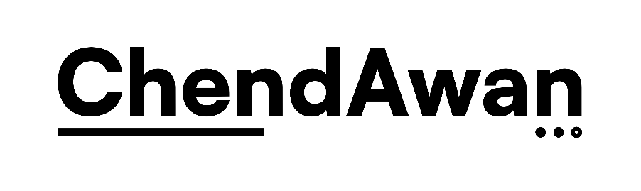  TEAM CHENDAWAN VENTURES  Sole Proprietorship • Software & Payroll Remediation Services | SLA

SERVICE LEVEL AGREEMENT
This Service Level Agreement (“Agreement” or “SLA”) is made on [Date] (“Effective Date”).
SERVICE PROVIDER  TEAM CHENDAWAN VENTURES  Registration No. 202603212164 (003878769-W)  A sole proprietorship duly registered in Malaysia, having its principal place of business at No. 22, Jalan Sutera 4/5, Taman Puteri, 86000 Kluang, Johor, Malaysia. | CLIENT  [Client Company Name]  Having its principal place of business at [Client Address].
The Service Provider and the Client are collectively referred to as the “Parties” and individually as a “Party”.
1. Purpose
This Agreement sets out the service levels, support standards, response times, maintenance expectations, and related obligations applicable to the Service Provider’s provision of information technology consultancy and services, custom software development, cybersecurity services, maintenance, bug fixing, security patching, and server monitoring in respect of [Project Name], or such other services as may be agreed in writing by the Parties.
2. Definitions
For the purposes of this Agreement:
- “Business Hours” means [insert hours] Malaysia time, excluding weekends and public holidays in Malaysia.
- “Business Day” means a day other than Saturday, Sunday, or a public holiday in Malaysia.
- “Incident” means any unplanned interruption, defect, vulnerability, service degradation, or support issue affecting the services.
- “Scheduled Maintenance” means planned maintenance notified in advance by the Service Provider.
- “Uptime” means the percentage of time the hosted or managed service is available and functional during a calendar month, excluding permitted downtime under this Agreement.
3. Scope of Services
The Service Provider shall provide the following services, as applicable to the Project:
- maintenance and support;
- bug fixing;
- security patching;
- server monitoring;
- incident triage and remediation;
- reasonable technical advice related to the supported system.
Any work outside the agreed scope shall be subject to a separate written agreement or change request.
4. Service Availability
Subject to the exclusions in this Agreement, the Service Provider shall use reasonable commercial efforts to maintain 99.9% monthly uptime for web portals and IoT infrastructure hosted or directly managed by the Service Provider.
Uptime shall be measured on a monthly basis. Downtime caused by Scheduled Maintenance, client actions, force majeure, or third-party systems outside the Service Provider’s reasonable control shall not count as unavailability.
5. Incident Priorities
Incidents shall be classified as follows:
Severity Level | Description | Target Response | Target Resolution
Severity 1  (Critical) | System down, security breach, or critical vulnerability being exploited. | Within 1 hour | Within 4 hours
Severity 2  (High) | Major functionality impacted and no practical workaround exists. | Within 4 hours | Within 24 hours
Severity 3  (Normal) | Minor bugs, UI issues, or general support queries. | Within 24 hours | Within 3–5 Business Days
Response time means the time from acknowledgment of the incident by the Service Provider. Resolution time means the time to provide a fix, workaround, or reasonable remediation plan.
6. Support Procedure
The Client shall report incidents via [email / ticketing system / WhatsApp / phone]. The Client shall provide reasonable details, including screenshots, error messages, reproduction steps, and relevant logs where available.
The Service Provider may request additional information before commencing investigation. Any delay caused by incomplete or inaccurate information provided by the Client shall not count against the Service Provider’s target times.
7. Scheduled Maintenance
Scheduled Maintenance shall ordinarily be carried out during off-peak hours, typically between 12:00 a.m. and 4:00 a.m. MYT, unless otherwise agreed in writing.
The Service Provider shall give the Client at least 48 hours’ prior notice of any scheduled downtime expected to exceed 30 minutes, except where urgent maintenance is required to address a security risk, active failure, or legal compliance issue.
8. Exclusions
The Service Provider shall not be liable for failure to meet service levels where such failure results from:
- Scheduled Maintenance;
- acts or omissions of the Client;
- modifications not made or approved by the Service Provider;
- internet, hosting, cloud, telecom, or third-party service failures outside the Service Provider’s reasonable control;
- force majeure events;
- misuse, unauthorized access, or interference by third parties not under the Service Provider’s control.
9. Service Credits
If agreed by the Parties in writing, the Client may be entitled to service credits if monthly uptime falls below the agreed threshold. Any such credits, if applicable, shall be the Client’s sole and exclusive remedy for uptime failures, unless otherwise agreed in writing.
10. Term and Termination
This Agreement shall commence on the Effective Date and shall remain in force until terminated in accordance with the primary service agreement between the Parties or upon written notice by either Party, subject to any accrued rights and obligations.
11. Confidentiality and Data Protection
Each Party shall keep confidential any non-public information obtained in connection with this Agreement and shall comply with applicable Malaysian data protection and security requirements in relation to personal data or security-related information handled under this Agreement.
12. Governing Law and Jurisdiction
This Agreement shall be governed by and construed in accordance with the laws of Malaysia. The Parties irrevocably submit to the exclusive jurisdiction of the courts of Malaysia.
13. Entire Agreement
This Agreement, together with the primary service contract and any written appendices, constitutes the entire agreement between the Parties with respect to its subject matter and supersedes prior discussions or understandings on the same subject matter.
14. Amendment
No amendment, variation, or modification of this Agreement shall be effective unless made in writing and signed by both Parties.
15. Execution
IN WITNESS WHEREOF, the Parties have caused this Agreement to be executed by their duly authorized signatories on the date first written above.
For and on behalf of Team ChendAwan Ventures  Name: MUHAMMAD SAIFUL IQBAL BIN ABDUL RANI  Title: Owner / Sole Proprietor  Date: [Date]  Signature | For and on behalf of [Client Company Name]  Name: [Signatory Name]  Title: [Title]  Date: [Date]  Signature

