How we formally proof that is impossible to make the listener know that there multiple signal?

Notations:

Set of warning signal S which D,C ⊆ S

Set of motor

Set of one-off discrete Boolean signals D =s0,s1,s2,…,sn,for sn ∈ D, such as battery low,edge detected…

For each of the motors, set of discrete signal C = {(Speed, Temperature,Time)} , which describe property of motor every second such as speed and temperature in each motor

By some function properties of signals can be mapped into continues representation. The set of frequency of set S and C can be described as Fre, which Fre(C) = {frequency(x)|x∈C}. And a set of pitch can be describe by Pitch(C) = {pitch(x)|x∈ C}.

For problem itself, other than the numerous human error that could be happen, we assume there are several human limitation that we want to proof that can be the case that:

Assume there is only 2 motors a mono speaker, the speak must hold more than one stream of sound. That makes there is probability that to stream shared same frequency and same signal. It makes the user cannot distinguish which signal from which motor.

for the signal itself, is it possible to create the same frequency signal that people cannot distinguish(assume that human cannot distinguish the sound with same frequency):

Ex,y ∈ C Fre(x) = Fre(y)

Or the signal are too close from each other:

Ex,y ∈ C |Fre(x) - Fre(y)|<n, which n is threshold.

Too many different sound on the same time, the user cannot distinguish which signal is which after n signals.

Uppaal is a software to vertifly auto automata and do synchonised simulation. The user can make different templete of models. The models are communicating though channel, which is the share variable.

Our aim is using UPPAAL, a timed automata to simulate how the machine work, also for how the error signals are probably mapped into different speakers

I don’t know how to do the accepting state of that so I just put the verifier on that and assume the verifier work as the accepting state. UPPAAL disadvantage: synchronization that is not allowed to make chained action at once…(Think that in the real world situation a function may include many action at once to get on with it.)

This is the automata to generate infinite string base on the motor action. Assume that speed and temp are increased and decreased continuously.

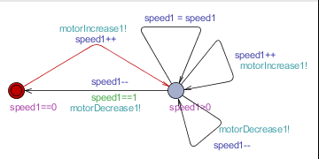

This automata take the string from 1, send out processed signal about the pitch or frequency.

Omega automata(2) is used to read the infinity string generated by (1).

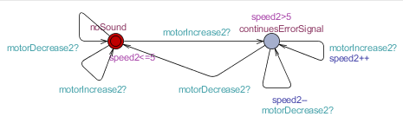

Since the transmission of sound is some kind of signal transmission, that is possible to have a look into the formal proof of wireless/wire protocol transmission signal proof of losing some signal during transmission.

Hearing is some kind of mutural access.(only allow 1 or 2 access at a time). Thus, we can have a look into how node is formal proofed in flooding protocal in wireless network.

Think that human reception is a kind of sensor, and the speaker of the car is the sender.

For the problem of “Hearing too much noise and not receiving any of the signal” is like the machine cannot reconise any signal when multiple RFID card is reading by the sensor in the same time.

My thesis is, if human brain hear the sound with similar volumn, tone and pitch, they are on the same track. Thus if there are too much track that has sound at the same time, human brain cannot distinguish between different track because