Results:

Expression analysis of miRNAs:

To understand the selective export mechanism of microRNAs, understanding which miRNAs are actually affected was required. By using previously complied RNA-seq data for small RNAs which measured miRNAs found in the cellular and extracellular vesicle content of the GFP-PC3 and the cavin-1::GFP-PC3 cell line, I can determine which of these miRNAs are in fact mediated by a change in lipid raft composition. The fold change between miRNA counts in the GFP and the cavin-1 cell lines was found for both cellular contents and the extracellular vesicles derived from these cells. By taking the difference between the fold change in the cell from the fold change in the extracellular vesicle, we can sort the miRNAs into three defined groups; miRNAs differentially down regulated upon lipid raft compositional change, miRNAs exported by chance due to proportional increase/decrease of the cell and exosome counts, and miRNAs differentially up regulated in the exosomes due to lipid raft composition.

|  |  |  |  |
| --- | --- | --- | --- |
| **Differential Up** | **Non-Diff** | | **Differential Down** |
| hsa-miR-140-3p | hsa-miR-222-3p | hsa-miR-181a-2-3p | hsa-miR-10b-5p * |
| hsa-miR-6087 | hsa-miR-769-5p | hsa-miR-362-5p | hsa-miR-32-5p |
| hsa-miR-185-5p | hsa-let-7g-5p | hsa-miR-532-5p | hsa-miR-147b- |
| hsa-miR-31-5p | hsa-miR-28-3p | hsa-miR-582-3p ψ | hsa-miR-186-5p- |
| hsa-miR-877-5p | hsa-miR-15b-5p | hsa-miR-183-5p | hsa-miR-98-5p * |
| hsa-let-7e-5p | hsa-let-7d-5p | hsa-miR-221-3p ψ | hsa-miR-148b-3p |
| hsa-miR-339-5p | hsa-miR-26b-5p | hsa-miR-25-3p | hsa-miR-3615 |
| hsa-miR-574-3p *ψ | hsa-miR-182-5p | hsa-miR-125a-5p | hsa-miR-151a-3p |
| hsa-miR-205-5p | hsa-miR-93-5p | hsa-miR-629-5p | hsa-miR-19a-3p *ψ |
| hsa-miR-361-5p | hsa-miR-92b-3p | hsa-miR-503-5p | hsa-miR-10a-3p |
| hsa-miR-27a-5p | hsa-miR-671-5p | hsa-miR-125b-2-3p | hsa-miR-22-3p |
| hsa-miR-1269a | hsa-miR-149-5p ψ | hsa-miR-148a-5p | hsa-miR-30e-5p |
| hsa-miR-4664-3p | hsa-miR-502-3p | hsa-miR-374a-3p | hsa-miR-30a-5p * |
| hsa-miR-196b-5p | hsa-miR-1180 | hsa-miR-363-3p *ψ | hsa-miR-20b-5p *ψ |
| hsa-miR-106b-3p | hsa-let-7d-3p | hsa-miR-500a-3p | hsa-miR-16-2-3p * |
| hsa-miR-484 | hsa-miR-191-5p | hsa-miR-99b-3p | hsa-miR-429 * |
| hsa-miR-30e-3p | hsa-miR-589-5p | hsa-miR-542-3p | hsa-miR-148a-3p * |
| hsa-let-7i-5p | hsa-miR-200b-3p | hsa-miR-450b-5p | hsa-miR-200a-3p * |
| hsa-miR-30b-5p | hsa-miR-30a-3p | hsa-miR-1307-3p | hsa-miR-17-5p |
| hsa-miR-221-5p ψ | hsa-let-7b-5p | hsa-miR-146a-5p *ψ | hsa-miR-125a-3p- |
| hsa-miR-375 | hsa-miR-200a-5p | hsa-miR-340-5p |  |
|  | hsa-miR-27a-3p | hsa-miR-421 |  |
|  | hsa-miR-99a-5p |  |  |

* indicates miRNAs with FCEXO p≤ 0.05 ψ indicates miRNAs with FCCELL p≤0.05

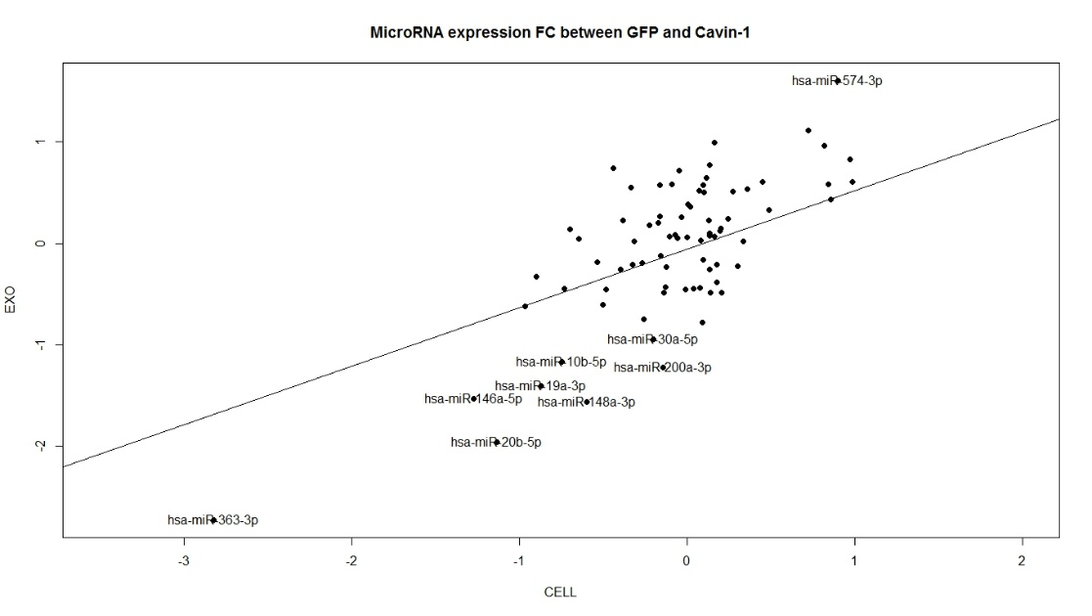

Proteomics data:

Previously, proteomics data (MS/MS) was compiled for the proteomic content of the total membrane, lipid rafts, extracellular vesicles, and total extracellular space for both the GFP and the cavin-1::GFP PC3 cell lines. The mean ratio was completed between GFP and cavin-1 cells to determine which proteins are modified upon lipid raft lipid composition, induced by cavin-1. Furthermore, a protein would be required to possess RNA-binding abilities to perform as a RNA-escort protein. By using Gene Ontology R package (BiomaRt), data was filtered for only proteins that can be a possible RNA escort protein by possessing RNA-binding domains. From this analysis, there were only 6 proteins found within the extracellular vesicles that possess RNA binding ability, where 5 of these are downregulated upon cavin-1 introduction. Within this data set, there is the FUS protein, that had been a previous point of interest, and hnRNPK, which is family members with a previously known RNA binding and potential miRNA escort protein. Furthermore, hnRNPK was found within the lipid raft fraction at a proportionate decrease, where FUS was not found at all. Lack of proteins in detected the fractions may occur due to low presence or due to crude extraction measures resulting in a higher threshold for detection. Other candidates either were incorrectly labelled at RNA binding, or only bind poly-(N) regions, by the ontology database or are not known to be found within lipid rafts, as per RaftProt.

Motif data:

Proteins will bind to certain miRNAs based on their sequence, where this sequence needs to be conserved to enable binding. Therefore, a set of RNAs would possess the same or similar motif in order to bind to the same protein domain. Using the grouped miRNAs based on differential export, we can establish a test set of miRNAs that are expected to bind to a proposed protein and a group of miRNAs are not selectively exported and therefore should not bind to proteins facilitating the selective export. The miRNAs that are not selectively exported are not expected to possess the shared motif of the differentially exported miRNAs, where this motif is proposed to be motif that’ll correspond to an RNA-binding protein. Using the open sourced TAMO module, from the Fraenkel Lab, 5 motifs were discovered for each miR group, between 4-10 nucleotides long. The following network reveals which miRs correspond to each motif. Red corresponds to miRs that were differentially exported, whereas blue is the remaining miRs. Maroon and light blue motifs are the motifs enriched when compared to the corresponding data sets. In particular, two motifs appear to correspond to the most miRNAs with limited crossover to the non-differential data set: TrmAgAwCy and AgTGCa.

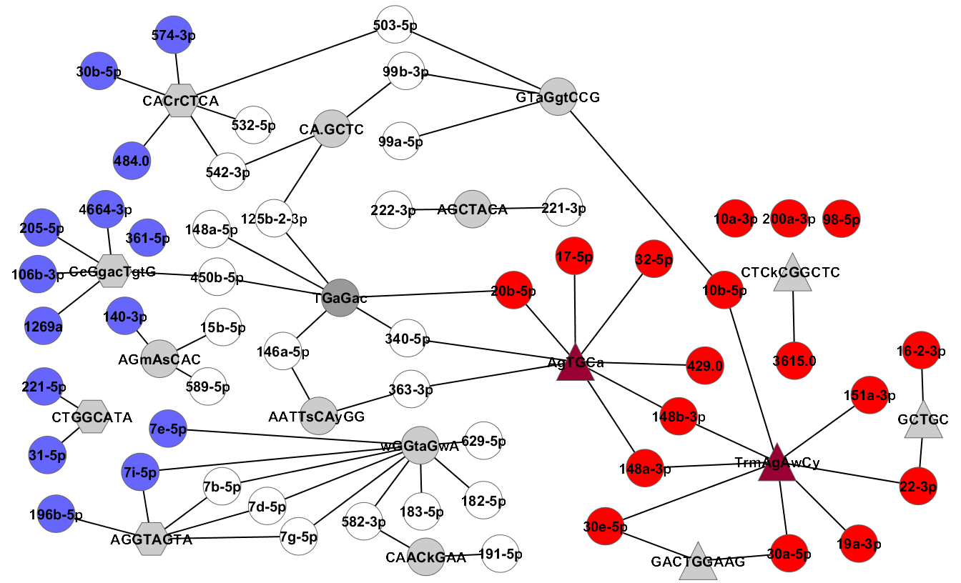

MicroRNAs possess two major regions within their small 17-24nucleotide, particularly the seed. This region ranges from nucleotide 2-8 which dictates the binding of the miRNA to a particular mRNA. Hereby, understanding where the motif is in the miRNAs can reveal the activity of the miRNAs whilst bound to the selective export protein.

|  |  |
| --- | --- |
| hsa-miR-22-3p | AAGCUGCCAGUUGAAGAACUGU |
| hsa-miR-148b-3p | UCAGUGCAUCACAGAACUUUGU |
| hsa-miR-19a-3p | UGCAAAUCUAUGCAAAACUGA |
| hsa-miR-30a-5p | UGUAAACAUCCUCGACUGGAAG |
| hsa-miR-151a-3p | CUAGACUGAAGCUCCUUGAGG |
| hsa-miR-10b-5p | UACCCUGUAGAACCGAAUUUGUG |
| hsa-miR-30e-5p | UGUAAACAUCCUUGACUGGAAG |
| hsa-miR-148a-3p | UCAGUGCACUACAGAACUUUGU |
| Reg expression | T[G/A]AAGA[A/T]CT |

|  |  |
| --- | --- |
| hsa-miR-148a-3p | UCAGUGCACUACAGAACUUUGU |
| hsa-miR-148b-3p | UCAGUGCAUCACAGAACUUUGU |
| hsa-miR-32-5p | UAUUGCACAUUACUAAGUUGCA |
| hsa-miR-429 | UUUUGCAAUAUGUUCCUGAAUA |
| hsa-miR-17-5p | CAAAGUGCUUACAGUGCAGGUAG |
| hsa-miR-20b-5p | CAAAGUGCUCAUAGUGCAGGUAG |
| hsa-miR-340-5p | UUAUAAAGCAAUGAGACUGAUU |
| Reg expression | AGTGCT |

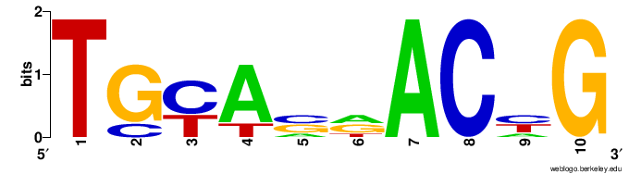These tables highlight the positions of the motifs on the miRNAs for each of the two important motifs. While the first motif appears to be more widespread across the miRs, the second motif seems to only be positioned in the seed region. This means that the miRs are not able to bind to their target mRNAs when bound to the export protein, if this is indeed the binding motif, or that the miRs are being targeted by an RNA-bound protein.

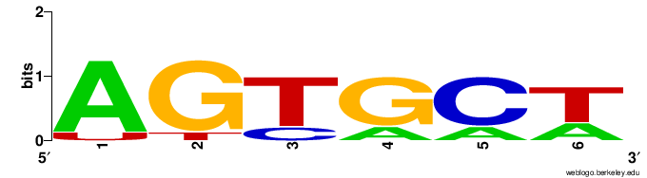Using the current information about the known motifs for proteins from the RBP database and Unix shell, the RNA binding proteins that are known to bind to similar miR regions can be found. From this analysis, YBX1 and SNRPA were of interest as they correspond to the TrmAgAwCy and AgTGCa motifs, respectively. However, the previous candidate proteins were not found to correlate to either of these motifs. Yet this could be due to last of RNA binding information about these proteins. Yet, both of these new candidiate proteins are known to interact physically with FUS and hnRNPK, which may explain any correlation to the change in miRNA export. Furthermore, YBX1 appears to be correlated to hnRNPK, FUS and miR down regulation in the exosomes and may be part of the mechanism dictating the export of the miRs.

qPCR:

Verify was required on the RNA-seq data. The 9 miRs that provided the most interesting based on fold change and significance will be verified using qPCR to assess whether they will be useful candidates for future research. MiR-125a-3p has been proposed as a candidate endogenous control for the exosome qpcrs due to its uniformity between the cell lines. However, this miR is still increased in the cellular content and as such care must be taken when comparing the cellular to exosome content of miRs when normalized to this reference gene.

Immunofluorescence:

To confirm the presence of the candidate protein to the extracellular vesicles, localization studies using immunofluorescence was performed. Initial experiments assessed only the presence of hnRNPK, FUS and YB1 protein in the model cell line (GFP). Of these candidates

Paper with information about transfection of miRNA:

http://www.ncbi.nlm.nih.gov/pmc/articles/PMC4667072/