Cells:

* Currently freezing stocks. Next split into T175 to transfer to plates
* Am I using the exoRNeasy kit? If so, ask specifics: How many plates would I need, how many columns per replicate etc.
* When I test the primer, do I do it on cell or exo derived RNAs?

Candidates:

* Show data found already: all in the lipid raft folder.
* Candidates: FUS, hnRNPK, small nuclear ribonecleoprotein Sm D3, Endoplasmin, ILF2.
* FUS: GGUG motif, consensus not found in the mirs, however second best AGUG found in 148a, 20b, 200a. Known to associate to lipid rafts (raft prot, 3 entries)
* hnRNPK: Appears to be poly(C) binding. Family member known to regulate exo miR content. Contains 3KH domains (RNA binding domains) and one RGG-box (also RNA binding domain). RBPDB: shown to bind to a range of non-polyC sequences. Also known to associate to lipid rafts (raft prot: 11 entries for human cells, 23 total)

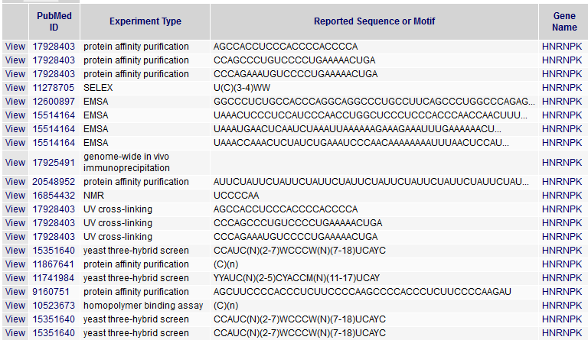

Got PWM and a logo:

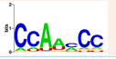

* SNRPD3: known to associate to lipid rafts (3 entries on raft prot), BUT is only known to bind to poly a, no entries in RBPDB.
* Endoplasmin: 22 human entries in raft prot. No information in RBPDB about rna binding.
* ILF2: 7 entries in raft prot, no entries on RBPDB.